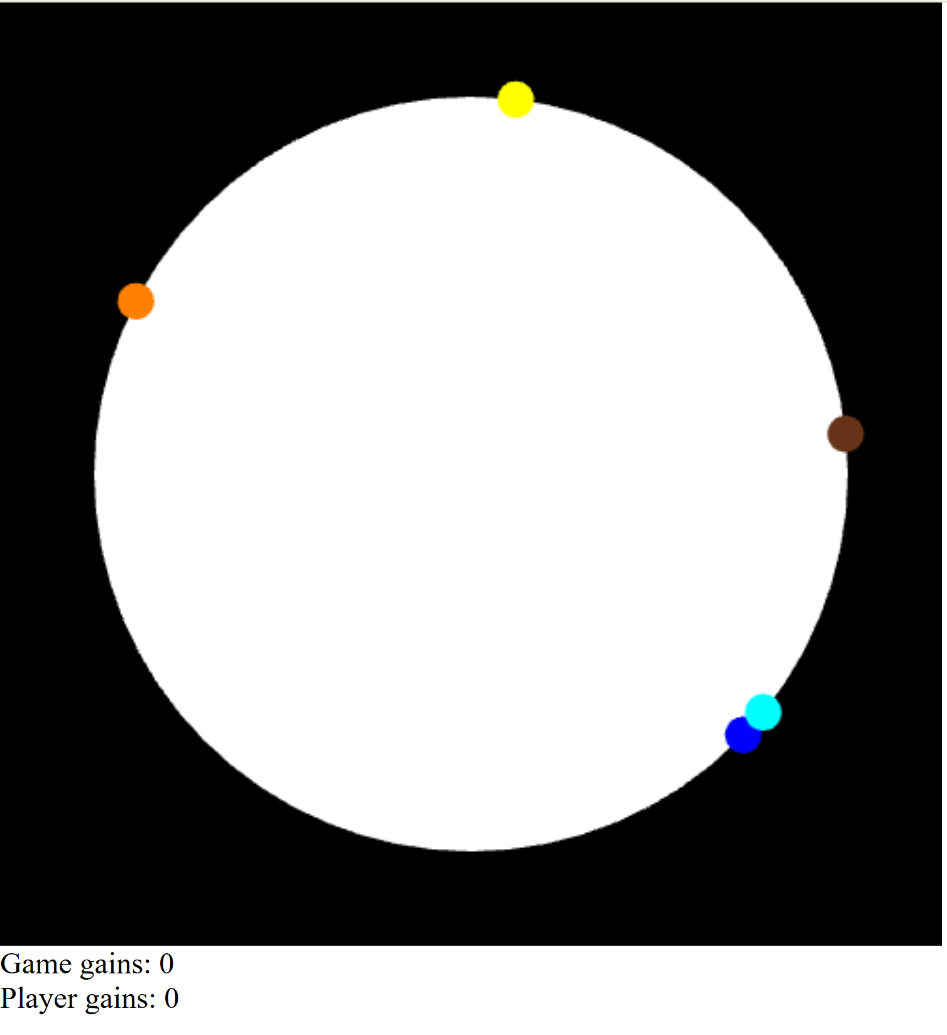
This shows the start of a round where five bacteria have spawned at the edge of the disk, and both the player and game scores are at zero.

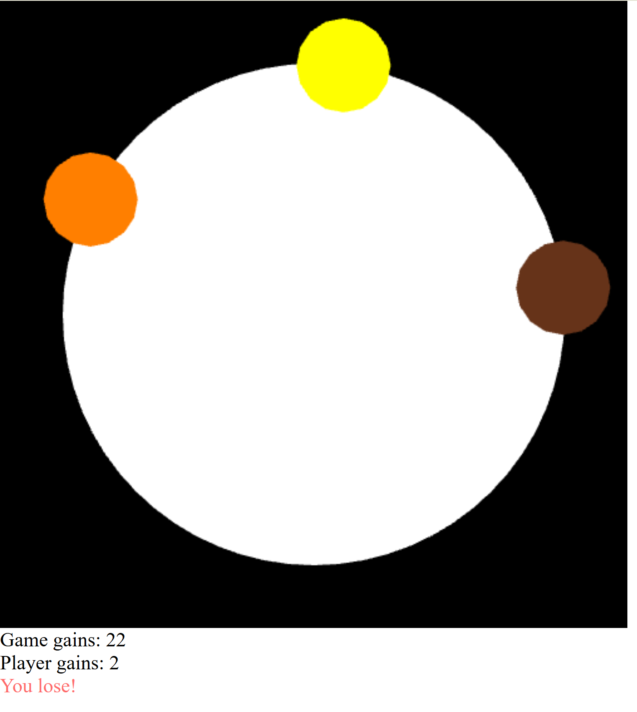
The player lost because at least two bacteria grew to the threshold size, resulting in a high "Game gains" score of 22.


The player won by quickly clicking and killing all five bacteria before two of them could reach the threshold size.

