GIT & GITHUB
Assignment Documentation
Flask + Git Workflow + MongoDB To-Do Application
Prepared by
Narinder Kumar
GitHub: Narinder-code17
Repository: Git_and_GitHub_Narinder
Repository URL: https://github.com/Narinder-code17/Git_and_GitHub_Narinder
This document records the commands, implementation steps, branch operations, merge/conflict resolution, reset, rebase, and evidence screenshots required by the assignment.

1. Assignment Overview
The objective of this assignment was to practice a complete Git and GitHub workflow using a Flask project. The work covered SSH authentication, repository cloning, branch creation, commits, merging, conflict resolution, sequential development branches, MongoDB integration, soft reset, and rebasing.

1.1 Submission Requirements Covered
- Created and worked with a GitHub repository using SSH.
- Created a username-based branch and merged the work into main.
- Created a second branch for JSON/API changes and resolved a real merge conflict.
- Created master_1 and master_2 for independent To-Do frontend and backend work.
- Added Item ID, Item UUID, and Item Hash as three separate commits.
- Used git reset --soft to roll main back to the Item ID commit and re-committed the staged state.
- Rebased master_1 onto the updated main while retaining the individual Task 4 commits.
- Collected 40 screenshots as evidence of the workflow.

1.2 Repository and Technology Details
Repository | Git_and_GitHub_Narinder
GitHub User | Narinder-code17
Clone Method | SSH
Application | Flask
API Data | data.json
Database | MongoDB Atlas
Python Packages | Flask, pymongo, python-dotenv
Frontend | HTML/CSS To-Do form
Branches Used | main, Narinder-code17, Narinder-code17_new, master_1, master_2

1.3 Final Project Structure
Git_and_GitHub_Narinder/
├── app.py
├── data.json
├── requirements.txt
├── .gitignore
├── .env.example
├── templates/
│ └── todo.html
└── screenshots/
├── 01 ... 40 evidence screenshots
└── ...
The real .env file contains the local MongoDB connection string and is intentionally excluded from the submission/repository through .gitignore. The safe .env.example file is included as a template.

2. Task 1 — GitHub Repository, SSH, Branching and Merge
Task 1 established the repository and basic Git workflow. The repository was cloned through SSH, the username branch was created, project files were committed, and main was established/published.

Important commands used:
git --version
ssh-keygen -t ed25519 -C "narinderkumar1517@gmail.com"
ssh -T git@github.com
git clone git@github.com:Narinder-code17/Git_and_GitHub_Narinder.git
git config user.name "Narinder Kumar"
git config user.email "narinderkumar1517@gmail.com"
git switch -c Narinder-code17
git add .
git commit -m "Add initial Flask project"
git push -u origin Narinder-code17
git switch -c main
git push -u origin main

Evidence Screenshots

01. SSH key added to GitHub
Added the generated SSH public key to the GitHub account so the repository could be accessed securely using SSH.
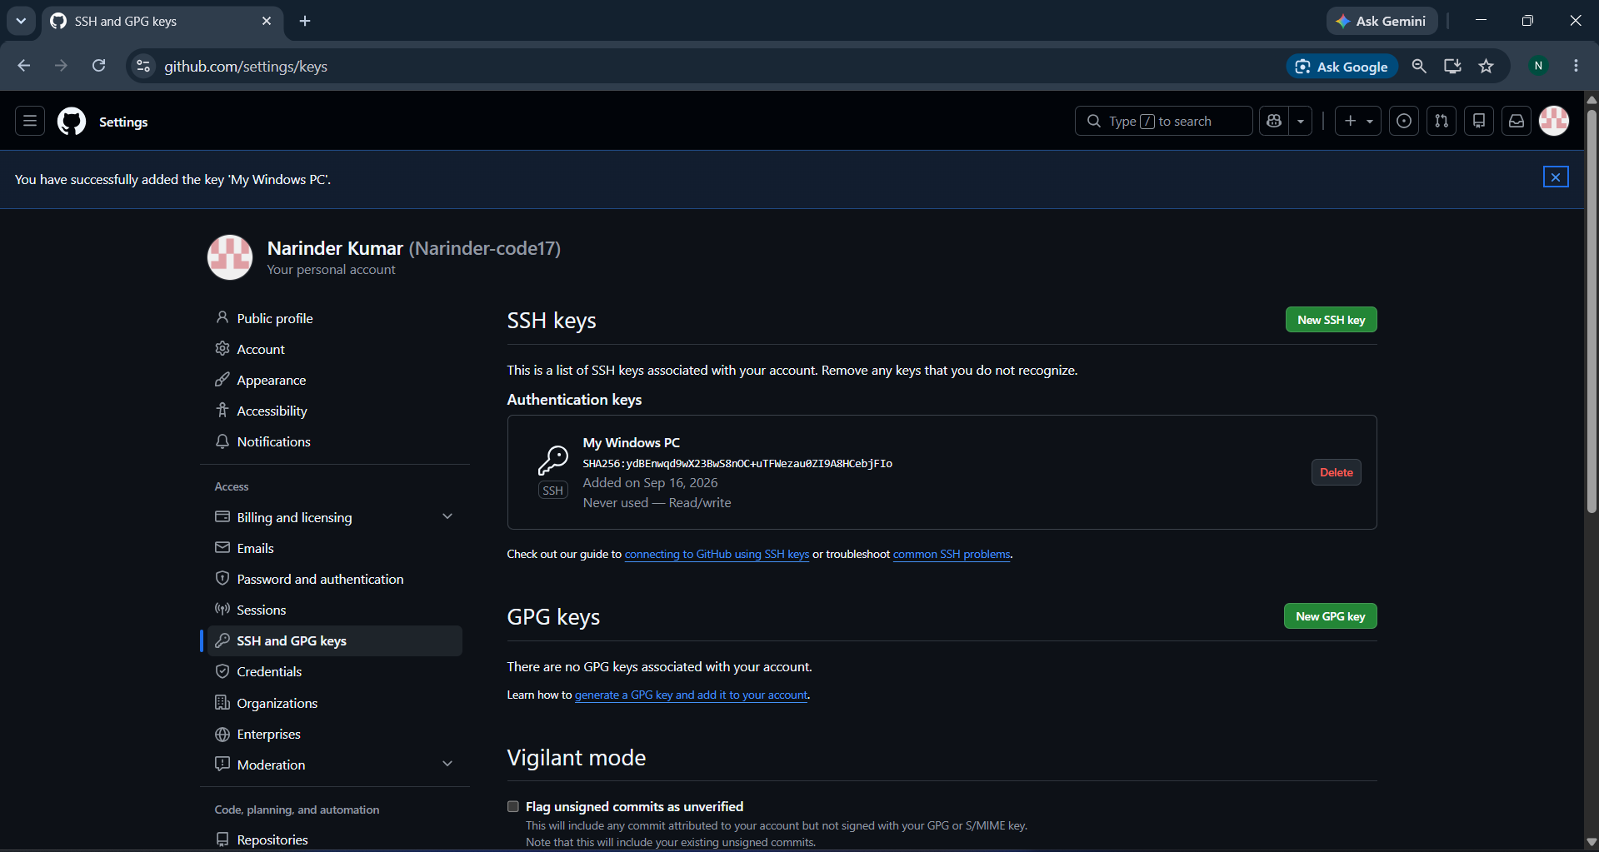
Screenshot 01 — Evidence for Task 1.

02. SSH connection verification
Verified SSH authentication with GitHub using `ssh -T git@github.com`.
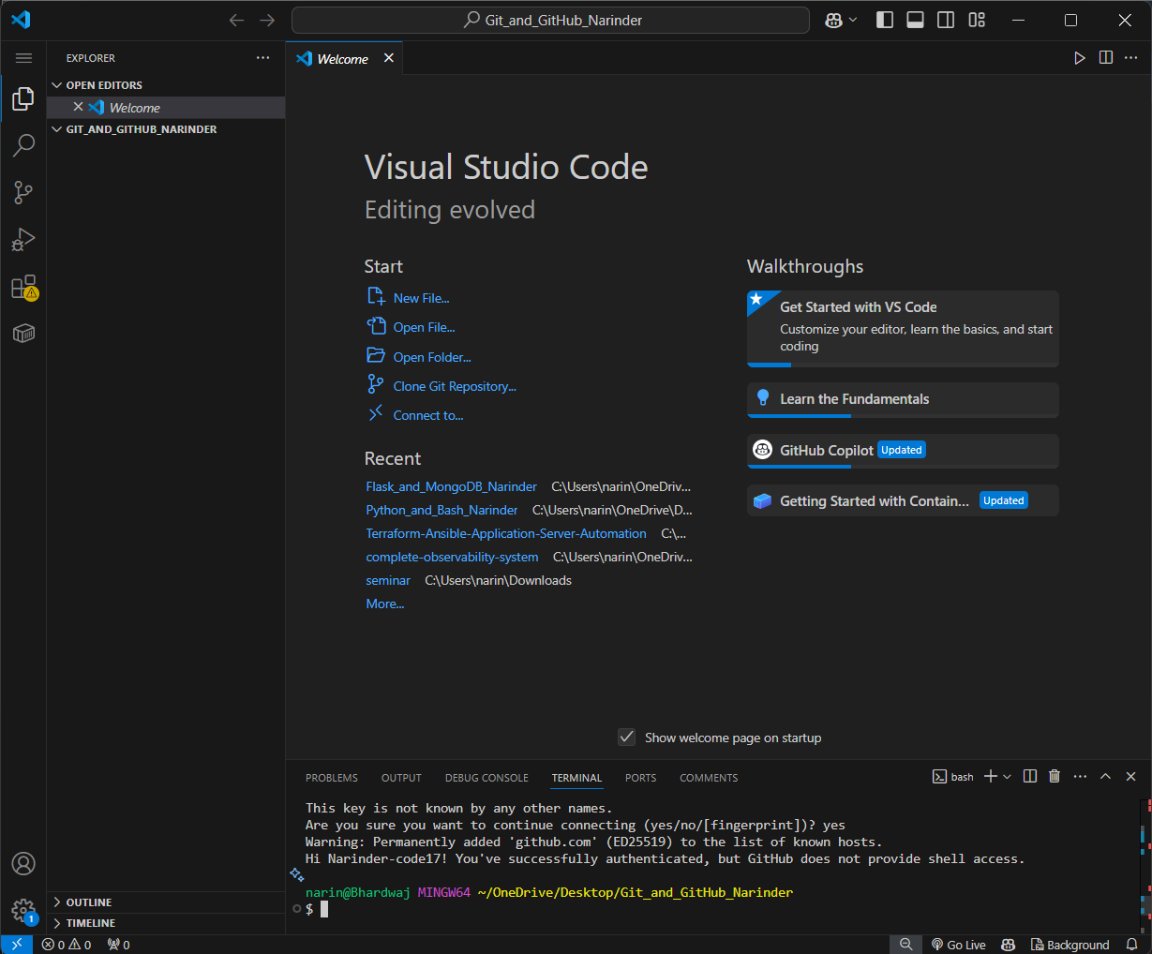
Screenshot 02 — Evidence for Task 1.

03. Repository cloned using SSH
Cloned the GitHub repository locally using the SSH repository URL.
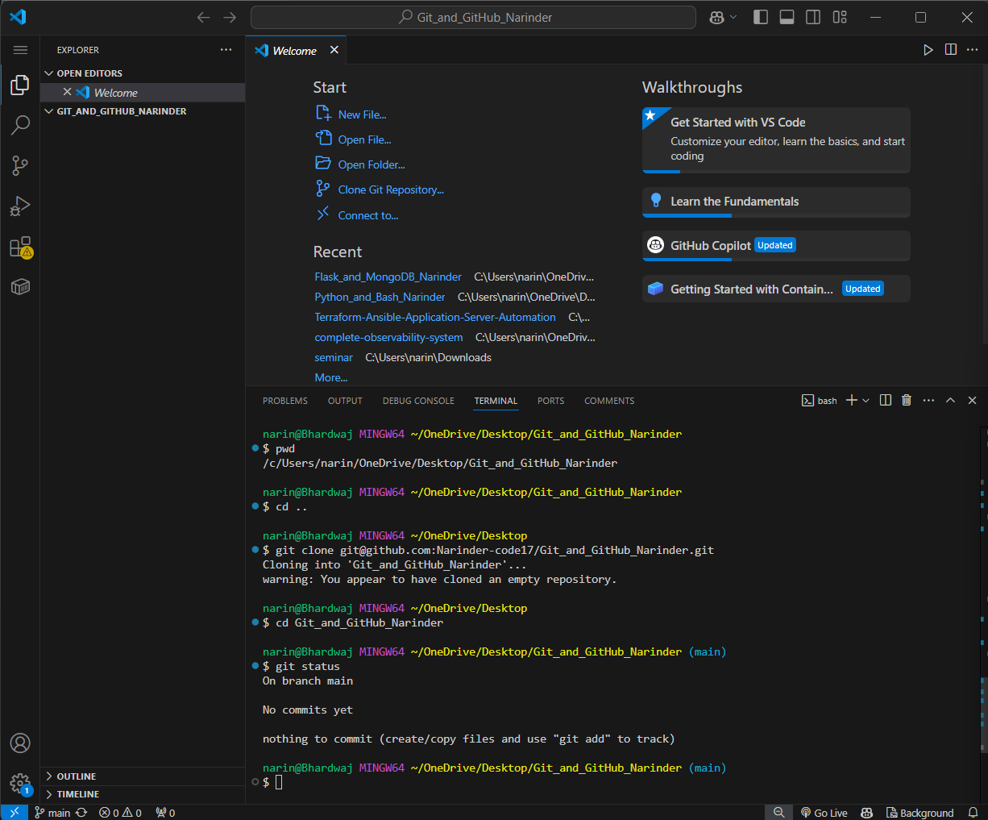
Screenshot 03 — Evidence for Task 1.

04. Flask server started
Started the Flask application locally and verified that the server was running.
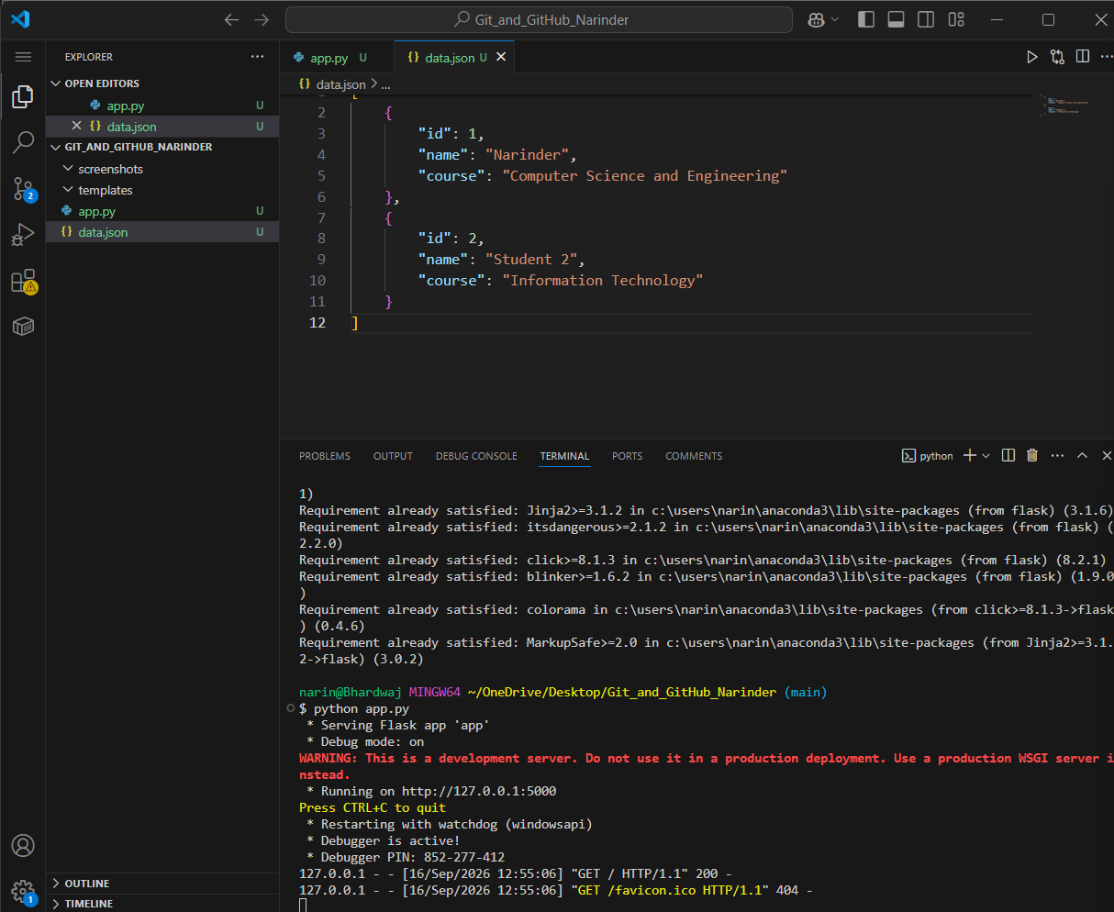
Screenshot 04 — Evidence for Task 1.

05. Flask home route
Opened `/` and verified the Flask application response.
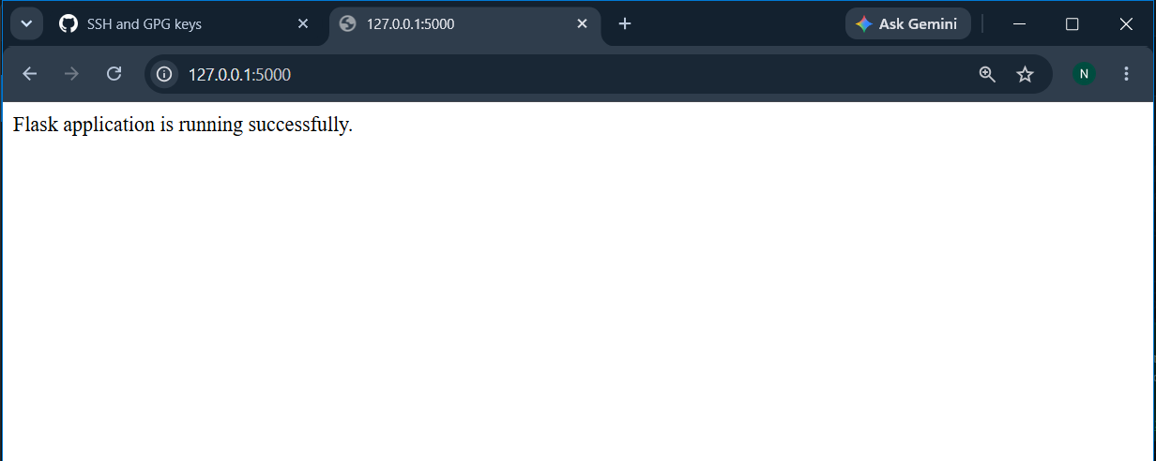
Screenshot 05 — Evidence for Task 1.

06. Flask API route
Opened `/api` and verified JSON data was returned from `data.json`.
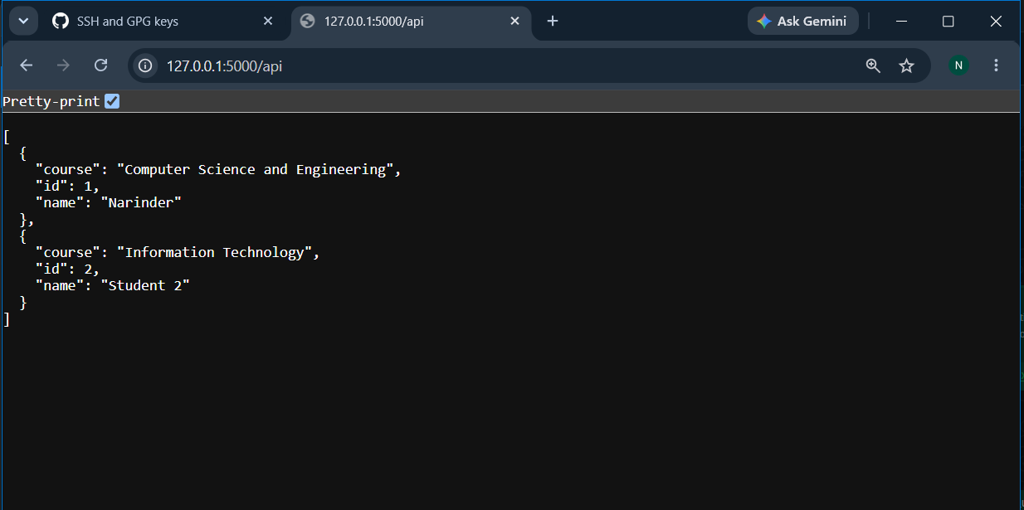
Screenshot 06 — Evidence for Task 1.

07. Git configuration
Configured the Git username and email for the repository.
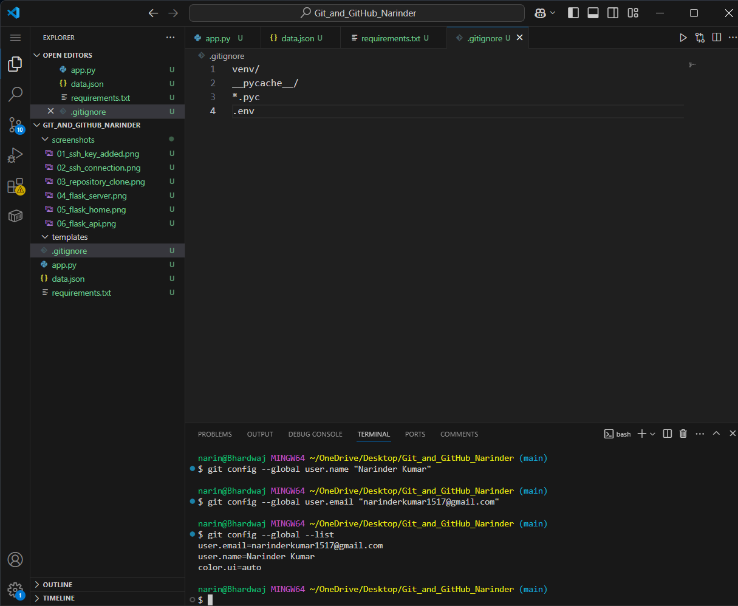
Screenshot 07 — Evidence for Task 1.

08. Username branch created
Created the username-based branch `Narinder-code17` as required by Task 1.
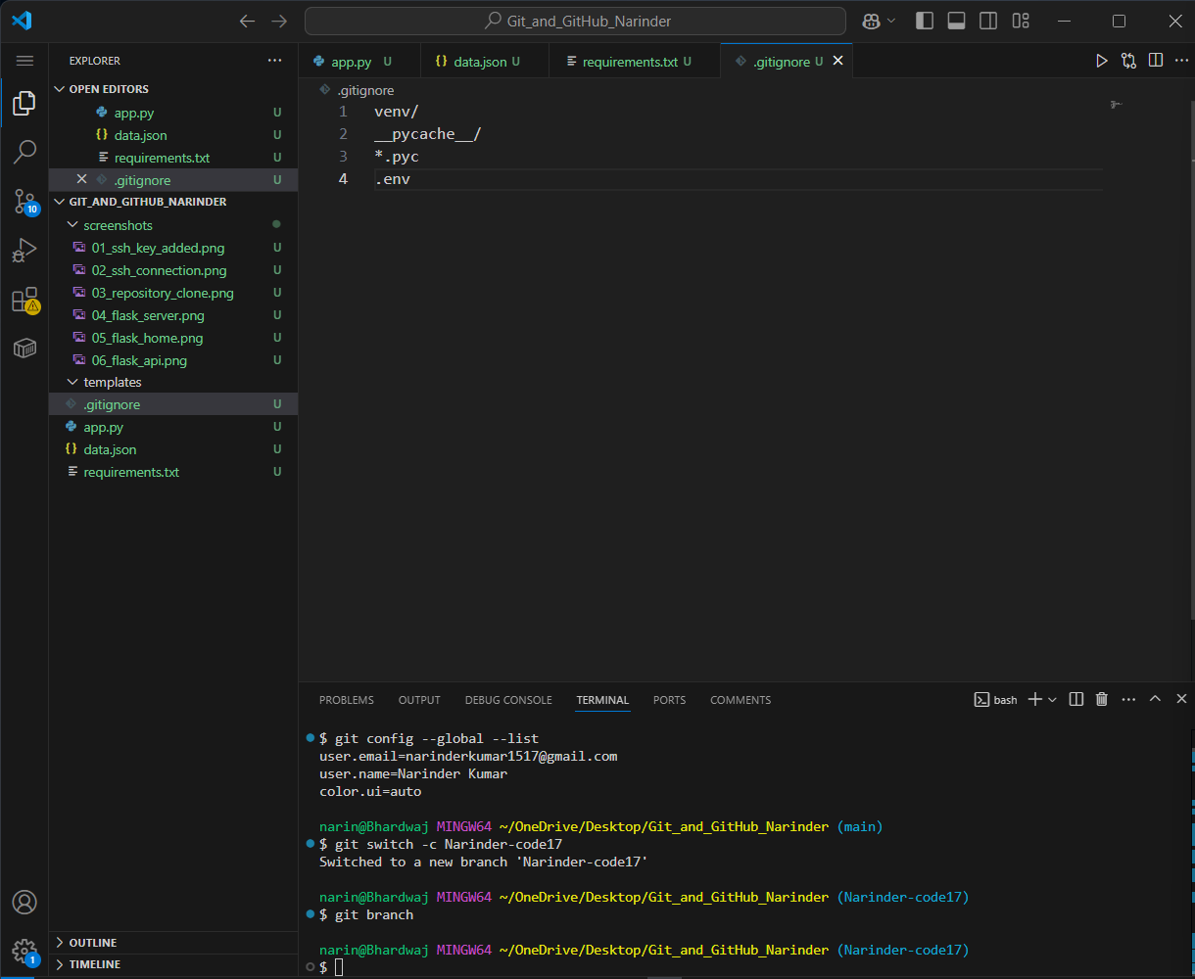
Screenshot 08 — Evidence for Task 1.

09. Project files staged
Added the Flask project files to Git using `git add`.
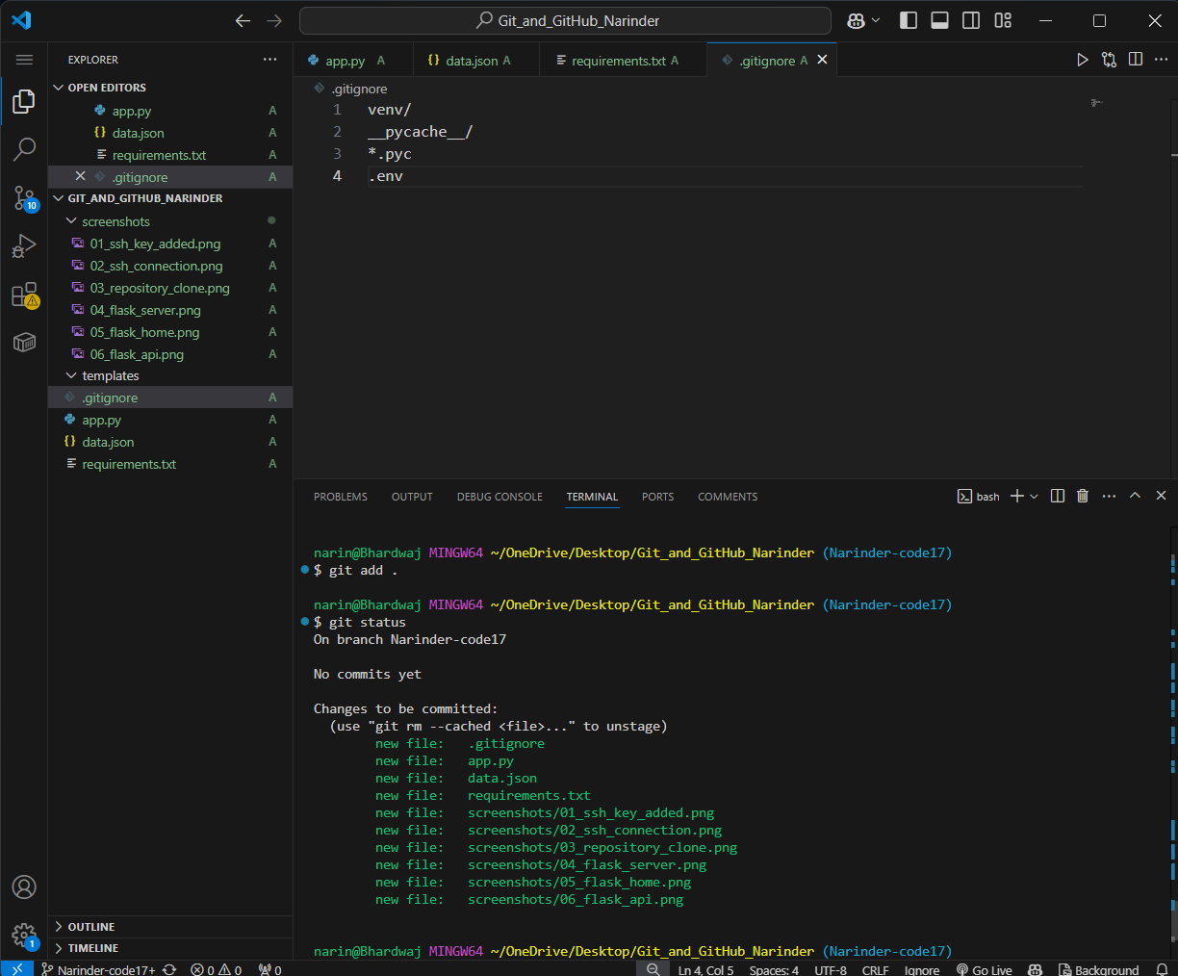
Screenshot 09 — Evidence for Task 1.

10. Initial project commit
Created the initial commit containing the Flask project.
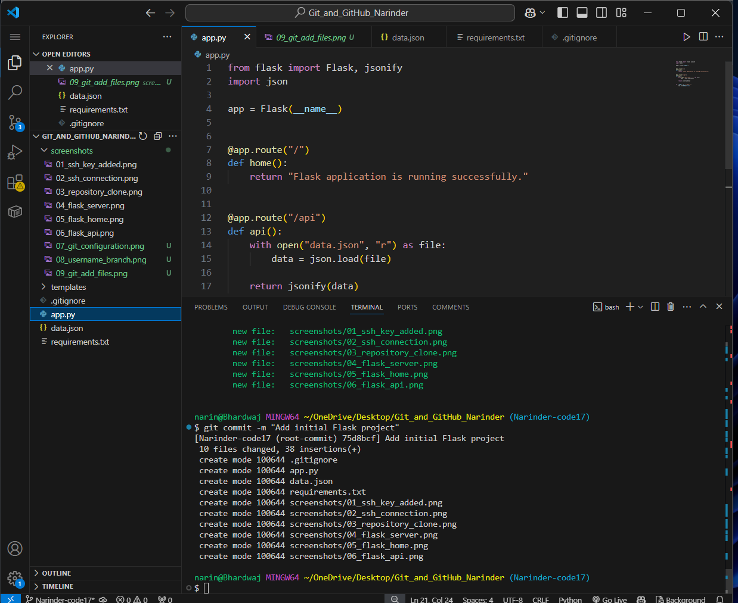
Screenshot 10 — Evidence for Task 1.

11. Username branch pushed
Pushed the `Narinder-code17` branch to GitHub.
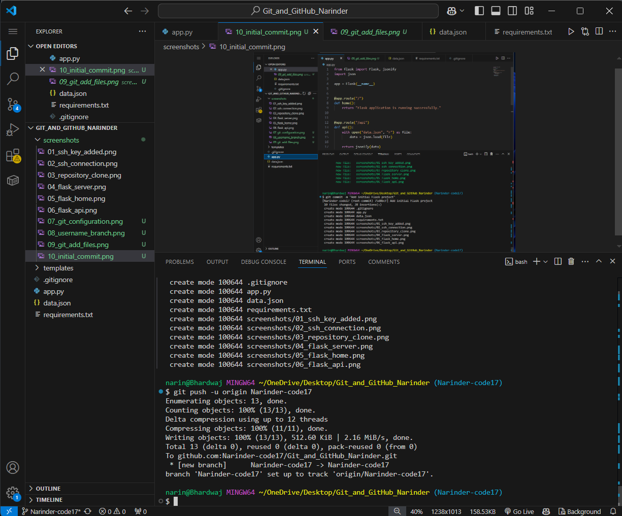
Screenshot 11 — Evidence for Task 1.

12. Main branch created
Created the `main` branch from the initial project history and published it to GitHub.
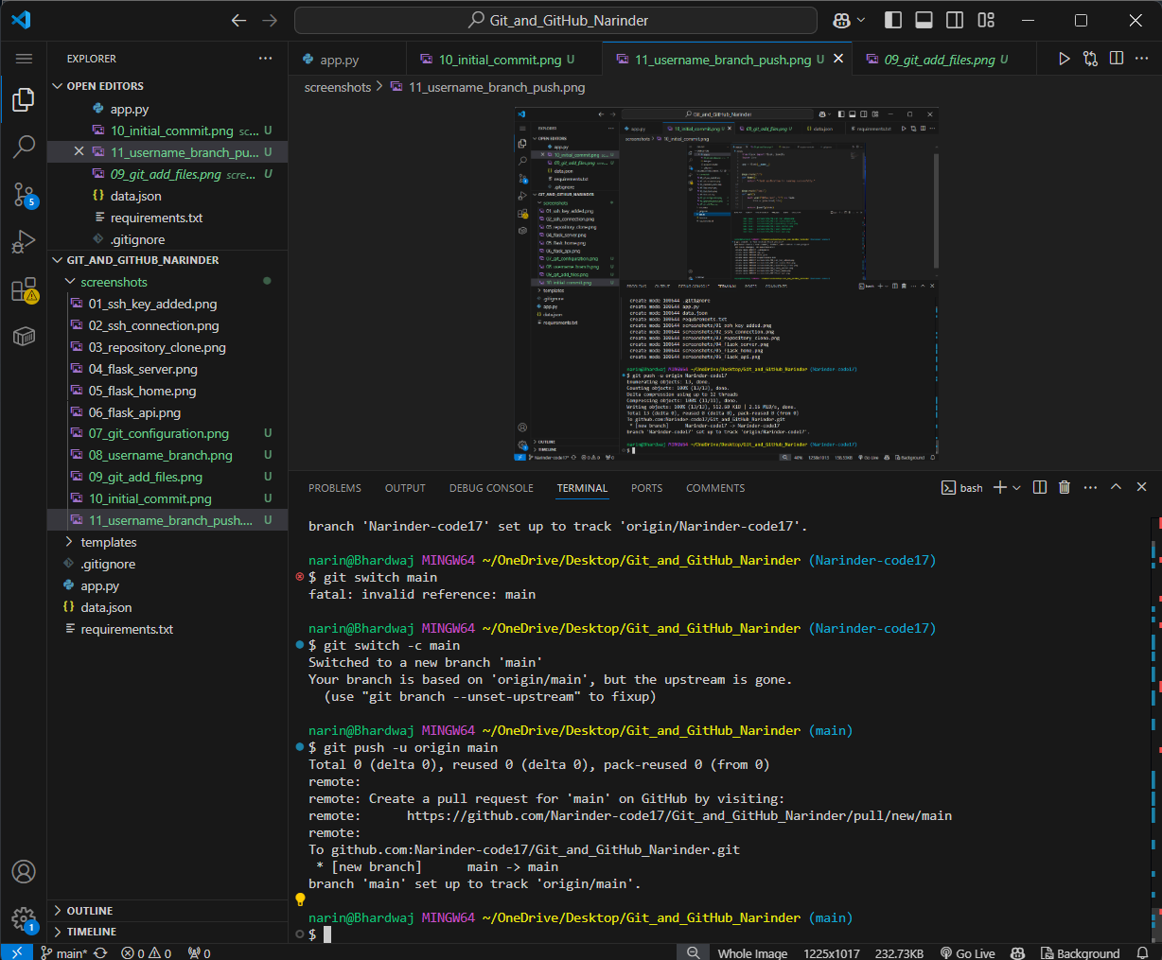
Screenshot 12 — Evidence for Task 1.

13. Task 1 merge
Completed the Task 1 merge workflow. The username branch was already represented in the main history, so Git reported no additional changes where applicable.
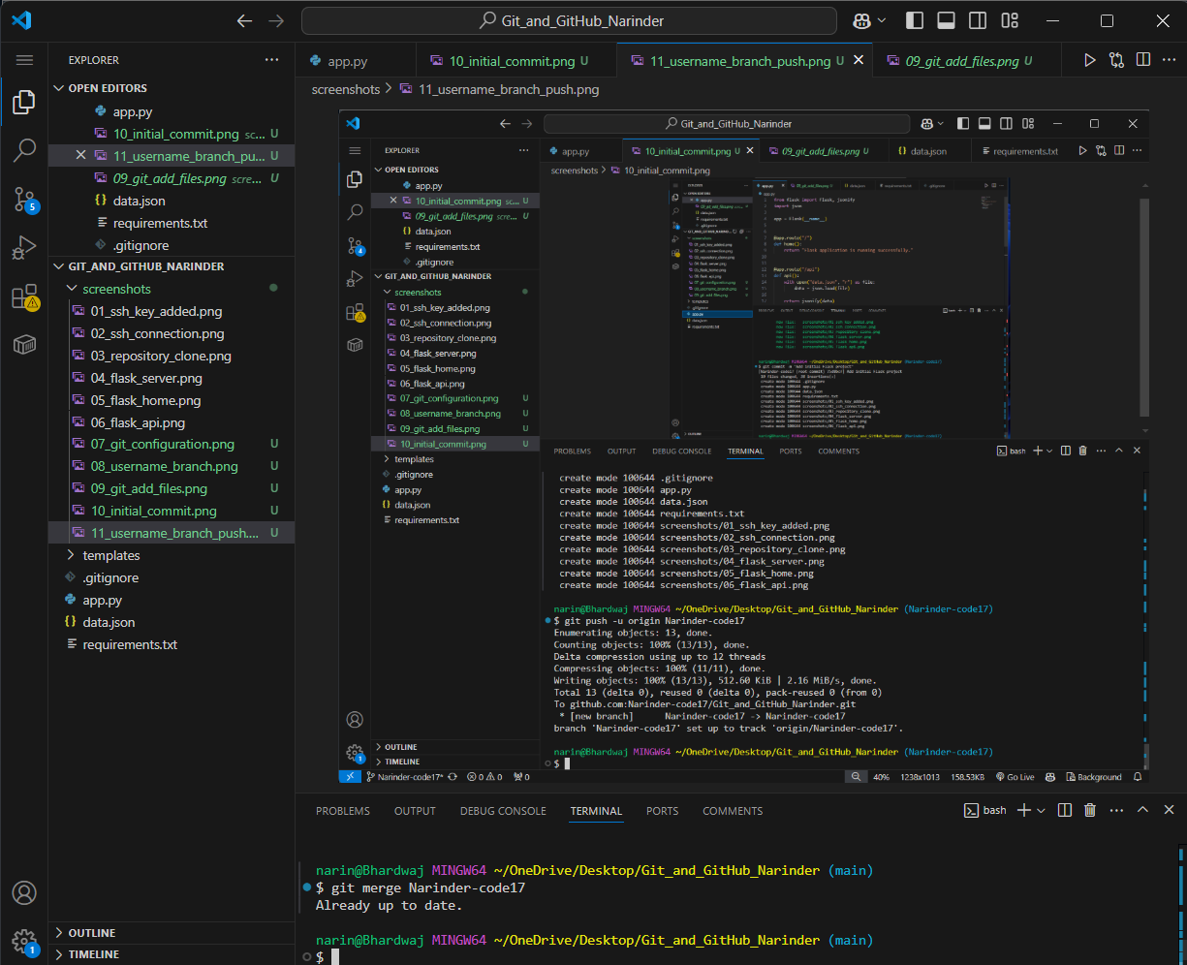
Screenshot 13 — Evidence for Task 1.

3. Task 2 — JSON Update, Merge Conflict and Resolution
Task 2 deliberately created different changes to data.json on two branches. The new branch added Student 3, while main changed Student 2’s course. Merging the branches produced a conflict. The conflict was resolved by accepting the incoming changes from Narinder-code17_new, then the resolved file was staged, committed, and pushed.
git switch main
git switch -c Narinder-code17_new
# update data.json and add Student 3
git add data.json
git commit -m "Update API JSON data"
git push -u origin Narinder-code17_new
git switch main
# modify Student 2 course on main
git add data.json
git commit -m "Update main API data"
git push origin main
git merge Narinder-code17_new
# resolve data.json by accepting incoming changes
git add data.json
git commit -m "Merge Narinder-code17_new and resolve conflict"
git push origin main

14. JSON updated on new branch
Updated `data.json` on `Narinder-code17_new` by adding a third student record.
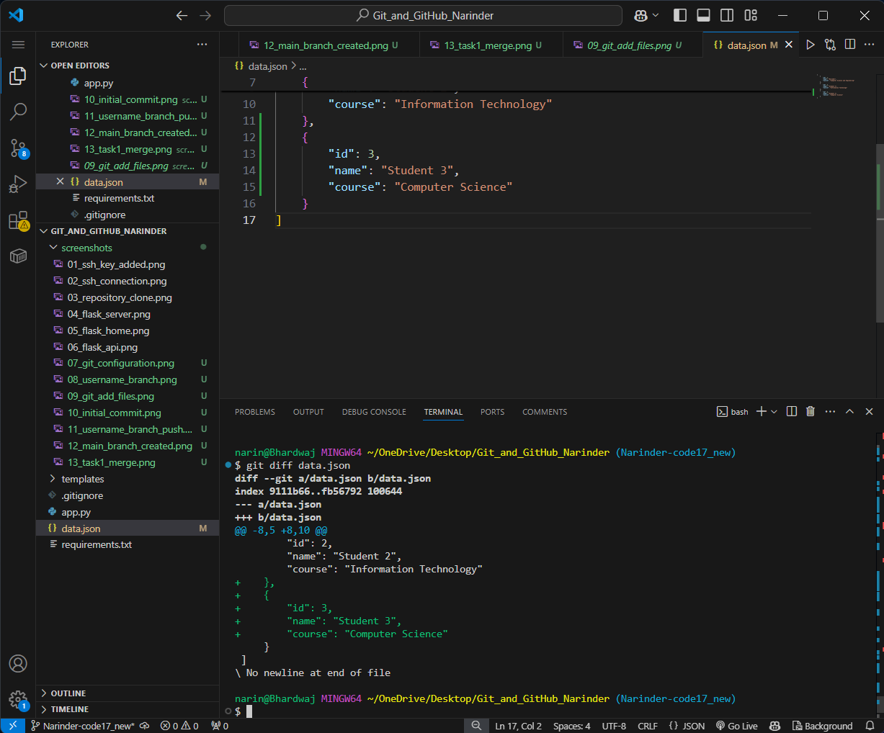
Screenshot 14 — Evidence for Task 2.

15. JSON update committed
Committed the API JSON update on `Narinder-code17_new`.
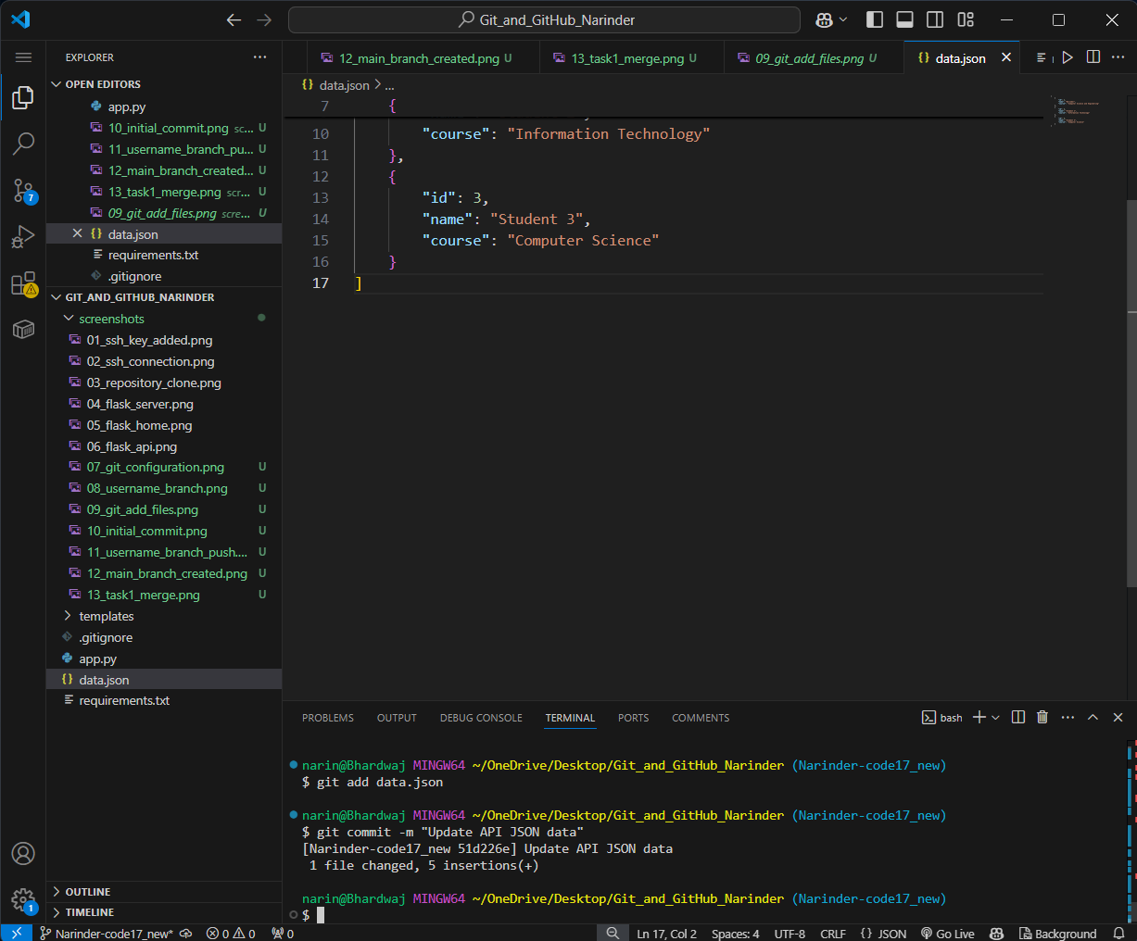
Screenshot 15 — Evidence for Task 2.

16. New branch pushed
Pushed `Narinder-code17_new` to GitHub.
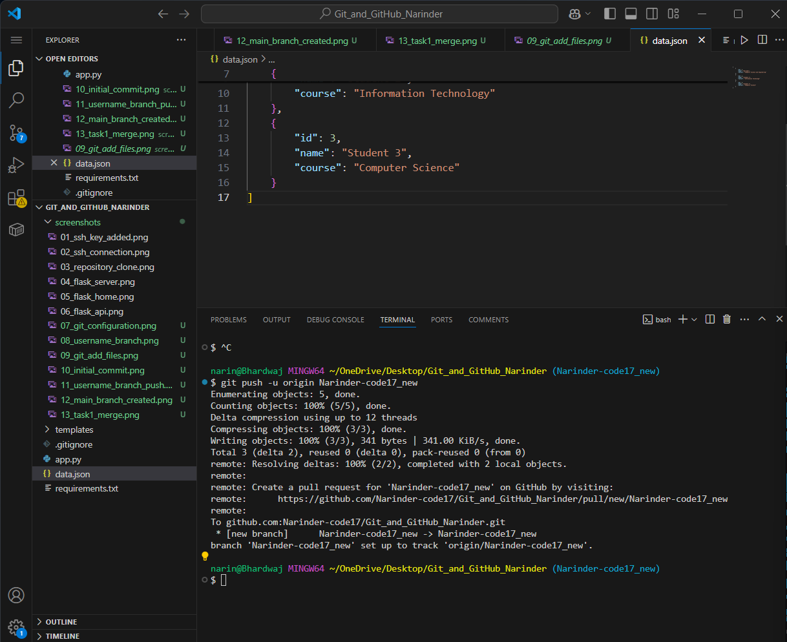
Screenshot 16 — Evidence for Task 2.

17. Conflicting main change
Changed the course value for Student 2 on `main`, creating a deliberate merge conflict with the new branch.
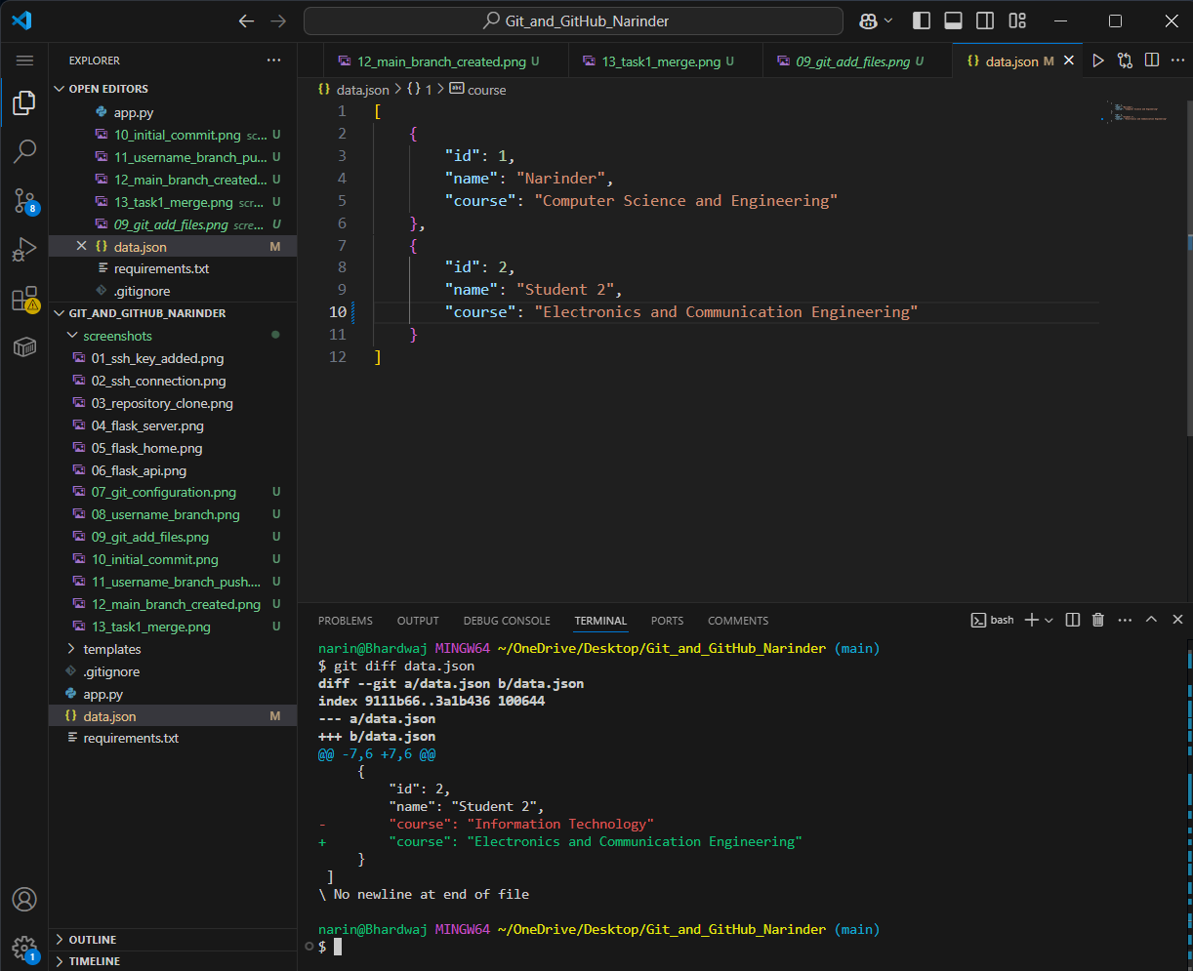
Screenshot 17 — Evidence for Task 2.

18. Main JSON change committed
Committed the conflicting `main` branch JSON change.
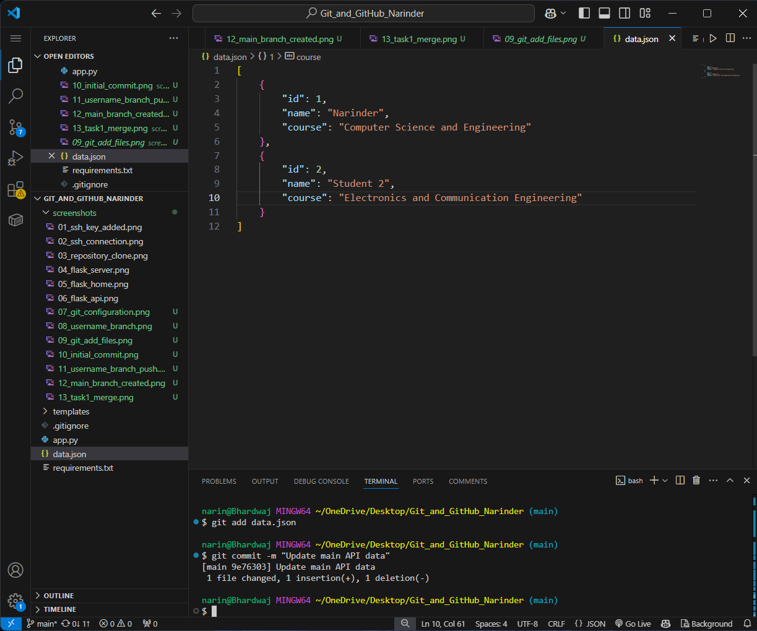
Screenshot 18 — Evidence for Task 2.

19. Main change pushed
Pushed the main-branch change to GitHub before merging the new branch.
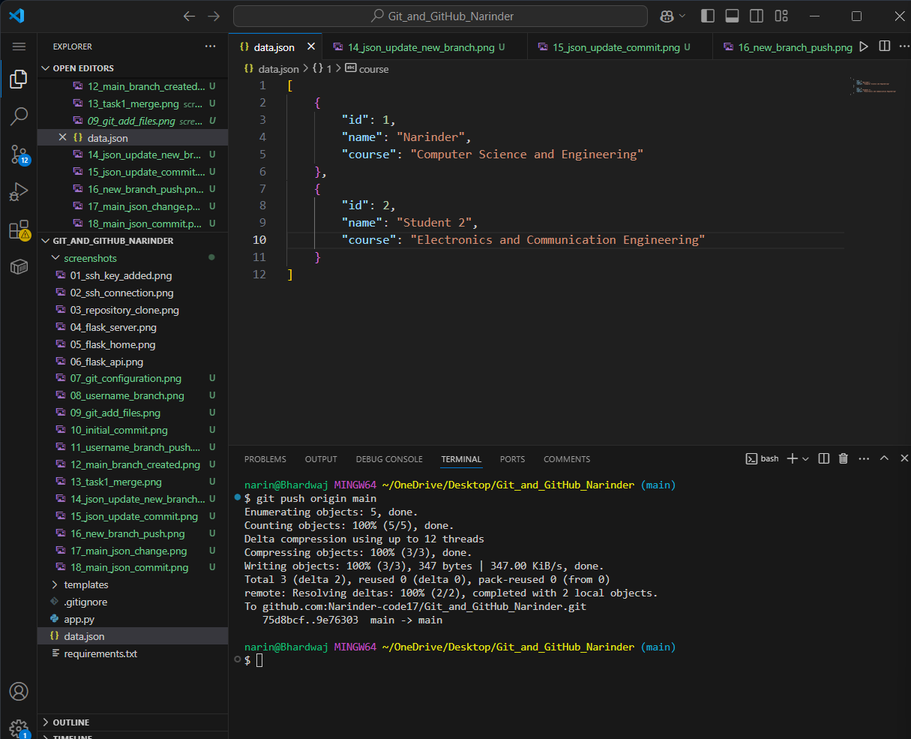
Screenshot 19 — Evidence for Task 2.

20. Merge conflict displayed
Merged `Narinder-code17_new` into `main` and Git reported a conflict in `data.json`.
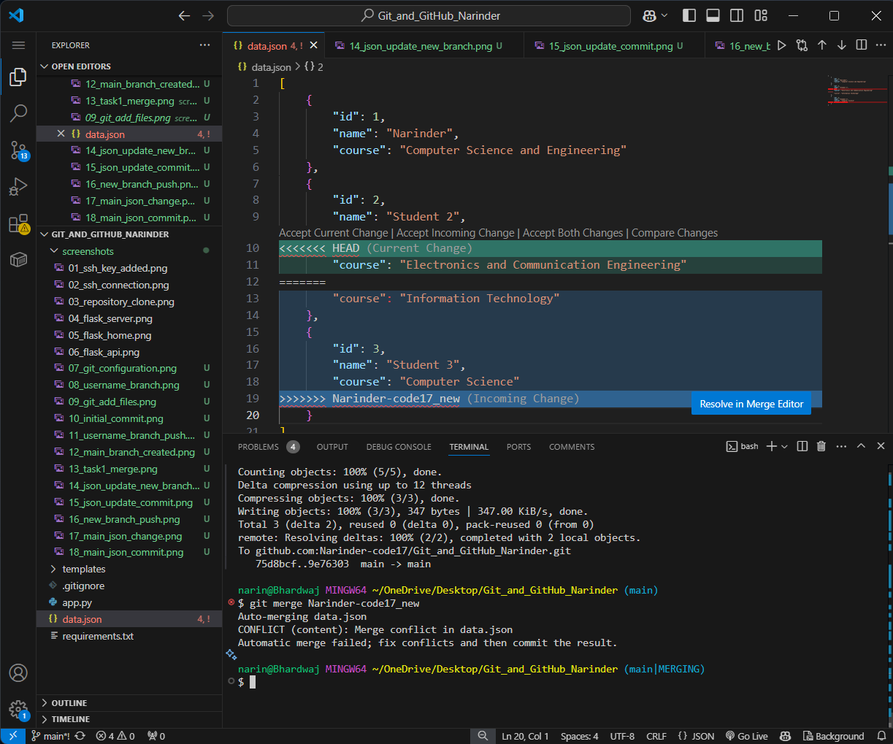
Screenshot 20 — Evidence for Task 2.

21. Conflict resolved
Resolved the conflict by accepting the incoming `Narinder-code17_new` changes, as required in Task 2.
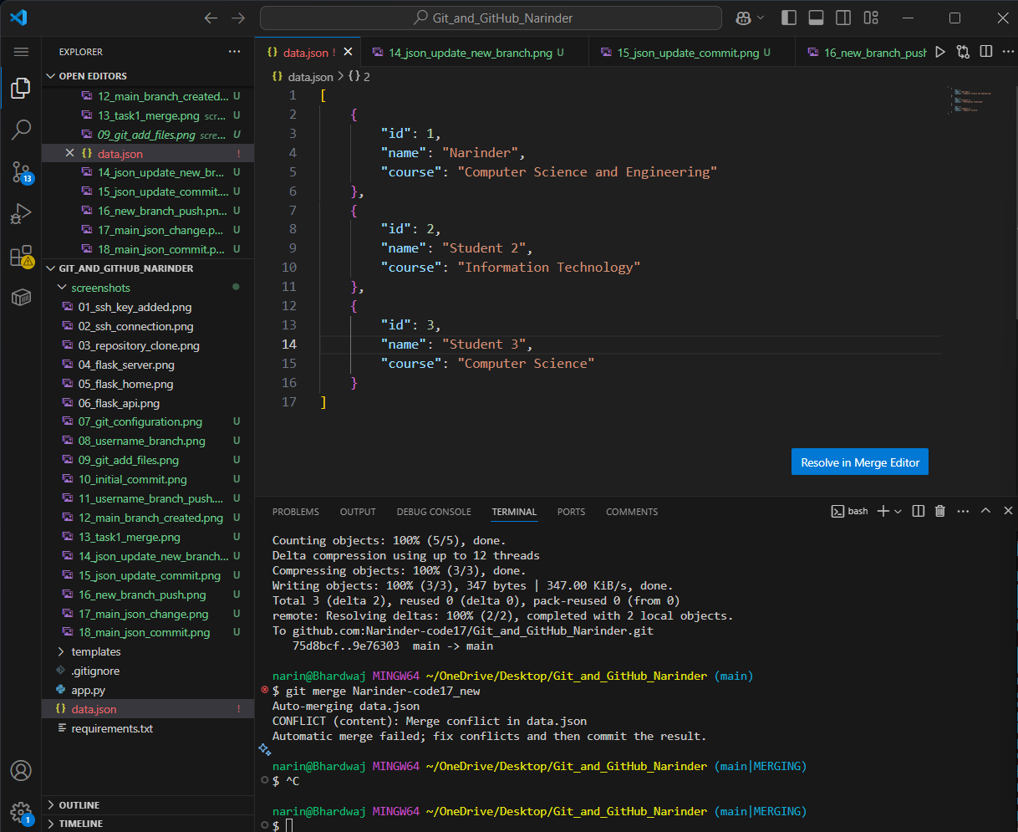
Screenshot 21 — Evidence for Task 2.

22. Resolved file staged
Staged the resolved `data.json` file after conflict resolution.
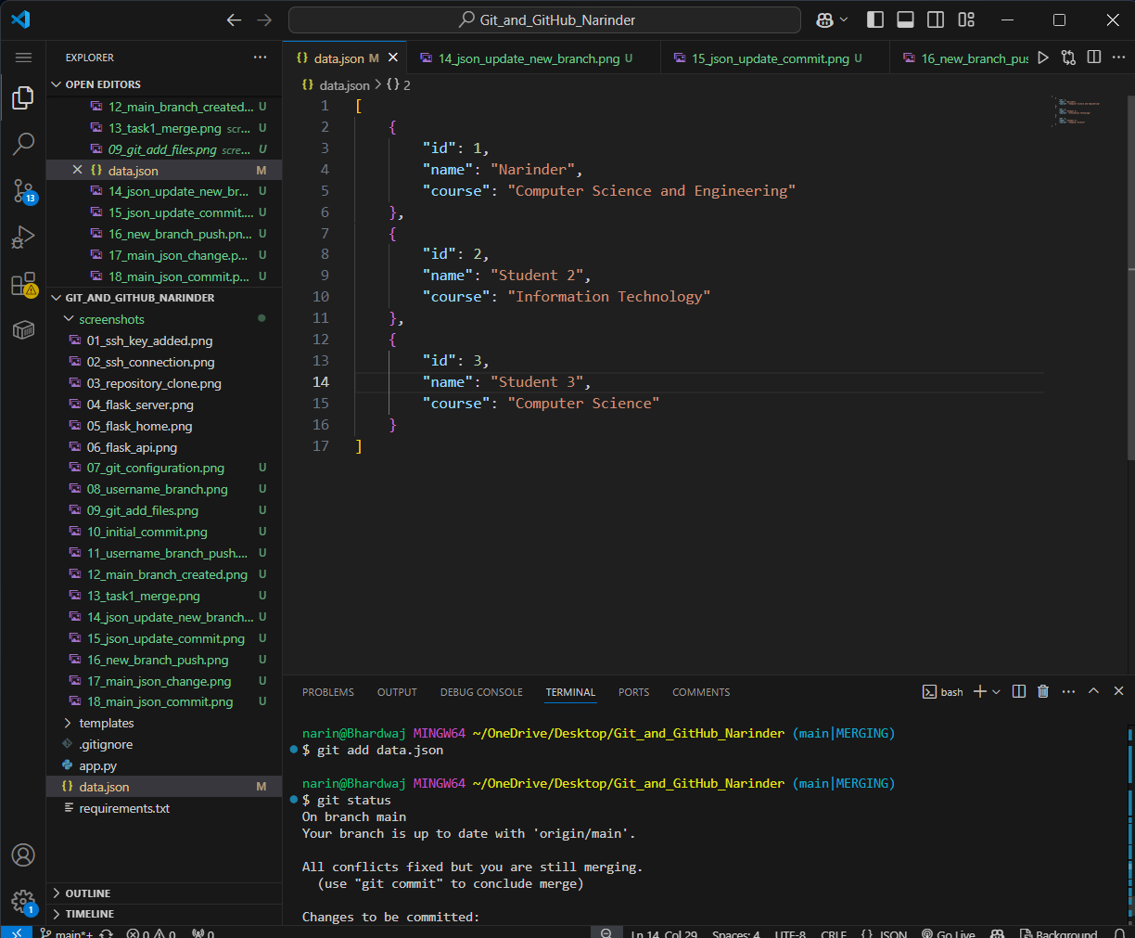
Screenshot 22 — Evidence for Task 2.

23. Conflict merge committed
Created the merge commit after resolving the conflict.
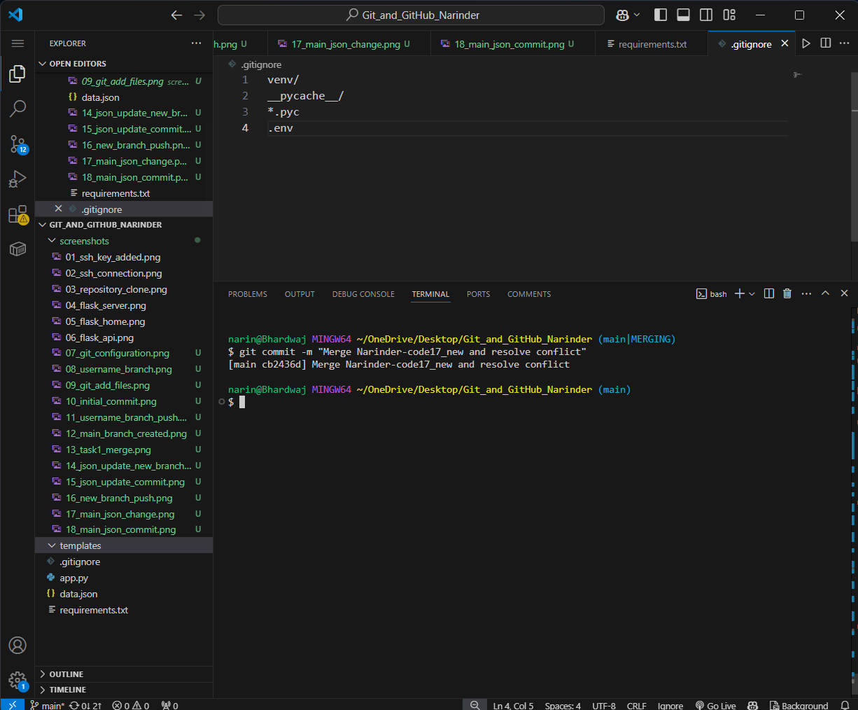
Screenshot 23 — Evidence for Task 2.

24. Task 2 merge pushed
Pushed the completed Task 2 merge to the remote `main` branch.
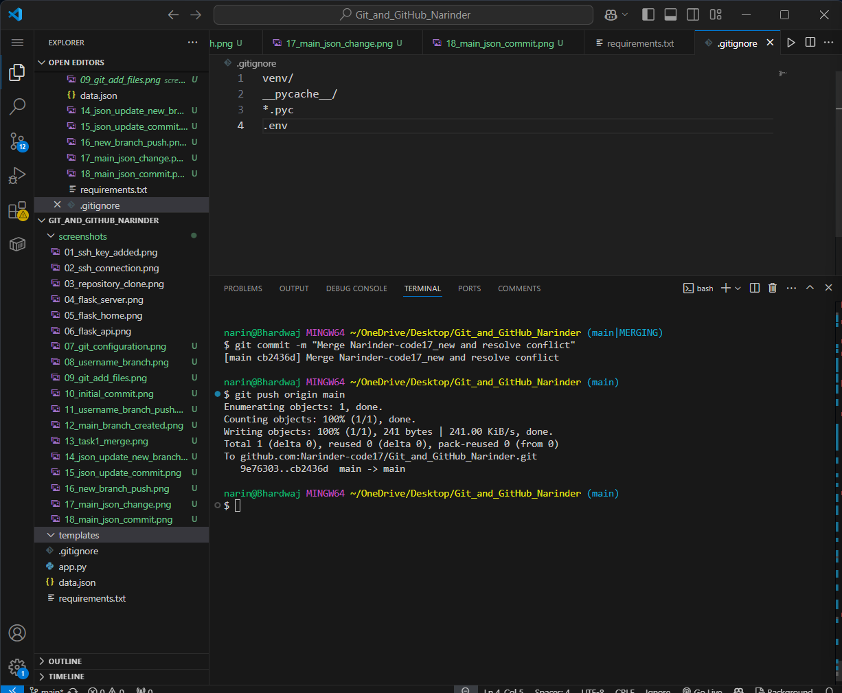
Screenshot 24 — Evidence for Task 2.

25. Task 2 Git history
Displayed the commit graph showing the main branch, new branch, conflict-resolution merge, and earlier commits.
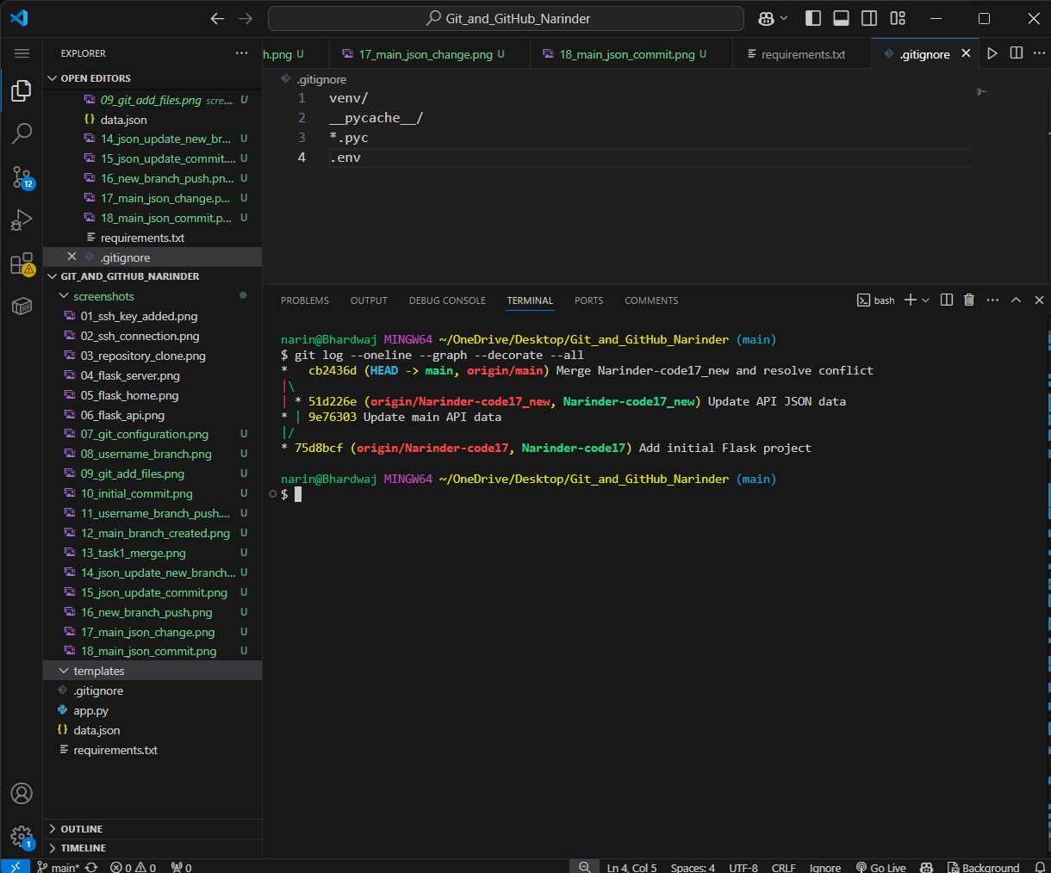
Screenshot 25 — Evidence for Task 2.

4. Task 3 — master_1 Frontend and master_2 MongoDB Backend

4.1 master_1 — To-Do Frontend
The master_1 branch implemented a To-Do page at /todo. The form contains Item Name and Item Description and submits the form to the backend endpoint /submittodoitem using POST.
git switch main
git pull
git switch -c master_1
git add templates/todo.html app.py
git commit -m "Create To-Do frontend"
git push -u origin master_1

26. master_1 branch created
Created `master_1` from the current `main` branch for the To-Do frontend work.
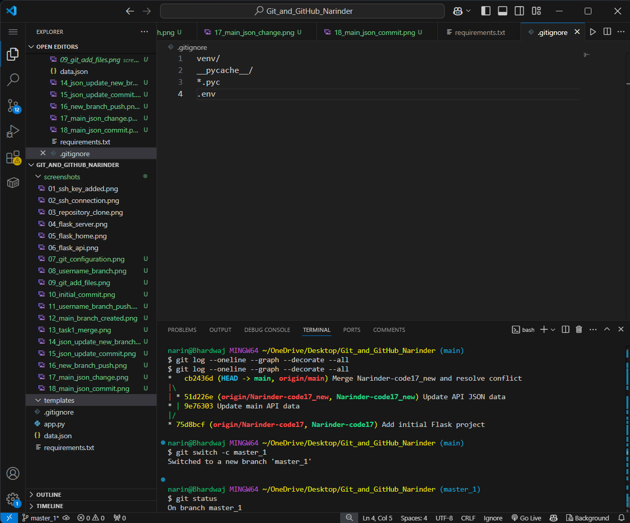
Screenshot 26 — Evidence for Task 3.

27. To-Do frontend
Implemented the To-Do frontend with Item Name and Item Description fields and a POST form.
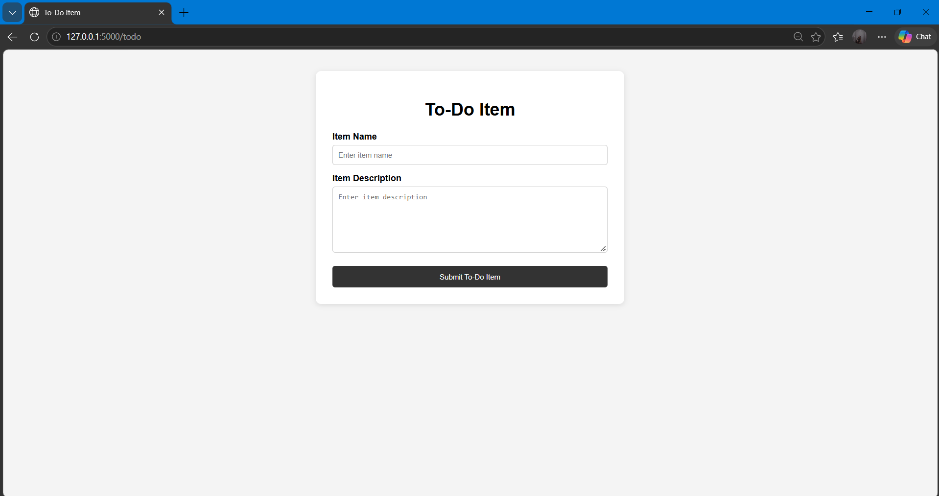
Screenshot 27 — Evidence for Task 3.

28. master_1 changes staged
Staged the frontend changes on `master_1`.
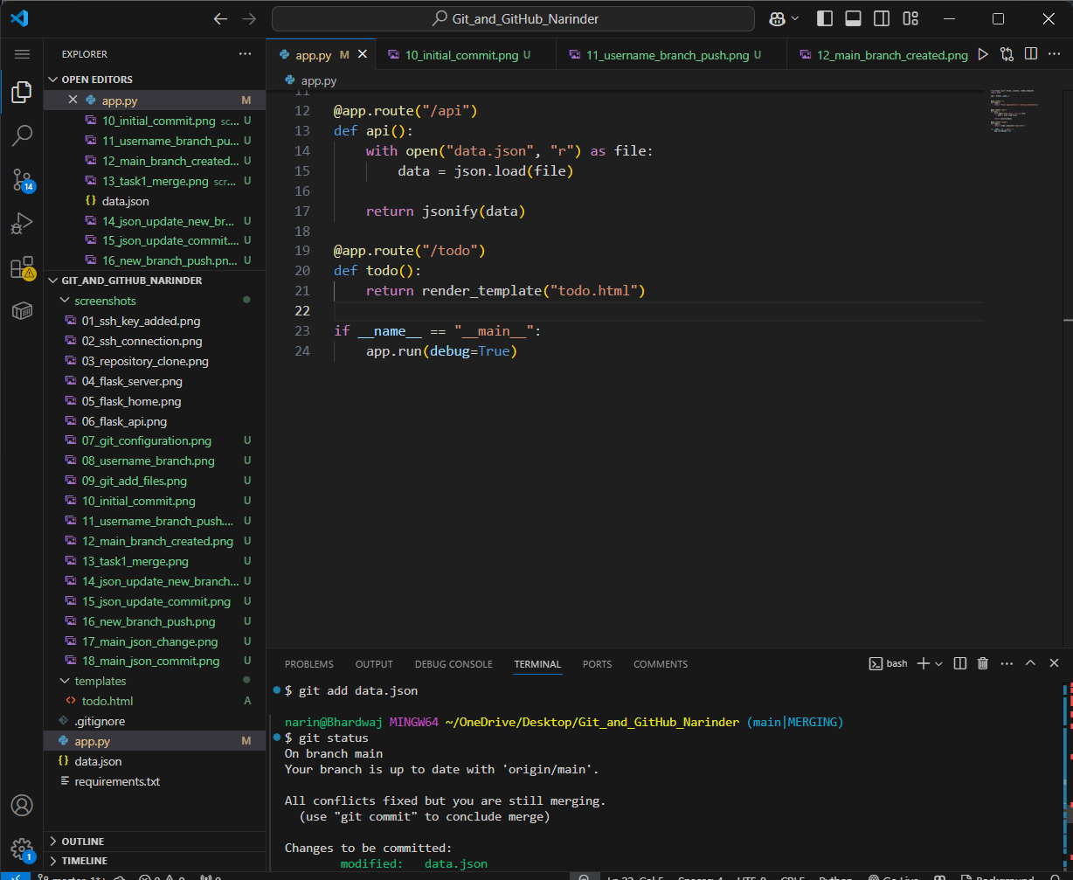
Screenshot 28 — Evidence for Task 3.

29. master_1 frontend commit
Committed the To-Do frontend implementation on `master_1`.
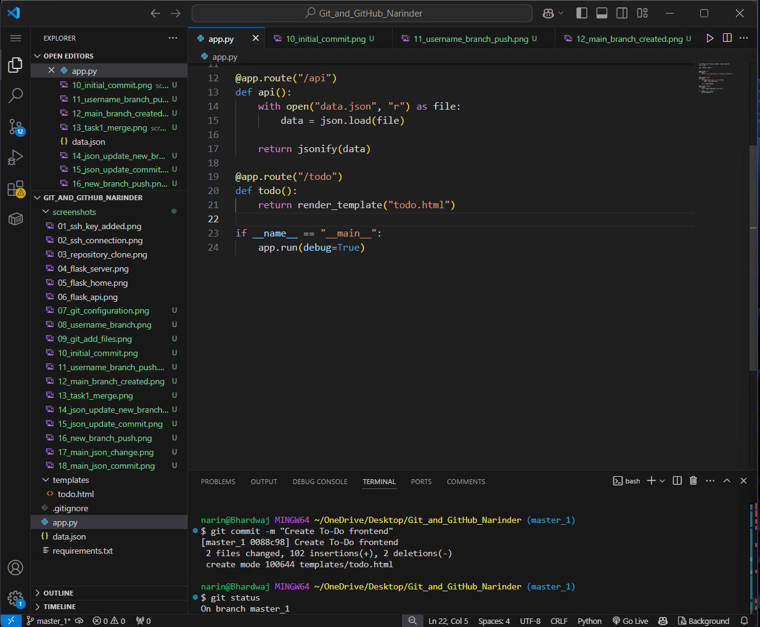
Screenshot 29 — Evidence for Task 3.

30. master_1 pushed
Pushed `master_1` to GitHub.
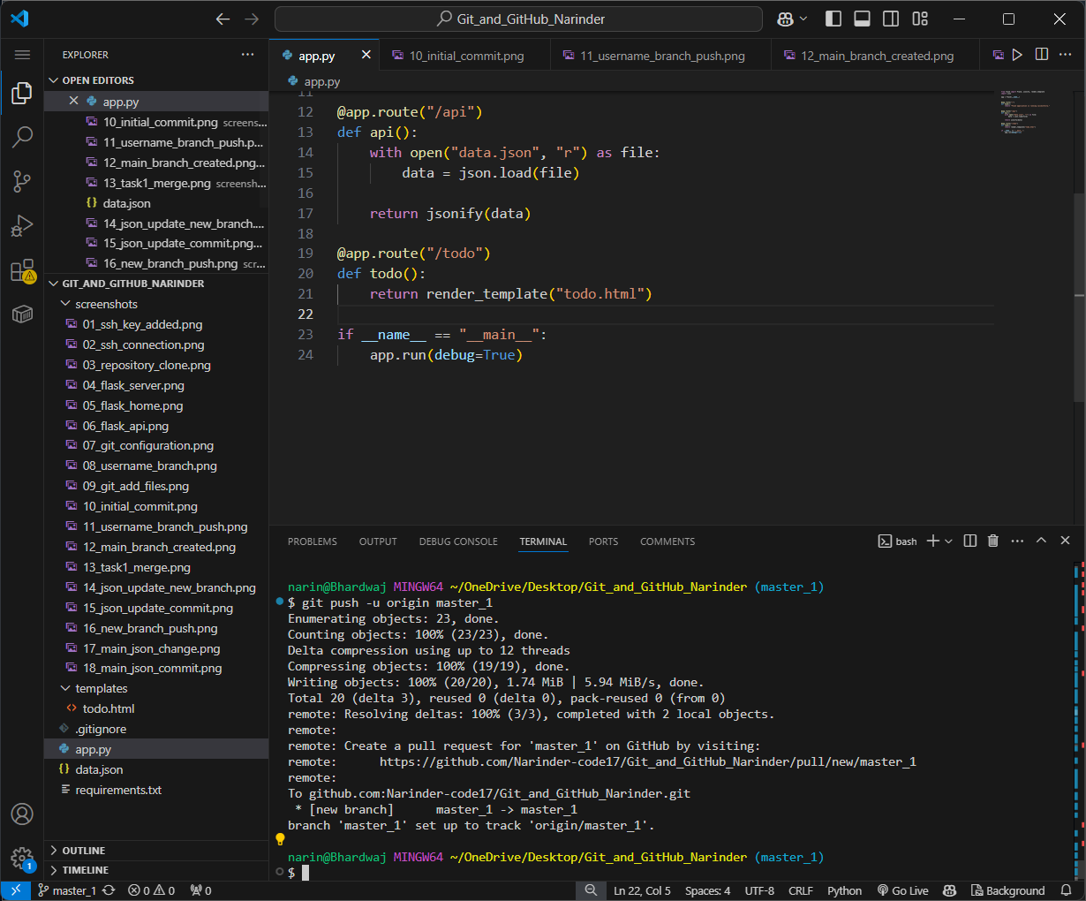
Screenshot 30 — Evidence for Task 3.

4.2 master_2 — Flask POST API and MongoDB
The master_2 branch implemented POST /submittodoitem. The endpoint accepts itemName and itemDescription from the form and stores them in a MongoDB collection. MongoDB connection settings are loaded from an environment variable, keeping credentials outside source control.
git switch main
git pull
git switch -c master_2
python -m pip install pymongo python-dotenv
git add app.py requirements.txt .env.example
git commit -m "Add MongoDB To-Do submission API"
git push -u origin master_2
The final Flask backend includes /, /api, /todo and /submittodoitem routes. The POST endpoint returns a success message and inserted MongoDB document ID when the insertion succeeds.

31. master_2 branch created
Created `master_2` from `main` for the backend/MongoDB To-Do submission work.
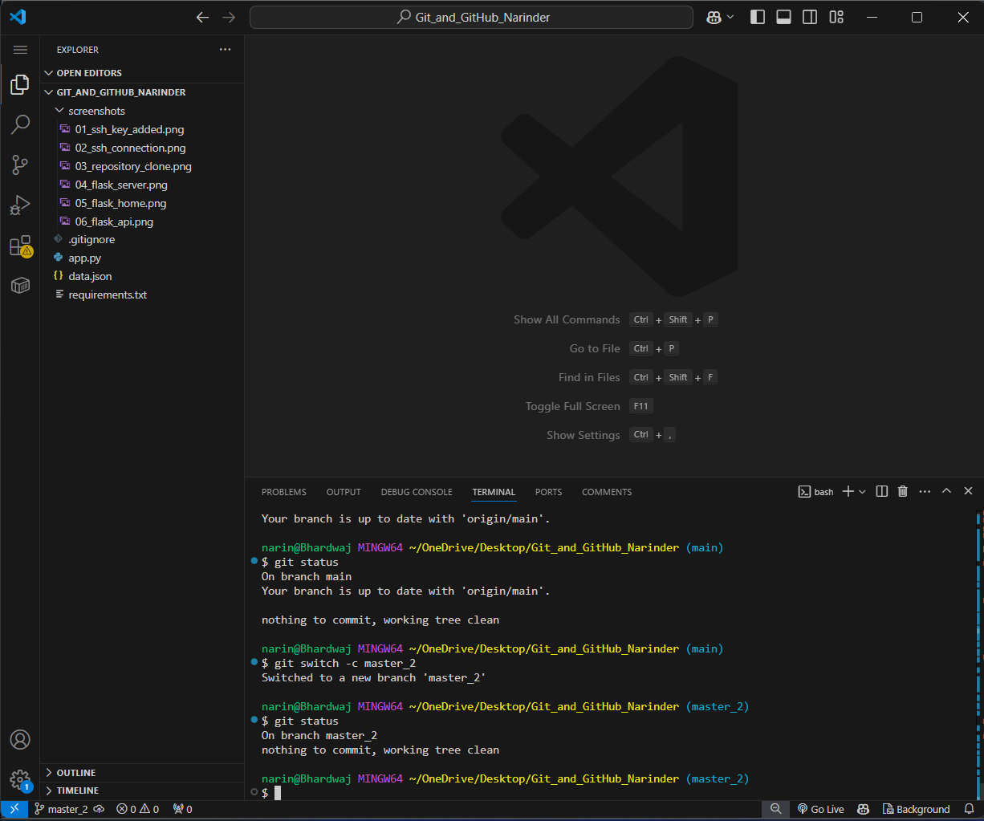
Screenshot 31 — Evidence for Task 3.

32. MongoDB dependencies installed
Installed and verified the MongoDB-related Python dependencies (`pymongo` and `python-dotenv`).
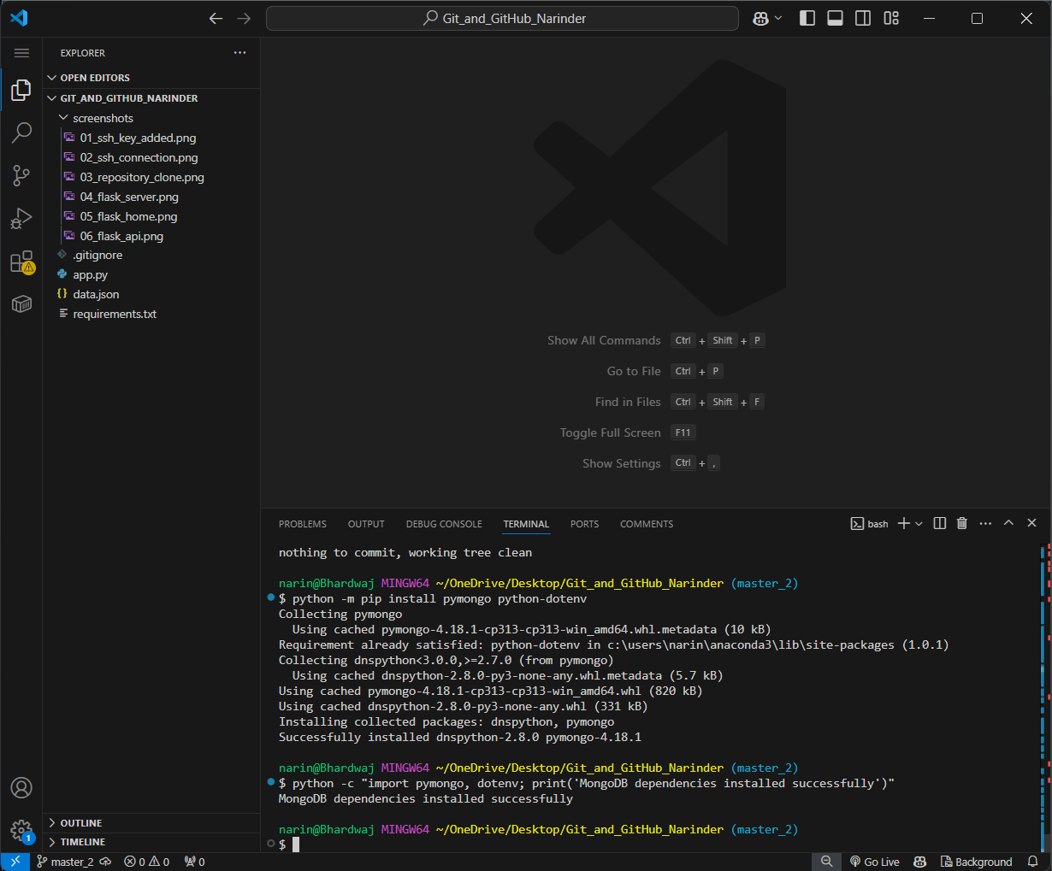
Screenshot 32 — Evidence for Task 3.

4.3 Integration into main
The master_1 and master_2 work was integrated into main. Where app.py had changes from both branches, the required combined result was retained so that the frontend route and MongoDB POST endpoint remained available.

5. Task 4 — Item ID, UUID, Hash, Soft Reset and Rebase
Task 4 demonstrates controlled Git history. Three fields were added to the To-Do form in three separate commits: Item ID, Item UUID, and Item Hash. The changes were then merged, rolled back with a soft reset to the Item ID commit, re-committed on main, and master_1 was rebased onto the updated main without squashing the three original Task 4 commits.

5.1 Three Separate Commits
git switch master_1
# add Item ID
git add templates/todo.html
git commit -m "Add Item ID to To-Do form"
# add Item UUID
git add templates/todo.html
git commit -m "Add Item UUID to To-Do form"
# add Item Hash
git add templates/todo.html
git commit -m "Add Item Hash to To-Do form"
After the rebase, the three commits retained their individual purpose and appeared in the rebased history as separate commits (with new commit IDs created by the rebase).

33. Three separate Task 4 commits
Created separate commits for Item ID, Item UUID, and Item Hash, preserving the requested individual commit history.
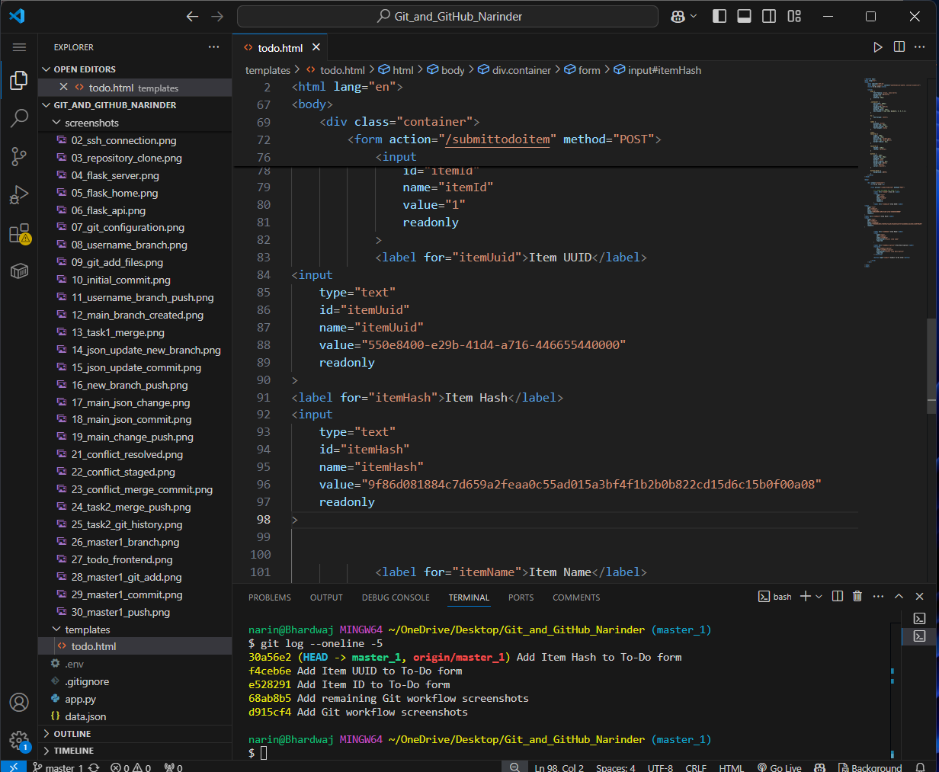
Screenshot 33 — Evidence for Task 4.

34. After soft-reset re-commit
Verified the main branch after using `git reset --soft` and creating the required re-commit of the staged Item UUID and Item Hash state.
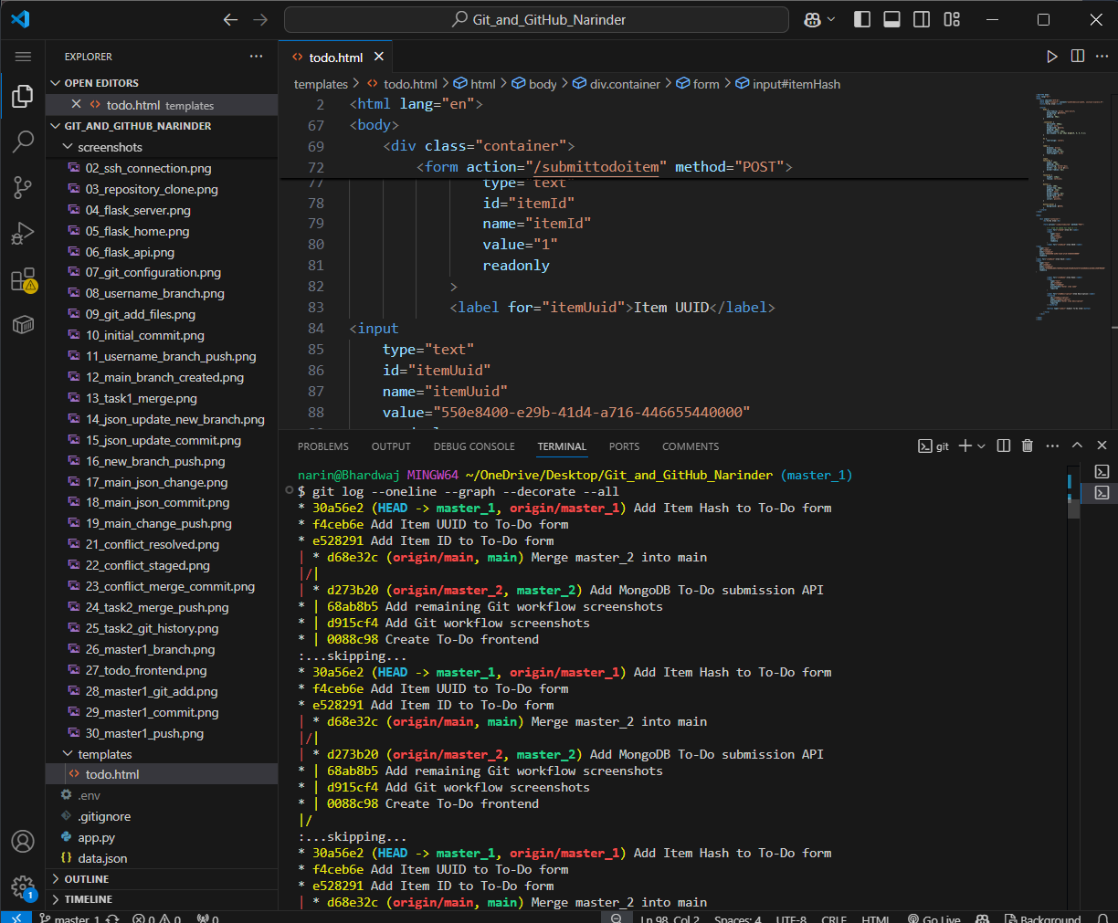
Screenshot 34 — Evidence for Task 4.

35. Final rebase
Rebased `master_1` onto the updated `main` using `git rebase main master_1`, preserving the individual Task 4 commits.
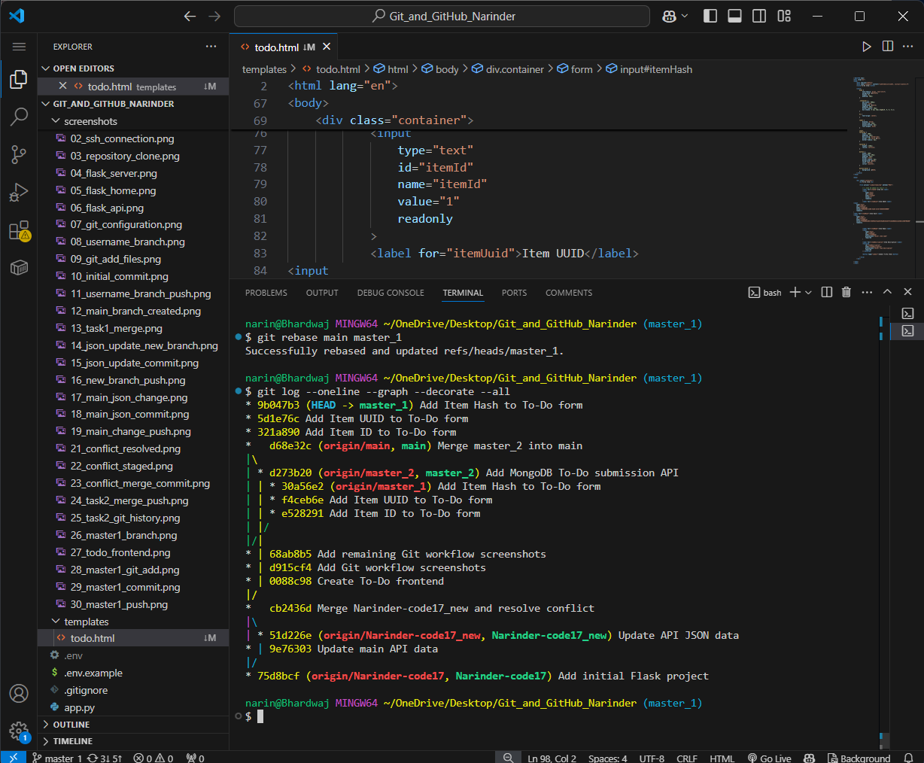
Screenshot 35 — Evidence for Task 4.

36. master_1 merged into main
Verified the merge/fast-forward stage where the Task 4 changes from `master_1` were brought into `main` before the rollback step.
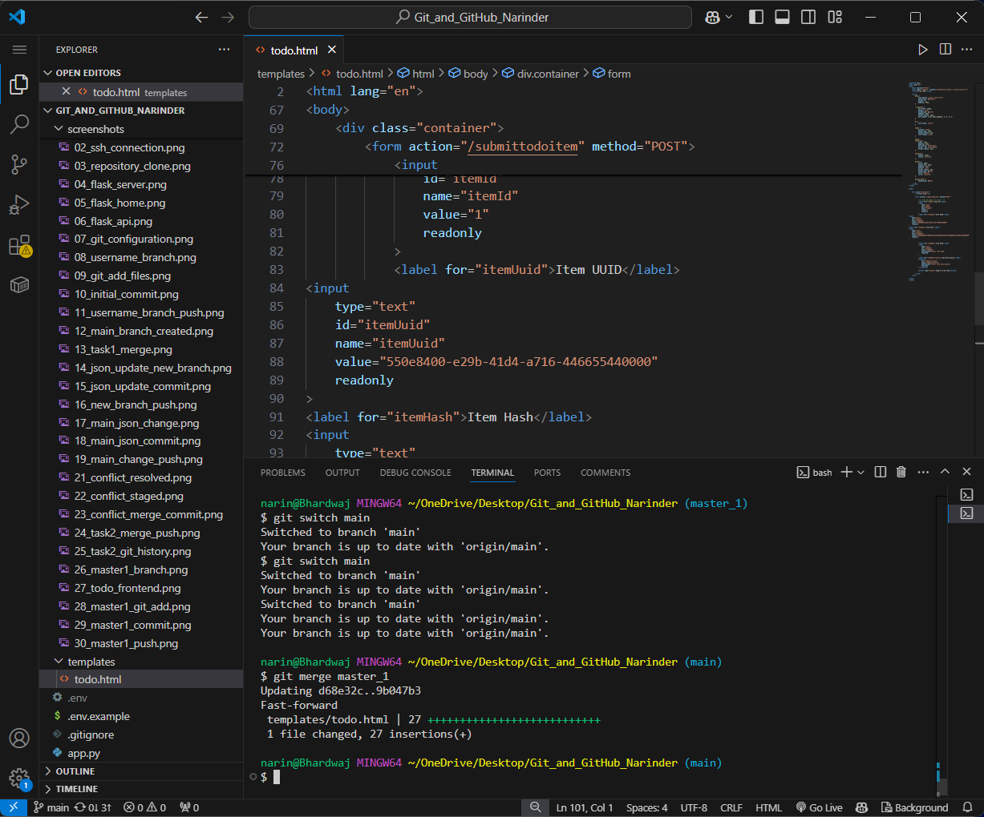
Screenshot 36 — Evidence for Task 4.

37. Soft reset with staged changes
Used `git reset --soft 321a890` to move `main` back to the Item ID commit while keeping later changes staged.
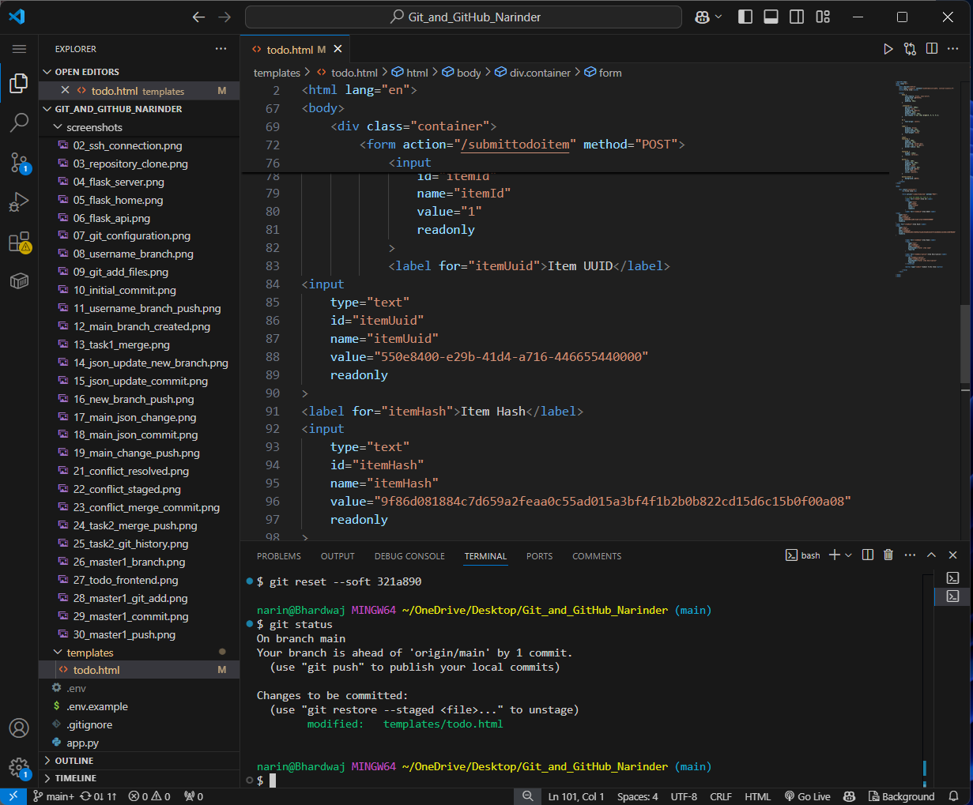
Screenshot 37 — Evidence for Task 4.

38. Soft-reset state re-committed
Created the re-commit on `main` from the staged state after the soft reset.
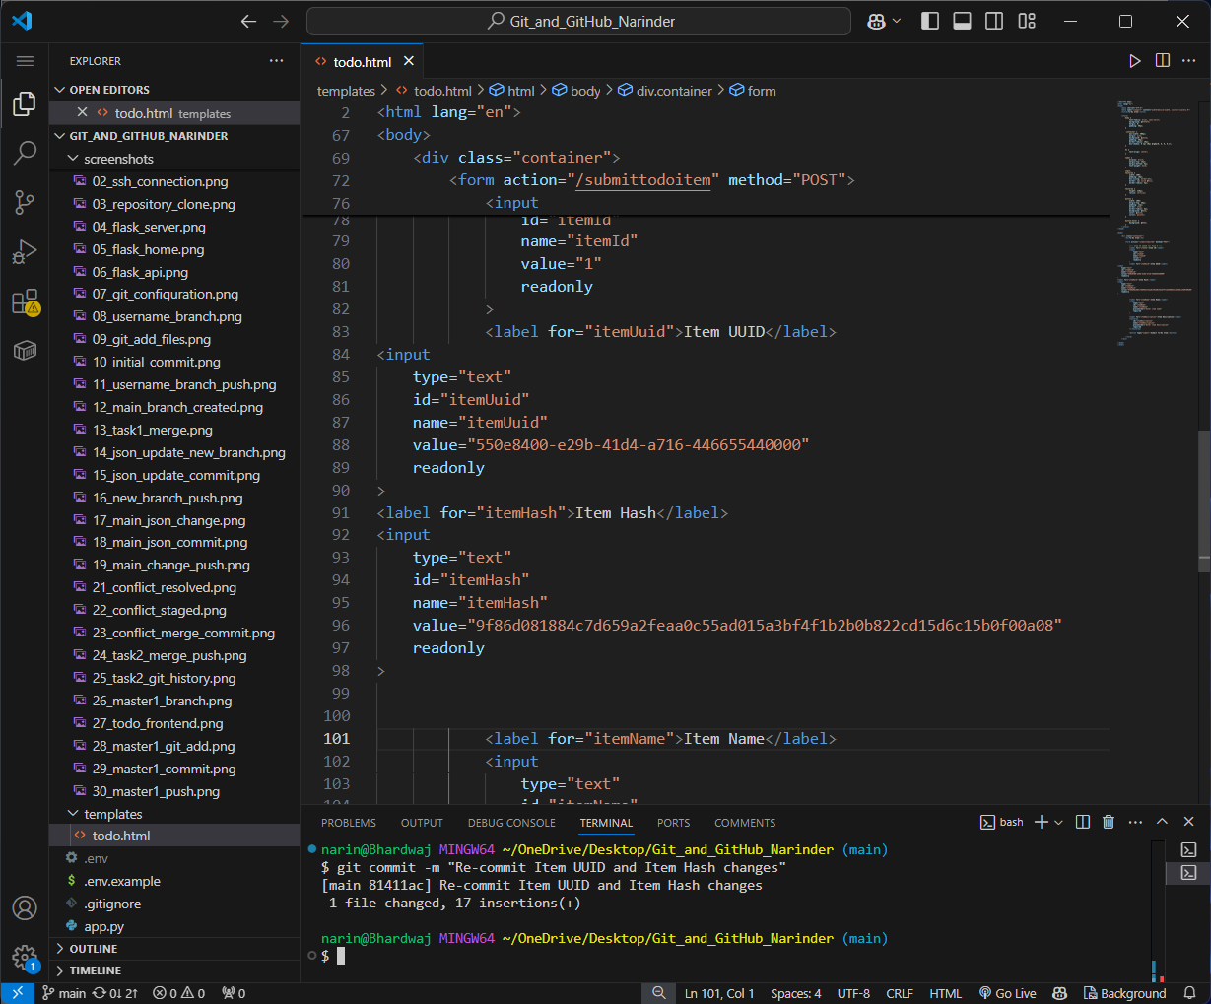
Screenshot 38 — Evidence for Task 4.

39. Updated main pushed
Pushed the updated `main` branch to GitHub after the reset/re-commit step.
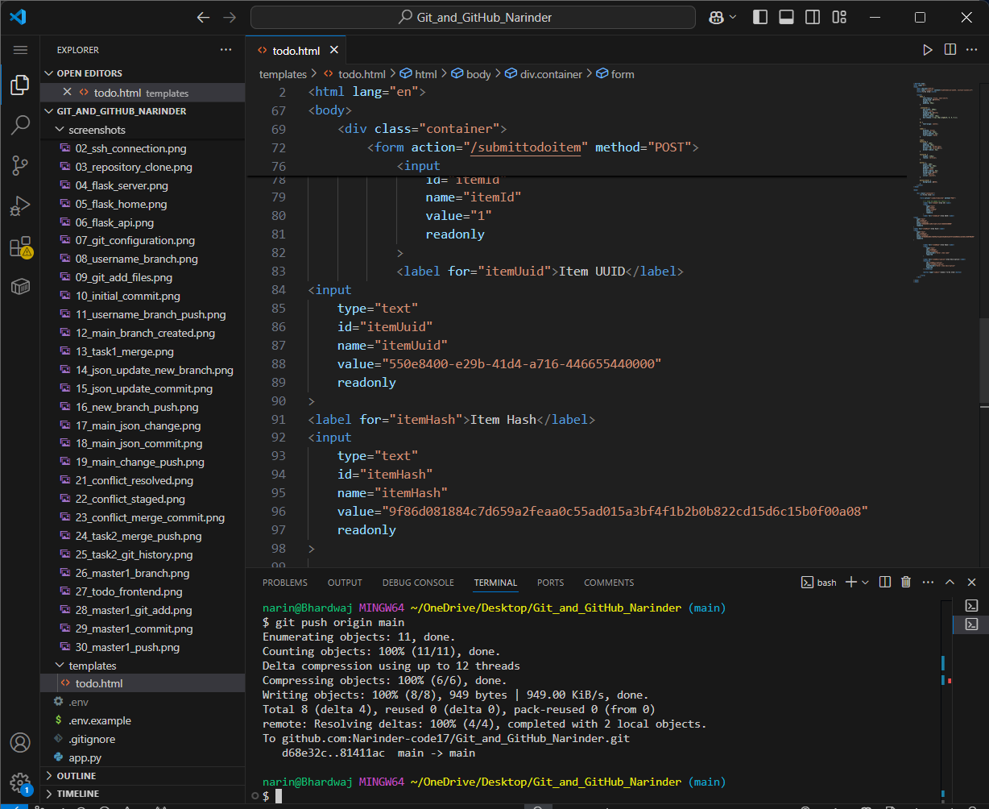
Screenshot 39 — Evidence for Task 4.

40. Rebased master_1 force-pushed
Force-pushed the rebased `master_1` using the safe force-with-lease workflow after the history rewrite.
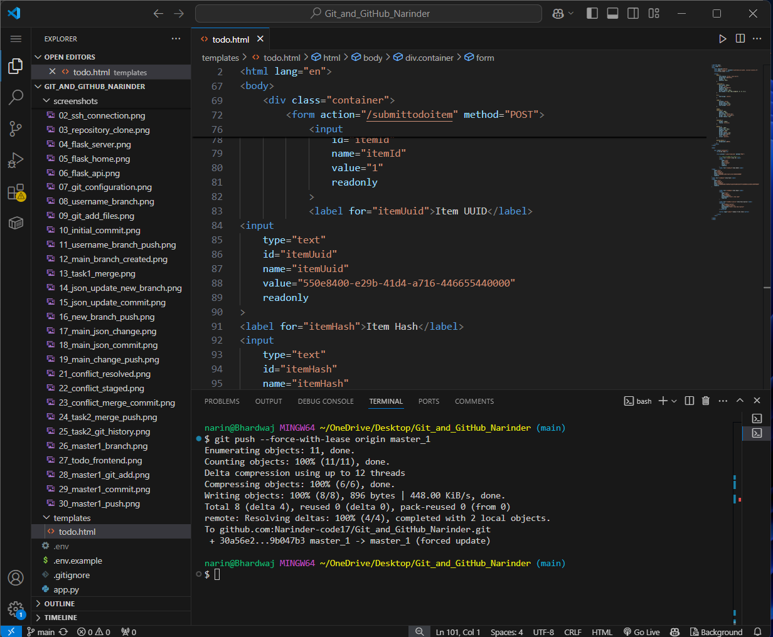
Screenshot 40 — Evidence for Task 4.

5.2 Key Task 4 Commands
git merge master_1
git reset --soft 321a890
git status
git commit -m "Re-commit Item UUID and Item Hash changes"
git push origin main
git rebase main master_1
git push --force-with-lease origin master_1
The soft reset moved the main branch pointer back to the Item ID commit while preserving subsequent changes in the staging area. The subsequent rebase replayed the master_1 Task 4 commits on top of the updated main history. Because rebase rewrites commit IDs, the rebased master_1 branch was safely force-pushed with --force-with-lease.

6. Final Verification
- main contains the Flask application, API data, To-Do frontend, MongoDB backend, and the soft-reset/re-commit history.
- master_1 retains separate Item ID, Item UUID, and Item Hash commits after rebasing.
- master_2 contains the MongoDB backend implementation.
- The repository uses SSH authentication.
- MongoDB credentials are not committed; .env is ignored and .env.example is provided.
- All 40 workflow screenshots are included in this documentation as evidence.

7. Conclusion
The assignment successfully demonstrates a complete Git and GitHub workflow around a Flask application. The project covers repository creation and SSH access, branching, commits, merging, conflict resolution, frontend and backend development on separate branches, MongoDB integration, controlled rollback with git reset --soft, and history rewriting through rebase. The included screenshots provide evidence for each major step.

