# Kubernetes_Narinder

## Kubernetes Deployment of Dockerized Full-Stack To-Do Application

A containerized full-stack To-Do application deployed and tested using **Kubernetes with Minikube**.

🔗 **GitHub Repository:**
https://github.com/Narinder-code17/Kubernetes_Narinder

The project consists of:

- **Flask** backend
- **Node.js + Express** frontend
- **Docker** containerization
- **Docker Hub** images
- **Kubernetes Deployments**
- **Kubernetes Services**
- **Minikube** for the local Kubernetes cluster
- Frontend-to-backend communication using Kubernetes Service discovery

---

## 1. Project Overview

This project demonstrates how a Dockerized full-stack web application can be deployed and managed using Kubernetes.

The application allows a user to enter:

- Item Name
- Item Description

The frontend sends the submitted data to the Flask backend. The backend validates the input and returns a JSON response confirming that the To-Do item was received.

The application was first containerized using Docker and then deployed to a Kubernetes cluster created using Minikube.

---

## 2. Objectives

The main objectives of this project are:

1. Create a Dockerized full-stack application.
2. Build separate Docker images for the frontend and backend.
3. Push Docker images to Docker Hub.
4. Create a local Kubernetes cluster using Minikube.
5. Deploy the backend using a Kubernetes Deployment.
6. Deploy the frontend using a Kubernetes Deployment.
7. Expose the backend using a ClusterIP Service.
8. Expose the frontend using a NodePort Service.
9. Configure frontend-to-backend communication using Kubernetes DNS/service discovery.
10. Verify the complete application through Kubernetes.
11. Test the application end-to-end from the browser.

---

## 3. Technologies Used

| Technology | Purpose |
|---|---|
| Python | Backend programming language |
| Flask | Backend web framework |
| Node.js | Frontend server runtime |
| Express.js | Frontend web server |
| HTML5 | Frontend interface |
| Docker | Containerization |
| Docker Hub | Container image registry |
| Kubernetes | Container orchestration |
| Minikube | Local Kubernetes cluster |
| kubectl | Kubernetes command-line tool |
| YAML | Kubernetes configuration |

---

## 4. Application Architecture

```text
User
|
v
+---------------------+
| Kubernetes NodePort|
| frontend-service |
| Port 3002 |
+----------+----------+
|
v
+---------------------+
| Frontend Deployment |
| Node.js + Express |
| Container Port 3002 |
+----------+----------+
|
| BACKEND_URL
| http://backend-service:5000
v
+---------------------+
| Backend Service |
| ClusterIP |
| Port 5000 |
+----------+----------+
|
v
+---------------------+
| Backend Deployment |
| Flask Application |
| Container Port 5000 |
+---------------------+

5. Application Flow
The application works as follows:
- The user opens the frontend through the Kubernetes NodePort service.
- The frontend displays the To-Do form.
- The user enters an item name and item description.
- The frontend sends a POST request to:
/api/submit
- The Express server forwards the request to the Flask backend.
- Inside Kubernetes, the frontend connects to the backend using:
http://backend-service:5000
- The Flask backend receives the request at:
POST /submit
- The backend validates the item name and description.
- The backend returns a JSON response.
- The frontend displays the returned message to the user.
Successful test response:
To-Do item received successfully

6. Backend Implementation
The backend is implemented using Flask.

Backend Port
5000

Backend Endpoints

GET /
Returns:
{
"message": "Flask backend is running successfully"
}

POST /submit
The backend expects:
{
"itemName": "Kubernetes Test",
"itemDescription": "Testing frontend and backend communication through Kubernetes"
}
If both values are provided, the backend returns:
{
"message": "To-Do item received successfully",
"itemName": "Kubernetes Test",
"itemDescription": "Testing frontend and backend communication through Kubernetes"
}
If either value is missing, the backend returns an error response with HTTP status 400.

7. Frontend Implementation
The frontend uses:
- Node.js
- Express.js
- HTML
- JavaScript

Frontend Port
3002
The Express server serves the static frontend from the public directory.
The frontend provides:
- Item Name input
- Item Description textarea
- Submit To-Do button
- Response message area
The browser sends requests to:
/api/submit
The Express server forwards them to the configured backend URL.

8. Docker Images
The application uses two Docker images hosted on Docker Hub.

Backend Image
narinder15/docker-narinder-backend:latest

Frontend Image
narinder15/docker-narinder-frontend:latest
These images are referenced directly by the Kubernetes Deployment manifests.

9. Kubernetes Cluster
The project was deployed using Minikube with the Docker driver.

Kubernetes Profile
k8s-assignment

Kubernetes Version
v1.35.1

Minikube Version
v1.38.1

Container Driver
Docker
The cluster was started using:
minikube start -p k8s-assignment --driver=docker
The Kubernetes node was verified using:
kubectl get nodes
The node reached:
STATUS: Ready

10. Kubernetes Deployments
Two Kubernetes Deployments are used.

Backend Deployment
File:
k8s/backend-deployment.yaml
Configuration:
Name: backend-deployment
Replicas: 1
Container Port: 5000
Image: narinder15/docker-narinder-backend:latest

Frontend Deployment
File:
k8s/frontend-deployment.yaml
Configuration:
Name: frontend-deployment
Replicas: 1
Container Port: 3002
Image: narinder15/docker-narinder-frontend:latest
The frontend Deployment uses the following environment variable:
BACKEND_URL=http://backend-service:5000
This allows the frontend container to communicate with the backend through the Kubernetes Service.

11. Kubernetes Services
Two application Services are configured.

Backend Service
File:
k8s/backend-service.yaml
Configuration:
Name: backend-service
Type: ClusterIP
Port: 5000
Target Port: 5000
The backend uses ClusterIP because it only needs to be accessible inside the Kubernetes cluster.
The frontend accesses it using:
http://backend-service:5000

Frontend Service
File:
k8s/frontend-service.yaml
Configuration:
Name: frontend-service
Type: NodePort
Port: 3002
Target Port: 3002
NodePort: 32096
The NodePort service makes the frontend accessible from outside the cluster.

12. Kubernetes Manifest Files
The project contains four Kubernetes YAML files:
k8s/
├── backend-deployment.yaml
├── backend-service.yaml
├── frontend-deployment.yaml
└── frontend-service.yaml

Apply Backend Deployment
kubectl apply -f .\k8s\backend-deployment.yaml

Apply Backend Service
kubectl apply -f .\k8s\backend-service.yaml

Apply Frontend Deployment
kubectl apply -f .\k8s\frontend-deployment.yaml

Apply Frontend Service
kubectl apply -f .\k8s\frontend-service.yaml

13. Verification Commands

Check Kubernetes Nodes
kubectl get nodes

Check All Kubernetes Pods
kubectl get pods -A

Check Deployments
kubectl get deployments

Check Pods
kubectl get pods

Check Services
kubectl get services

Access Frontend Service
minikube service frontend-service -p k8s-assignment --url

14. Final Deployment Status
The final Kubernetes deployment was successfully verified.

Deployments
NAME READY UP-TO-DATE AVAILABLE
backend-deployment 1/1 1 1
frontend-deployment 1/1 1 1

Pods
backend-deployment-65f9b99f89-rn6jx
STATUS: Running
READY: 1/1
RESTARTS: 0

frontend-deployment-5554478548-p28xj
STATUS: Running
READY: 1/1
RESTARTS: 0

Services
backend-service ClusterIP 5000/TCP
frontend-service NodePort 3002:32096/TCP

15. Application Testing
The frontend was exposed through the Kubernetes NodePort service using:
minikube service frontend-service -p k8s-assignment --url
The generated local access URL was:
http://127.0.0.1:64183
The frontend application loaded successfully.
A test To-Do item was submitted through the browser.
The application returned:
To-Do item received successfully
This verified successful communication between:
Frontend
↓
Express /api/submit
↓
backend-service
↓
Flask /submit
↓
Successful JSON response

16. Screenshots / Evidence
The project contains eight screenshots documenting the implementation and verification process.

Screenshot 01 — Kubernetes Tools Check
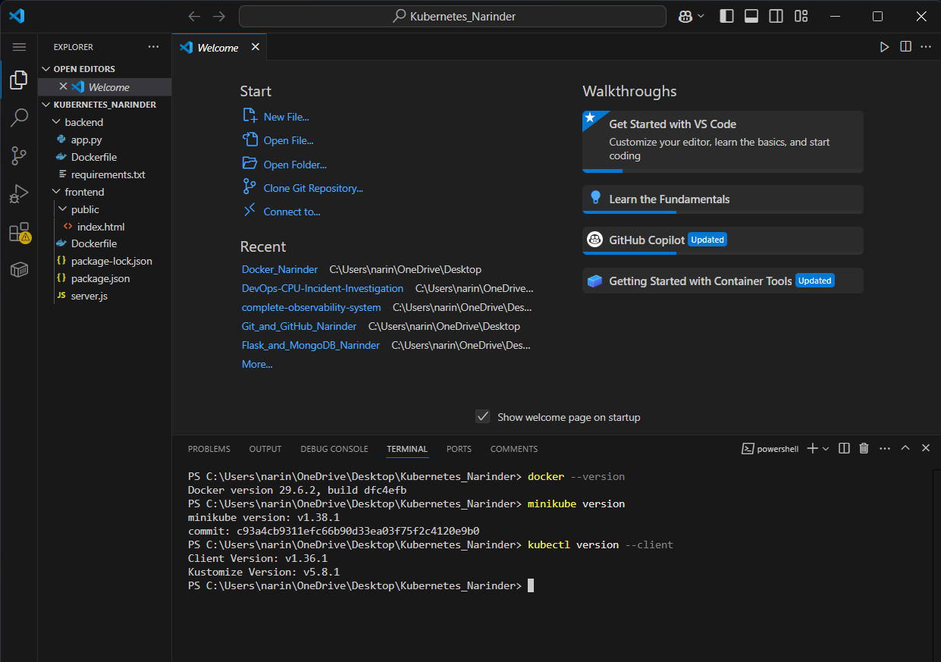
Shows the Kubernetes-related tools and version information.

Screenshot 02 — Minikube Node Status
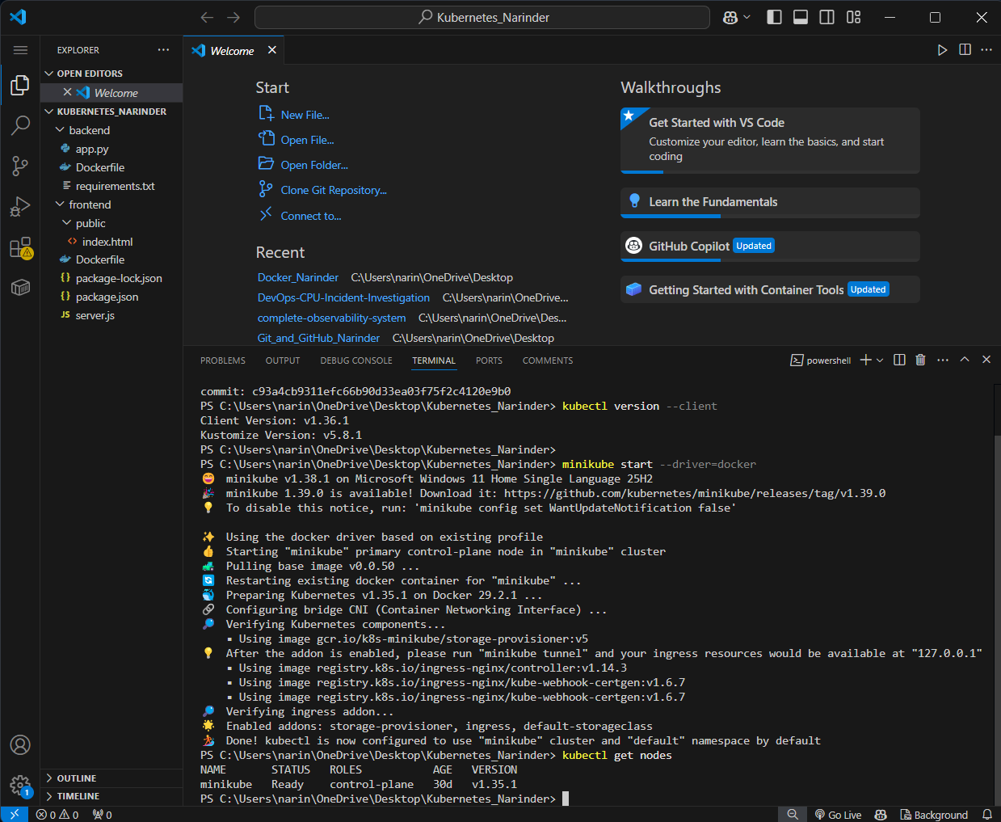
Shows the Minikube Kubernetes node in Ready state.

Screenshot 03 — Kubernetes YAML Validation
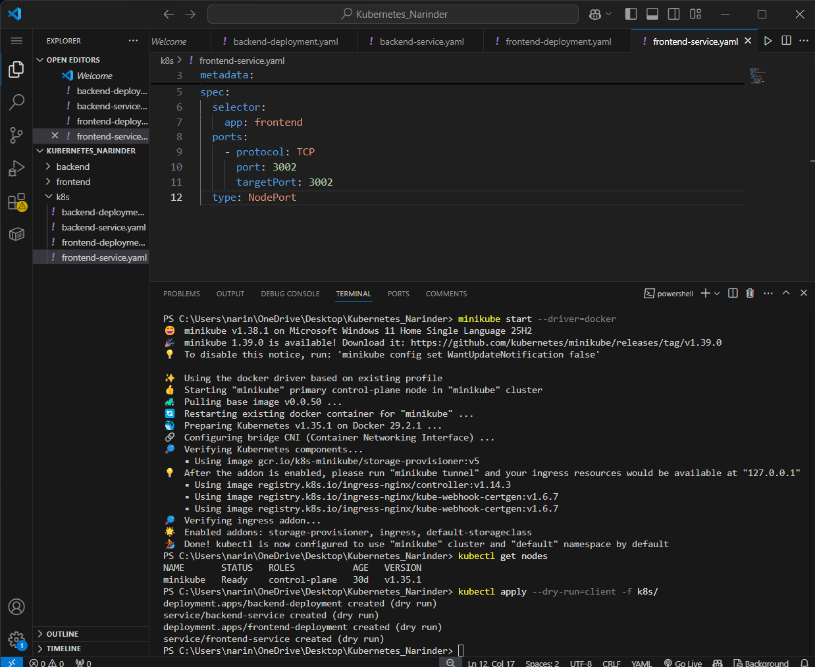
Shows the Kubernetes manifest configuration/validation evidence.

Screenshot 04 — Kubernetes Services
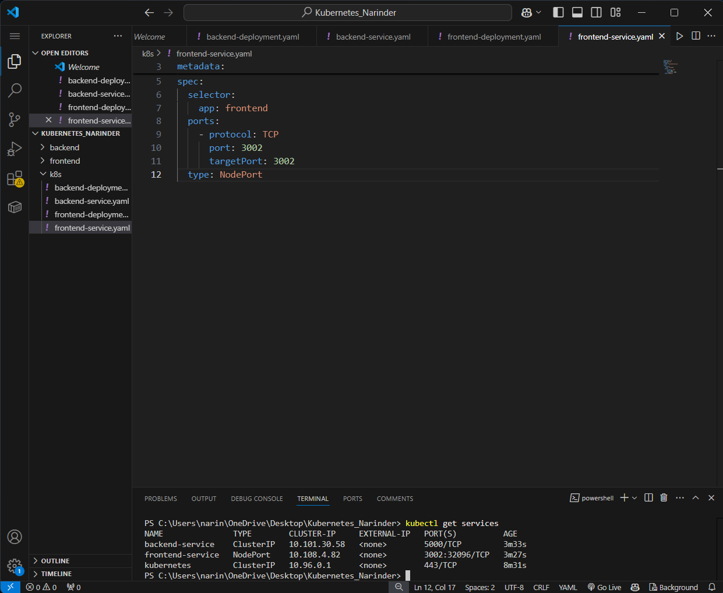
Shows the configured backend ClusterIP and frontend NodePort services.

Screenshot 05 — Deployments and Pods
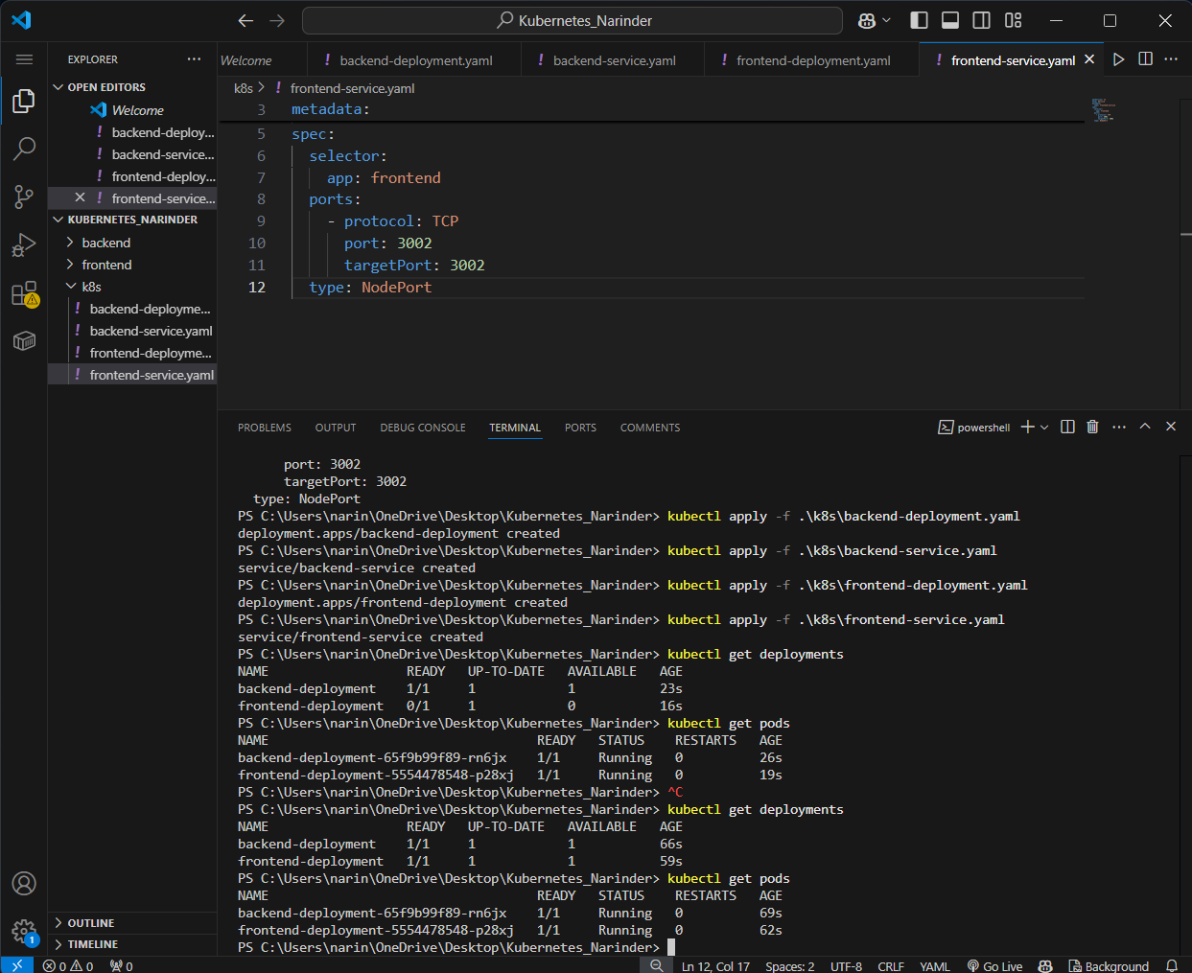
Shows both application Deployments and Pods running successfully.

Screenshot 06 — Kubernetes Frontend
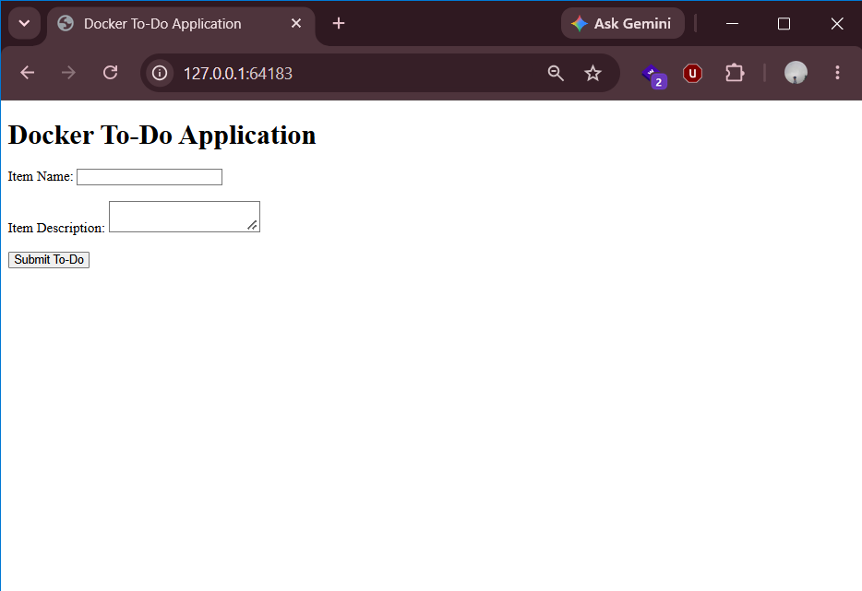
Shows the To-Do application running through the Kubernetes frontend service.

Screenshot 07 — Frontend and Backend Test
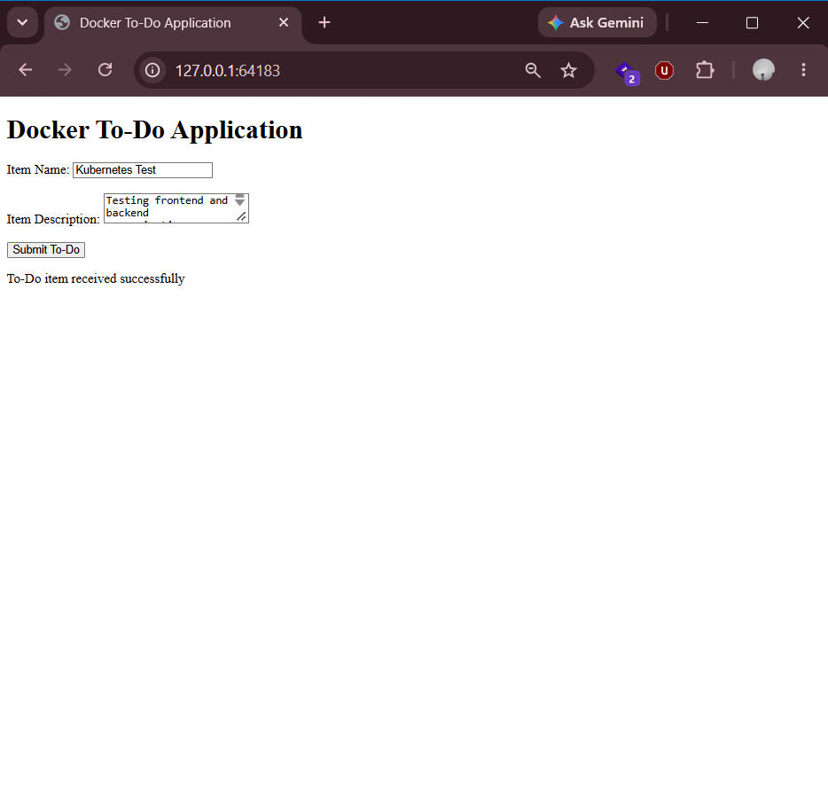
Shows the successful:
To-Do item received successfully
response after submitting a To-Do item.

Screenshot 08 — Final Kubernetes Status
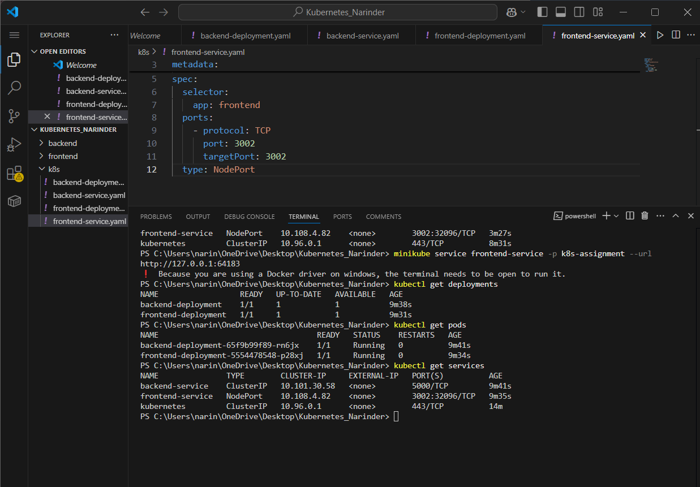
Shows the final status of Deployments, Pods, and Services.

17. Project Structure
Kubernetes_Narinder/
│
├── backend/
│ ├── app.py
│ ├── Dockerfile
│ └── requirements.txt
│
├── frontend/
│ ├── Dockerfile
│ ├── package.json
│ ├── package-lock.json
│ ├── server.js
│ └── public/
│ └── index.html
│
├── k8s/
│ ├── backend-deployment.yaml
│ ├── backend-service.yaml
│ ├── frontend-deployment.yaml
│ └── frontend-service.yaml
│
├── screenshots/
│ ├── 01_kubernetes_tools_check.png
│ ├── 02_minikube_node_status.png
│ ├── 03_kubernetes_yaml_validation.png
│ ├── 04_kubernetes_services.png
│ ├── 05_kubernetes_deployments_pods.png
│ ├── 06_kubernetes_frontend.png
│ ├── 07_kubernetes_frontend_backend_test.png
│ └── 08_kubernetes_final_status.png
│
└── README.md

18. How to Run the Project

Step 1 — Start Minikube
minikube start -p k8s-assignment --driver=docker

Step 2 — Verify the Cluster
kubectl get nodes
The node should show:
Ready

Step 3 — Deploy the Backend
kubectl apply -f .\k8s\backend-deployment.yaml
kubectl apply -f .\k8s\backend-service.yaml

Step 4 — Deploy the Frontend
kubectl apply -f .\k8s\frontend-deployment.yaml
kubectl apply -f .\k8s\frontend-service.yaml

Step 5 — Verify Pods
kubectl get pods
Both application Pods should reach:
1/1 Running

Step 6 — Verify Services
kubectl get services
The services should include:
backend-service
frontend-service

Step 7 — Access the Application
minikube service frontend-service -p k8s-assignment --url
Open the generated URL in a browser.

19. Troubleshooting

Problem: Old Minikube cluster was unhealthy
The original Minikube profile had Kubernetes API server health issues and did not create the expected application Pods.
Instead of deleting the existing profile, a separate profile was created:
minikube start -p k8s-assignment --driver=docker
This allowed the existing Minikube environment to remain untouched while providing a clean Kubernetes cluster for this project.

Problem: Docker network subnet warning
During the creation of the new Minikube profile, Minikube reported that it could not find a dedicated Docker network subnet.
Despite the warning, Minikube successfully completed startup and the Kubernetes node became:
Ready
The Kubernetes control-plane components and application workloads subsequently ran successfully.

Problem: Frontend-to-backend communication
The frontend Deployment uses:
BACKEND_URL=http://backend-service:5000
This allows Kubernetes DNS/service discovery to route frontend requests to the backend Service.
The end-to-end browser test successfully returned:
To-Do item received successfully

20. Key Kubernetes Concepts Demonstrated
This project demonstrates the following Kubernetes concepts:

Deployment
Used to manage and run the frontend and backend application Pods.

Pod
The basic execution unit containing the application containers.

Service
Provides stable networking and service discovery for Kubernetes workloads.

ClusterIP
Used for internal backend communication.
backend-service

NodePort
Used to expose the frontend outside the Kubernetes cluster.
frontend-service

Kubernetes DNS
The frontend communicates with the backend using the Kubernetes Service name:
backend-service
instead of using a hard-coded Pod IP address.

Minikube
Provides a local Kubernetes environment for development and testing.

kubectl
Used to create, inspect, and manage Kubernetes resources.

21. GitHub Repository

The complete project source code and Kubernetes configuration are available on GitHub:

Repository:
https://github.com/Narinder-code17/Kubernetes_Narinder

The repository contains:

Backend source code

Frontend source code

Dockerfiles

Kubernetes Deployment manifests

Kubernetes Service manifests

Project screenshots

.gitignore

Project documentation

22. Final Result
The Dockerized full-stack To-Do application was successfully deployed on Kubernetes using Minikube.
The final system successfully achieved:
- Dockerized Flask backend
- Dockerized Node.js/Express frontend
- Docker Hub image usage
- Kubernetes backend Deployment
- Kubernetes frontend Deployment
- Backend ClusterIP Service
- Frontend NodePort Service
- Kubernetes service discovery
- Successful frontend-to-backend communication
- Successful browser-based application testing
- Final Kubernetes resource verification
The final application test produced:
To-Do item received successfully
Therefore, the complete application deployment and end-to-end Kubernetes test were successfully completed.

