PYTHON & BASH | DEVOPS ASSIGNMENT

============================================================
STUDENT INFORMATION
============================================================

Name: Narinder Kumar
Branch: Computer Science and Engineering
College: Mangalore Institute of Technology and Engineering (MITE)
Assignment: Python & Bash | DEVOPS

============================================================
1. INTRODUCTION
============================================================

This assignment demonstrates the basic concepts of Python programming and Bash scripting. The Python programs cover conditional statements, dictionaries, and file handling operations such as writing and reading files. A basic Bash script is also included to demonstrate command-line operations.

============================================================
2. OBJECTIVE
============================================================

The objective of this assignment is to practise core Python programming concepts such as conditionals, dictionaries, and file handling. The assignment also includes a basic Bash script to demonstrate command-line operations.

============================================================
3. ENVIRONMENT USED
============================================================

Operating System: Windows
Code Editor: Visual Studio Code
Python Version: Python 3.13.9
Python Package Manager: pip
Bash Environment: Git Bash
Programming Languages: Python and Bash

============================================================
TASK 1 – GRADE CHECKER
============================================================

Requirement:
Take a score as input and print the grade according to the following conditions:

90 and above → A
80–89 → B
70–79 → C
60–69 → D
Below 60 → F

Program File:
grade_checker.py

Concepts Used:
• input()
• int()
• if statement
• elif statement
• else statement
• Conditional decision making

Code:

score = int(input("Enter your score: "))

if score >= 90:
grade = "A"
elif score >= 80:
grade = "B"
elif score >= 70:
grade = "C"
elif score >= 60:
grade = "D"
else:
grade = "F"

print("Grade:", grade)

Explanation:
The program takes the student's score as input and converts it into an integer. It then checks the score using if, elif, and else conditions. Based on the range of the score, the appropriate grade is assigned and displayed.

Sample Execution:

Command:
python grade_checker.py

Input:
95

Output:
Enter your score: 95
Grade: A

Result:
The Grade Checker program executed successfully and correctly displayed grade A for a score of 95.

SCREENSHOT – TASK 1:
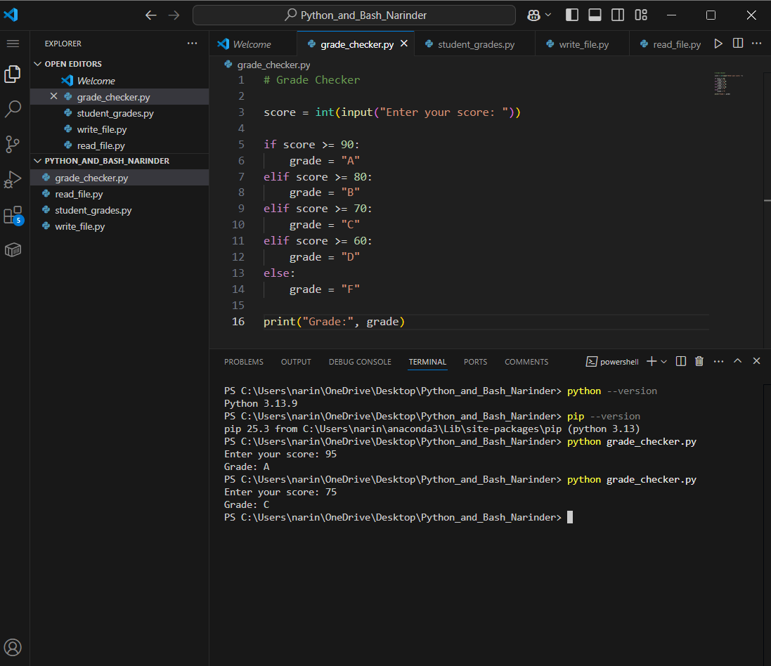

============================================================
TASK 2 – STUDENT GRADES
============================================================

Requirement:
Create a dictionary containing student names and their grades. The program should allow the user to add a new student, update an existing student's grade, and display all student grades.

Program File:
student_grades.py

Concepts Used:
• Dictionary
• Key-value pairs
• Dictionary items()
• Adding dictionary elements
• Updating dictionary elements
• if / elif / else
• for loop

Initial Dictionary:

students = {
"Rahul": "A",
"Priya": "B",
"Amit": "C"
}

Explanation:
A Python dictionary is used to store student names as keys and their grades as values. The program provides two choices to the user. The first choice adds a new student and grade. The second choice updates the grade of an existing student. The program also checks whether a student already exists before performing an operation.

-----------------------------
2.1 ADDING A NEW STUDENT
-----------------------------

The user selects option 1, enters a new student name and grade, and the program adds the student to the dictionary.

Sample Execution:

Enter your choice: 1
Enter student name: Narinder
Enter grade: A
Student added successfully.

All Student Grades:
Rahul : A
Priya : B
Amit : C
Narinder : A

Result:
A new student was successfully added to the dictionary.

SCREENSHOT – ADD STUDENT:
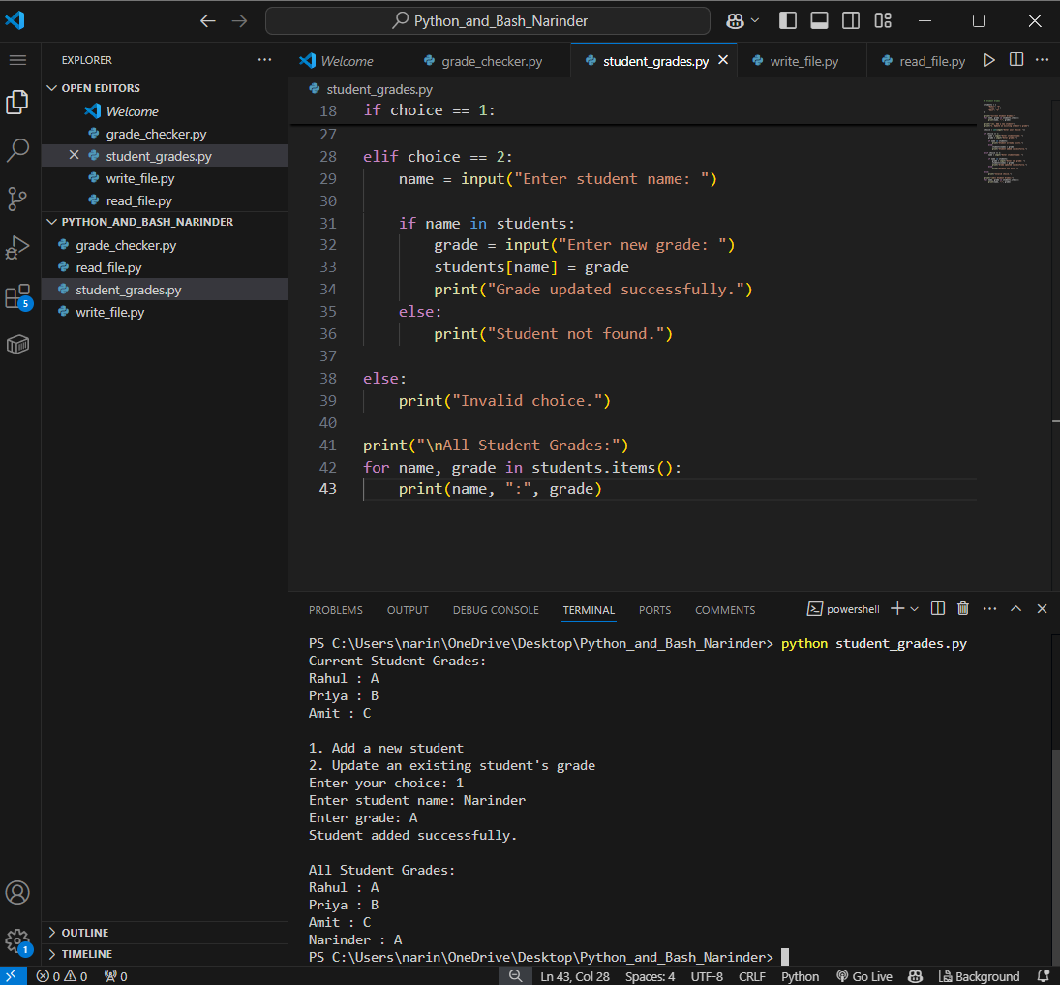

-----------------------------
2.2 UPDATING AN EXISTING STUDENT
-----------------------------

The user selects option 2 and enters an existing student's name. The program then accepts a new grade and updates the dictionary.

Sample Execution:

Enter your choice: 2
Enter student name: Rahul
Enter new grade: A+
Grade updated successfully.

All Student Grades:
Rahul : A+
Priya : B
Amit : C

Result:
The existing student's grade was successfully updated.

SCREENSHOT – UPDATE STUDENT:
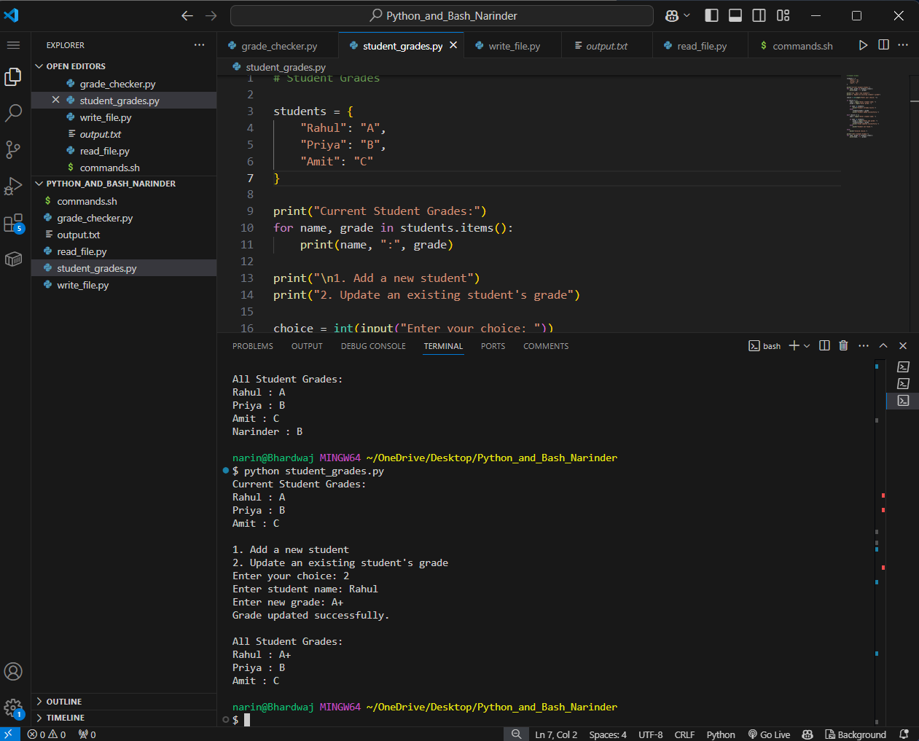

Supporting screenshot showing the Python dictionary program:
Insert: student_grades_code.png

============================================================
TASK 3 – WRITE TO A FILE
============================================================

Requirement:
Create a text file and write content to it using Python file handling functions such as open() and write().

Program File:
write_file.py

Concepts Used:
• open()
• Write mode ("w")
• write()
• close()
• File handling

Code:

file = open("output.txt", "w")

file.write("Hello, this is my Python file handling assignment.\n")
file.write("Python can create and write data into text files.\n")
file.write("This file was created using open() and write().\n")

file.close()

print("Content written to output.txt successfully.")

Explanation:
The program opens a file named output.txt in write mode using open(). The write() function is used to store text inside the file. Finally, close() is used to close the file.

Sample Output:

Content written to output.txt successfully.

The program successfully created the output.txt file and wrote the required content into it.

Result:
The file was successfully created and data was written into it.

SCREENSHOT – TASK 3:
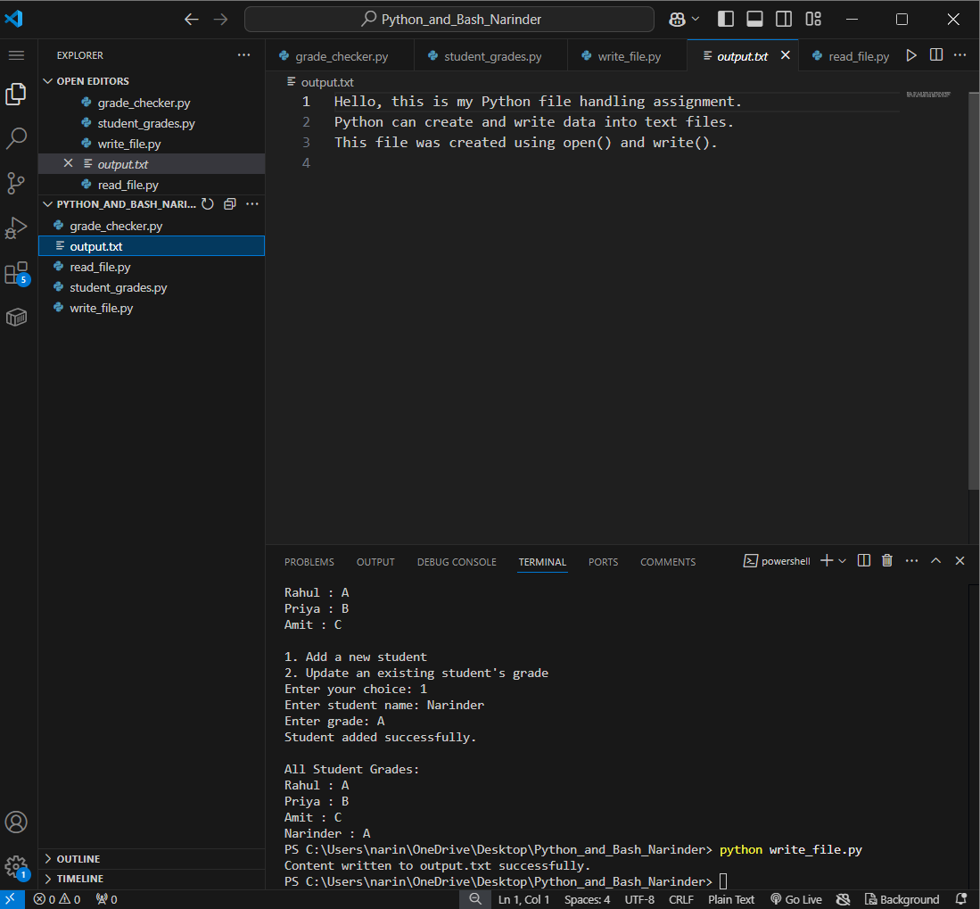

============================================================
TASK 4 – READ FROM A FILE
============================================================

Requirement:
Open the previously created text file in read mode and use file.read() to read and display its contents.

Program File:
read_file.py

Concepts Used:
• open()
• Read mode ("r")
• read()
• close()
• File handling

Code:

file = open("output.txt", "r")

content = file.read()

print("Content of output.txt:")
print(content)

file.close()

Explanation:
The program opens output.txt in read mode using open(). The read() function reads the complete contents of the file and stores them in the content variable. The contents are then displayed in the terminal.

Sample Output:

Content of output.txt:
Hello, this is my Python file handling assignment.
Python can create and write data into text files.
This file was created using open() and write().

Result:
The contents of the text file were successfully read and displayed.

SCREENSHOT – TASK 4:
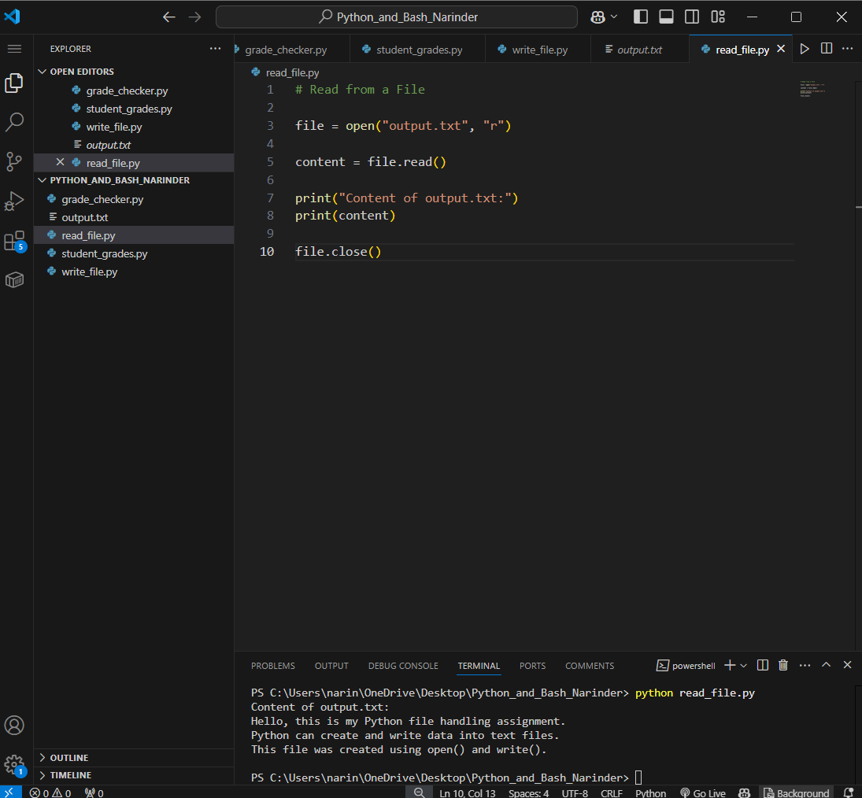

============================================================
BASH SCRIPT
============================================================

Bash Script File:
commands.sh

Purpose:
A basic Bash script was created to demonstrate command-line operations. The script displays the assignment title, current working directory, files present in the project directory, and a successful execution message.

Bash Code:

#!/bin/bash

echo "Python and Bash Assignment"
echo "Current directory:"
pwd

echo "Files in the project:"
ls -l

echo "Bash script executed successfully."

Command Used:

bash commands.sh

Sample Output:

Python and Bash Assignment
Current directory:
/c/Users/narin/OneDrive/Desktop/Python_and_Bash_Narinder

Files in the project:
commands.sh
grade_checker.py
student_grades.py
write_file.py
read_file.py
write_file.py
output.txt

Bash script executed successfully.

Result:
The Bash script executed successfully using Git Bash and displayed the current directory and project files.

SCREENSHOT – BASH:
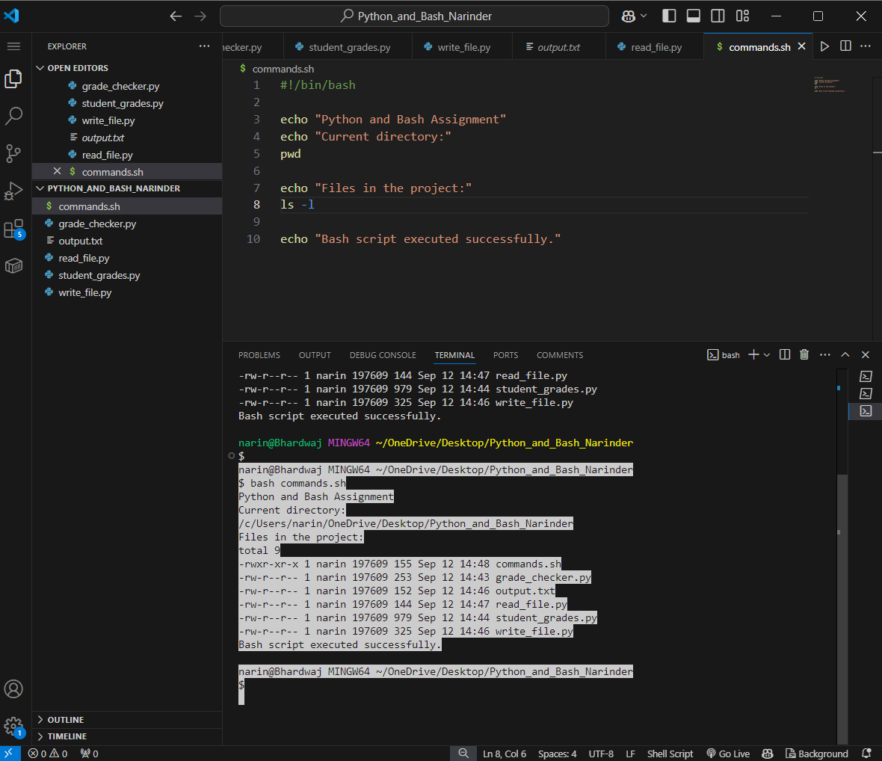

============================================================
PROJECT FILE STRUCTURE
============================================================

Python_and_Bash_Narinder/
│
├── grade_checker.py
├── student_grades.py
├── write_file.py
├── read_file.py
├── commands.sh
├── output.txt
│
└── screenshots/
├── task1_grade_checker.png
├── task2_student_add.png
├── task2_student_update.png
├── task3_write_file.png
├── task4_read_file.png
├── bash_commands.png
└── student_grades_code.png

============================================================
RESULTS
============================================================

The assignment was completed successfully.

The following concepts were implemented:

1. Conditional statements using if, elif, and else.
2. Grade calculation based on score ranges.
3. Dictionary creation and key-value operations.
4. Adding a new student to a dictionary.
5. Updating an existing student's grade.
6. Writing content to a text file.
7. Reading content from a text file using read().
8. Basic Bash scripting and command-line operations.

============================================================
GITHUB REPOSITORY
============================================================

GitHub Repository:

https://github.com/Narinder-code17/Python_and_Bash_Narinder

Repository Name:
Python_and_Bash_Narinder

The complete source code and project files are available in the GitHub repository.

============================================================
CONCLUSION
============================================================

This assignment provided practical experience with basic Python programming and Bash scripting. The Grade Checker demonstrated conditional statements, while the Student Grades program demonstrated dictionaries and basic dictionary operations. The file handling programs demonstrated how Python can create, write, read, and display data from text files. The Bash script provided additional practice with command-line operations.

All required programs were implemented and tested successfully. Screenshots of the commands and outputs are included as evidence of completion.

============================================================
SUBMISSION CHECKLIST
============================================================

☑ Grade Checker program completed
☑ Student Grades dictionary program completed
☑ Add student operation completed
☑ Update student operation completed
☑ All student grades displayed
☑ Write to File program completed
☑ Read from File program completed
☑ Bash script completed
☑ Screenshots included
☑ Documentation completed
☑ Complete source code included
☑ GitHub repository created
☑ GitHub repository link added
☐ Final project folder compressed into ZIP
☐ Final ZIP uploaded to submission portal

============================================================
END OF DOCUMENT
============================================================

