PYTHON & BASH – DEVOPS ASSIGNMENT

MENU-DRIVEN CALCULATOR

Name: Narinder Kumar

============================================================
1. INTRODUCTION
============================================================

This assignment focuses on developing a menu-driven calculator using Python along with a basic Bash script.

The calculator performs four fundamental arithmetic operations:

1. Addition
2. Subtraction
3. Multiplication
4. Division

Each arithmetic operation is implemented as a separate reusable Python function. The calculator uses a continuous while loop to repeatedly display the menu and accept user choices until the user selects the Exit option.

The program also includes division-by-zero handling to prevent the application from crashing when the user attempts to divide a number by zero.

A Bash script is also included to demonstrate basic Bash commands and execution using Git Bash.

============================================================
2. OBJECTIVES
============================================================

The main objectives of this assignment are:

• To implement basic arithmetic operations using Python.
• To create reusable functions using the def keyword.
• To develop a menu-driven calculator.
• To use a loop for continuous menu execution.
• To implement division-by-zero error handling.
• To handle invalid numeric input using exception handling.
• To understand basic Bash scripting.
• To execute and test the Python and Bash programs successfully.

============================================================
3. TOOLS AND TECHNOLOGIES
============================================================

Programming Language:
• Python

Scripting Language:
• Bash

Development Environment:
• Visual Studio Code

Terminal:
• Git Bash

Operating System:
• Windows

============================================================
4. PROJECT STRUCTURE
============================================================

Python_and_Bash_Narinder/
│
├── calculator.py
├── commands.sh
├── Python_Bash_Calculator_Documentation.docx
│
└── screenshots/
├── calculator_code.png
├── calculator_execution.png
└── bash_commands.png

============================================================
5. CALCULATOR IMPLEMENTATION
============================================================

File Name:

calculator.py

The calculator is implemented using four reusable functions:

• addition()
• subtraction()
• multiplication()
• division()

The user selects an operation from the displayed menu.

The program then accepts two numbers and calls the corresponding function.

The calculator uses a while True loop so that the menu is displayed repeatedly after each operation.

The program terminates when the user selects option 5.

Division by zero is handled using a condition inside the division() function.

Invalid numeric input is handled using try and except ValueError.

============================================================
6. PYTHON SOURCE CODE
============================================================

# Menu-Driven Calculator
# Python & Bash DevOps Assignment

def addition(a, b):
"""Return the sum of two numbers."""
return a + b

def subtraction(a, b):
"""Return the difference between two numbers."""
return a - b

def multiplication(a, b):
"""Return the product of two numbers."""
return a * b

def division(a, b):
"""Return the division result with zero-division handling."""
if b == 0:
return "Error: Cannot divide by zero."
return a / b

while True:
print("\n===== MENU-DRIVEN CALCULATOR =====")
print("1. Addition")
print("2. Subtraction")
print("3. Multiplication")
print("4. Division")
print("5. Exit")

choice = input("Enter your choice: ")

if choice == "5":
print("Calculator exited successfully.")
break

if choice in ["1", "2", "3", "4"]:
try:
num1 = float(input("Enter first number: "))
num2 = float(input("Enter second number: "))

if choice == "1":
result = addition(num1, num2)

elif choice == "2":
result = subtraction(num1, num2)

elif choice == "3":
result = multiplication(num1, num2)

elif choice == "4":
result = division(num1, num2)

print("Result:", result)

except ValueError:
print("Invalid input. Please enter numbers only.")

else:
print("Invalid choice. Please select an option from 1 to 5.")

============================================================
7. EXPLANATION OF PYTHON FUNCTIONS
============================================================

7.1 Addition Function

The addition() function accepts two numbers as parameters and returns their sum.

Example:

addition(10, 5)

Result:

15

7.2 Subtraction Function

The subtraction() function accepts two numbers and returns the difference between them.

Example:

subtraction(10, 5)

Result:

5

7.3 Multiplication Function

The multiplication() function accepts two numbers and returns their product.

Example:

multiplication(10, 5)

Result:

50

7.4 Division Function

The division() function divides the first number by the second number.

Before performing the division, the program checks whether the second number is zero.

If the second number is zero, the function returns:

Error: Cannot divide by zero.

This prevents the program from terminating because of a division-by-zero error.

============================================================
8. MENU-DRIVEN LOOP
============================================================

The calculator uses:

while True:

This creates a continuous execution loop.

The menu is displayed repeatedly and the user can perform multiple operations during the same program execution.

The program uses:

break

when the user selects option 5.

This terminates the loop and exits the calculator.

Therefore, the program does not terminate after performing a single operation.

============================================================
9. INPUT VALIDATION
============================================================

The calculator uses exception handling with:

try:
...
except ValueError:
...

This handles cases where the user enters invalid non-numeric input.

Instead of crashing, the program displays:

Invalid input. Please enter numbers only.

This improves the reliability of the calculator.

============================================================
10. CALCULATOR SOURCE CODE SCREENSHOT
============================================================

The following screenshot demonstrates the implementation of:

• Addition function
• Subtraction function
• Multiplication function
• Division function
• while loop
• Menu-driven interface
• Division-by-zero handling
• Input validation

SCREENSHOT:

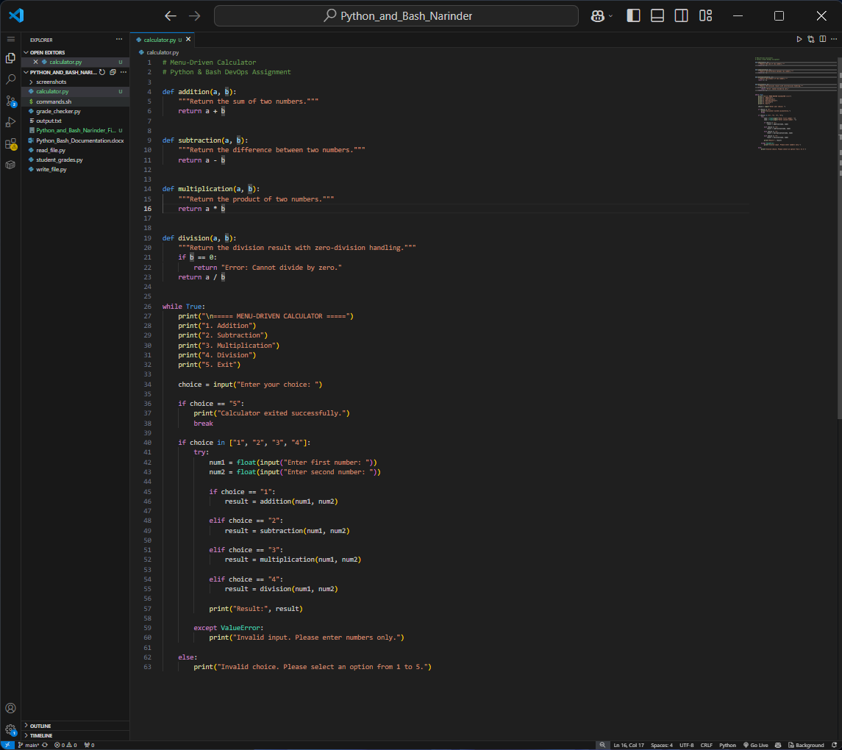

calculator_code.png

============================================================
11. CALCULATOR EXECUTION
============================================================

The calculator was executed using the following command:

python calculator.py

The following operations were tested successfully.

Test 1 – Addition

Input:

Choice: 1
First number: 10
Second number: 5

Output:

Result: 15.0

Test 2 – Subtraction

Input:

Choice: 2
First number: 10
Second number: 5

Output:

Result: 5.0

Test 3 – Multiplication

Input:

Choice: 3
First number: 10
Second number: 5
Output:

Result: 50.0

Test 4 – Division

Input:

Choice: 4
First number: 10
Second number: 5

Output:

Result: 2.0

Test 5 – Division by Zero

Input:

Choice: 4
First number: 10
Second number: 0

Output:

Result: Error: Cannot divide by zero.

The program did not crash and returned to the calculator menu.

Test 6 – Exit

Input:

Choice: 5

Output:

Calculator exited successfully.

============================================================
12. CALCULATOR EXECUTION SCREENSHOT
============================================================

The execution screenshot demonstrates:

• Menu-driven operation
• Addition
• Subtraction
• Multiplication
• Division
• Repeated menu execution
• Division-by-zero handling
• Successful program exit

SCREENSHOT:

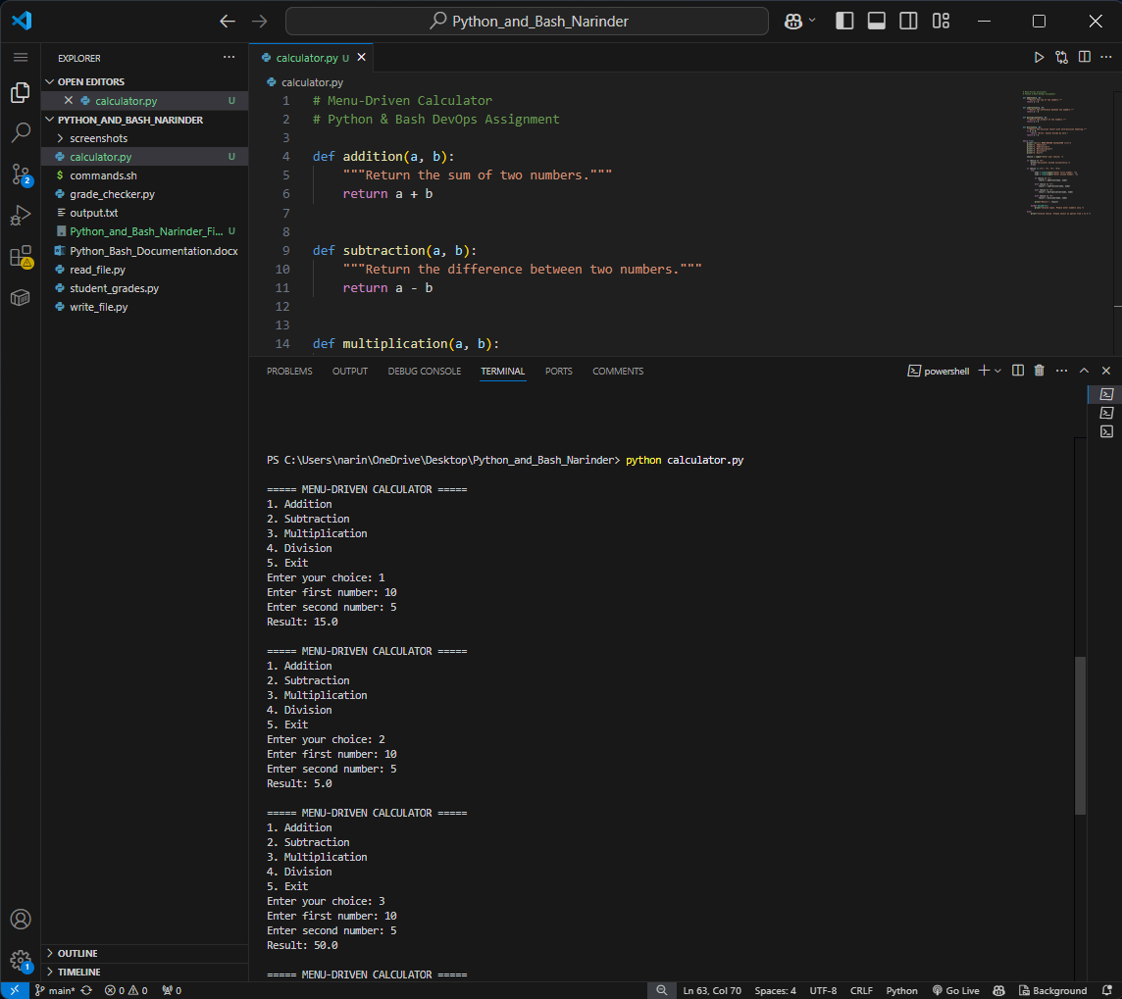
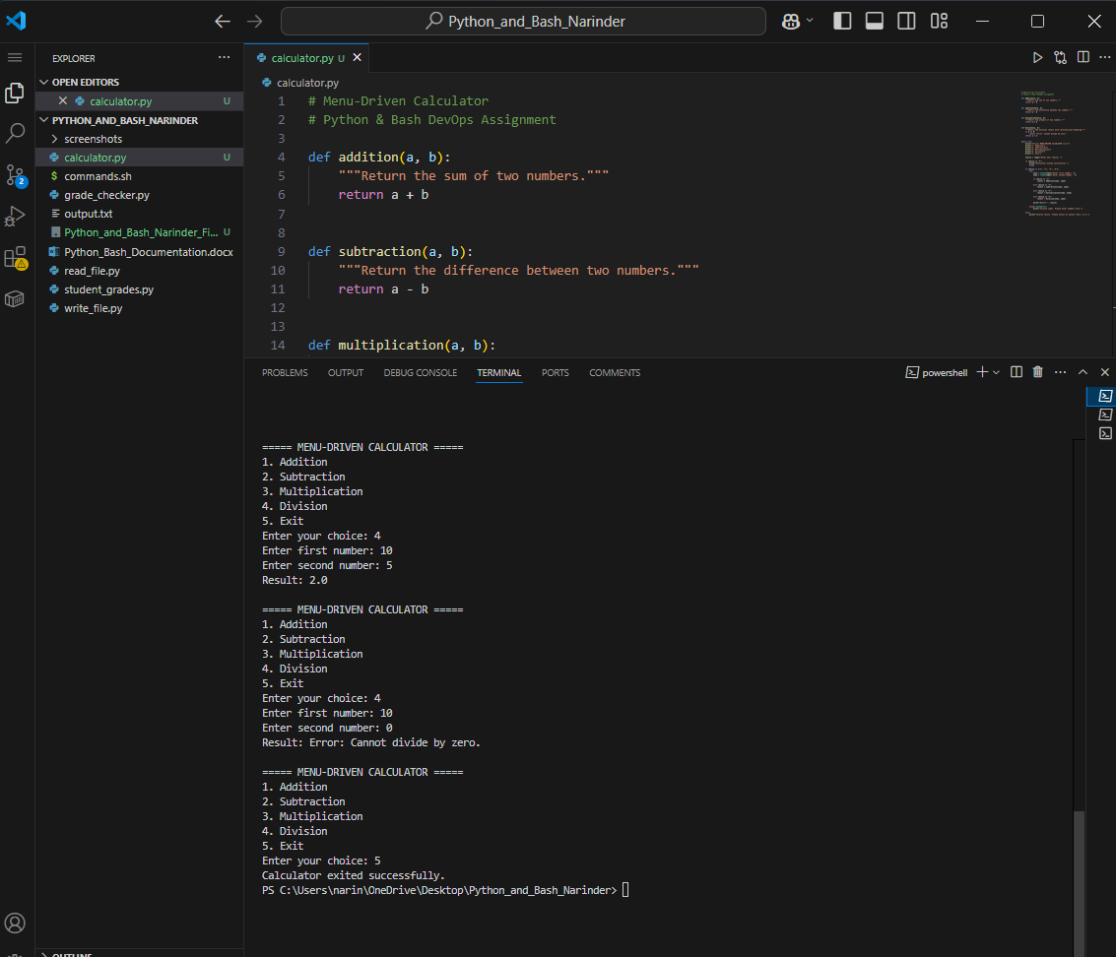
calculator_execution.png

============================================================
13. BASH SCRIPT
============================================================

File Name:

commands.sh

The Bash script demonstrates basic Bash commands.

The script displays:

• Assignment title
• Calculator project information
• Current working directory
• Project files
• Successful execution message

Bash Source Code:

#!/bin/bash

echo "===== Python & Bash Assignment ====="
echo "Calculator Project"
echo ""
echo "Current Directory:"
pwd
echo ""
echo "Project Files:"
ls -l
echo ""
echo "Bash script executed successfully."

============================================================
14. BASH COMMAND EXPLANATION
============================================================

#!/bin/bash

Specifies that the script should be executed using Bash.

echo

Displays text on the terminal.

pwd

Displays the current working directory.

ls -l

Displays the files and directories in the current directory in detailed format.

============================================================
15. BASH EXECUTION
============================================================

The Bash script was executed using Git Bash with:

bash commands.sh

The script successfully displayed the project information, current directory, project files, and successful execution message.

============================================================
16. BASH EXECUTION SCREENSHOT
============================================================

The following screenshot demonstrates successful Bash script execution.

SCREENSHOT:

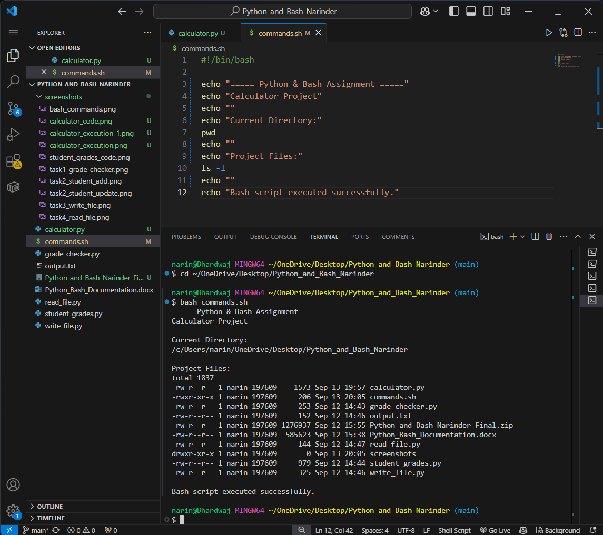

bash_commands.png

============================================================
17. TEST CASES
============================================================

Test Case 1:
Operation: Addition
Input: 10, 5
Expected Result: 15
Actual Result: 15.0
Status: PASS

Test Case 2:
Operation: Subtraction
Input: 10, 5
Expected Result: 5
Actual Result: 5.0
Status: PASS

Test Case 3:
Operation: Multiplication
Input: 10, 5
Expected Result: 50
Actual Result: 50.0
Status: PASS

Test Case 4:
Operation: Division
Input: 10, 5
Expected Result: 2
Actual Result: 2.0
Status: PASS

Test Case 5:
Operation: Division by Zero
Input: 10, 0
Expected Result: Error message
Actual Result: Error: Cannot divide by zero.
Status: PASS

Test Case 6:
Operation: Exit
Input: 5
Expected Result: Program terminates
Actual Result: Calculator exited successfully.
Status: PASS

============================================================
18. KEY CONCEPTS DEMONSTRATED
============================================================

The project demonstrates the following concepts:

• Python functions
• Function parameters
• Return values
• Conditional statements
• while loop
• break statement
• Menu-driven programming
• Exception handling
• Division-by-zero handling
• User input
• Bash scripting
• Basic Bash commands
• Program testing

============================================================
19. RESULT
============================================================

The menu-driven calculator was successfully implemented using Python.

Four reusable arithmetic functions were created for addition, subtraction, multiplication, and division.

A continuous while loop was implemented to allow the user to perform multiple operations without restarting the program.

Division by zero was handled safely by checking the denominator before performing the division.

Invalid numeric input was also handled using exception handling.

The Bash script was successfully executed using Git Bash.

All tested calculator operations produced the expected results.

Therefore, the required calculator functionality, reusable functions, execution loop, error handling, and Bash scripting requirements were successfully completed.

============================================================
20. GITHUB REPOSITORY
============================================================

GitHub Repository:

https://github.com/Narinder-code17/Python_and_Bash_Narinder

============================================================
21. CONCLUSION
============================================================

This assignment provided practical experience in developing a menu-driven Python application.

The project demonstrates how reusable functions can be used to organize arithmetic operations into separate components.

The while loop allows continuous execution of the calculator menu, while the division-by-zero check prevents runtime errors during invalid division operations.

Exception handling further improves the reliability of the program by handling invalid user input.

The Bash script provided additional practice with basic shell commands and Git Bash execution.

The complete source code, Bash script, screenshots, documentation, and project files are included in the final submission.

============================================================
22. SUBMISSION CHECKLIST
============================================================

✓ Menu-driven calculator implemented

✓ Addition function implemented

✓ Subtraction function implemented

✓ Multiplication function implemented

✓ Division function implemented

✓ Reusable Python functions created using def

✓ Continuous execution implemented using while loop

✓ Exit option implemented using break

✓ Division-by-zero handling implemented

✓ Invalid input handling implemented

✓ Bash script implemented

✓ Calculator source code screenshot included

✓ Calculator execution screenshot included

✓ Bash execution screenshot included

✓ GitHub repository updated

✓ Documentation included

✓ Complete source code included

✓ Final ZIP will contain all required files

