Narmatha R

9003048866

narmatharavi1997@gmail.com

OBJECTIVE

Seeking for the challengeable role, where I can prove my talent and skills and to explore the various technologies and developments in my area of interest.

TECHNICAL SKILLS

* Programming language : C programming
* Simulation tools : Xilinx, ARDUINO

NETWORKING SKILLS

* Pursuing certification in CCNA.

EDUCATION

* Pursuing **B.E/Electronics and communication Engineering** in Saveetha Engineering College in Thandalam,CGPA:7.93,2018.
* **HSC (12th)** from Daniel Thomas Matriculation Higher Secondary School in koyambedu with 86%, 2014.
* **SSLC (10th)** from Daniel Thomas Matriculation Higher Secondary School in koyambedu with 93%, 2012.

TRAINING EXPERIENCES

* “BLUE EYES” workshop on bluetooth with aurduino at Saveetha Engineering College, Thandalam.
* One Day National level workshop on “LASER PHYSICS” at Saveetha Engineering College, Thandalam.
* Workshop on “BOOMING AND BOOM OF IOT” at SSN college of Engineering.
* A one week “INPLANT TRAINING” at Doordarshan Kendra, Chennai.
* “BRAINWAVE CONTROLLED ROBOTICS” workshop on controlling robot with your brainwaves at Amrita University, Amritapuri campus, Kerala.

PAPER PRESENTATION (NATIONAL)

* “MATHEMATICAL MODELLING” in 4th National Conference on Emerging Trends in Saveetha Engineering College, Thandalam.
* ”LASER PHYSICS IN NEW TECHNOLOGY” in 4th National Conference on Emerging Trends in Saveetha Engineering College , Thandalam.

CO-CURRICULAR ACTIVITIES:

* Participated in Line Follower competition in ROBOTSAVAM’17, Amrita University, Amritapuri campus, Kerala.
* Coordinated an event “PICTRON” in DRESTEIN on 18th February, 2017.
* Secured 3rd place in PROJECT DISPLAY on National Science Day 26thMarch, 2015.
* Participated in Guinness World Record on CPR Training and CPR relay, 2015.
* Conducted stalls in “SAVEE BAZAAR” on 27th September, 2014.

AREA OF INTEREST:

* Digital electronics
* VLSI Design
* Computer Networks

PERSONAL PROFILE:

* **Name**  : Narmatha R
* **Date of Birth** : 18-06-1997
* **Father’s Name** :Mr. Ravi. B
* **Gender** : Female
* **Nationality** : Indian
* **Religion** : Hindu
* **Languages**

**known**  : Tamil , English

DECLARATION:

I hereby declare that the above-mentioned information is true to my knowledge.

Place: 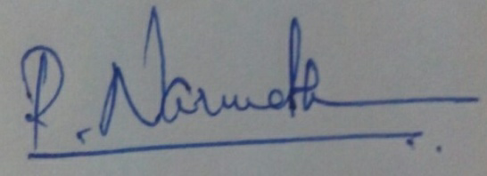

Date :