# **Selenium Cucumber Framework**

This project aims to give a sample of automation test framework that uses Selenium and Cucumber with Java as the programming language.

## **1.Background**

We have used Page Object Model pattern for modeling different pages of the application, in order to ensure that framework is robust to UI changes and quite easy to maintain

## **2.Tools and Libraries**

This project using 2 main tools, Selenium and Cucumber.

The complete list of tools, you can see in the pom.xml file.

**Installation:**

Eclipse  
Java 8  
Eclipse Cucumber Plugin  
Eclipse TestNG Plugin  
Other necessary Jars will be downloaded by Maven.

## **Requirements**

* Java Development Kit –JDK 8

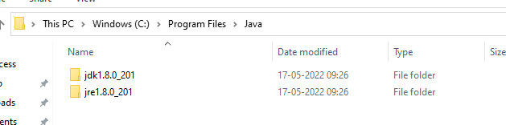

* Maven
* ChromeDriver
* Eclipse: Version: 2020-06 (4.16.0)

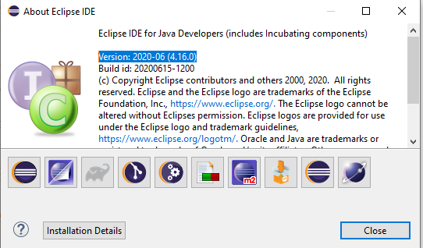

* Automation tool: Selenium webdriver
* BDD framework: Cucumber jvm
* Testing framework: Testng
* Build tool: maven
* Logging: log4j?
* Reporting: cucumber or extent report?
* JUnit
* Git
* Repository: GitHUb
* CI-CD Tool: Jenkins

## **Application Under Test:**

<https://parabank.parasoft.com/parabank/index.htm>

## **Aim**

It is intended as a brief, easy guide to create a framework for Automation testing from scratch. Once the framework is ready, we will Automate few of the test cases for above website. So, what we are going to do?

1. Create a framework.
2. Automate some of the sample test flow for above website in BDD.
3. Execute the test scripts.
4. Integrate with Jenkins

**Pom.xml:**

<?xml version="1.0" encoding="UTF-8"?>

<project xmlns="https://maven.apache.org/POM/4.0.0"

xmlns:xsi="https://www.w3.org/2001/XMLSchema-instance"

xsi:schemaLocation="https://maven.apache.org/POM/4.0.0 http://maven.apache.org/xsd/maven-4.0.0.xsd">

<modelVersion>4.0.0</modelVersion>

<groupId>ParaBank</groupId>

<artifactId>ParaBank</artifactId>

<version>0.0.1-SNAPSHOT</version>

<name>ParaBank</name>

<!-- FIXME change it to the project's website -->

<url>http://www.example.com</url>

<properties>

<project.build.sourceEncoding>UTF-8</project.build.sourceEncoding>

<maven.compiler.source>1.7</maven.compiler.source>

<maven.compiler.target>1.7</maven.compiler.target>

</properties>

<dependencies>

<dependency>

<groupId>junit</groupId>

<artifactId>junit</artifactId>

<version>4.11</version>

<scope>test</scope>

</dependency>

<dependency>

<groupId>info.cukes</groupId>

<artifactId>cucumber-java</artifactId>

<version>1.2.5</version>

</dependency>

<dependency>

<groupId>info.cukes</groupId>

<artifactId>cucumber-junit</artifactId>

<version>1.2.5</version>

</dependency>

<dependency>

<groupId>io.github.bonigarcia</groupId>

<artifactId>webdrivermanager</artifactId>

<version>5.1.1</version>

</dependency>

<dependency>

<groupId>info.cukes</groupId>

<artifactId>cucumber-jvm-deps</artifactId>

<version>1.0.5</version>

<scope>provided</scope>

</dependency>

<dependency>

<groupId>net.masterthought</groupId>

<artifactId>cucumber-reporting</artifactId>

<version>5.0.2</version>

</dependency>

<dependency>

<groupId>info.cukes</groupId>

<artifactId>gherkin</artifactId>

<version>2.12.2</version>

<scope>provided</scope>

</dependency>

<dependency>

<groupId>junit</groupId>

<artifactId>junit</artifactId>

<version>4.13</version>

</dependency>

<dependency>

<groupId>org.seleniumhq.selenium</groupId>

<artifactId>selenium-java</artifactId>

<version>3.141.59</version>

</dependency>

<dependency>

<groupId>org.testng</groupId>

<artifactId>testng</artifactId>

<version>6.14.3</version>

<scope>test</scope>

</dependency>

</dependencies>

<build>

<pluginManagement><!-- lock down plugins versions to avoid using Maven

defaults (may be moved to parent pom) -->

<plugins>

<!-- clean lifecycle, see https://maven.apache.org/ref/current/maven-core/lifecycles.html#clean_Lifecycle -->

<plugin>

<artifactId>maven-clean-plugin</artifactId>

<version>3.1.0</version>

</plugin>

<!-- default lifecycle, jar packaging: see https://maven.apache.org/ref/current/maven-core/default-bindings.html#Plugin_bindings_for_jar_packaging -->

<plugin>

<artifactId>maven-resources-plugin</artifactId>

<version>3.0.2</version>

</plugin>

<plugin>

<artifactId>maven-compiler-plugin</artifactId>

<version>3.8.0</version>

</plugin>

<plugin>

<artifactId>maven-surefire-plugin</artifactId>

<version>2.22.1</version>

</plugin>

<plugin>

<artifactId>maven-jar-plugin</artifactId>

<version>3.0.2</version>

</plugin>

<plugin>

<artifactId>maven-install-plugin</artifactId>

<version>2.5.2</version>

</plugin>

<plugin>

<artifactId>maven-deploy-plugin</artifactId>

<version>2.8.2</version>

</plugin>

<!-- site lifecycle, see https://maven.apache.org/ref/current/maven-core/lifecycles.html#site_Lifecycle -->

<plugin>

<artifactId>maven-site-plugin</artifactId>

<version>3.7.1</version>

</plugin>

<plugin>

<artifactId>maven-project-info-reports-plugin</artifactId>

<version>3.0.0</version>

</plugin>

</plugins>

</pluginManagement>

</build>

</project>