**Prerequisites to run the application**

* Installation of Node JS and GIT. Refer Node JS and GIT installation documentation in case these soft wares not installed in local machine.

**Testing required software’s are installed in local machine or not.**

* node --version
* git –version

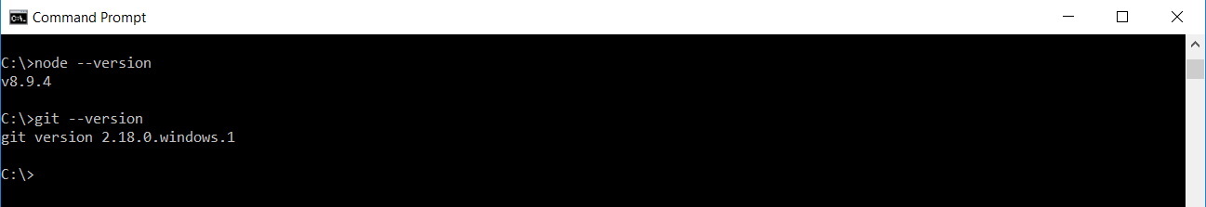

**Get application code from GIT repository to local machine and install required Node JS modules**

Download code from git url ‘https://github.com/NarmadaKandhikattu/appleassignment.git’ using below git command. Execution of below command create a directory with the name ‘appleassignment’ in the current directory.

* git clone <https://github.com/NarmadaKandhikattu/appleassignment.git>

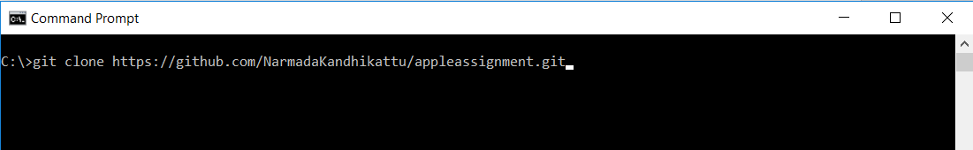

Switch to folder created newly with the above execution command.

* cd appleassignment

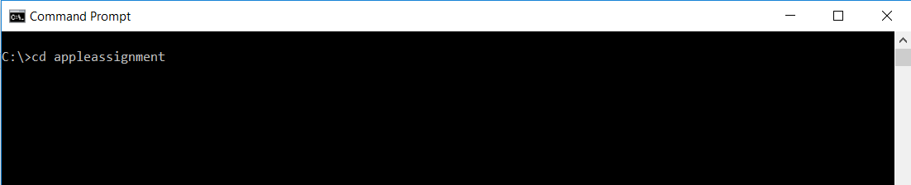

Run ‘npm install’ command to install the required Node JS dependency modules.

* npm install

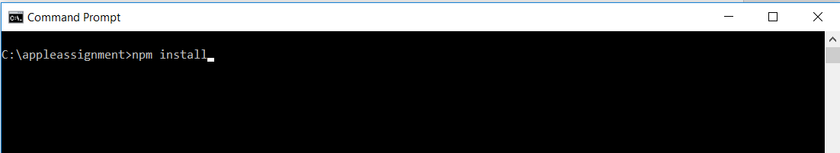

**Start Node JS server & listen on port 8765**

Run ‘npm start’ command to start the Node JS server and listen on port 8765

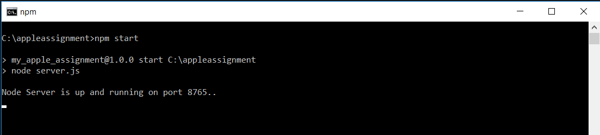

Testing Application

Open a new command prompt and run the below ‘curl’ commands to test the application.

**Scenario1: (Given DOB date is same as today date)**

curl localhost:8765/api/greetings -H "Content-type:application/x-www-form-urlencoded" -X POST -d "firstName=Narmada&lastName=Kandhikattu&DOB=06-04"

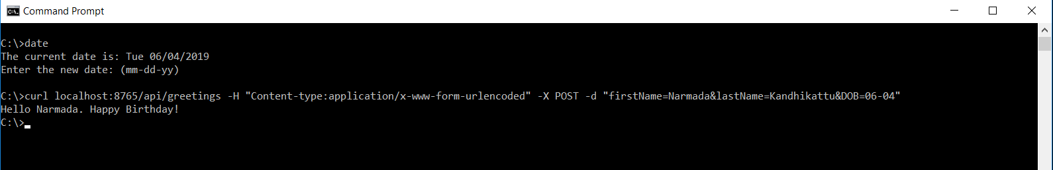

**Scenario2: (Given DOB date is greater than current month and day)**

curl localhost:8765/api/greetings -H "Content-type:application/x-www-form-urlencoded" -X POST -d "firstName=Narmada&lastName=Kandhikattu&DOB=06-05"

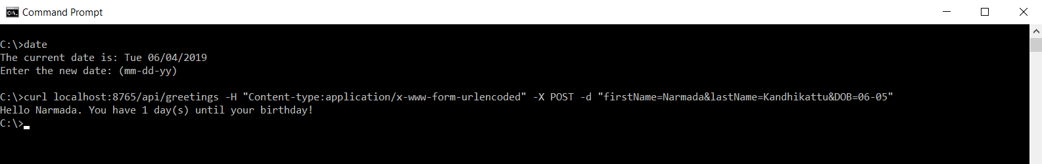

**Scenario3: (Given DOB date is older than current month and day)**

curl localhost:8765/api/greetings -H "Content-type:application/x-www-form-urlencoded" -X POST -d "firstName=Narmada&lastName=Kandhikattu&DOB=06-03"

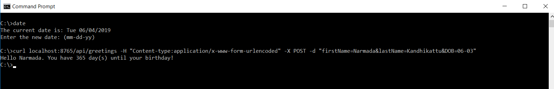

Note: In the above scenario we can see current date as ‘June 04 2019’ and given DOB value is ’06-03’ (i.e June 03 2019). If coming year is leap year we should receive 365 days in the response. Else we should receive 364 days.