##### **PRODUCT SALES ANALYSIS**

**S.DEEPIKA**

**420721104006**

#### **CK COLLEGE OF ENGINEERING AND TECHNOLOGY**

# INTRODUCTION

# Product sales analysis using data analytics in IBM Cognos involves using data-driven techniques to gain insights into your product sales performance. It allows you to

# explore and understand how your products are selling, identify trends, make

# data-informed decisions to optimize sales strategies.

# DATA PREPARATION

# The data preparation is preparing the data set by involving the dataset into collection, data cleaning and data integration.

* **DATA COLLECTION**

Collect all pertinent data sources, such as bidder and item details, action records, transaction data, and any other pertinent data.

* **DATA CLEANING**

To make sure your analysis is precise and trustworthy, it entails finding and fixing mistakes, inconsistencies and missing values in your dataset.

# VISUALIZATION

Utilize IBM Cognos to create various types of visualizations that offer a comprehensive view of your product sales data. Common types of visualizations include bar charts, line charts, pie charts, heat maps, scatter plots.

**REVENUE AND SALES VOLUME TREND**

* Create line charts to visualize trends in revenue and sales volume over time. This can help you identify seasonality, growth, or decline in sales.
* Use trend lines to highlight the overall direction of sales and add annotations to explain significant changes or events that impacted sales.

**OUR DATASET REPORT**

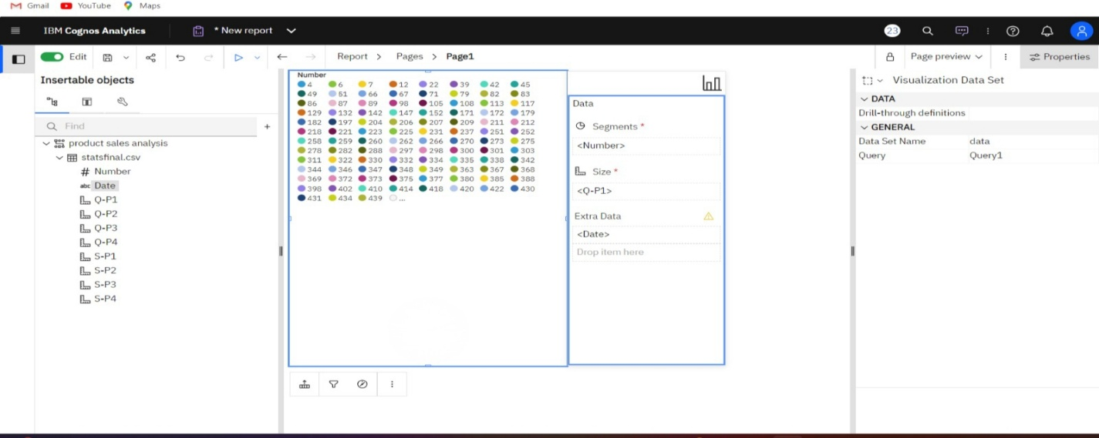

**ANALYSIS OF CUSTOMER SEGMENTION**

* Develop pie charts or stacked bar charts to segment customers by demographics buying behavior. For example, you can visualize the distribution of customers by

age group, location, or purchase frequency.

* Businesses use this information to better understand their target market, target marketing campaigns, and raise consumer satisfaction levels.

**BAR GRAPH**

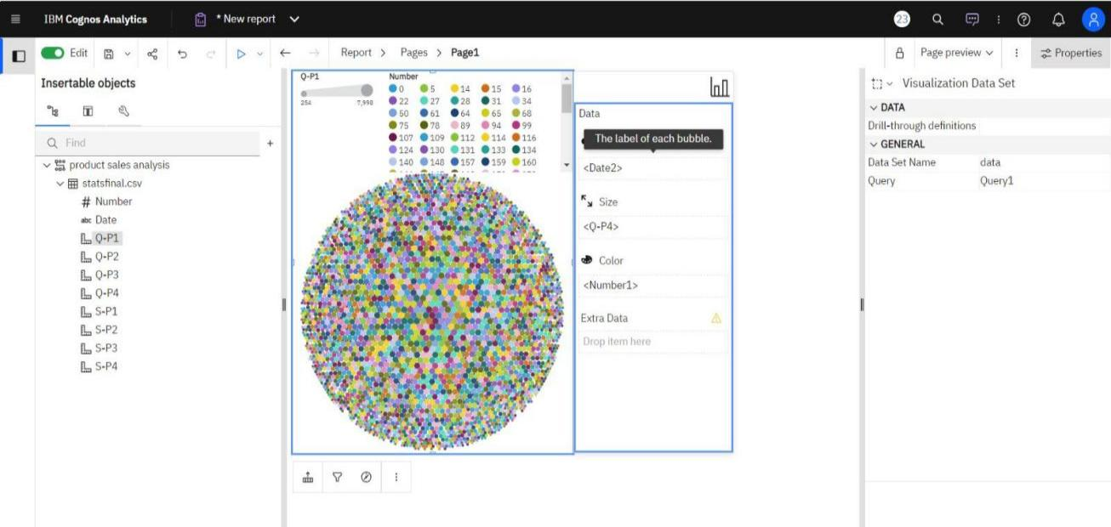

**CUSTOMER PREFERENCES**

Examine consumer preferences and behavior. Utilize methods such as association rule mining to determine which products are frequently bought in tandem. This might assist you in making product recommendations or developing bundling plans.

* **INTERACTIVE DASHBOARDS**

To display the insights and analysis findings, create interactive dashboards and

reports to IBM Cognos. Stakeholders can examine the data and get practical

insights from these dashboards.

* **SALES TRENDS**

To see sales patterns over time, use an area or line chart.

Put the total sales on the Y-axisand the date/time on the X-axis. Provide filters so users can change the date range.

## DASHBOARD 1

* In this first dashboard we will add the date and number and then compare the product sales data and customer buying data.
* By comparing them we will get the highest sales in product 3 and product 4 sales when compared to the product 1 and product 2.

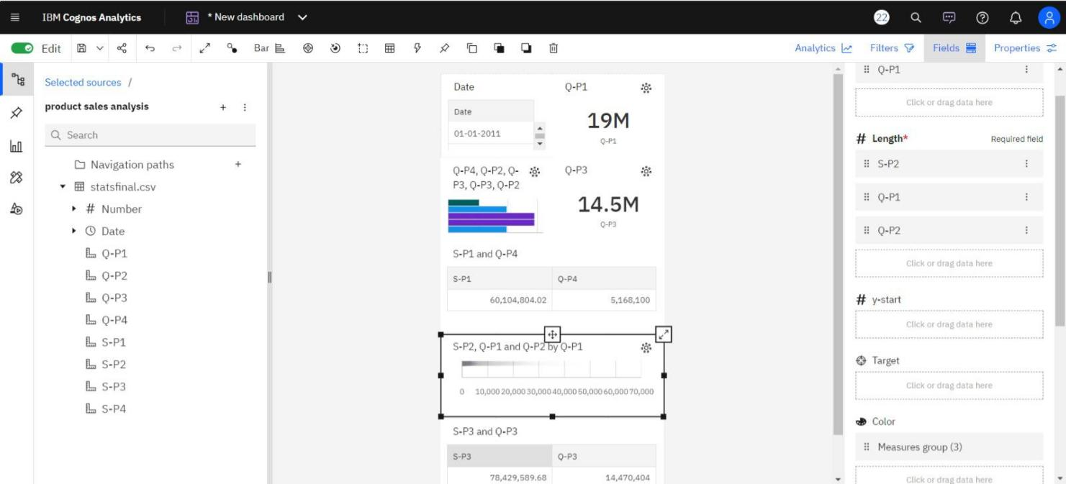

**DASHBOARD 2**

* In this dashboard we had compared the last year product sales with this year

product sales.

* Include interactive features that let users choose which time periods to compare with by including a date range filter.
* When users click over each bar, include tooltips with detailed information (e.g., total sales values).

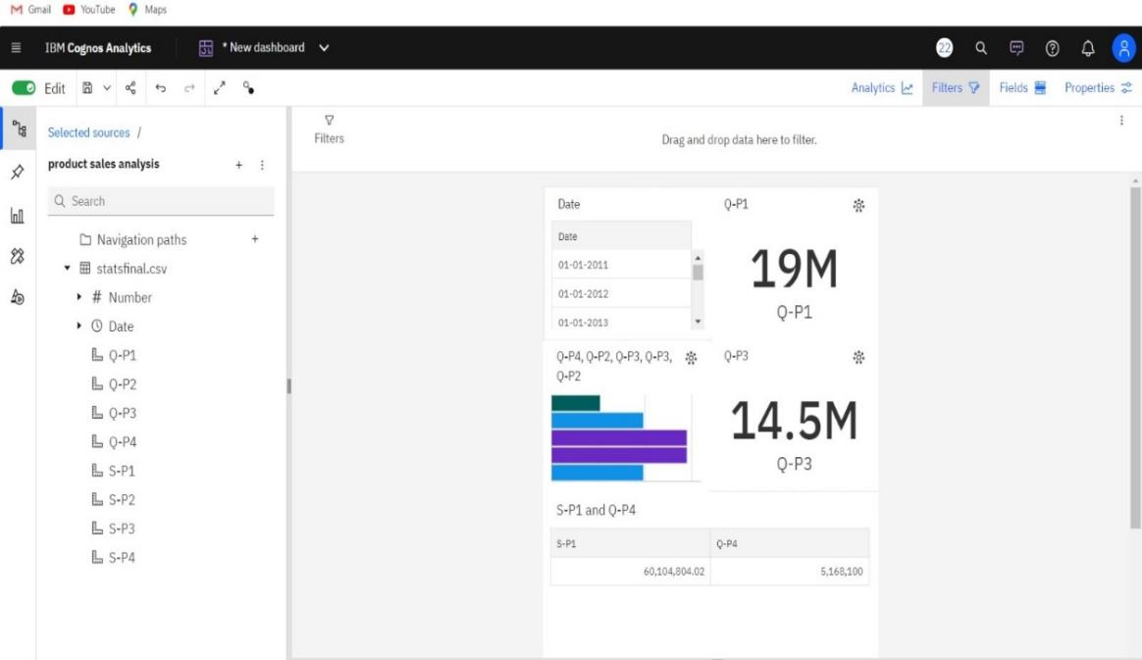

**DASHBOARD 3**

* **COMPARISION SALES BY CATEGORY**

Utilize the dashboard to evaluate sales results for the chosen time periods across various product categories.

* **IDENTIFY TRENDS**

Examine which product categories had increases or decreases in sales over the

course of the two periods.

* **SEASONAL PATTERNS**

Seek out trends in sales that could indicate a relationship with marketing

campaigns or seasonal circumstances.

* **ACTIONABLE INSIGHTS**

Make practical inferences from our findings. For instance, plan to change

inventories to match greater demand in growing categories or devote marketing resources to product categories that are dropping.

**HIGHEST SALES**

* Create a bar graph with the names of the products on the X-axis and the total sales

on the Y-axis.

* The product with the most sales will be at the top of the list when the bars are sorted in descending order.
* To show the precise sales amount, add a data label to the top bar.

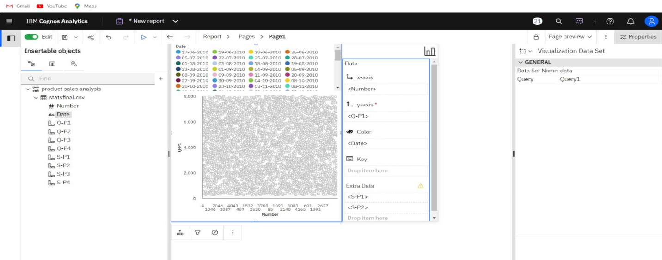

**PEAK SALES PERIODS**

* Make a line graph where the Y-axis represents total sales and the X-axis

represents time intervals (such as daily, weekly, or monthly).

* To organize your data according to time intervals, use a temporal hierarchy.
* Incorporate trendlines or annotations to draw attention to moments of peak sales.

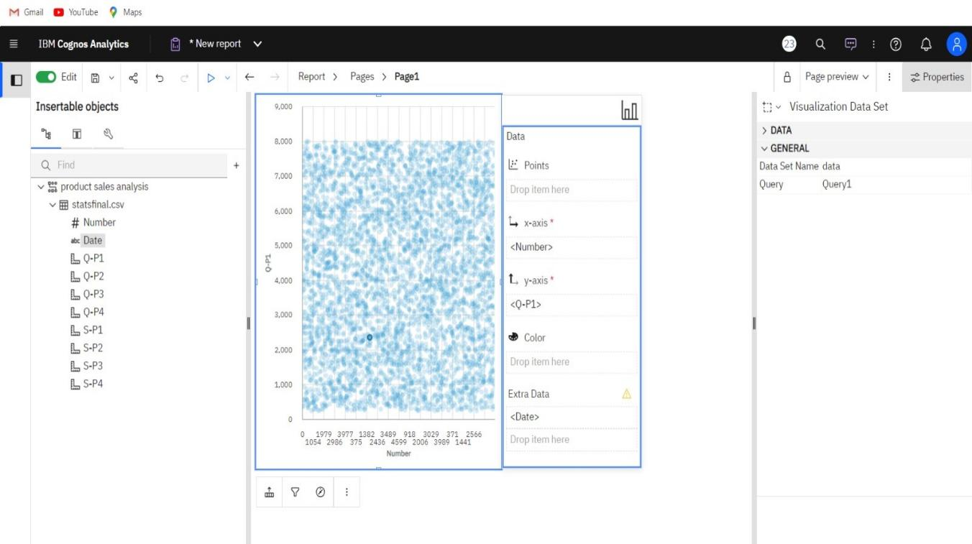

**CUSTOMER PREFERENCES FOR SPECIFIC PRODUCTS**

* Make a stacked bar chart that illustrates the differences in client preferences between several product categories.

* A bar represents each product category, and the height of each bar is segmented to represent distinct customer preferences (e.g., "like," "neutral," and "dislike").

This is a scatter plot for defining the sales analysis by using a customer buying product details and dates of buying that product.

**CONCLUSION**

In conclusion, product sales analysis using IBM Cognos Analytics is a potent way for companies to improve their sales strategy by gaining important insights and making data-driven decisions through the development of dashboards and reports.

* **DATA DRIVEN DECISION MAKING**

IBM Cognos Analytics enables companies to generate dynamic dashboards and reports that help them fully utilize the potential of their sales data. This makes it possible to make data-driven, well-informed decisions and guarantees that

activities are in line with actual sales success.

* **VISUALISATION OF CLARITY**

Pie charts, line charts, and bar charts are examples of visualizations that are

essential for clearly and understandably displaying complex sales data. These

graphics make it easy to spot trends, patterns, and potential improvement areas.