**PRODUCT SALES ANALYSIS**

**N. NARMADHA DEVI**

**REG NO:420721104026**

***CK COLLEGE OF ENGINEERING AND TECHNOLOGY***

**INTRODUCTION**

* Product sales analysis is a critical component of business intelligence and strategy. It involves the examination of sales data to gain insights into product performance, customer behavior, and market trends.

* Analysing product sales is crucial for any business to make informed decisions. IBM Cognos Visualization provides a powerful platform for dissecting sales data and uncovering valuable insights.

* In this report, we will explore the capabilities of IBM Cognos Visualization to visualize, analyse, and interpret product sales data.

* By leveraging this tool, businesses can gain a deeper understanding of their sales performance, identify trends, and make data-driven decisions to improve profitability and overall success.

* This analysis aims to showcase the potential of IBM Cognos Visualization in enhancing product sales strategies and driving business growth.

**GIVEN DATA SET**

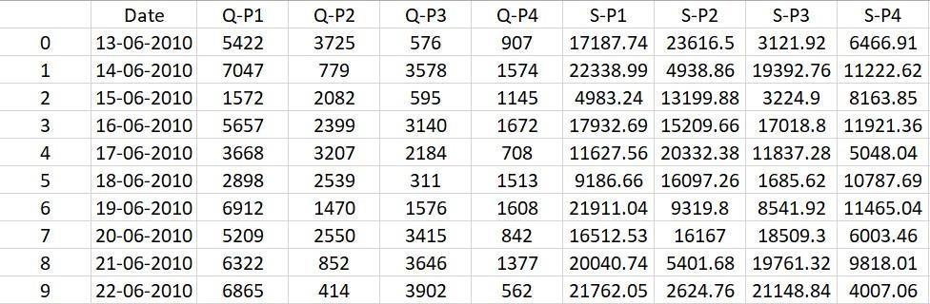

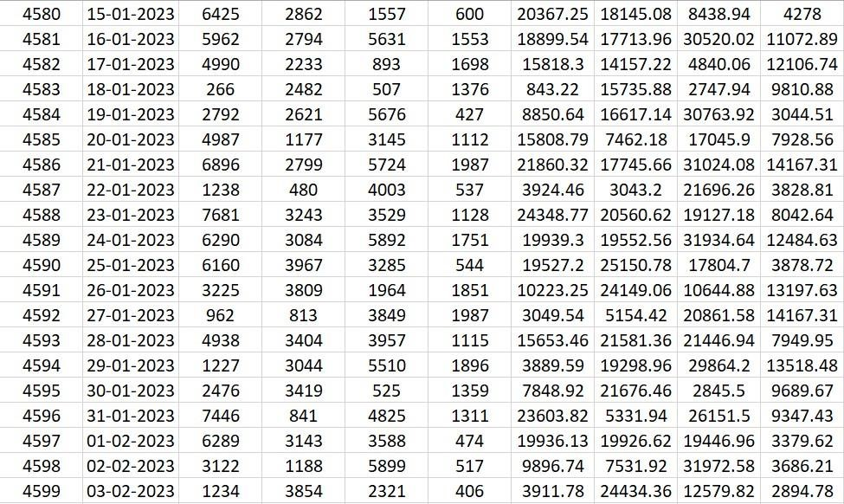

**NECESSARY STEP TO FOLLOW**

IBM Cognos Visualization primarily relies on its native features and integration capabilities for product sales analysis. However, to enhance your product sales analysis using IBM Cognos Visualization, you may want to consider integrating it with other tools and libraries for data preparation and data source connectivity.

* **IBM Cognos Analytics:**

This is the primary platform for creating reports and dashboards using IBM Cognos

Visualization. It provides a wide range of data connectors and data modelling capabilities.

* **IBM Data Warehouse or DataMart:**

Ensure that your sales data is well-organized in a data warehouse or Datamart, making it easier to access and analyse in IBM Cognos.

* **ETL (Extract, Transform, Load) Tools:**

Consider using ETL tools like IBM DataStage or open-source alternatives like Talend or Apache Nefi to extract, clean, and transform data from various sources into a format compatible with IBM Cognos.

* **Exploratory data analysis:**

Exploratory data analysis (EDA) is a critical step in understanding your product sales data before using IBM Cognos for visualization. Here's a general process:

* **Data Collection:**

Gather product sales data from various sources and ensure it's in a structured format.

* **Data Cleaning:**

Remove duplicates, handle missing values, and standardize data types prepare for analysis.

* **Total unit sales Product 1, Product 2, Product 3, Product 4** q = df[["Q-P1","Q-P2","Q-P3","Q-P4"]].sum()print(q)plt.figure(figsize=(8,8))

plt.pie(q,labels=df[["Q-P1","Q-P2","Q-P3","Q-

P4"]].sum().index,shadow=True,autopct="%0.01f%%",textprops={"fontsize":20},we dgeprops={'width': 0.8},explode=[0,0,0,0.3])plt.legend(loc='center right', bbox_to_anchor=(1.2, 0.8));

Extract year from the 'Day' 'Month' 'year' from the 'Date' column using a lambda function. We need to get the year from the data to analyse sales year to yeardata['Day'] = data['Date'].apply(lambda x: x.split('-')[0])data['Month'] = data['Date'].apply(lambda x: x.split('-')[1])data['Year'] = data['Date'].apply(lambda x: x.split('-')[2])

* **SQL and Database Libraries:**

If you're dealing with large datasets, you may need to leverage SQL and database libraries to optimize your queries. IBM Db2 or open-source databases like PostgreSQL are commonly used.

* **Python or R for Data Analysis:**

For advanced analytics, you can use Python with libraries like Pandas, NumPy, or R with libraries like ggplot2 to preprocess and analyse data before visualizing it in IBM Cognos.

* **Data Visualization Libraries:**

While IBM Cognos Visualization is robust, you can complement it with other data visualization libraries like D3.js or Plotly for creating custom visualizations or interactive charts.

**IMPORTANCE OF LOADING AND PREPROCESSING**

Loading and preprocessing are crucial steps in product sales analysis using IBM Cognos Visualization for several reasons:

* **Data Integrity:**

Loading and preprocessing ensure that the data used for analysis is accurate and complete. Any inconsistencies or errors in the data can lead to incorrect insights and decisions.

* **Performance Optimization:**

Proper preprocessing can help optimize data for faster querying and reporting. This is particularly important for large datasets, as it reduces the time required for analysis.

* **Data Transformation:**

Preprocessing allows you to transform raw data into a format that is suitable for analysis. This includes cleaning, aggregating, and structuring the data in a way that aligns with your specific analysis goals.

* **Data Integration:**

Loading and preprocessing enable you to integrate data from multiple sources, such as sales data, customer data, and product data. This integration can provide a more holistic view of your business, helping you identify correlations and trends.

* **Data Security:**

Proper loading and preprocessing can help ensure that sensitive information is handled securely, complying with data privacy regulations and company policies.

* **User Experience:**

Well-pre-processed data results in a smoother and more user-friendly experience for analysts and decision-makers using IBM Cognos Visualization. They can create dashboards and reports with confidence in the data's accuracy.

In summary, loading and preprocessing are fundamental steps in product sales analysis using IBM Cognos Visualization. They set the stage for accurate, efficient, and insightful data analysis, which, in turn, supports data-driven decision-making within an organization.

**CHALLENGES INVOLVED IN LOADING AND PREPROCESSING A PRODUCT SALES ANALYSIS**

Overcoming challenges in loading and preprocessing for product sales analysis in IBM Cognos Visualization requires careful planning and execution. Here are some strategies to address common challenges:

* **Data quality assurance:**

Invest in data quality tools and processes to identify and rectify errors in the source data. Establish data governance policies to ensure data accuracy and consistency**.**

* **Data Integration:**

Use ETL (Extract, Transform, Load) tools to consolidate and integrate data from multiple sources. Ensure proper mapping and transformation of data to match the required format.

**HOW TO OVERCOME THE CHALLENGES OF LOADING AND PREPROCESSING A PRODUCT SALES ANALYSIS**

* **Monitoring and Error Handling:**

Set up monitoring systems to detect data loading and preprocessing failures. Establish error-handling processes to address issues promptly.

* **Training and Skill Development:**

Invest in training for data professionals to ensure they are proficient in IBM Cognos and data processing techniques. Stay updated on best practices and new features in Cognos.

* **Performance Tuning:**

Continuously monitor and analyse performance metrics to identify bottlenecks and make necessary adjustments to the loading and preprocessing workflows.

**LOADING A DATASET IN IBM COGNOS FOR PRODUCT SALES**

**ANALYSIS INVOLVES SEVERAL STEPS. HERE'S A HIGH-LEVEL OVERVIEW OF THE PROCESS**

* **Data Source Connection:**

Open IBM Cognos.Connect to your data source, which can be a database, spreadsheet, or other data storage. You can use data modules, data servers, or direct connections, depending on your source.

* **Import Data:**

Once connected, select the option to import your dataset. Choose the dataset that contains your product sales data. This can be a table from a database or a file like Excel.

* **Data Transformation:**

Depending on your dataset, you may need to transform and clean the data. This might include data type conversions, filtering, and handling missing values.

* **Create Data Source:**

After importing and transforming the data, create a data source in Cognos. This data source will serve as the foundation for your analysis.

* **Data Modelling:**

Define relationships between the tables, create calculations, and customize your data source to suit your analysis requirements.

**Program:**

<chart>

<options>

<chartSize autoScaling="yes"/>

</options>

<type>Bar</type>

<data>

<crosstab>

<data>

<value name="Product" expr="[Product].[Product Name]"/>

<value name="Sales" expr="total([Sales])"/>

</data>

</crosstab>

</data> </chart> import numpy as np # linear algebra import pandas as pd # data processing, CSV file I/O (e.g. pd.read_csv) Input data files are available in the read-only "../input/" directory import os for dirname, _, filenames in os.walk('/kaggle/input'): for filename in filenames:

print(os.path.join(dirname, filename))

**LOADING DATASET**

**Program:**

df=pd.read_csv("/kaggle/input/product-sales-data/statsfinal.csv")

df.head(5)

**Output:**





**PREPROCESSING THE DATASET**

Preprocessing a dataset for product sales analysis in IBM Cognos Visualization involves several steps. Here's a general outline of the process:

* **Data Collection:**

Gather your sales data from various sources, such as databases, spreadsheets, or APIs.

* **Data Cleaning:**

Clean the data to remove any inconsistencies, missing values, or outliers. This ensures that your analysis is based on high-quality data.

* **Data Transformation:**

Depending on your analysis goals, you might need to transform the data. For example, you can aggregate daily sales data into monthly or yearly totals.

**VISUALIZATION AND PREPROCESSINGOF DATA**

**Program:**

def plot_bar_chart(df, columns, stri, str1, val): if val == 'sum':

sales_by_year = df.groupby('Year')[columns].sum().reset_index() elif val == 'mean':

sales_by_year = df.groupby('Year')[columns].mean().reset_index()

sales_by_year_melted = pd.melt(sales_by_year, id_vars='Year', value_vars=columns, va r_name='Product', value_name='Sales')

plt.figure(figsize=(20,4)) s

ns.barplot(data=sales_by_year_melted, x='Year', y='Sales', hue='Product')

**Output:**

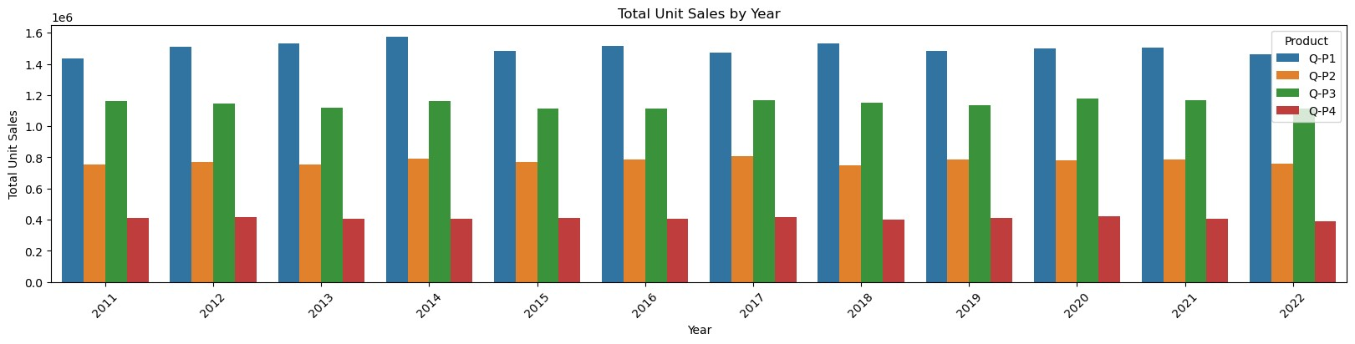

**Program:**

tte="cividis")

plt.xlabel('Year') plt.ylabel(stri) plt.title(f'**{**stri**}** by **{**str1**}**') plt.xticks(rotation=45) plt.show()

plot_bar_chart(data_reduced, ['Q-P1', 'Q-P2', 'Q-P3', 'Q-P4'],'Total Unit Sales', 'Year', 'sum') plot_bar_chart(data_reduced, ['Q-P1', 'Q-P2', 'Q-P3', 'Q-P4'],'Mean Unit Sales', 'Year', 'mean')

**Output:**

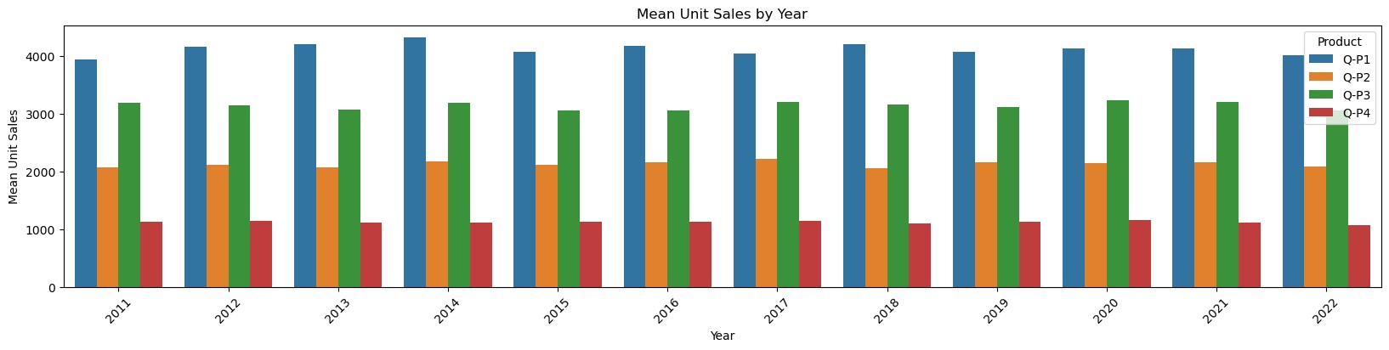

**Program:** def month_plot():

fig, ax = plt.subplots()

data_reduced.groupby('Month')[['Q-P1', 'Q-P2', 'Q-P3', 'Q-P4']].sum().plot(ax=ax) ax.set_xlim(left=0, right=13) ax.set_xlabel('Month') ax.set_ylabel('Total unit sales') ax.set_title('Trend in sales of all four products by month')

plt.show()

month_plot()

**Output:**

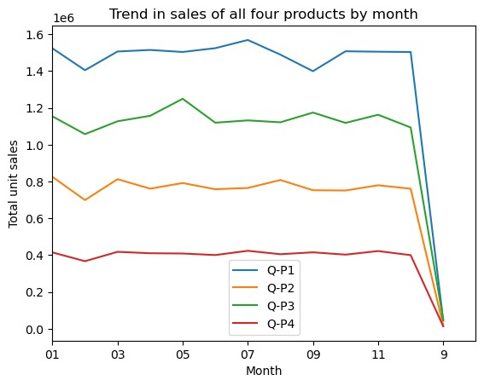

**Program:**

data_reduced['Month'] = data['Month'].replace('9', '09')month_plot()

**Output:**

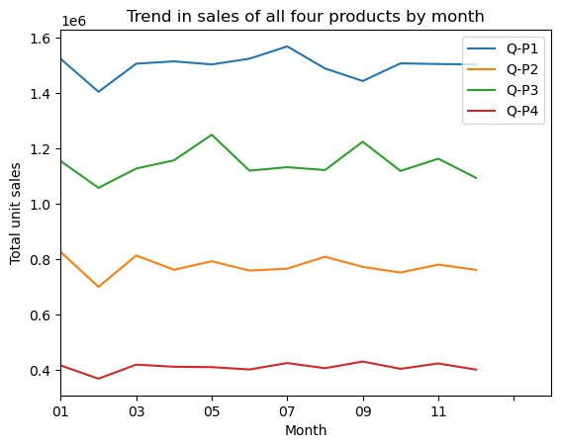

**VISUALIZATION CORRELATION**

**Program:**

plt.figure(figsize=(10,10)) sns.heatmap(df.corr(),annot=True)

**Output:**

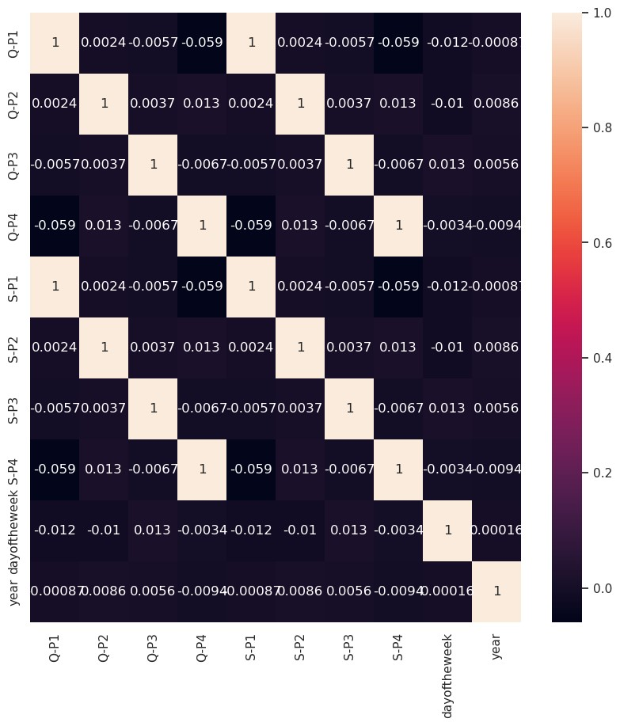

**Program:**

def avg_on_31st(df, product): df_31 = df[df['Day'] == '31'] avg_sales = df_31[product].mean() return avg_sales

avg_on_31st(data_reduced, ['Q-P1', 'Q-P2', 'Q-P3', 'Q-P4']).round(2) avg_on_31st(data_reduced, ['S-P1', 'S-P2', 'S-P3', 'S-P4']).round(2)

**Output:**

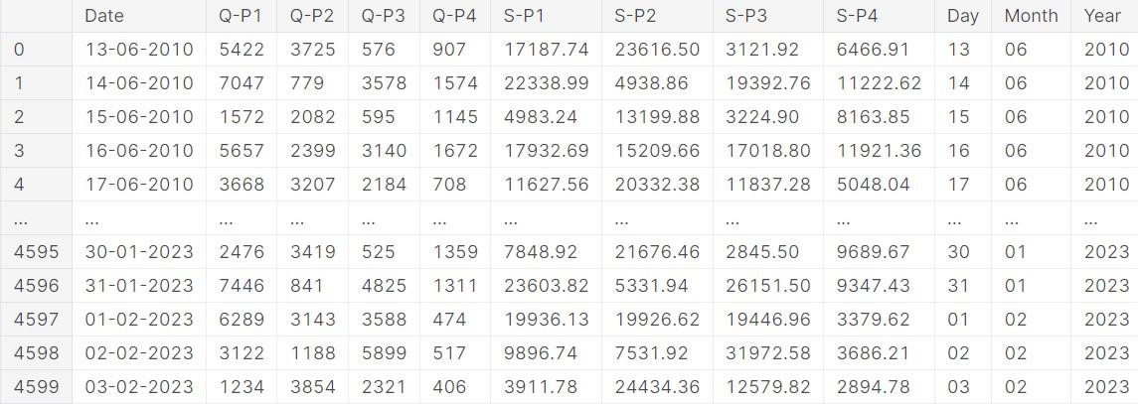

**AVERAGE FOR UNIT SALES**

**Output:**

Q-P1 3813.74

Q-P2 2058.80

Q-P3 3183.88 Q-P4 1098.61 dtype: float64

# AVERAGE FOR REVENUE

**Output:**

S-P1 12089.55

S-P2 13052.78

S-P3 17256.63 S-P4 7833.07

dtype: float64

# CONCLUSION

Analyzing product sales data using IBM Cognos visualization has provided valuable insights into our business performance. The visualizations have enabled us to make data-driven decisions and identify key trends and opportunities. In conclusion, this tool has been instrumental in improving our sales strategies, optimizing inventory management, and enhancing overall business efficiency. We will continue to leverage IBM Cognos visualization to drive growth and success in our organization. A product sales analysis can provide a comprehensive view of a product's performance in the market, helping you make data-driven decisions to optimize sales, marketing, and product development strategies. It's important to regularly conduct such analyses to adapt to changing market conditions and customer preferences.