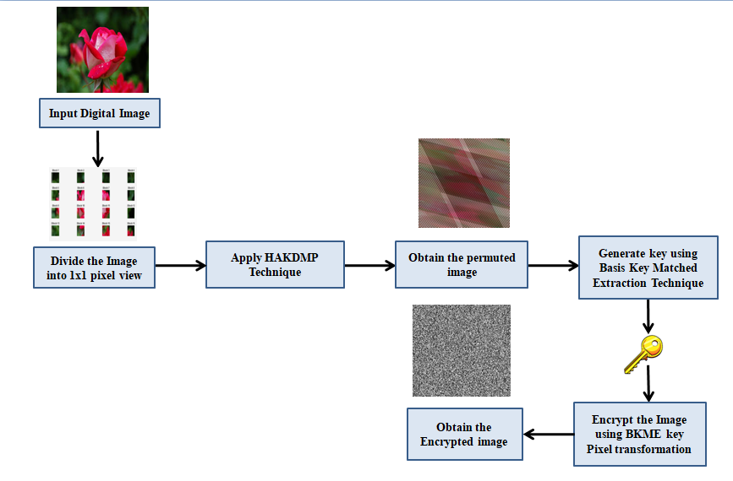
Fig 1. Block Diagram of HAKDMP and BMKE Technique
Fig 1. Explains overall working principle of the newly introduced methodology where an input image is taken and divided into blocks [29] to apply HAKDM permutation on each block to obtain a permuted image as output. Second phase works by applying BMKE encryption to the permuted result of previous process. This results in the image that appears completely encrypted. BMKE phase involves quantum inspired key generation to encrypt the image data. Since the proposed methodology applies confusion, diffusion and quantum inspired key generation it shows high resistance against various types of attacks on the digital image data.
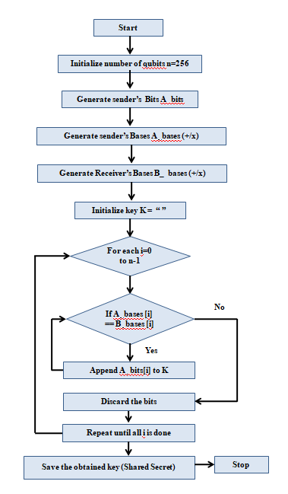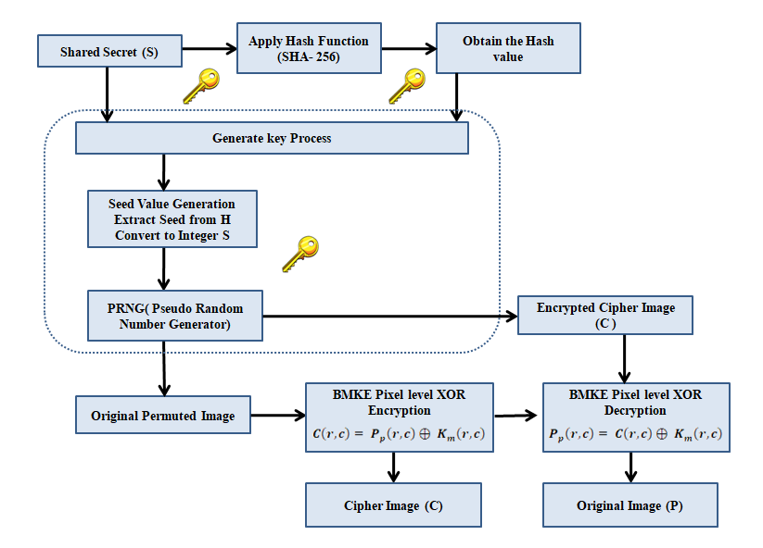
Fig 2: Architecture of BMKE Key Generation and Encryption
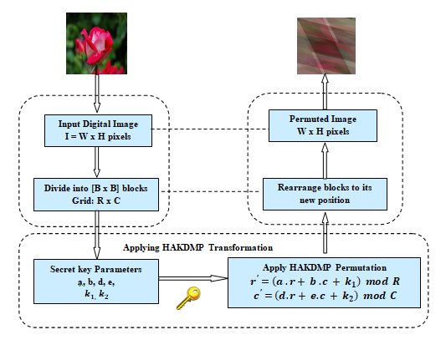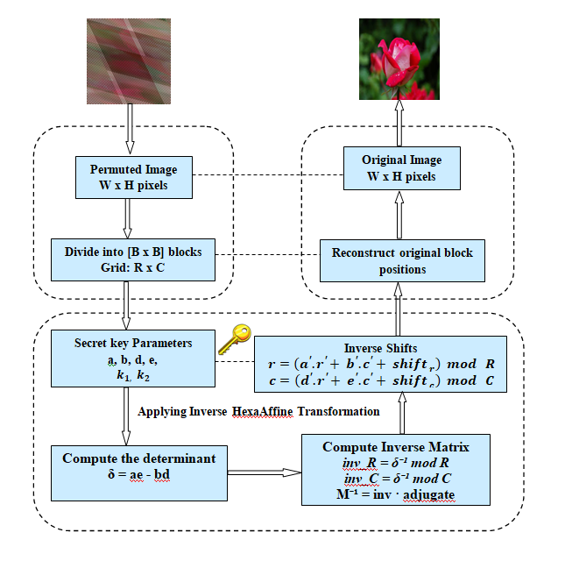
Fig 3: HAKDMP Permutation and Restoration Process
Fig3.Represent the flowchart of HAKDMP shuffling and restoration process with a sample image data. The encryption process produces a completely shuffled image data. The reverse process will produce the initial image back taken and proves that the proposed methodology is completely a reversible process.
Fig 5. Demonstrates the entropy graph of image those are plain as well as encrypted. This graph makes it evident that pixels are inconsistently distributed in real image and evenly distributed in encipher image. Even pixel distribution is a sign of high resistivity against statistic attacks [23] [24]
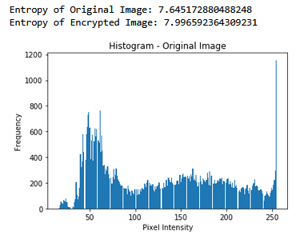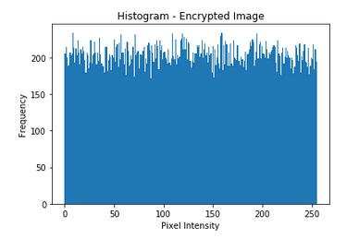
Fig 5. Original and Encrypted Image Entropy

Visual Analysis
Analysis of image visuals are taken to show that implemented technique works effectively [5]. Fig6. Displays the comparative view of original, pixel permuted and encrypted images using MATLAB. Theencrypted images appear completely in a noise pattern which indicates that the BMKE encryption framework removes the spatial patterns within image along with reduction in pixel correlation among neighbours as well. Decrypted image exactly matches the original one, thus proves the reversibility process.
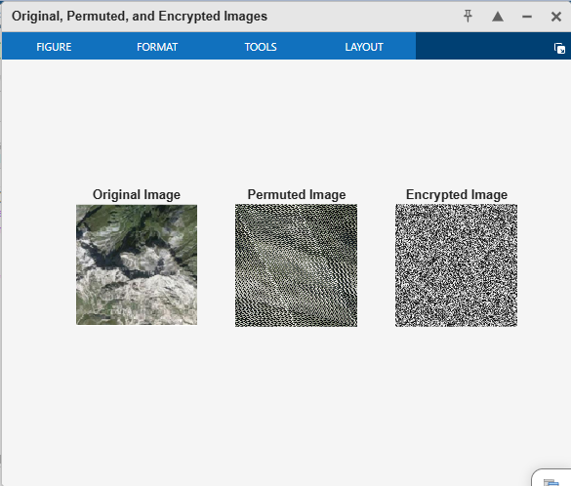
Fig 6. Original, Permuted and Encrypted Image- Visual Analysis

Histogram View
Image histograms are generated to understand image intensity [15] and how the pixels are distributed [11][14][28] [30]. Fig’s. 7, 8, 9, 10, 11, 12, 13, 14, 15 reveals the histogram results obtained in various phases of the implemented framework. Histograms are computed separately for red, green and blue channels. The results show high and partial concentration for source and scrambled image. Uniform distribution of intensity in each pixel is observed for encrypted image. These observations show intense resistance of the proposed methodology to statistical attacks.
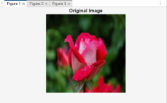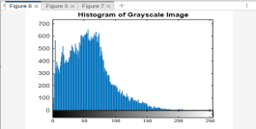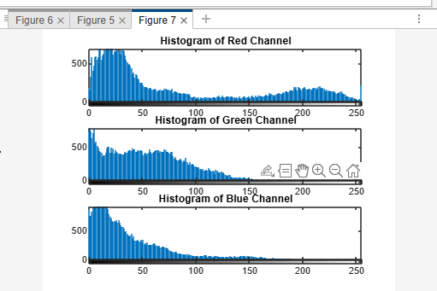
Fig 7. Original Image(OI) Fig 8.Histogram of OI Fig 9. RGB Histogram
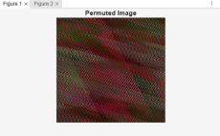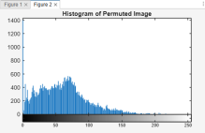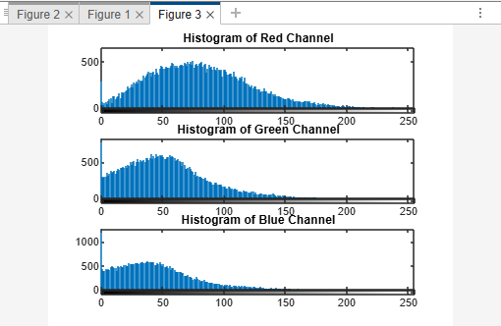
Fig 10.Permuted Image (PI) Fig 11.Histogram of PI Fig 12. RGB Histogram
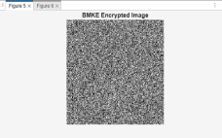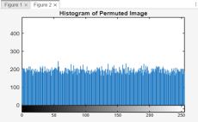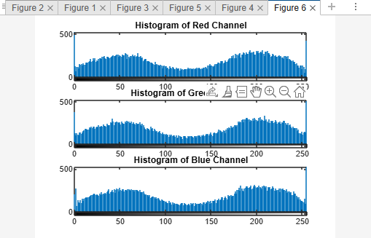
Fig 13. Encrypted Image (EI) Fig 14. Histogram of EI Fig 15: RGB Histogram

5.3 Correlation Plot
Existence of similarity degree within the image pixels are referred using Correlation plots [24][27]. In Fig’s 16, 17, 18, 19, 20, 21, 22, 23, 24 pictorial representations of vertical and diagonal correlation for original, permuted & encrypted image are laid [13][24][26] [30]. Generally, in a correlation plot, the points aligned in an increasing order along a linear line shows that there exists a powerful correlation [27]. Similarly, scatter points in the plot shows that the pixels in the image exhibits low correlation. The correlations plots generated have proven that the encrypted image has lost its entire visible pattern which is a strong sign of security. Correlation visuals generated makes it evident that extracting any details by using the image is tough.

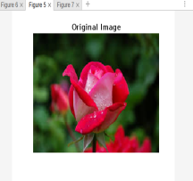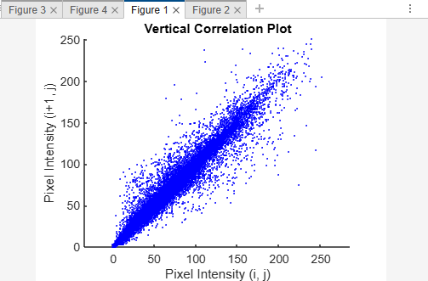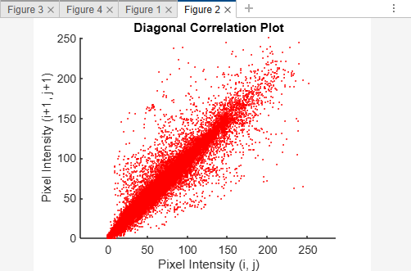
Fig 16.Original Image Fig 17.Vertical Correlation Fig 18.Horizontal Correlation
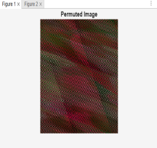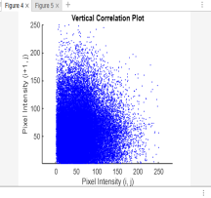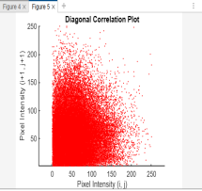
Fig 19.Permuted Image Fig 20.Vertical Correlation Fig 21.Diagonal Correlation

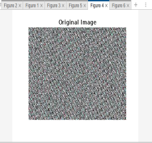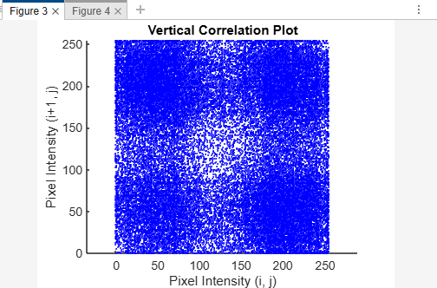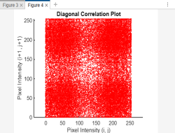
Fig 22.Permuted Image Fig 23.Vertical Correlation Fig 24. Diagonal Correlation

Entropy Analysis
Fig 25.Presentsthe entropy value of original and encrypted digital image with the help of chart. The chart reveals that the encrypted image's value approaches 7.996, which is extremely near to the optimal value of 8[27]for 8-bit grayscale images, indicating high randomness.
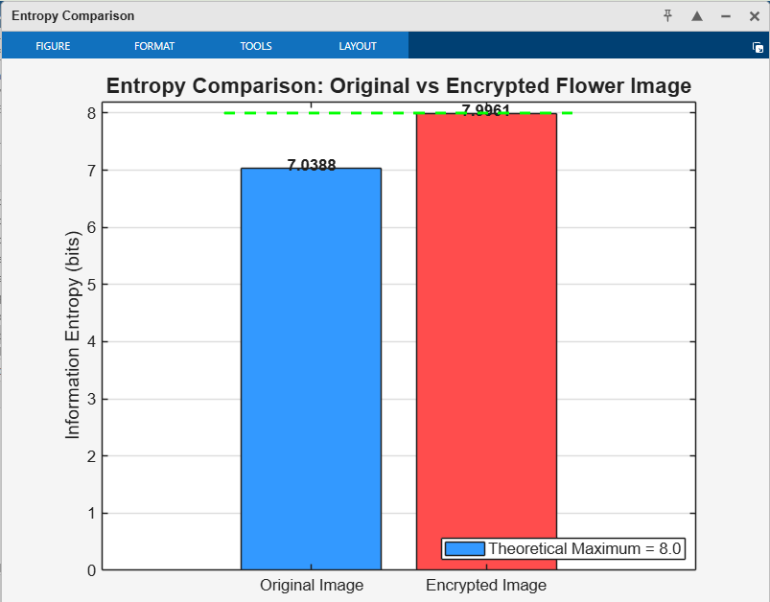
Fig 25. Entropy Chart
5.5 Bit Distribution Analysis.
Bit distribution analysis is done to check whether the binary digits in the image are uniformly distributed. A good image encryption mechanism should randomly distribute the bits in the image. Fig 24: Depicts the bit distribution analysis of the encrypted image. Here the total count of 1’s & 0’s are approximately equal which proves that the proposed mechanism provides great randomness in the image data and shows its resistance against the statistical attacks. The result of the encrypted image data shows 50% of zeros and 50% ones in the result. This is a good indication of strong shuffling in the introduced method.
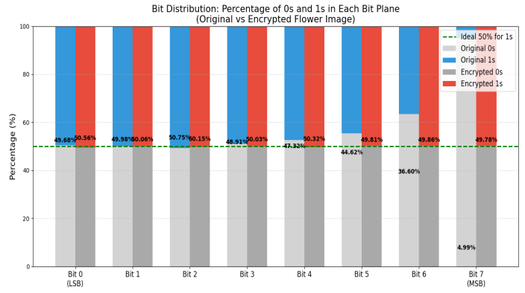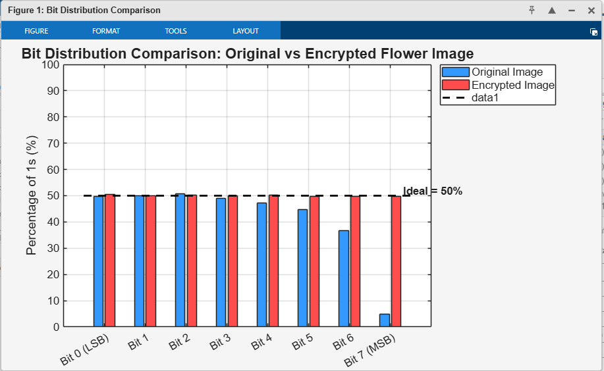
Fig 24: Bit Distribution Analysis

