**SMART PARKING**

**Objectives:**

The objective of a smart water system project is to monitor and manage water resources efficiently using IoT technology. Key goals typically include real-time data collection, analysis, and user-friendly control through a mobile app. This project aims to improve water conservation, quality, and distribution.

**IoT Sensor Setup:**

* Water Quality Sensors: Deploy sensors to monitor various water quality parameters, such as pH levels, turbidity, and chemical contaminants.
* Water Flow Sensors: Install flow meters to measure water consumption, detect leaks, and control water distribution.
* Water Level Sensors: Use ultrasonic or pressure sensors to measure water levels in reservoirs, tanks, or rivers.
* Temperature Sensors: Monitor water temperature for various applications, such as heating and cooling systems or environmental studied.
* Humidity Sensors: Measure humidity levels to prevent water damage or mold growth in sensitive areas.
* Pressure Sensors: Install pressure sensors in pipes to monitor water pressure and detect anomalies.

**Mobile App Development:**

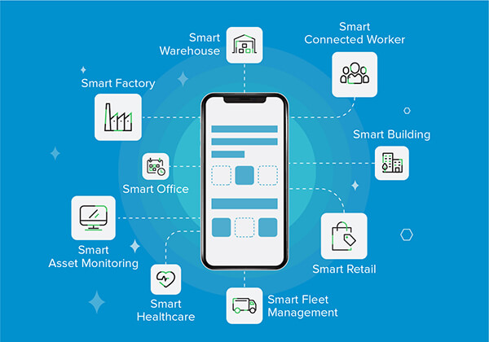

To Develop a user-friendly mobile application to provide users with real-time access to data and control over the smart water system. Key features may include:

* Data Visualization: Display real-time data from sensors in an easy-to-understand format, including charts and graphs.
* Alerts and Notifications: Send notifications for critical events like leaks, low water levels, or poor water quality
* Remote Control: Allow users to remotely control water systems, such as turning pumps on/off or adjusting temperature settings.
* Historical Data: Store and present historical data for analysis and decision-making.
* User Management: Implement user accounts, access controls, and permissions to manage who can control and access the system.

**Raspberry Pi Integration:**

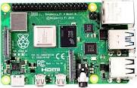

**Raspberry pi**

Use Raspberry Pi as a central hub to collect data from IoT sensors and communicate with the mobile app. Raspberry Pi can be connected to the sensors via GPIO pins or other interfaces. Additionally, it may be used for data processing and storage. You can also employ the MQTT protocol to facilitate communication between the Raspberry Pi and the IoT devices.

**Code Implementation:**

Here's a simplified overview of code implementation for a smart water system:

* Sensor Data Collection: Write code to interface with each sensor and collect data. This may involve libraries and APIs provided by sensor manufacturers.
* Data Processing: Use Python or other suitable languages to process and normalize sensor data.
* MQTT Integration: Set up an MQTT broker on the Raspberry Pi, and write code to publish sensor data to MQTT topics.
* Mobile App Development: Develop a mobile app (iOS and Android) using appropriate frameworks (e.g., React Native or Flutter) with MQTT support to subscribe to sensor data.
* User Interface: Design and implement the app's user interface to display real-time data and provide control options.
* Alerts and Notifications: Add code to send push notifications to the mobile app based on sensor readings and system events.
* Database Integration: Store historical data in a database (e.g., SQLite or PostgreSQL) for analysis and reporting.

Security: Implement authentication and authorization for user access and data encryption for secure communication.

* Testing and Deployment: Thoroughly test the system, both the hardware and software components. Once tested, deploy the system in the target environment.

Monitoring and Maintenance: Set up remote monitoring capabilities for the Raspberry Pi and sensors, and establish a maintenance plan for long-term operation.

**Flow chart:**

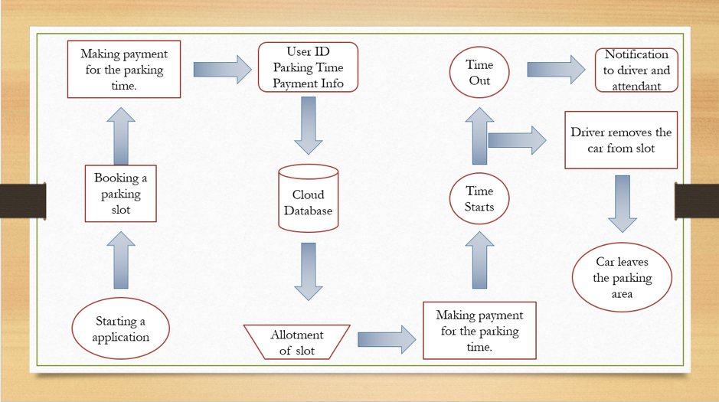

**A real-time parking availability system is a technology-driven solution that provides up-to-the-minute information about parking spaces in a given area. This system can benefit drivers and alleviate parking issues in several ways**

**Time and Fuel Savings:**

By knowing where available parking spaces are located in real time, drivers can avoid aimlessly circling around looking for parking. This reduces the time spent searching for a spot and minimizes fuel consumption and emissions, contributing to environmental sustainability.

**Reduced Traffic Congestion:**

As drivers spend less time searching for parking, it can reduce traffic congestion and alleviate one of the major contributors to urban traffic jams, which is cars looking for parking spots. Less congestion leads to quicker commutes and a reduction in overall travel time.

**Lower Stress Levels:**

Parking can be a major source of stress for drivers, particularly in busy urban areas. Real-time parking availability information can help alleviate this stress, making the overall driving experience more pleasant.

**Improved Air Quality:**

Reduced time spent searching for parking and reduced traffic congestion can contribute to improved air quality in urban areas. Fewer vehicles on the road means less pollution, which can benefit both public health and the environment.

**Increased Revenue for Local Businesses:**

When drivers can easily find parking, they are more likely to visit local businesses and spend money, which can boost the local economy. This is particularly important for small businesses that rely on foot traffic.

**Efficient Space Utilization:**

Real-time parking availability systems can help cities and parking facility operators better utilize their parking spaces. They can analyze data to determine peak usage times, optimize pricing strategies, and even identify areas with consistently high demand for parking.

**Enhanced Accessibility:**

For individuals with disabilities or special parking needs, real-time availability information is especially valuable. They can find accessible parking spots with ease, improving their overall mobility and accessibility to various locations.

**Sustainability:**

By encouraging efficient use of parking spaces and reducing the need for additional parking infrastructure, real-time parking availability systems can contribute to sustainable urban planning by promoting public transportation, cycling, and walking as alternative modes of transportation.

**Data Insights:**

The data collected by these systems can be used by city planners and transportation authorities to make informed decisions about parking policies, infrastructure investments, and traffic management. This data can help improve overall urban mobility and planning.

**Smart City Integration:** Real-time parking availability systems can be integrated into broader smart city initiatives, allowing for seamless connections between parking, traffic management, public transportation, and other urban services.

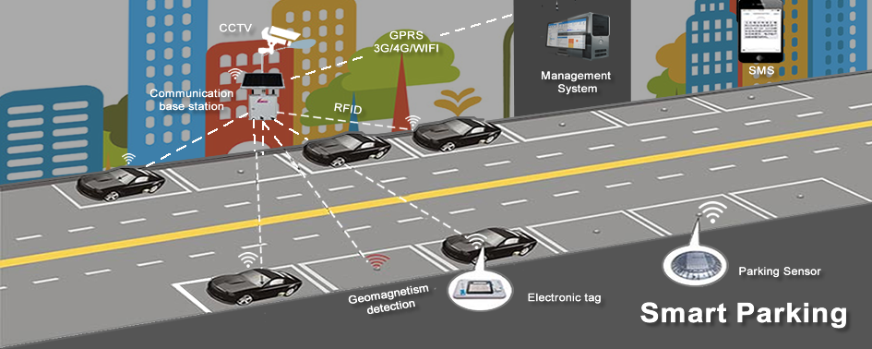

**Programme:**

import random

import time

# Simulated parking spaces

parking_spaces = [False, False]

def check_parking_availability():

# Simulate parking space availability (in a real system, this data would come from sensors)

parking_spaces[0] = random.choice([True, False])

parking_spaces[1] = random.choice([True, False])

def display_parking_status():

print("Parking Space 1:", "Occupied" if parking_spaces[0] else "Available")

print("Parking Space 2:", "Occupied" if parking_spaces[1] else "Available")

def main():

while True:

check_parking_availability()

display_parking_status()

time.sleep(5) # Simulate checking parking availability every 5 seconds

if __name__ == "__main__":

main()

**Conclusion:**

A real-time parking availability system offers a multitude of benefits, including reduced congestion, lower stress, and enhanced sustainability. By helping drivers quickly locate available parking spaces, these systems play a crucial role in improving the overall urban transportation experience while supporting more efficient and sustainable city planning.