Cardiology_Database_Management
Database Design & SQL Query Project
Prepared by Narmaja Medarametla
Theme
A cardiology clinic wants to maintain patient and doctor details, schedule appointments, record diagnostic tests, and keep prescriptions with the medicines prescribed, so that patient care, test costs and doctor workload can be analysed from one database (cardiology_db, MySQL InnoDB).
Modules
- Patients – patient name, age, gender, phone and city
- Doctors – doctor name, specialization, experience and phone
- Appointments – date, time and status of each patient–doctor visit
- Medical Tests – test name, date, result and cost for each patient
- Prescriptions – prescription date and notes written by a doctor for a patient
- Medicines – medicine catalogue with manufacturer and price
- Prescription Items – medicines, dosage, duration and quantity in each prescription
ER Diagram
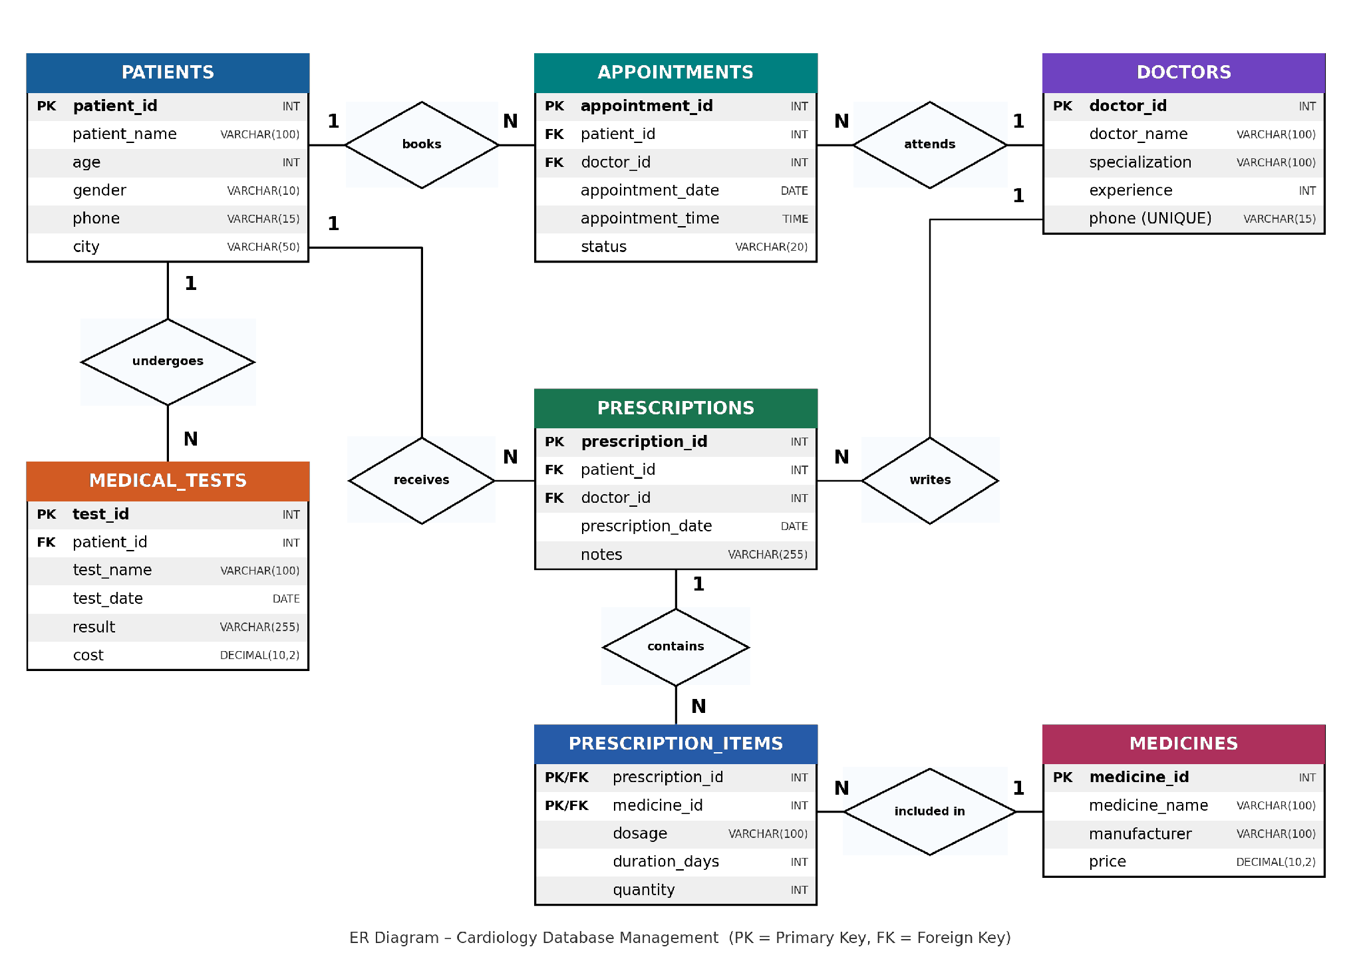
Relationships
- Patients → Appointments: One patient can have many appointments (1 : N).
- Doctors → Appointments: One doctor can have many appointments (1 : N).
- Patients → Medical Tests: One patient can undergo many tests (1 : N).
- Patients → Prescriptions: One patient can receive many prescriptions (1 : N).
- Doctors → Prescriptions: One doctor can write many prescriptions (1 : N).
- Prescriptions → Prescription Items: One prescription can contain many items (1 : N).
- Medicines → Prescription Items: One medicine can appear in many items (1 : N).
Prescription Items is the bridge table that makes Prescriptions and Medicines a many-to-many relationship. Its primary key is the pair (prescription_id, medicine_id).
Table Structure
PATIENTS
Column | Data Type | Key
patient_id | INT | Primary Key
patient_name | VARCHAR(100) | NOT NULL
age | INT
gender | VARCHAR(10)
phone | VARCHAR(15)
city | VARCHAR(50)
DOCTORS
Column | Data Type | Key
doctor_id | INT | Primary Key
doctor_name | VARCHAR(100) | NOT NULL
specialization | VARCHAR(100)
experience | INT | Years of experience
phone | VARCHAR(15) | Unique
APPOINTMENTS
Column | Data Type | Key
appointment_id | INT | Primary Key
patient_id | INT | Foreign Key → patients
doctor_id | INT | Foreign Key → doctors
appointment_date | DATE | NOT NULL
appointment_time | TIME
status | VARCHAR(20) | Default 'Scheduled'
MEDICAL_TESTS
Column | Data Type | Key
test_id | INT | Primary Key
patient_id | INT | Foreign Key → patients
test_name | VARCHAR(100) | NOT NULL
test_date | DATE
result | VARCHAR(255)
cost | DECIMAL(10,2)
PRESCRIPTIONS
Column | Data Type | Key
prescription_id | INT | Primary Key
patient_id | INT | Foreign Key → patients
doctor_id | INT | Foreign Key → doctors
prescription_date | DATE | NOT NULL
notes | VARCHAR(255)
MEDICINES
Column | Data Type | Key
medicine_id | INT | Primary Key
medicine_name | VARCHAR(100) | NOT NULL
manufacturer | VARCHAR(100)
price | DECIMAL(10,2)
PRESCRIPTION_ITEMS
Column | Data Type | Key
prescription_id | INT | Primary Key (part 1), Foreign Key → prescriptions
medicine_id | INT | Primary Key (part 2), Foreign Key → medicines
dosage | VARCHAR(100)
duration_days | INT
quantity | INT
Sample Data
PATIENTS
patient_id | patient_name | age | gender | phone | city
1 | Rahul Kumar | 45 | Male | 9876501001 | Srikakulam
2 | Priya Sharma | 38 | Female | 9876501002 | Visakhapatnam
3 | Arjun Reddy | 55 | Male | 9876501003 | Vijayawada
4 | Sneha Rao | 42 | Female | 9876501004 | Hyderabad
5 | Kiran Kumar | 60 | Male | 9876501005 | Srikakulam
DOCTORS
doctor_id | doctor_name | specialization | experience | phone
1 | Dr. Suresh Reddy | Cardiologist | 15 | 9888001001
2 | Dr. Anitha Rao | Interventional Cardiologist | 12 | 9888001002
3 | Dr. Rajesh Kumar | Cardiac Surgeon | 18 | 9888001003
4 | Dr. Lakshmi Devi | Cardiologist | 10 | 9888001004
APPOINTMENTS
appointment_id | patient_id | doctor_id | appointment_date | appointment_time | status
1 | 1 | 1 | 2026-11-02 | 09:30:00 | Scheduled
2 | 2 | 2 | 2026-11-02 | 10:00:00 | Scheduled
3 | 3 | 3 | 2026-11-03 | 11:00:00 | Scheduled
4 | 4 | 1 | 2026-11-04 | 12:00:00 | Scheduled
5 | 5 | 4 | 2026-11-05 | 09:00:00 | Scheduled
MEDICAL_TESTS
test_id | patient_id | test_name | test_date | result | cost
1 | 1 | ECG | 2026-10-20 | Normal rhythm | 500.00
2 | 2 | Echocardiogram | 2026-10-21 | Requires doctor review | 2500.00
3 | 3 | Lipid Profile | 2026-10-22 | Cholesterol elevated | 800.00
4 | 4 | Stress Test | 2026-10-23 | Requires doctor review | 1800.00
5 | 5 | ECG | 2026-10-24 | Requires doctor review | 500.00
PRESCRIPTIONS
prescription_id | patient_id | doctor_id | prescription_date | notes
1 | 1 | 1 | 2026-10-20 | Sample prescription; follow the treating doctor advice
2 | 2 | 2 | 2026-10-21 | Sample prescription; follow the treating doctor advice
3 | 3 | 3 | 2026-10-22 | Sample prescription; follow the treating doctor advice
4 | 4 | 1 | 2026-10-23 | Sample prescription; follow the treating doctor advice
5 | 5 | 4 | 2026-10-24 | Sample prescription; follow the treating doctor advice
MEDICINES
medicine_id | medicine_name | manufacturer | price
1 | Aspirin | Sample Pharma A | 50.00
2 | Atorvastatin | Sample Pharma B | 120.00
3 | Metoprolol | Sample Pharma C | 90.00
4 | Amlodipine | Sample Pharma D | 75.00
5 | Clopidogrel | Sample Pharma E | 110.00
PRESCRIPTION_ITEMS
prescription_id | medicine_id | dosage | duration_days | quantity
1 | 1 | As entered by the treating doctor | 5 | 5
1 | 2 | As entered by the treating doctor | 30 | 30
2 | 3 | As entered by the treating doctor | 7 | 14
3 | 4 | As entered by the treating doctor | 10 | 10
4 | 5 | As entered by the treating doctor | 15 | 15
5 | 2 | As entered by the treating doctor | 30 | 30
All dosage and result values are placeholder sample data for learning purposes.
Queries
1. Display All Patients
SELECT * FROM patients;
Output
patient_id | patient_name | age | gender | phone | city
1 | Rahul Kumar | 45 | Male | 9876501001 | Srikakulam
2 | Priya Sharma | 38 | Female | 9876501002 | Visakhapatnam
3 | Arjun Reddy | 55 | Male | 9876501003 | Vijayawada
4 | Sneha Rao | 42 | Female | 9876501004 | Hyderabad
5 | Kiran Kumar | 60 | Male | 9876501005 | Srikakulam
2. Display All Doctors
SELECT * FROM doctors;
Output
doctor_id | doctor_name | specialization | experience | phone
1 | Dr. Suresh Reddy | Cardiologist | 15 | 9888001001
2 | Dr. Anitha Rao | Interventional Cardiologist | 12 | 9888001002
3 | Dr. Rajesh Kumar | Cardiac Surgeon | 18 | 9888001003
4 | Dr. Lakshmi Devi | Cardiologist | 10 | 9888001004
3. Display Appointments with Patient and Doctor Names
SELECT a.appointment_id,
p.patient_name,
d.doctor_name,
a.appointment_date,
a.appointment_time,
a.status
FROM appointments AS a
JOIN patients AS p ON a.patient_id = p.patient_id
JOIN doctors AS d ON a.doctor_id = d.doctor_id
ORDER BY a.appointment_date, a.appointment_time;
Output
appointment_id | patient_name | doctor_name | appointment_date | appointment_time | status
1 | Rahul Kumar | Dr. Suresh Reddy | 2026-11-02 | 09:30:00 | Scheduled
2 | Priya Sharma | Dr. Anitha Rao | 2026-11-02 | 10:00:00 | Scheduled
3 | Arjun Reddy | Dr. Rajesh Kumar | 2026-11-03 | 11:00:00 | Scheduled
4 | Sneha Rao | Dr. Suresh Reddy | 2026-11-04 | 12:00:00 | Scheduled
5 | Kiran Kumar | Dr. Lakshmi Devi | 2026-11-05 | 09:00:00 | Scheduled
4. Display Medical Test Details with Patient Names
SELECT p.patient_name,
mt.test_name,
mt.test_date,
mt.result,
mt.cost
FROM medical_tests AS mt
JOIN patients AS p ON mt.patient_id = p.patient_id
ORDER BY mt.test_date;
Output
patient_name | test_name | test_date | result | cost
Rahul Kumar | ECG | 2026-10-20 | Normal rhythm | 500.00
Priya Sharma | Echocardiogram | 2026-10-21 | Requires doctor review | 2500.00
Arjun Reddy | Lipid Profile | 2026-10-22 | Cholesterol elevated | 800.00
Sneha Rao | Stress Test | 2026-10-23 | Requires doctor review | 1800.00
Kiran Kumar | ECG | 2026-10-24 | Requires doctor review | 500.00
5. Display Prescription and Medicine Details
SELECT p.patient_name,
d.doctor_name,
pr.prescription_date,
m.medicine_name,
pi.dosage,
pi.duration_days,
pi.quantity,
m.price
FROM prescription_items AS pi
JOIN prescriptions AS pr ON pi.prescription_id = pr.prescription_id
JOIN patients AS p ON pr.patient_id = p.patient_id
JOIN doctors AS d ON pr.doctor_id = d.doctor_id
JOIN medicines AS m ON pi.medicine_id = m.medicine_id
ORDER BY pr.prescription_id, m.medicine_id;
Output
patient_name | doctor_name | prescription_date | medicine_name | dosage | duration_days | quantity | price
Rahul Kumar | Dr. Suresh Reddy | 2026-10-20 | Aspirin | As entered by the treating doctor | 5 | 5 | 50.00
Rahul Kumar | Dr. Suresh Reddy | 2026-10-20 | Atorvastatin | As entered by the treating doctor | 30 | 30 | 120.00
Priya Sharma | Dr. Anitha Rao | 2026-10-21 | Metoprolol | As entered by the treating doctor | 7 | 14 | 90.00
Arjun Reddy | Dr. Rajesh Kumar | 2026-10-22 | Amlodipine | As entered by the treating doctor | 10 | 10 | 75.00
Sneha Rao | Dr. Suresh Reddy | 2026-10-23 | Clopidogrel | As entered by the treating doctor | 15 | 15 | 110.00
Kiran Kumar | Dr. Lakshmi Devi | 2026-10-24 | Atorvastatin | As entered by the treating doctor | 30 | 30 | 120.00
6. Total Medical Test Cost for Each Patient
SELECT p.patient_name,
SUM(mt.cost) AS total_test_cost
FROM patients AS p
JOIN medical_tests AS mt ON p.patient_id = mt.patient_id
GROUP BY p.patient_id, p.patient_name;
Output
patient_name | total_test_cost
Rahul Kumar | 500.00
Priya Sharma | 2500.00
Arjun Reddy | 800.00
Sneha Rao | 1800.00
Kiran Kumar | 500.00
7. Display Patients Older Than 40 Years
SELECT *
FROM patients
WHERE age > 40;
Output
patient_id | patient_name | age | gender | phone | city
1 | Rahul Kumar | 45 | Male | 9876501001 | Srikakulam
3 | Arjun Reddy | 55 | Male | 9876501003 | Vijayawada
4 | Sneha Rao | 42 | Female | 9876501004 | Hyderabad
5 | Kiran Kumar | 60 | Male | 9876501005 | Srikakulam
8. Count the Total Number of Patients
SELECT COUNT(*) AS total_patients
FROM patients;
Output
total_patients
5
9. Doctors with More Than 10 Years of Experience
SELECT doctor_name, specialization, experience
FROM doctors
WHERE experience > 10;
Output
doctor_name | specialization | experience
Dr. Suresh Reddy | Cardiologist | 15
Dr. Anitha Rao | Interventional Cardiologist | 12
Dr. Rajesh Kumar | Cardiac Surgeon | 18
10. Count Appointments for Each Doctor
SELECT d.doctor_name,
COUNT(a.appointment_id) AS total_appointments
FROM doctors AS d
LEFT JOIN appointments AS a ON d.doctor_id = a.doctor_id
GROUP BY d.doctor_id, d.doctor_name;
Output
doctor_name | total_appointments
Dr. Suresh Reddy | 2
Dr. Anitha Rao | 1
Dr. Rajesh Kumar | 1
Dr. Lakshmi Devi | 1
11. Display Scheduled Appointments
SELECT *
FROM appointments
WHERE status = 'Scheduled';
Output
appointment_id | patient_id | doctor_id | appointment_date | appointment_time | status
1 | 1 | 1 | 2026-11-02 | 09:30:00 | Scheduled
2 | 2 | 2 | 2026-11-02 | 10:00:00 | Scheduled
3 | 3 | 3 | 2026-11-03 | 11:00:00 | Scheduled
4 | 4 | 1 | 2026-11-04 | 12:00:00 | Scheduled
5 | 5 | 4 | 2026-11-05 | 09:00:00 | Scheduled
12. Display Medicines Costing More Than ₹80
SELECT medicine_name, manufacturer, price
FROM medicines
WHERE price > 80;
Output
medicine_name | manufacturer | price
Atorvastatin | Sample Pharma B | 120.00
Metoprolol | Sample Pharma C | 90.00
Clopidogrel | Sample Pharma E | 110.00
13. Display Each Patient's Medical Tests and Costs
SELECT p.patient_name,
mt.test_name,
mt.cost
FROM patients AS p
JOIN medical_tests AS mt ON p.patient_id = mt.patient_id
ORDER BY p.patient_name;
Output
patient_name | test_name | cost
Arjun Reddy | Lipid Profile | 800.00
Kiran Kumar | ECG | 500.00
Priya Sharma | Echocardiogram | 2500.00
Rahul Kumar | ECG | 500.00
Sneha Rao | Stress Test | 1800.00
14. Display Doctors in Alphabetical Order
SELECT *
FROM doctors
ORDER BY doctor_name ASC;
Output
doctor_id | doctor_name | specialization | experience | phone
2 | Dr. Anitha Rao | Interventional Cardiologist | 12 | 9888001002
4 | Dr. Lakshmi Devi | Cardiologist | 10 | 9888001004
3 | Dr. Rajesh Kumar | Cardiac Surgeon | 18 | 9888001003
1 | Dr. Suresh Reddy | Cardiologist | 15 | 9888001001
15. Display All Tables
SHOW TABLES;
Output
Tables_in_cardiology_db
appointments
doctors
medical_tests
medicines
patients
prescription_items
prescriptions

PROJECT SUMMARY
The Cardiology Database Management project organizes the main activities of a cardiology clinic in a MySQL InnoDB database named cardiology_db.
• Database design: Seven tables are used: Patients, Doctors, Appointments, Medical_Tests, Prescriptions, Medicines, and Prescription_Items.
• Relationships: Patients and doctors connect to appointments; patients connect to medical tests and prescriptions; doctors connect to prescriptions. Prescription_Items links prescriptions and medicines.
• Keys and integrity: Primary keys identify records, while foreign keys connect related tables. Prescription_Items uses a composite primary key made from prescription_id and medicine_id.
• Sample data: The document includes example records for patients, doctors, appointments, tests, prescriptions, medicines, and prescription items. Values are for learning purposes.
• SQL practice: The examples demonstrate selecting records, joining tables, filtering with WHERE, sorting with ORDER BY, grouping and aggregation, counting records, and listing database tables.
• Purpose: Together, the schema and queries demonstrate how clinic information can be stored consistently and queried to review appointments, test costs, prescriptions, medicines, and doctor workloads.
Note: Sample patient details, test results, and prescription values are illustrative and should not be treated as real clinical advice.

