CARDIOLOGY
HOSPITAL MANAGEMENT SYSTEM
MYSQL DATABASE PROJECT DOCUMENT
Database Design • SQL Queries • ER Diagram • Summary • Viva Questions
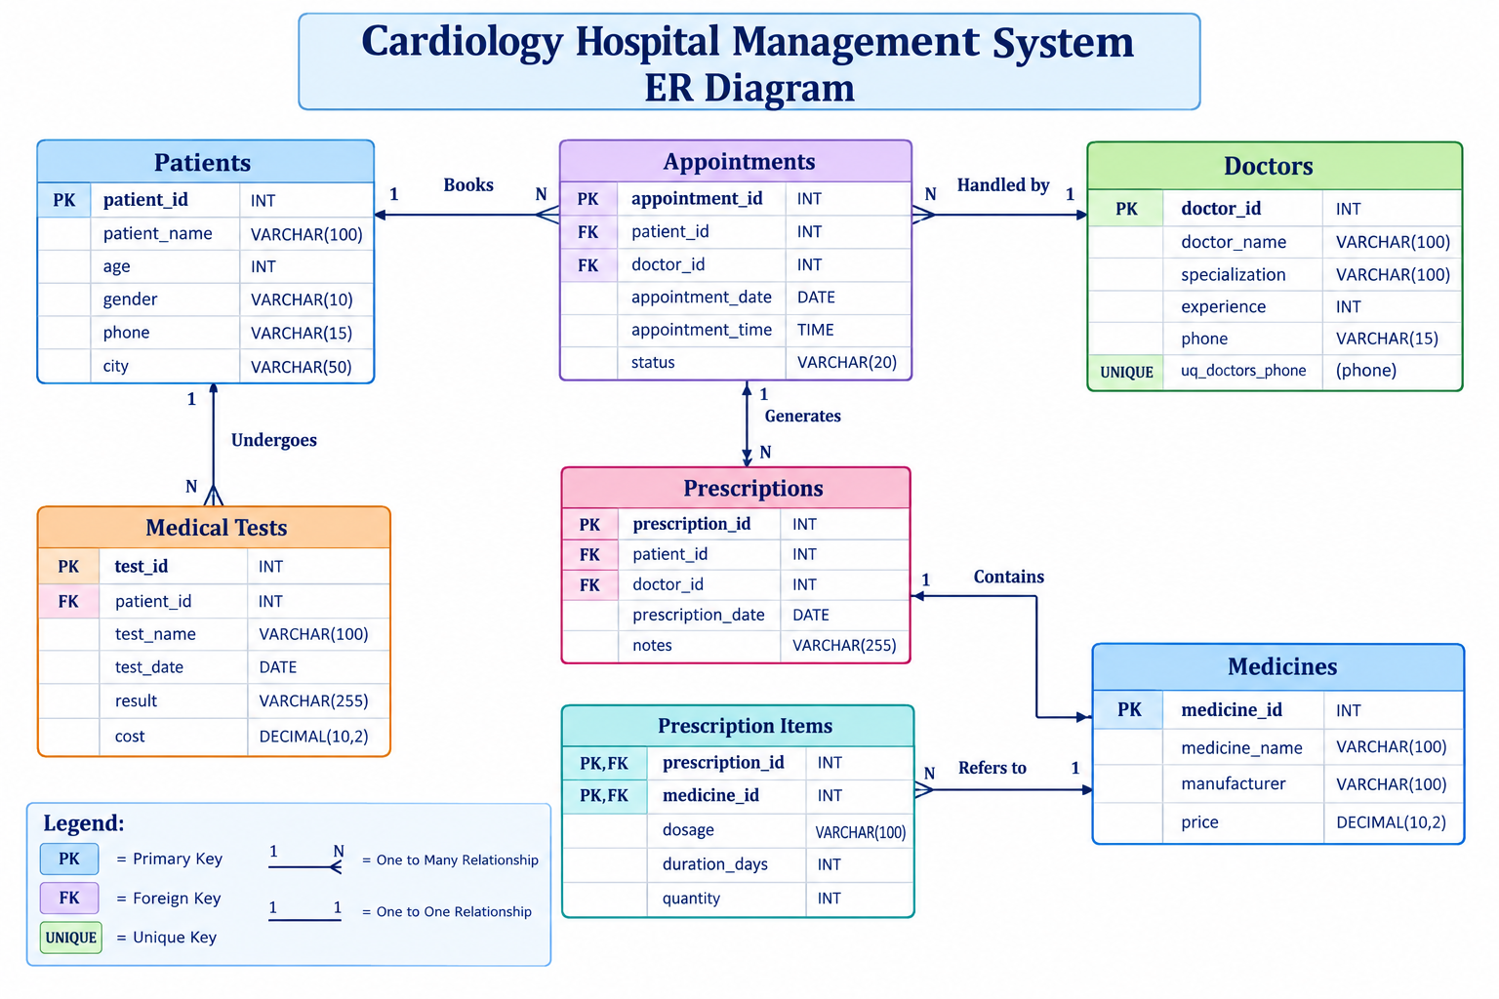
Prepared as a learning and project-reference document

1. Project Overview
The Cardiology Hospital Management System is a relational database project designed to organize core information for a cardiology department. It stores patient and doctor details, appointments, medical tests, prescriptions, medicines, and the medicines associated with each prescription. The database uses MySQL and the InnoDB storage engine, with primary keys and foreign keys to maintain relationships between records.

2. Project Objectives
- Maintain patient and doctor information in structured tables.
- Record appointments with dates, times, assigned patients, doctors, and status.
- Store medical test details, results, dates, and costs for each patient.
- Record prescriptions written by doctors for patients.
- Maintain a medicine catalogue and connect medicines to prescriptions.
- Use joins and aggregate functions to generate useful reports.

3. Tools and Technologies
- Database Management System: MySQL
- SQL environment: MySQL Workbench (or another MySQL client)
- Storage engine: InnoDB
- Main SQL concepts: CREATE TABLE, primary key, foreign key, UNIQUE, INSERT, ON DUPLICATE KEY UPDATE, JOIN, GROUP BY, SUM, ORDER BY

4. Database Tables
Table | Primary Key | Purpose
patients | patient_id (PK) | Stores patient name, age, gender, phone, and city.
doctors | doctor_id (PK) | Stores doctor name, specialization, experience, and unique phone number.
appointments | appointment_id (PK) | Links a patient and a doctor to an appointment date, time, and status.
medical_tests | test_id (PK) | Stores each patient's test name, date, result, and cost.
prescriptions | prescription_id (PK) | Links a patient and doctor to a prescription date and notes.
medicines | medicine_id (PK) | Stores medicine name, manufacturer, and price.
prescription_items | (prescription_id, medicine_id) composite PK | Bridge table linking prescriptions and medicines; stores dosage, duration, and quantity.

5. Entity Relationship Diagram (ERD)
The ER diagram below summarizes the seven tables and their main relationships. A primary key uniquely identifies a row. A foreign key references a related row in another table.

Relationship Notes
- Patients → Appointments: one patient can have many appointments; each appointment refers to one patient.
- Doctors → Appointments: one doctor can have many appointments; each appointment refers to one doctor.
- Patients → Medical_Tests: one patient can have many medical test records.
- Patients → Prescriptions: one patient can have many prescriptions.
- Doctors → Prescriptions: one doctor can issue many prescription records.
- Prescriptions ↔ Medicines: many-to-many relationship implemented through Prescription_Items.
- Prescription_Items uses a composite primary key (prescription_id, medicine_id), preventing the same medicine from appearing twice in the same prescription.

6. Important SQL Concepts Used
USE cardiology_db; Selects the database in which the tables will be created.
DROP TABLE IF EXISTS Removes a table if it exists. Use carefully because dropping a table deletes its data.
CREATE TABLE Defines a table and its columns, data types, keys, and constraints.
AUTO_INCREMENT Automatically generates a new numeric identifier when one is not supplied.
PRIMARY KEY Uniquely identifies each row and does not allow NULL values.
FOREIGN KEY Maintains a relationship with a referenced table and helps enforce referential integrity.
UNIQUE KEY Prevents duplicate values in the specified column; here, doctors.phone is unique.
INSERT ... ON DUPLICATE KEY UPDATE Inserts a row, or updates the existing row when a primary-key or unique-key conflict occurs.
JOIN Combines related rows from two or more tables using matching key values.
GROUP BY and SUM() Groups rows and calculates an aggregate such as total medical test cost.
ORDER BY Sorts the result, for example by appointment date and time.

7. Key Queries Explained

7.1 Appointments with patient and doctor names
Purpose | Display appointment ID, patient name, doctor name, appointment date and time, and status.
Tables used | appointments (a), patients (p), doctors (d)
SQL query | SELECT a.appointment_id, p.patient_name, d.doctor_name,  a.appointment_date, a.appointment_time, a.status  FROM appointments AS a  JOIN patients AS p ON a.patient_id = p.patient_id  JOIN doctors AS d ON a.doctor_id = d.doctor_id  ORDER BY a.appointment_date, a.appointment_time;
Explanation | JOIN connects each appointment with its patient and doctor. ORDER BY sorts the schedule by date and time.

7.2 Medical tests with patient names
Purpose | Show each patient's test name, test date, result, and cost.
Tables used | medical_tests (mt), patients (p)
SQL query | SELECT p.patient_name, mt.test_name, mt.test_date, mt.result, mt.cost  FROM medical_tests AS mt  JOIN patients AS p ON mt.patient_id = p.patient_id  ORDER BY mt.test_date;
Explanation | JOIN matches each test to its patient using patient_id. ORDER BY sorts test records by date.

7.3 Prescription and medicine details
Purpose | List the patient, doctor, prescription date, medicine, dosage, duration, quantity, and price.
Tables used | prescription_items (pi), prescriptions (pr), patients (p), doctors (d), medicines (m)
SQL query | SELECT p.patient_name, d.doctor_name, pr.prescription_date,  m.medicine_name, pi.dosage, pi.duration_days, pi.quantity, m.price  FROM prescription_items AS pi  JOIN prescriptions AS pr ON pi.prescription_id = pr.prescription_id  JOIN patients AS p ON pr.patient_id = p.patient_id  JOIN doctors AS d ON pr.doctor_id = d.doctor_id  JOIN medicines AS m ON pi.medicine_id = m.medicine_id  ORDER BY pr.prescription_id, m.medicine_id;
Explanation | The joins connect each prescription item to its prescription, patient, doctor, and medicine. Each result row represents one medicine item.

7.4 Total medical test cost for each patient
Purpose | Calculate the total cost of recorded medical tests for each patient.
Tables used | patients (p), medical_tests (mt)
SQL query | SELECT p.patient_name, SUM(mt.cost) AS total_test_cost  FROM patients AS p  JOIN medical_tests AS mt ON p.patient_id = mt.patient_id  GROUP BY p.patient_id, p.patient_name;
Explanation | SUM adds test costs for each patient group. INNER JOIN means patients without test records do not appear.

8. Practical Notes and Improvements
- The script drops and recreates tables. Run it only when you are comfortable losing existing data in those tables.
- Foreign-key checks are disabled around table creation. This is generally unnecessary when tables are dropped and created in dependency order; use this setting cautiously and always restore it.
- The alias form INSERT INTO ... VALUES (...) AS new_data ON DUPLICATE KEY UPDATE new_data.column is supported in newer MySQL versions. If MySQL Workbench reports a syntax error, check the installed MySQL version and use syntax supported by that version.
- The phone field in doctors is UNIQUE, but phone fields in patients are not. Add a UNIQUE constraint to patients.phone only if your project rules require every patient phone number to be distinct.
- For real hospital use, patient information and test results require strong access control, privacy safeguards, backups, and validation. The sample names and test results here are illustrative, not clinical guidance.
- The sample medicine dosage text is a placeholder. Actual medication, dosage, and duration must be determined by a qualified treating clinician.

9. Project Summary
The Cardiology Hospital Management System demonstrates how a relational database can organize the main activities of a cardiology department. Seven related tables reduce unnecessary duplication and make it possible to connect patients, doctors, appointments, tests, prescriptions, and medicines. Primary keys identify records, foreign keys link related records, and a composite key in prescription_items models the many-to-many relationship between prescriptions and medicines. The report queries demonstrate joins for readable reports and aggregation for calculating each patient's total medical test cost. Overall, the project provides a practical foundation for learning database design and SQL reporting; a production system would need additional validation, security, audit logging, and workflow features.

10. Conclusion
This project applies fundamental relational database concepts to a hospital scenario. It offers practice with table creation, constraints, inserting and updating records, joins, sorting, and aggregate functions. The ER diagram and viva questions can be used to explain the design during a class presentation or project review.

11. Additional MySQL Queries
The following queries provide additional practice for retrieving, filtering, joining, grouping, and summarizing data in the Cardiology Hospital Management System. Run them after creating the tables and inserting the sample records.

Query 1: Find patients older than 40
SELECT patient_id, patient_name, age, city
FROM patients
WHERE age > 40
ORDER BY age DESC;
Explanation: Lists patients whose age is greater than 40, from oldest to youngest.

Query 2: Find female patients
SELECT patient_id, patient_name, age, phone
FROM patients
WHERE gender = 'Female';
Explanation: Returns only patients whose gender is recorded as Female.

Query 3: Count patients in each city
SELECT city, COUNT(*) AS patient_count
FROM patients
GROUP BY city
ORDER BY patient_count DESC;
Explanation: Counts the patients registered in each city.

Query 4: Find doctors with at least 12 years of experience
SELECT doctor_id, doctor_name, specialization, experience
FROM doctors
WHERE experience >= 12
ORDER BY experience DESC;
Explanation: Shows doctors who have 12 or more years of experience.

Query 5: Count doctors by specialization
SELECT specialization, COUNT(*) AS doctor_count
FROM doctors
GROUP BY specialization
ORDER BY doctor_count DESC;
Explanation: Groups doctors by specialization and counts each group.

Query 6: Show appointments scheduled for a particular date
SELECT appointment_id, patient_id, doctor_id, appointment_date,
appointment_time, status
FROM appointments
WHERE appointment_date = '2026-11-02'
ORDER BY appointment_time;
Explanation: Displays appointments scheduled on November 2, 2026, in time order.

Query 7: Show upcoming appointments
SELECT appointment_id, appointment_date, appointment_time, status
FROM appointments
WHERE appointment_date >= CURRENT_DATE()
ORDER BY appointment_date, appointment_time;
Explanation: Returns appointments whose date is today or later.

Query 8: Count appointments by status
SELECT status, COUNT(*) AS appointment_count
FROM appointments
GROUP BY status;
Explanation: Counts appointments in each status category.

Query 9: Show appointment details for every patient and doctor
SELECT a.appointment_id, p.patient_name, d.doctor_name,
a.appointment_date, a.appointment_time, a.status
FROM appointments AS a
INNER JOIN patients AS p ON p.patient_id = a.patient_id
INNER JOIN doctors AS d ON d.doctor_id = a.doctor_id
ORDER BY a.appointment_date, a.appointment_time;
Explanation: Combines appointment information with patient and doctor names.

Query 10: Find medical tests costing more than 1000
SELECT test_id, patient_id, test_name, test_date, cost
FROM medical_tests
WHERE cost > 1000
ORDER BY cost DESC;
Explanation: Lists tests whose recorded cost exceeds 1000.

Query 11: Calculate average medical test cost
SELECT ROUND(AVG(cost), 2) AS average_test_cost
FROM medical_tests;
Explanation: Calculates the average cost across all medical test records.

Query 12: Calculate total medical test cost by patient
SELECT p.patient_id, p.patient_name,
COALESCE(SUM(mt.cost), 0) AS total_test_cost
FROM patients AS p
LEFT JOIN medical_tests AS mt ON mt.patient_id = p.patient_id
GROUP BY p.patient_id, p.patient_name
ORDER BY total_test_cost DESC;
Explanation: Includes every patient, even if no medical test is recorded for them.

Query 13: Find patients who have no medical test records
SELECT p.patient_id, p.patient_name
FROM patients AS p
LEFT JOIN medical_tests AS mt ON mt.patient_id = p.patient_id
WHERE mt.test_id IS NULL;
Explanation: Finds patients without a matching medical test record.

Query 14: Show prescriptions with patient and doctor names
SELECT pr.prescription_id, p.patient_name, d.doctor_name,
pr.prescription_date, pr.notes
FROM prescriptions AS pr
JOIN patients AS p ON p.patient_id = pr.patient_id
JOIN doctors AS d ON d.doctor_id = pr.doctor_id
ORDER BY pr.prescription_date DESC;
Explanation: Displays each prescription together with its patient and prescribing doctor.

Query 15: Count prescriptions written by each doctor
SELECT d.doctor_id, d.doctor_name,
COUNT(pr.prescription_id) AS prescription_count
FROM doctors AS d
LEFT JOIN prescriptions AS pr ON pr.doctor_id = d.doctor_id
GROUP BY d.doctor_id, d.doctor_name
ORDER BY prescription_count DESC;
Explanation: Counts prescriptions per doctor, including doctors with zero prescriptions.

Query 16: Find medicines priced above 80
SELECT medicine_id, medicine_name, manufacturer, price
FROM medicines
WHERE price > 80
ORDER BY price DESC;
Explanation: Lists medicines with a price greater than 80.

Query 17: Show medicines included in each prescription
SELECT pi.prescription_id, m.medicine_name, pi.dosage,
pi.duration_days, pi.quantity
FROM prescription_items AS pi
JOIN medicines AS m ON m.medicine_id = pi.medicine_id
ORDER BY pi.prescription_id, m.medicine_name;
Explanation: Combines prescription item details with medicine names.

Query 18: Calculate the estimated medicine cost per prescription item
SELECT pi.prescription_id, m.medicine_name, pi.quantity, m.price,
(pi.quantity * m.price) AS estimated_item_cost
FROM prescription_items AS pi
JOIN medicines AS m ON m.medicine_id = pi.medicine_id
ORDER BY pi.prescription_id, estimated_item_cost DESC;
Explanation: Multiplies the recorded quantity by the medicine price. This is an estimate, not a billing record.

Query 19: Calculate estimated medicine cost per prescription
SELECT pi.prescription_id,
SUM(pi.quantity * m.price) AS estimated_medicine_cost
FROM prescription_items AS pi
JOIN medicines AS m ON m.medicine_id = pi.medicine_id
GROUP BY pi.prescription_id
ORDER BY estimated_medicine_cost DESC;
Explanation: Adds the estimated item costs for each prescription.

Query 20: Find medicines that have never been prescribed
SELECT m.medicine_id, m.medicine_name
FROM medicines AS m
LEFT JOIN prescription_items AS pi ON pi.medicine_id = m.medicine_id
WHERE pi.medicine_id IS NULL;
Explanation: Identifies medicine records that do not appear in prescription_items.

