Hello, I am Narmathan. I am in process of AI math tutor process, here I successfully created that chatbot with gemini model. But I want to this as adoptive teacher after I intergrate the white board
for adaptability I am going to implement the
Student input->step parse-> Error classifier->miss conception database->adoptive explanation generator->progress memory update.

Student Input
↓
Step Parser (Gemini extraction)
↓
Validation Checker
↓
Error / Misconception Classifier
↓
Misconception Knowledge Database Lookup
↓
Explanation Generator
↓
Decision Router
↓
Output Display + Speech + Whiteboard Animation

Step parse
Step parser in my tutor system, that works as translator between human input and ai generator
Translator
Human input---- Step Parser --------AI

Read the full answer
Splits the solution into meaningful mathematical steps
Identifies the expresstion, operations and etc
Send the structure step in for to your error -analysis module
Validation Checker
I used Sympy for this.

Decision Layer( My model begins) (Lead to Hybrid model)

Your model will function as a specialised prediction and support component inside the tutor system rather than as the central controller. The transformer model will focus on generating or verifying simple arithmetic predictions such as one-digit addition or multiplication, acting as a fast numerical assistant when the decision router determines that the problem type is suitable. The main reasoning, explanation, and pedagogical tutoring logic will be handled by the hybrid reasoning layer using models like those provided through Google Gemini APIs. Control of the tutoring flow will be managed by rule-based logic combined with confidence scoring, which keeps the system behaviour predictable, easier to debug, and more reliable for student feedback. Your model’s role is therefore to enhance performance efficiency and prediction accuracy inside a broader adaptive tutoring architecture rather than serve as the decision-making brain of the platform.

Decision Router

Llama
Own Transformer Model

Gemini 2.5 flash

05/04/2026
Today I login the google colab in visual studio code and connect the note book to visual studio code in order to connect llama model to main.py with fastapi. But here is the problem that I want start the fastapi in colab server as well.
So this is the plan
Start the fastapi and connect and get first output
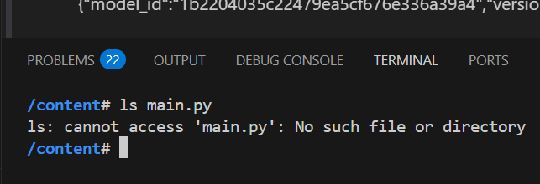

I logged into VS Code, connecting it to Google Colab. My goal was to expose my custom model alongside a Llama model using FastAPI. I spent days fighting port forwarding, environment boundaries, and crippling security errors trying to make local servers talk to cloud hosted notebooks. I was spending more time fighting network configurations than building my tutor.

20/04/2026
I drew a line in the sand. I decided to abandon the traditional, rigid method of hardcoding API connections and move to a modern framework: LangGraph.
By shifting the architecture to LangGraph’s state-driven, cyclic graphs, I could cleanly map out my entire reasoning pipeline—from step parsing to error classification—without getting bogged down in state management bugs.
Looking Forward to August
With LangGraph handling the complex conversational loops and the base reasoning model finally taking shape, the bottleneck is broken. I am on track for my August MVP. My focus is shifting to where the magic truly happens: bringing this entire adaptive engine to life right on the student's whiteboard.

21.04.2026
To completely bypass the network restrictions of Google Colab, I took control of my local environment by installing Ollama directly onto my machine. I opened up my Visual Studio Code terminal, initialized the server, and ran the command: ollama run llama3.2. Typing a simple "hi" and seeing the model instantly respond locally was a massive milestone. By shifting Llama 3.2 to a local Ollama instance running seamlessly in the background, I finally bridged the gap to FastAPI without the headache of network proxy errors.

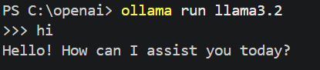

22.04.2026
I brought the system to life by building the user-facing layer. I created math.html, style.css, and a JavaScript engine to form a clean, functional chat interface. On the backend, I coded validation_checker.py and linked it directly to main.py. Through the validate_solution function, the system successfully compared the student's final answers and calculation steps against a verified model answer, even outputting the active AI model name right onto the web page.
The code worked beautifully, but it revealed a profound pedagogical problem: the raw text answers generated by the AI were mathematically accurate, but completely unsuitable for a student. The output felt like a rigid textbook answer key rather than a supportive, adaptive teacher. This breakthrough solidified exactly why I needed LangGraph and a whiteboard—to transform cold computational data into dynamic, guided learning.

18.05.2026 (The Architecture Evolution):
As I pushed the model further, the reasoning became increasingly unstable. I initially tried separating my prompts by category—equations, arithmetic, calculus—but this triggered massive Prompt Collision. Even at a temperature of $0$, the non-deterministic nature of LLMs meant they chose chaotic, unreliable reasoning paths.
I completely re-engineered the system. I upgraded prompt_router.py to use a single, unified public prompt structure, adding a strict "no json" rule. This allowed the model to focus purely on tutoring logic, shifting JSON extraction downstream into main.py. Most importantly, I removed calculation duties from Llama entirely. Now, the pipeline routes the user's question directly to SymPy to compute a flawless mathematical anchor, and Llama simply weaves the pedagogical steps between the question and SymPy's definitive answer.
While this stabilized the output immensely, my automated accuracy tests hit a new wall: validation failures. SymPy is marking mathematically equivalent responses as incorrect—failing to recognize that $35/3$ matches a decimal equivalent, or that a coordinate set shift from $[3,1]$ to $[1,3]$ represents the exact same geometric point.

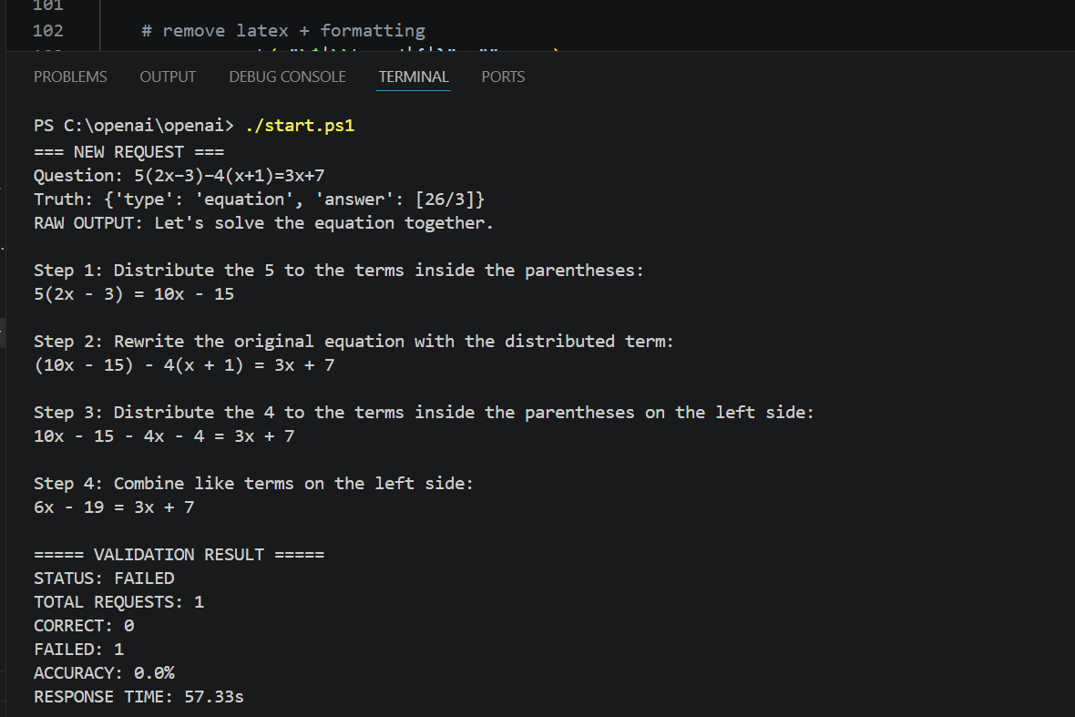

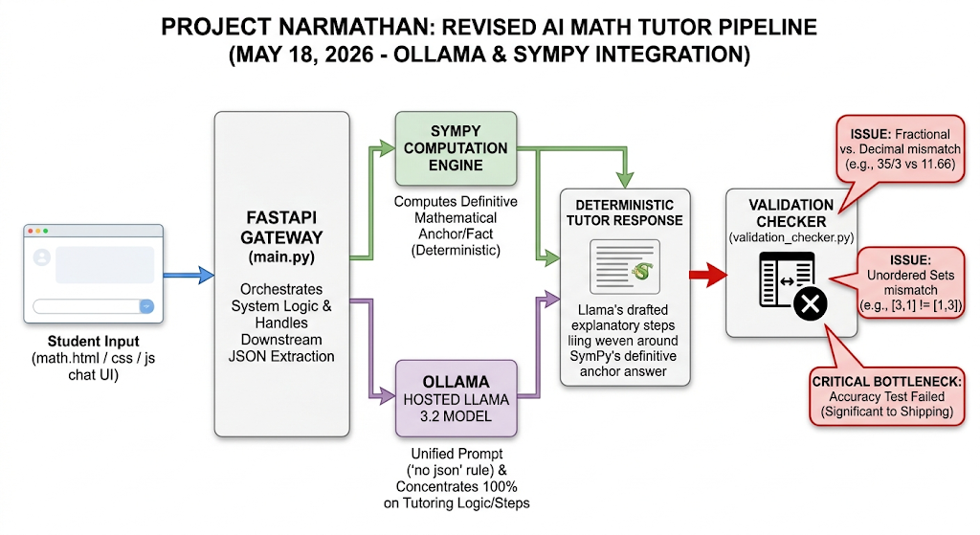

10/06/2026
I am getting closer to my launch of my product. Accordingly my reasoning layer is now 50% accuracy now. So I am stucking for months for perfect ai math tutor. This gives me one learning that if we looking for perfect engine, we lose the motivation and momentum for the next task sometimes this keeps untrack of the product. I decided to move on from that. Even that is messy output, I started to create my next milestone that is ai math tutor white board idea integration. Today I created canvas for that. If student write on that automatically converted as mathematical computation equation and call sympy to and call_llama.

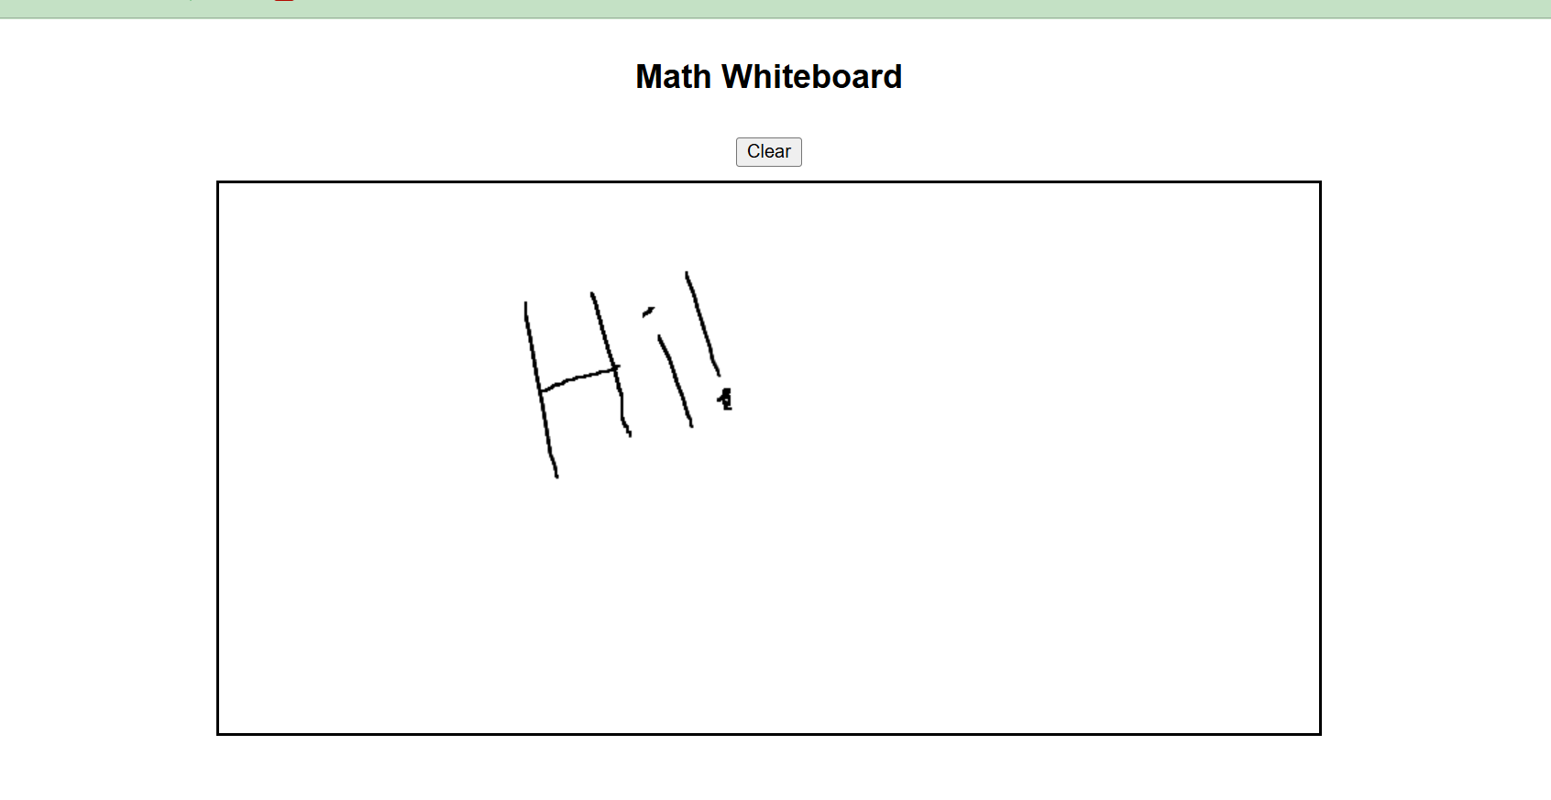
12/06/2026
Today, I connected the whiteboard canvas with backend. But I got error in backend and frontend connection .however, I can see the greetings on whiteboard because I already declare the output for “hi, how are you, hello” as manually like” Hi, I am Your AI math tutor”. So I can see on my Canvas as well. Now next stage would be figured out the error between backend and frontend connection, and solve it
This is the ouput for today’s progress
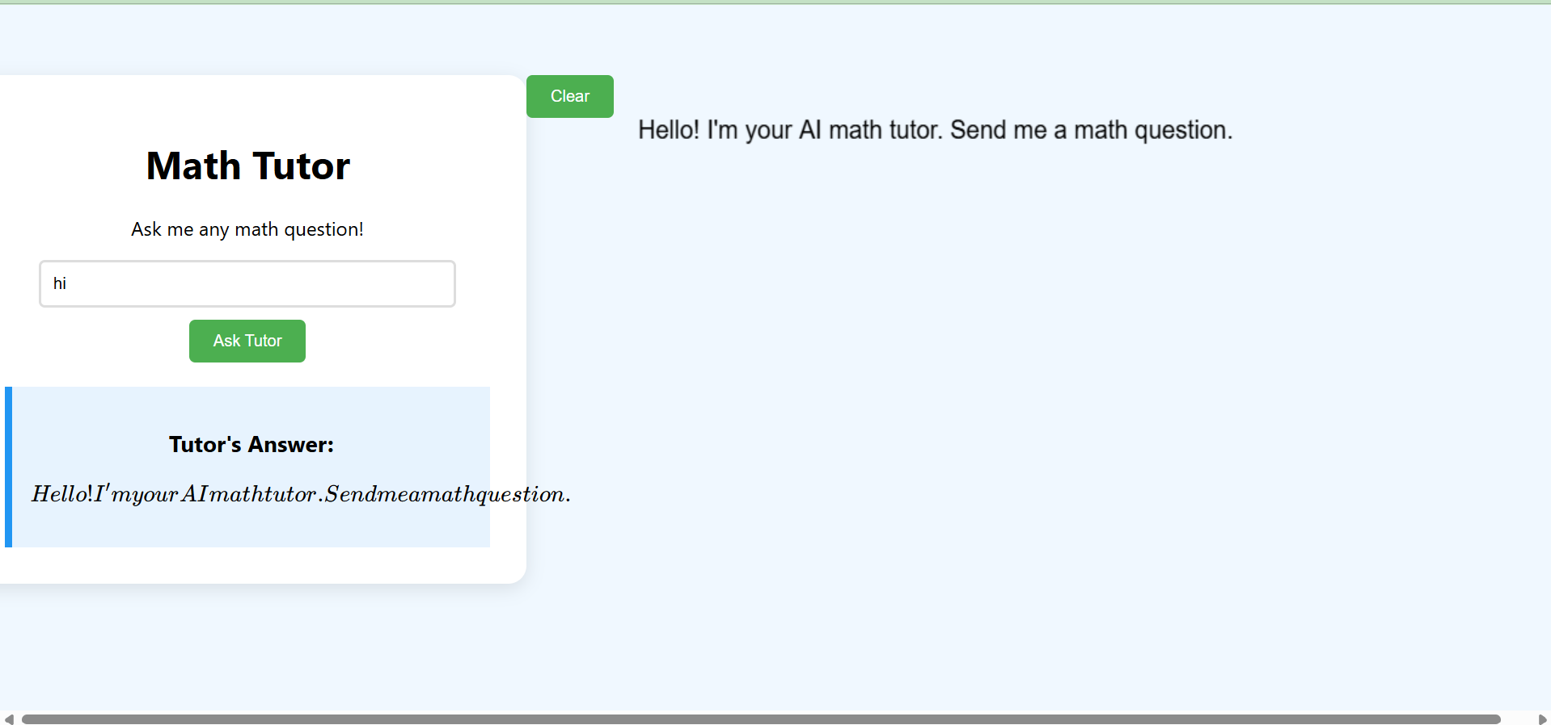

Streaming The Output
Streaming the Output is the One of the Significant strategy to engage the user while llm generate the output. In my Case llm generate the Output ->Change to the Json ->Validate The Output. So between of these Process which has huge processing time. So Streaming helps to decrease the Waiting Time and engage the user At the same time like Chatgpt. My Stragy is in this mean time

Overview
The AI Math Tutor is designed to provide a responsive and engaging learning experience by combining real-time text streaming with structured whiteboard animations. Instead of waiting for the entire solution to be generated before displaying any output, the system streams the explanation to the user as it is produced, creating an experience similar to ChatGPT.
Architecture
The solution follows a three-stage pipeline:
Stage 1 – Live Text Streaming
When the user submits a mathematics problem, the backend immediately sends the request to the language model using a streaming API. As the model generates tokens, each token is streamed to the frontend using Server-Sent Events (SSE).
The frontend appends each token to the output area immediately, allowing the explanation to appear naturally, one word or one character at a time. This gives users instant visual feedback that the AI is actively working, significantly improving perceived responsiveness.
Stage 2 – Background Solution Collection
While the explanation is being streamed to the user, the backend simultaneously stores every streamed token in a buffer.
After streaming finishes, the complete response is available as a single string. This complete output is then converted into a structured JSON representation containing:
- Step descriptions
- Mathematical expressions
- Final answer
Using the complete response avoids parsing incomplete JSON fragments during streaming and produces a reliable structured solution.
Stage 3 – Whiteboard Animation
Once the structured JSON has been created, the frontend begins the whiteboard animation.
Each mathematical expression is rendered sequentially on the canvas, while arrows and transitions visually connect consecutive steps. This transforms the explanation into a classroom-style demonstration where the solution is written progressively rather than appearing all at once.
User Experience
The interaction follows this sequence:
- The user enters a mathematics question.
- The AI immediately begins streaming an explanation.
- The explanation grows continuously as the model generates tokens.
- The backend collects the complete response in the background.
- The response is converted into structured JSON.
- The whiteboard animation begins using the structured mathematical steps.
- The final answer is highlighted after all solution steps have been presented.
This workflow keeps users engaged throughout the generation process and closely resembles the experience of interacting with a human tutor.
Advantages
- Immediate feedback without long loading delays.
- ChatGPT-like streaming experience.
- Reliable JSON generation after the response completes.
- Smooth whiteboard animations driven by structured mathematical data.
- Easy integration with future features such as voice narration, avatars, collaborative whiteboards, and adaptive tutoring.
Future Improvements
Future versions of the AI Math Tutor will synchronize streamed explanations with whiteboard animations in real time, allowing each explanation paragraph to appear simultaneously with its corresponding mathematical expression. Additional enhancements may include voice synthesis, handwriting-style animations, collaborative learning sessions, and interactive step-by-step guidance.

July 14
Memory Management
I planned to do the memory management system like chatgpt. But I don’t want to fully chatgpt memory management system like long term memory in this meantime. Because I am in MVP phase. This is long enough time consuming and complexity as well.
User Question
↓
Normalizer
↓
Problem Classifier
↓
SymPy Truth
↓
Memory Manager
↓
Prompt Router
↓
LLM
↓
JSON Parser
↓
Validator
↓
Frontend

Now I am going to do single session for trial

