JustIT Data Bootcamp Assignment 2: Querying SQL Using World DB

REPORT BY NARMEEN MOHAMMED

DUE 10.05.2024

2024

**Contents**

Assignment Questions & My Answers   
(comments included in query)…………………...……………………Pages 3-17

Reflection of the Assignment…………………………………………. Page 18

1. **Count Cities in USA:**

*Scenario:* You've been tasked with conducting a demographic analysis of cities in the United States. Your first step is to determine the total number of cities within the country to provide a baseline for further analysis.

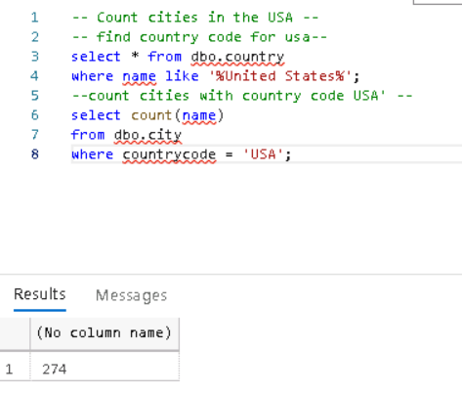

1. **Country with Highest Life Expectancy:**

*Scenario:* As part of a global health initiative, you've been assigned to identify the country with the highest life expectancy. This information will be crucial for prioritizing healthcare resources and interventions.

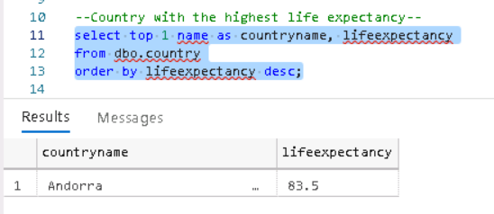

1. **"New Year Promotion: Featuring Cities with 'New’ :**

*Scenario:* In anticipation of the upcoming New Year, your travel agency is gearing up for a special promotion featuring cities with names including the word 'New'. You're tasked with swiftly compiling a list of all cities from around the world. This curated selection will be essential in creating promotional materials and enticing travellers with exciting destinations to kick off the New Year in style.

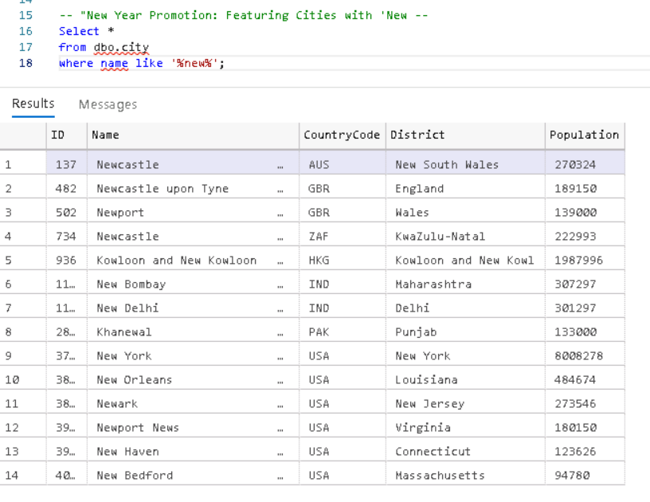

1. **Display Columns with Limit (First 10 Rows):**

*Scenario:* You're tasked with providing a brief overview of the most populous cities in the world. To keep the report concise, you're instructed to list only the first 10 cities by population from the database.

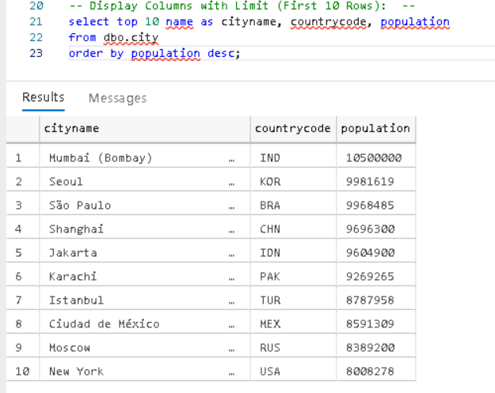

1. **Cities with Population Larger than 2,000,000:**

*Scenario:* A real estate developer is interested in cities with substantial population sizes for potential investment opportunities. You're tasked with identifying cities from the database with populations exceeding 2 million to focus their research efforts.

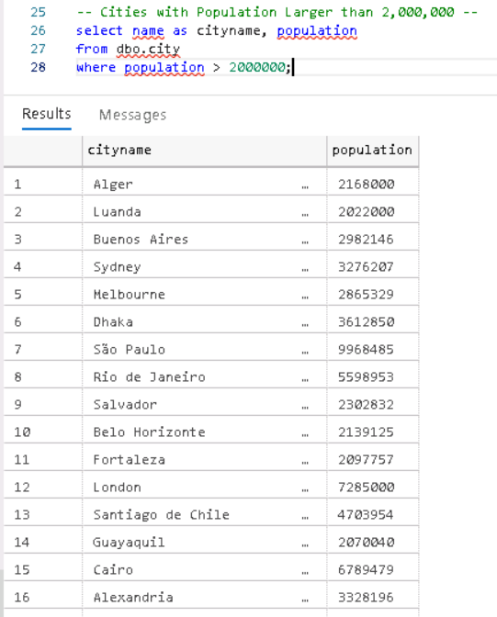

1. **Cities Beginning with 'Be' Prefix:**

*Scenario:* A travel blogger is planning a series of articles featuring cities with unique names. You're tasked with compiling a list of cities from the database that start with the prefix 'Be' to assist in the blogger's content creation process.

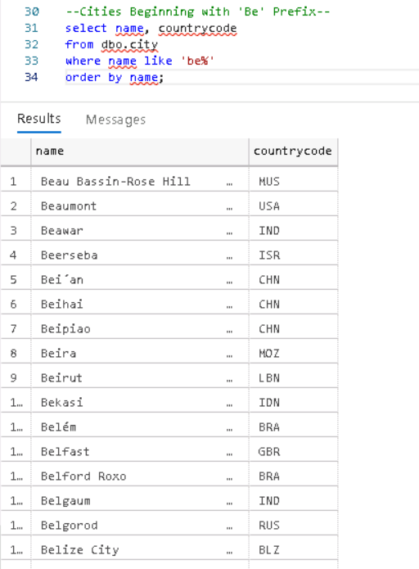

1. **Cities with Population Between 500,000-1,000,000:**

*Scenario:* An urban planning committee needs to identify mid-sized cities suitable for infrastructure development projects. You're tasked with identifying cities with populations ranging between 500,000 and 1 million to inform their decision-making process.

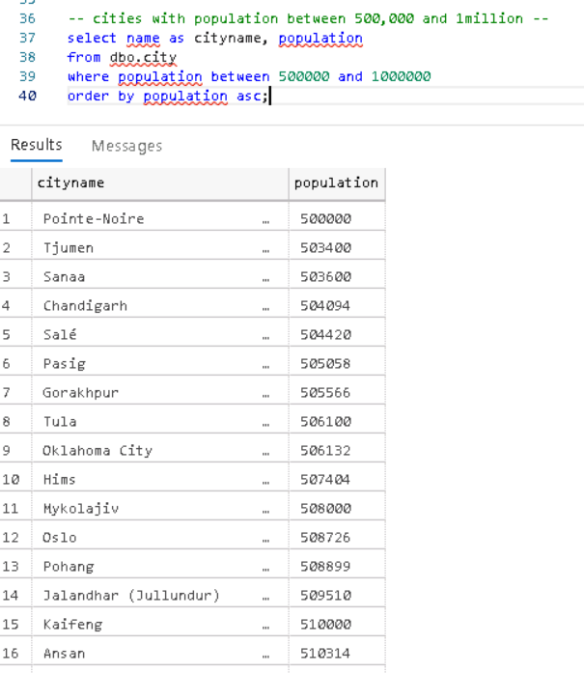

1. **Display Cities Sorted by Name in Ascending Order:**

*Scenario:* A geography teacher is preparing a lesson on alphabetical order using city names. You're tasked with providing a sorted list of cities from the database in ascending order by name to support the lesson plan.

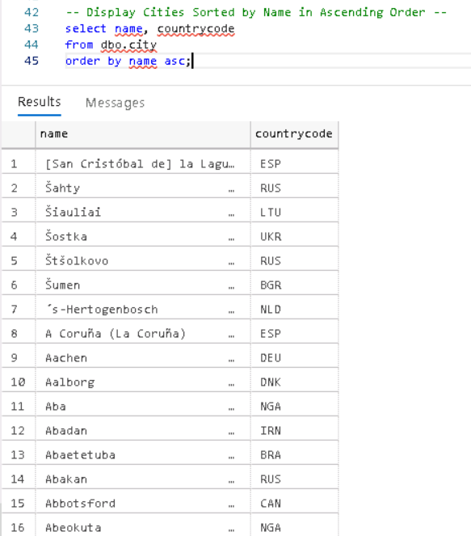

1. **Most Populated City:**

*Scenario:* A real estate investment firm is interested in cities with significant population densities for potential development projects. You're tasked with identifying the most populated city from the database to guide their investment decisions and strategic planning.

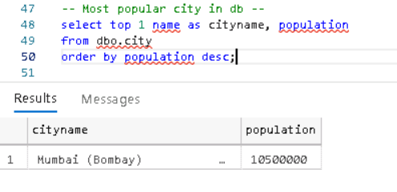

1. **City Name Frequency Analysis: Supporting Geography Education:**

*Scenario*: In a geography class, students are learning about the distribution of city names around the world. The teacher, in preparation for a lesson on city name frequencies, wants to provide students with a list of unique city names sorted alphabetically, along with their respective counts of occurrences in the database.

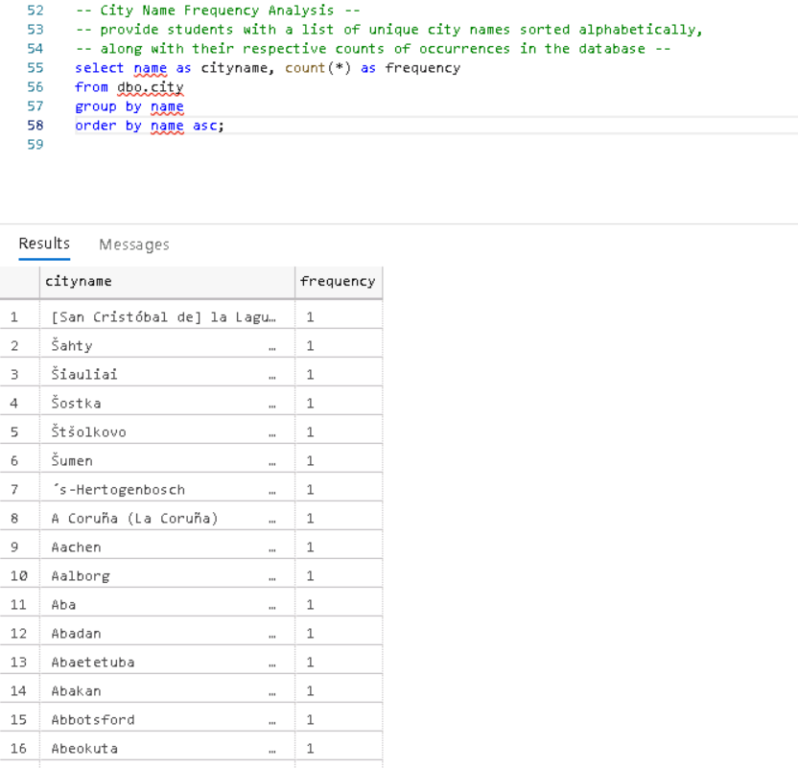

1. **City with the Lowest Population:**

*Scenario:* A census bureau is conducting an analysis of urban population distribution. You're tasked with identifying the city with the lowest population from the database to provide a comprehensive overview of demographic trends.

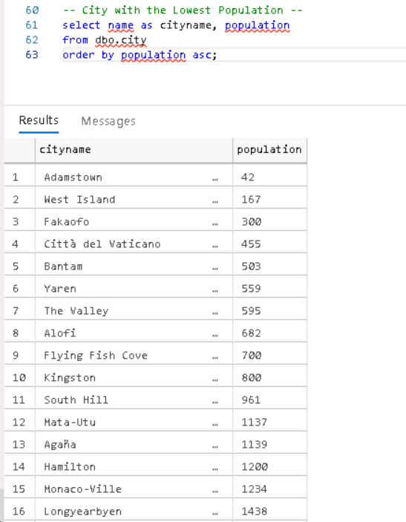

1. **Country with Largest Population:**

*Scenario:* A global economic research institute requires data on countries with the largest populations for a comprehensive analysis. You're tasked with identifying the country with the highest population from the database to provide valuable insights into demographic trends.

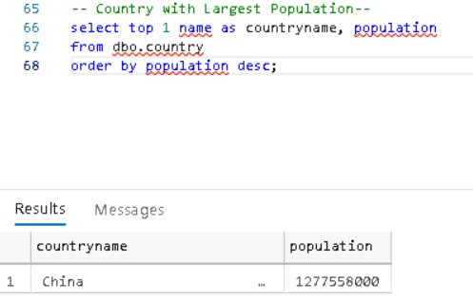

1. **Capital of Spain:**

*Scenario:* A travel agency is organizing tours across Europe and needs accurate information on capital cities. You're tasked with identifying the capital of Spain from the database to ensure itinerary accuracy and provide travellers with essential destination information.

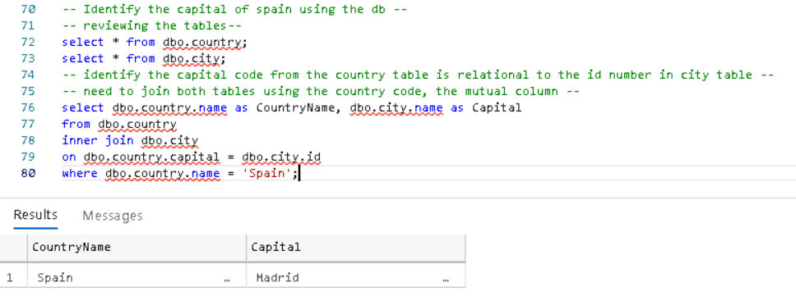

1. **Country with Highest Life Expectancy:**

*Scenario:* A healthcare foundation is conducting research on global health indicators. You're tasked with identifying the country with the highest life expectancy from the database to inform their efforts in improving healthcare systems and policies.

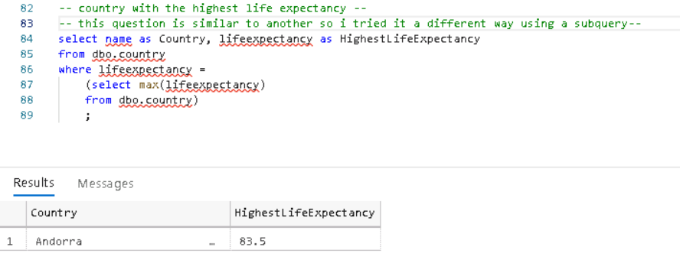

1. **Cities in Europe:**

*Scenario:* A European cultural exchange program is seeking to connect students with cities across the continent. You're tasked with compiling a list of cities located in Europe from the database to facilitate program planning and student engagement.

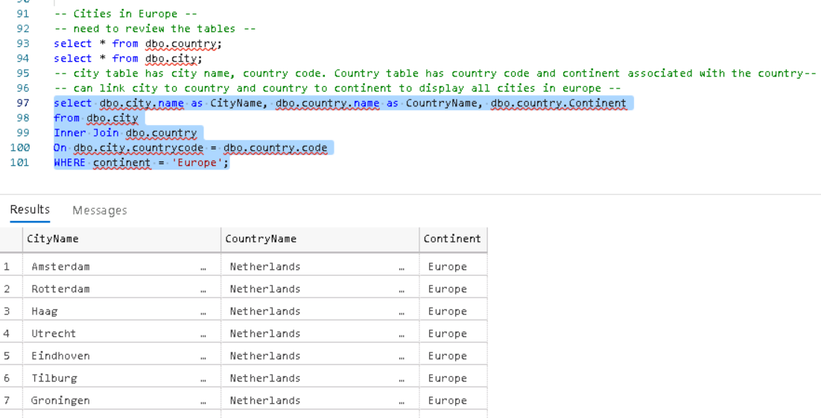

1. **Average Population by Country:**

*Scenario:* A demographic research team is conducting a comparative analysis of population distributions across countries. You're tasked with calculating the average population for each country from the database to provide valuable insights into global population trends.

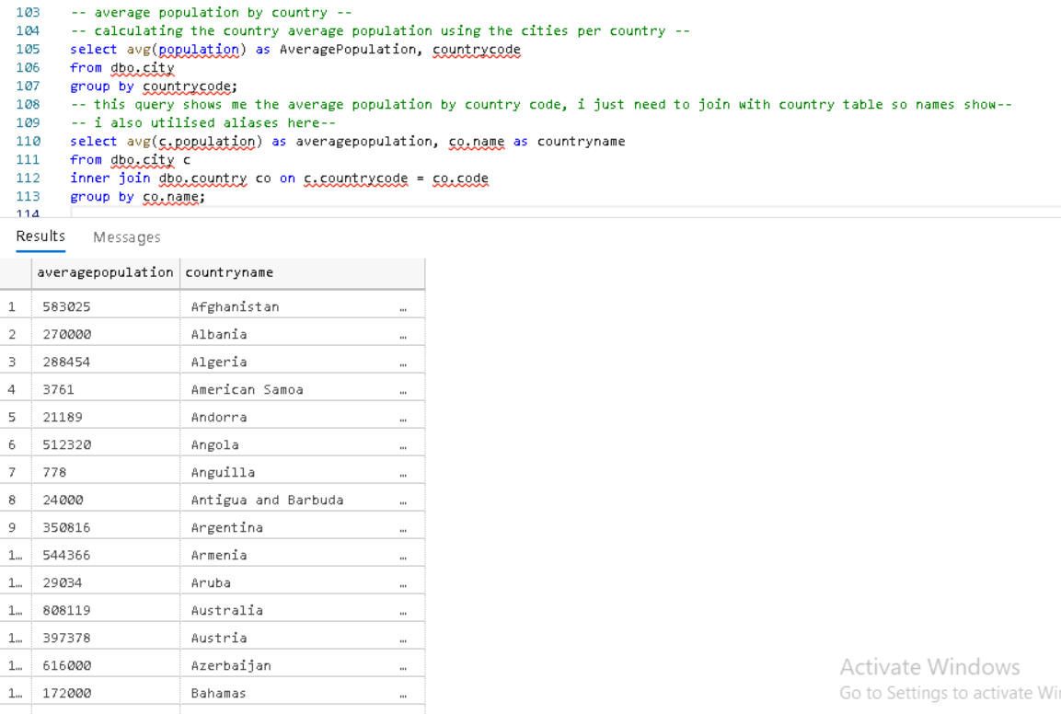

1. **Capital Cities Population Comparison:**

*Scenario:* A statistical analysis firm is examining population distributions between capital cities worldwide. You're tasked with comparing the populations of capital cities from different countries to identify trends and patterns in urban demographics.

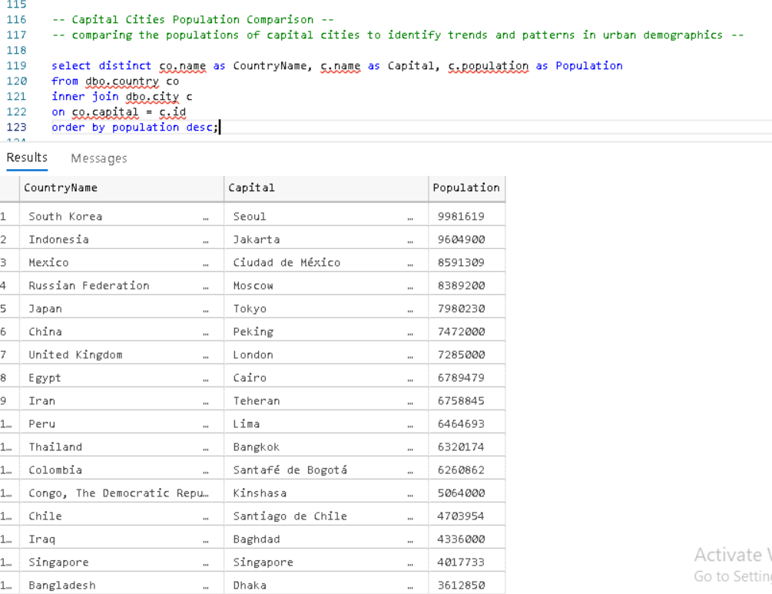

1. **Countries with Low Population Density:**

*Scenario:* An agricultural research institute is studying countries with low population densities for potential agricultural development projects. You're tasked with identifying countries with sparse populations from the database to support the institute's research efforts.

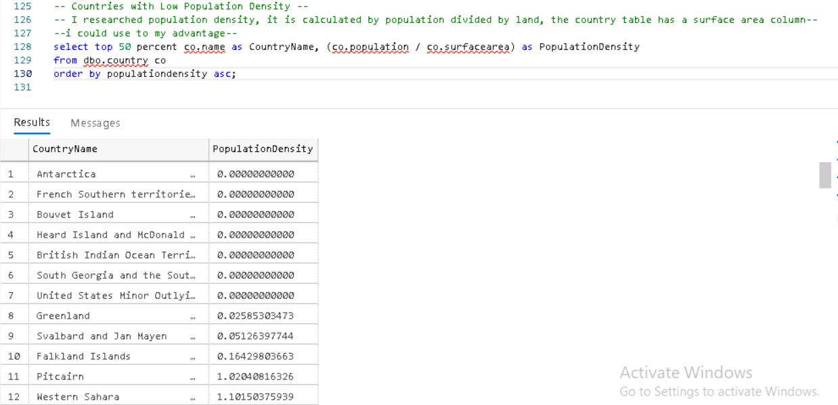

Reflection

Engaging in this task proved to be both challenging and fulfilling.

It provided an opportunity for me to not only demonstrate my knowledge through the report but also to reinforce it within myself, resulting in a notable boost to my self-confidence. Reviewing my progress highlighted how much I've learned while also revealing areas where I can further develop, particularly in tackling more intricate queries.

Although I encountered difficulty with the bonus questions, I'm committed to revisiting them at my own pace as part of my ongoing self-learning journey. Mastering SQL is a personal goal I'm eager to achieve, and I recognize that persistent practice is key to overcoming obstacles and enhancing my skills.

Despite the challenges, I take pride in my accomplishments and proficiency thus far. However, I remain dedicated to continual improvement, acknowledging that there's always more to learn and explore. Reflecting on my journey thus far serves as motivation to maintain momentum and strive for excellence in my SQL proficiency.