SQL Queries and Results
Query 1: Top 5 Products by Revenue
SELECT Product,
SUM(Total_Sales) AS Revenue
FROM sales
GROUP BY Product
ORDER BY Revenue DESC
LIMIT 5;
Result:
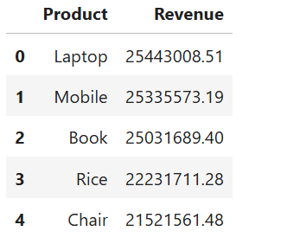

Query 2: Revenue by Category
SELECT Category,
SUM(Total_Sales) AS Revenue
FROM sales
GROUP BY Category
ORDER BY Revenue DESC;
Result:
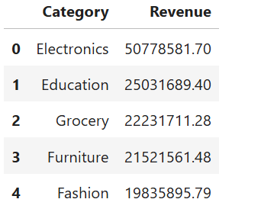

Query 3: Average Sales by Category
SELECT Category,
AVG(Total_Sales) AS Avg_Sales
FROM sales
GROUP BY Category;
Result:
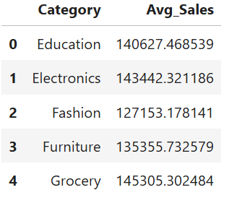

Query 4: Top Customers by Revenue
SELECT Customer_Name,
SUM(Total_Sales) AS Revenue
FROM sales
GROUP BY Customer_Name
ORDER BY Revenue DESC
LIMIT 10;
Result:
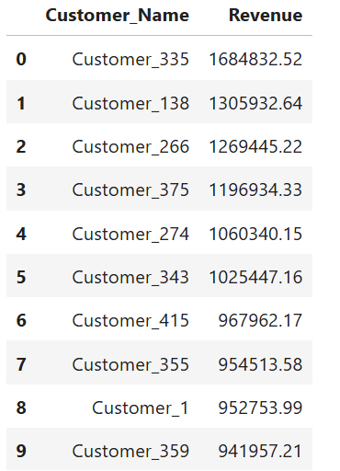-

Query 5: Monthly Revenue Trend
SELECT strftime('%m', Order_Date) AS Month,
SUM(Total_Sales) AS Revenue
FROM sales
GROUP BY Month
ORDER BY Month;
Result:
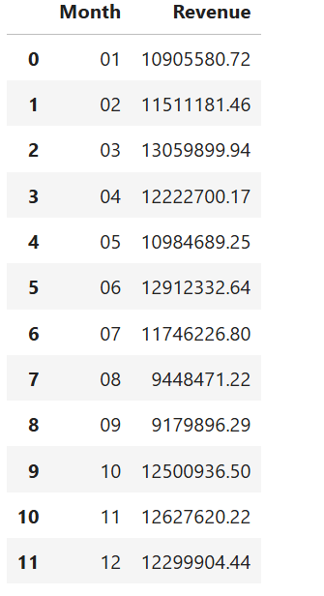

Query 6: Quantity Sold by Category
SELECT Category,
SUM(Quantity) AS Total_Quantity
FROM sales
GROUP BY Category
ORDER BY Total_Quantity DESC;
Result:
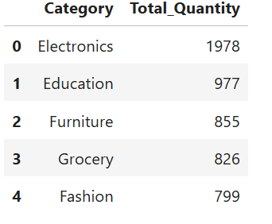

Query 7: Top Customers by Orders
SELECT Customer_Name,
COUNT(Order_ID) AS Orders
FROM sales
GROUP BY Customer_Name
ORDER BY Orders DESC
LIMIT 10;
Result:
