WEEK 1 2520030080
N. Greeshma
Aim:
To design and implement the BookFlow library database using SQL by creating tables, applying data integrity constraints, and inserting sample records.

Step – 1 : Create Database :
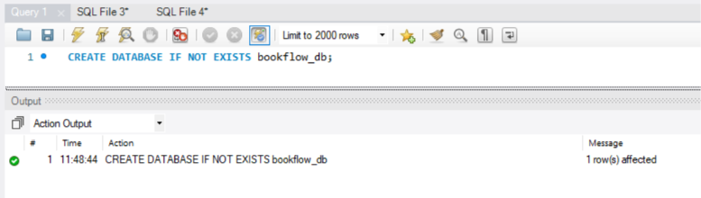
Step 2 — Select the database:
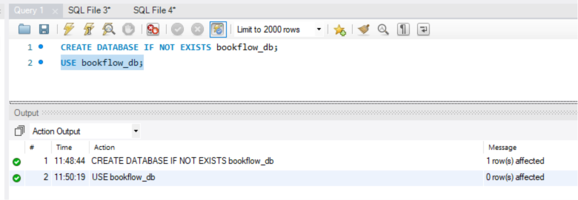

Step 3 — Table Creation (DDL) with Constraints:
1.Create the books table :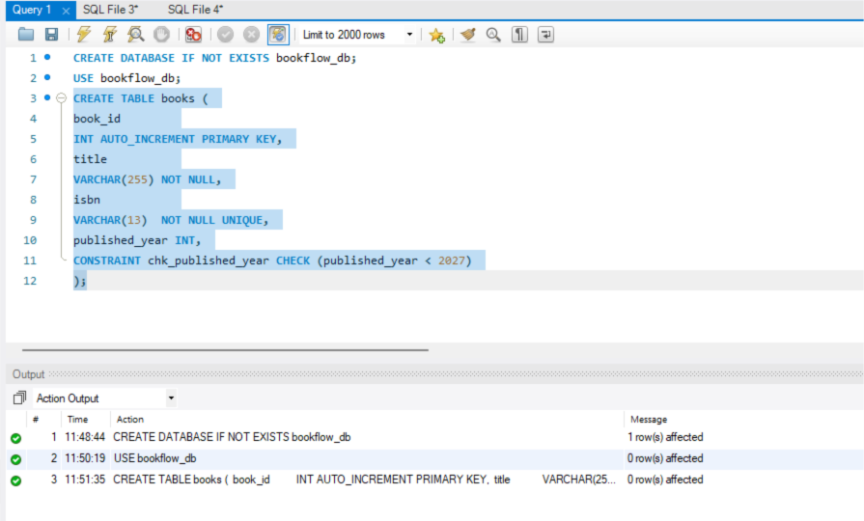
2.Create the members table:
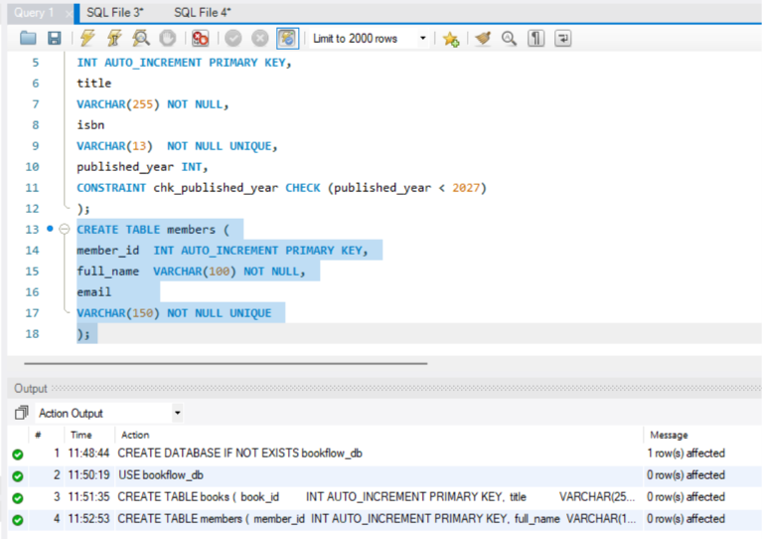

3.Inspect the table structures:
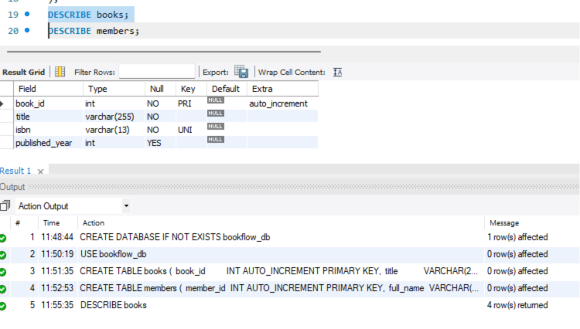
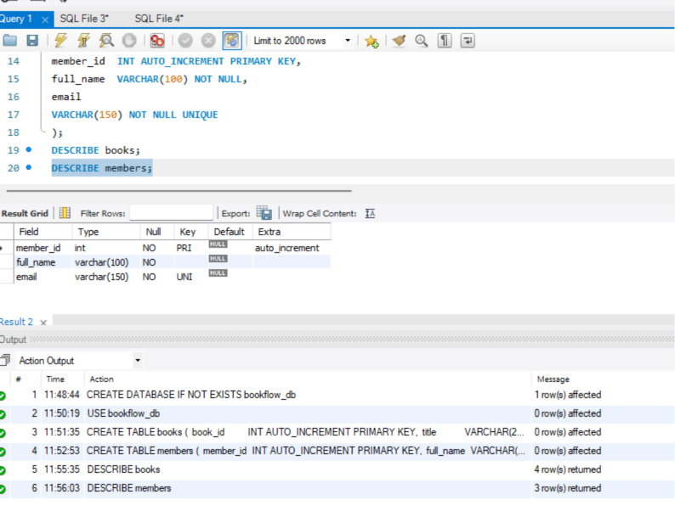

Step 4 - Initial Seeding (Valid Data):
1.Insert 3 books 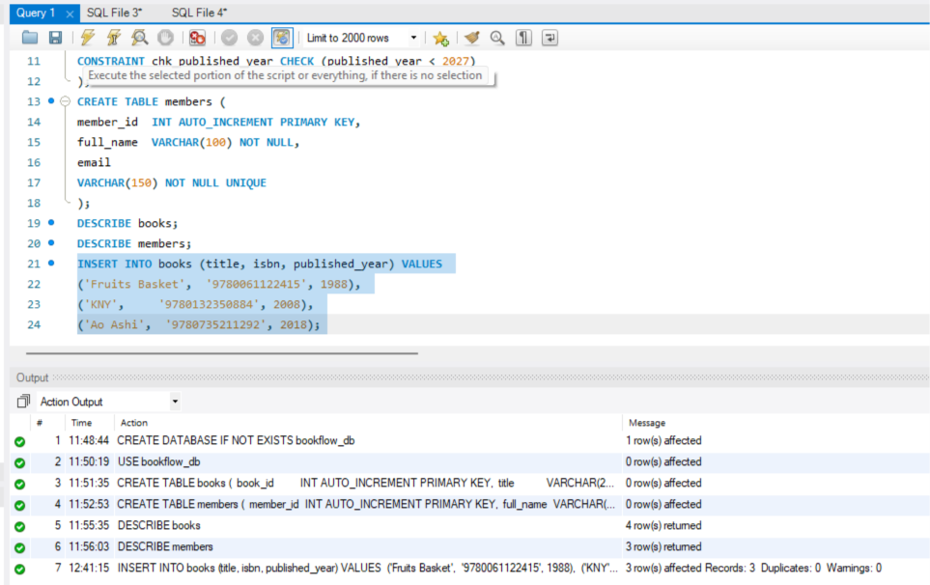
2.Insert 3 members:
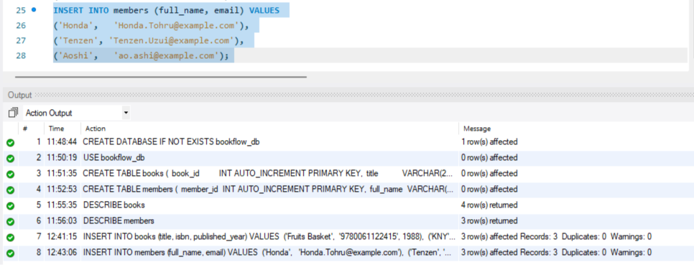
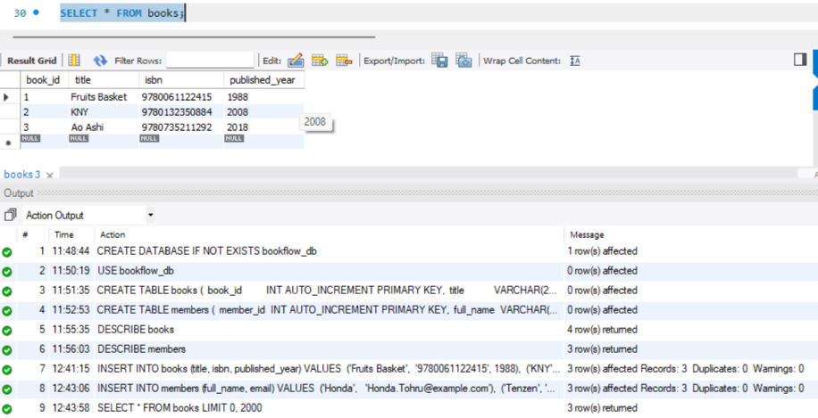

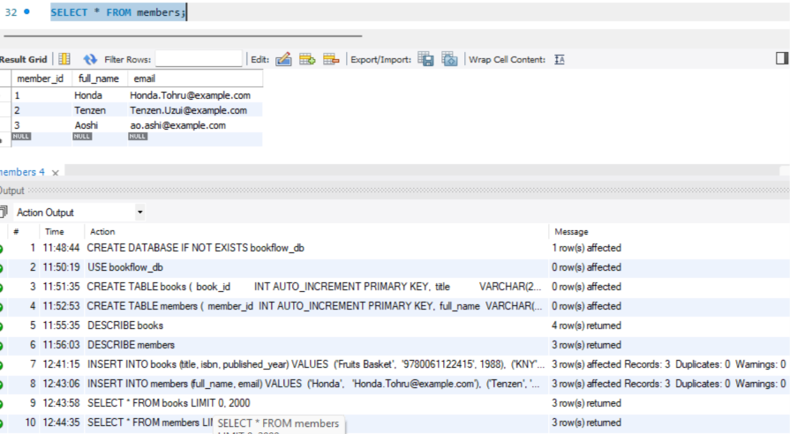
Step 4 Constraint Tests (These MUST Fail):
Test 1:
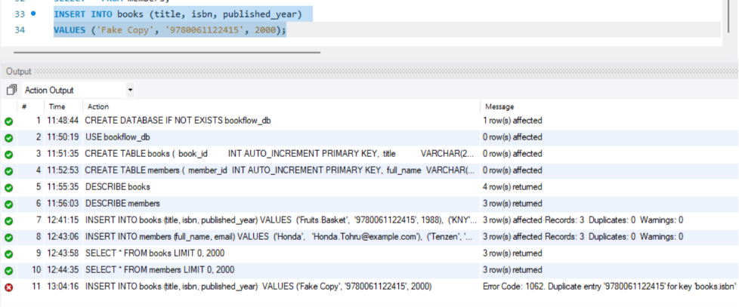
Test 2:
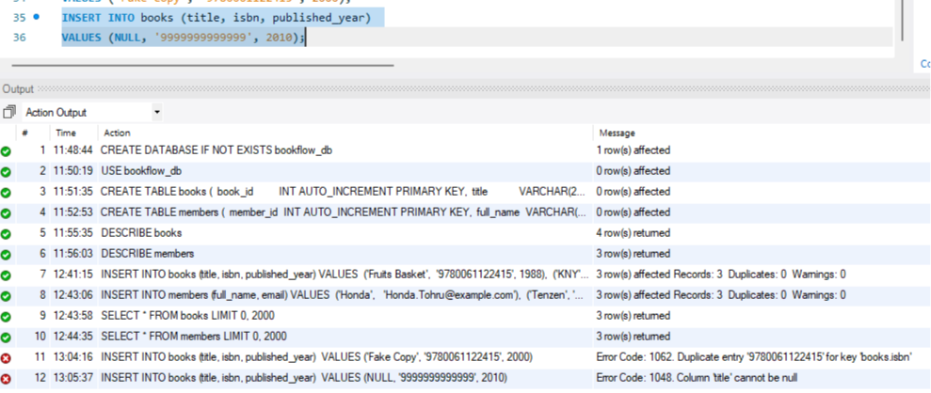
Test 3: Future publication year (CHECK violation):
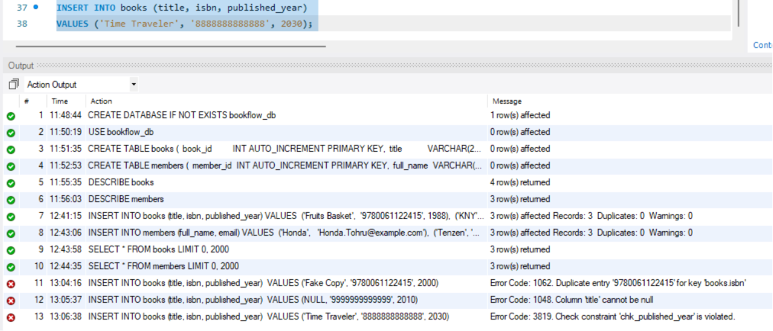
Test 4: Duplicate email (UNIQUE violation):
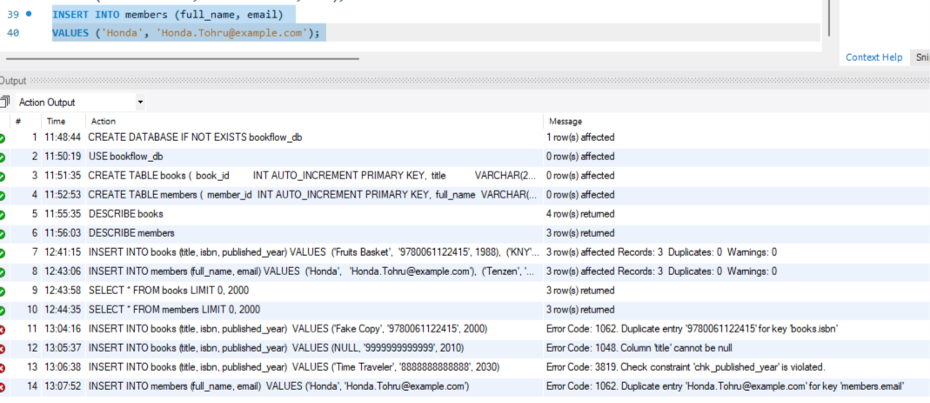
Conclusion:
The BookFlow database was successfully created with appropriate tables, constraints, and sample records, ensuring accurate and reliable management of books and members.

