DATABASE SYSTEMS ENGINEERING AND DISTRIBUTED BACKEND DEVELOPMENT

NAME : NARNE GREESHMA
ROLL NUMBER: 2520030080
WEEK-4

Step 1: Create Database
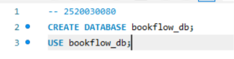
Output:
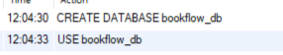
Step 2: Create Books Table
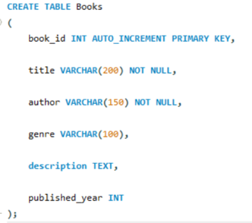
Output:
Step 3 : Check Table
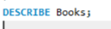

Output:
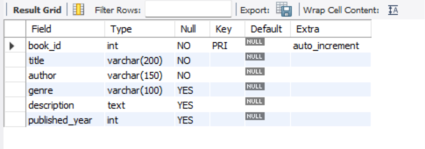
Step 4:Insert Book Data
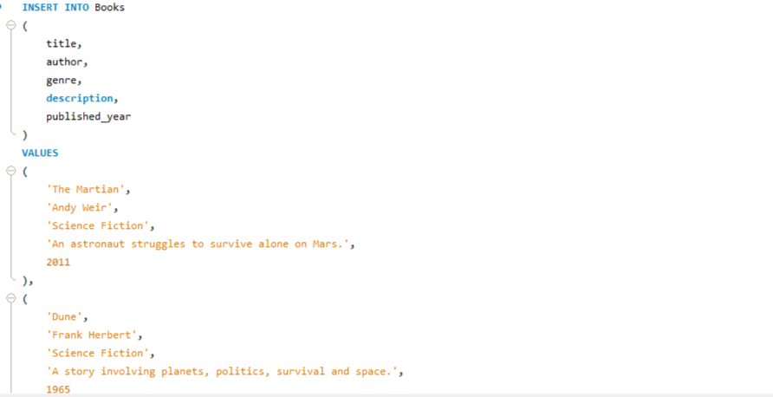
Output:
Step 5: Display Books
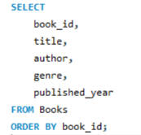
Output:
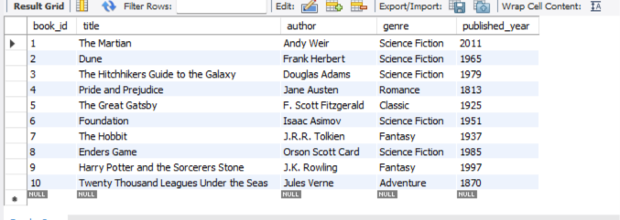

Step 6:Add Embedding Column
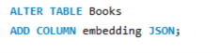
Output:
Check:
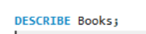
Output:
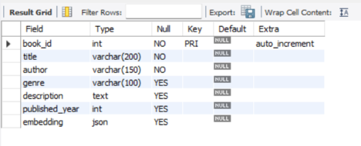
Step 7: Insert Mock Vectors:
BOOK 1 – THE MARTIAN:
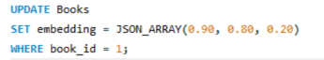
Output:
BOOK 2 – DUNE:
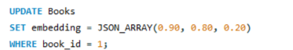
Output:

BOOK 3 – HITCHHIKERS GUIDE:
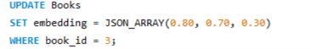
Output:
BOOK 4 – PRIDE AND PREJUDICE:
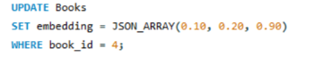
Output:
BOOK 5 – GREAT GATSBY:
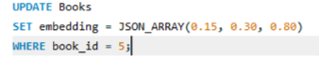
Output:
BOOK 6 – FOUNDATION:
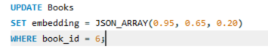
Output:
BOOK 7 – THE HOBBIT:
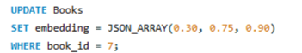
Output:

BOOK 8 – ENDERS GAME:
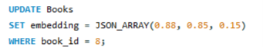
Output:
BOOK 9 – HARRY POTTER:
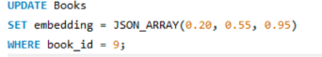
Output:
BOOK 10 – TWENTY THOUSAND LEAGUES:
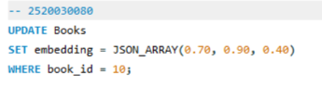
Output:
Step 8: Verify All Vectors
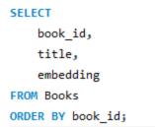
Output:
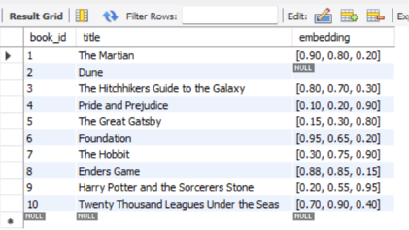
Step 9:L2 Distance
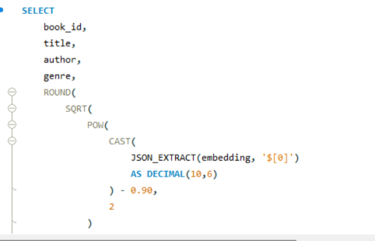
Output:
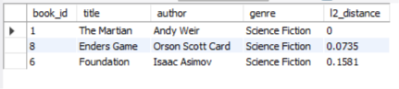
Part 10: Cosine Similarity:
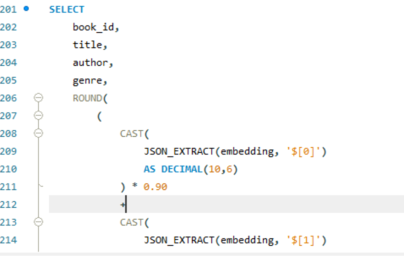
Output:
