

STUDENT CASE STUDY EXECUTION REPORT

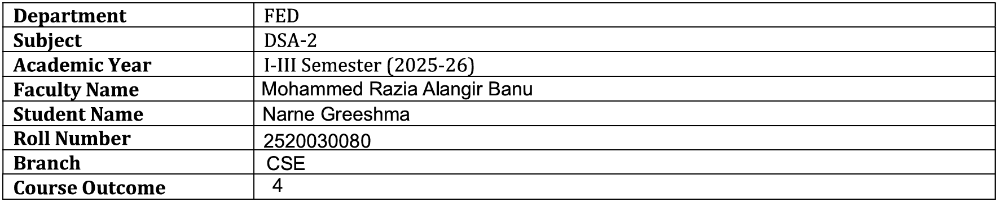
Case Study Topic: Emergency Ambulance Routing System using Dijkstra Algorithm
Work Done Summary:

In this case study, Dijkstra's Algorithm was implemented to find the shortest route for an ambulance to reach different hospitals. A weighted graph was used where locations were represented as nodes and road distances as edges. The algorithm calculated the minimum travel distance from the ambulance station to all hospitals. The shortest routes were displayed efficiently using a priority queue. This system helps improve emergency response time and demonstrates the practical application of graph algorithms in healthcare services.

Implementation Details:
- Created a weighted graph representing locations and road distances.
- Represented ambulance station and hospitals as graph vertices.
- Stored road distances as weighted edges.
- Applied Dijkstra's Algorithm to find shortest paths.
- Used a Priority Queue for efficient distance calculations.
- Displayed the minimum distance from the ambulance station to each hospital.
- Generated the shortest route information for emergency services.

Result: Screenshots / Output
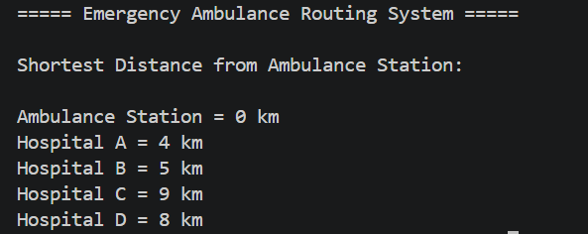

The Emergency Ambulance Routing System successfully identified the shortest and most efficient paths from the ambulance station to all nearby hospitals using Dijkstra’s Algorithm. The system accurately computed minimum travel distances by considering real road weights in the graph. The use of a priority queue improved the efficiency of route calculation, making the system suitable for real-time emergency scenarios. The output clearly displayed the optimal route and shortest distance for each hospital, helping to reduce response time. This demonstrates the practical effectiveness of graph algorithms in solving real-world transportation and healthcare routing problems.

Time Complexity:
O((V + E) log V)

Conclusion:
The Emergency Ambulance Routing System using Dijkstra’s Algorithm effectively determines the shortest and most optimal routes from the ambulance station to nearby hospitals. By modeling the road network as a weighted graph and applying a priority queue-based approach, the system ensures fast and accurate computation of minimum travel distances. This significantly reduces emergency response time and improves the efficiency of ambulance services. The case study demonstrates how graph algorithms can be successfully applied to real-world healthcare systems for better decision-making and life-saving outcomes.
GitHub Link:
https://github.com/NarneGreeshma/DSA2

