

STUDENT CASE STUDY EXECUTION REPORT


Case Study Topic: Online Gaming Leaderboard System using Quick Sort
Work Done Summary:

In this case study, Quick Sort was implemented to maintain an Online Gaming Leaderboard System. Player scores were stored in an array and sorted in descending order using Quick Sort with a pivot strategy. The leaderboard automatically ranks players based on their game scores, allowing efficient identification of top performers. Quick Sort efficiently handles large player datasets and provides fast ranking updates. The system demonstrates the practical application of sorting algorithms in gaming platforms and competitive e-sports environments.

Implementation Details:

- Stored player scores in an integer array.
- Implemented Quick Sort using a pivot-based partition method.
- Selected the last element as the pivot.
- Sorted scores in descending order.
- Generated leaderboard rankings after sorting.
- Displayed player scores before and after sorting.
- Identified the highest-scoring player.
- Analyzed Quick Sort performance using complexity metrics.

Result: Screenshots / Output
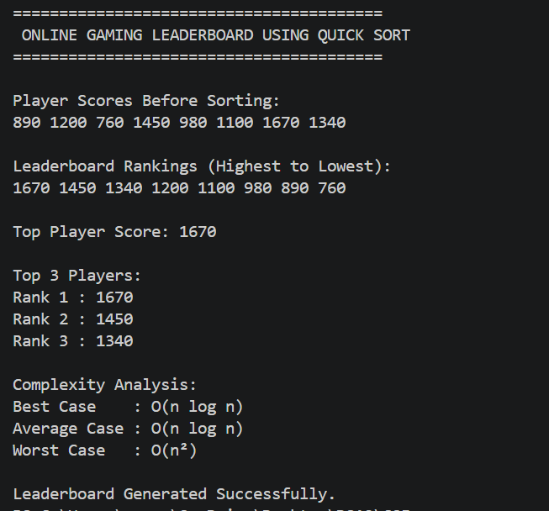

Time Complexity:
- Best Case: O(n log n)
- Average Case: O(n log n)
- Worst Case: O(n²)
- Quick Sort efficiently ranks players and updates leaderboard positions for large gaming datasets.
Conclusion:
The Online Gaming Leaderboard System using Quick Sort successfully ranked players based on their scores. By applying pivot-based partitioning, the algorithm efficiently sorted player records in descending order and generated a leaderboard. This case study demonstrates the practical use of sorting algorithms in online gaming platforms, e-sports tournaments, and competitive ranking systems.

GitHub Link:

https://github.com/NarneGreeshma/DSA2



