

STUDENT CASE STUDY EXECUTION REPORT


Case Study Topic: Amazon Product Price Index using AVL Tree
Work Done Summary:

In this case study, we implemented an AVL Tree to manage Amazon product prices efficiently. Product prices were inserted into the tree while maintaining balance through AVL rotations. We performed search, insertion, and deletion operations to analyze performance. The AVL Tree stored prices in sorted order and enabled quick retrieval of minimum and maximum prices. We observed that AVL Trees provide faster operations than regular BSTs due to their balanced structure. This implementation demonstrates an efficient solution for managing dynamic product pricing data in e-commerce systems.

Implementation Details:
- Created an AVL Tree data structure to store Amazon product prices in a balanced manner.
- Inserted product prices into the AVL Tree in the order:
2400, 1800, 3600, 2500, 4200, 1500, 3000, 5000
- Calculated the height and balance factor of each node after every insertion.
- Performed AVL balancing operations (LL, RR, LR, and RL rotations) whenever the balance factor exceeded the allowed range.
- Implemented in-order traversal to display all product prices in ascending order.
- Implemented a search operation to locate a specific product price quickly within the AVL Tree.
- Retrieved the minimum product price using the leftmost node and the maximum product price using the rightmost node.
- Compared AVL Tree performance with a standard Binary Search Tree (BST) and observed that AVL Trees maintain logarithmic search time due to self-balancing.
- Displayed the time complexities of insertion, search, deletion, and traversal operations.
- Verified that the AVL Tree maintained a balanced structure throughout all product price updates, ensuring efficient data management.

Result: Screenshots / Output
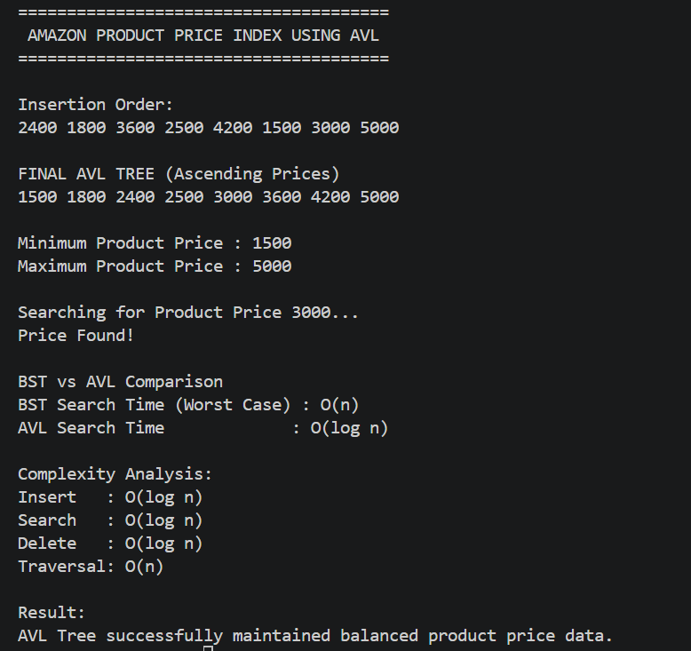

The Amazon Product Price Index was successfully implemented using an AVL Tree. Product prices were stored in sorted order while maintaining tree balance through rotations. The implementation provided efficient insertion, search, and retrieval operations, demonstrating the suitability of AVL Trees for managing dynamic product pricing data in large-scale e-commerce applications.
Time Complexity:
AVL Insert – O(log n)
AVL Search – O(log n)
AVL Delete – O(log n)
In-order Traversal – O(n)
Conclusion:
The Amazon Product Price Index using AVL Tree provides efficient management of product pricing data and ensures fast access to products even when the database contains a large number of entries.

GitHub Link:
https://github.com/NarneGreeshma/DSA2



