

STUDENT CASE STUDY EXECUTION REPORT
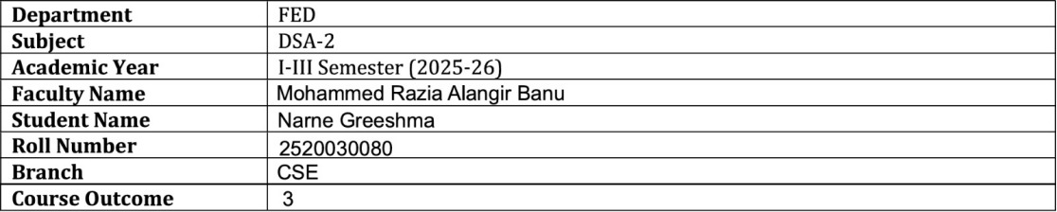

Case Study Topic: Netflix Content Recommendation Network using BFS
Work Done Summary:

In this case study, Breadth First Search (BFS) was implemented to simulate a Netflix Content Recommendation Network. Movies and TV shows were represented as graph nodes, while content similarities were represented as edges. BFS traversal was used to explore related content level by level and generate recommendations efficiently. The system analyzed connected content networks and suggested similar titles based on graph traversal. BFS proved effective in discovering nearby recommendations and exploring content relationships.

Implementation Details:

- Created a Graph class using adjacency list representation.
- Represented Netflix movies and TV shows as graph nodes.
- Connected similar content using graph edges.
- Implemented BFS traversal using a Queue.
- Used a visited array to prevent duplicate traversal.
- Generated recommendations level by level.
- Displayed connected content suggestions.
- Concluded BFS is suitable for recommendation systems and content discovery.

Result: Screenshots / Output:

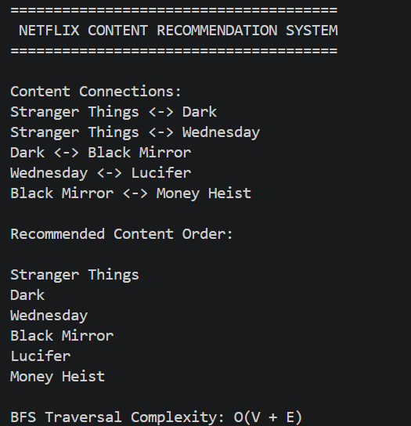

Time Complexity:
- BFS Traversal: O(V + E)
- Graph Construction: O(E)
- BFS efficiently explores connected content networks and generates recommendations level by level.
Conclusion:
The Netflix Content Recommendation Network using BFS successfully explored related content through graph traversal. By representing movies and TV shows as graph nodes and similarities as edges, the system efficiently generated recommendations level by level. BFS ensured complete exploration of connected content while avoiding repeated visits. This case study demonstrates the practical application of graph traversal algorithms in recommendation systems and content discovery platforms.

GitHub Link:

https://github.com/NarneGreeshma/DSA2

