OPERATING SYSTEMS AND SYSTEM PROGRAMMING
PRACTICAL – 02
1.Aim:
To develop a C program that uses the system calls open(), read(), write(), and close() to copy the contents of one file to another, and to use the strace utility to trace and analyze the system calls generated by cat sample.txt.
2.Objectives:
- Implement file copying using system calls.
- Understand file descriptors and file operations.
- Analyze the transition between user space and kernel space.
- Trace system calls using strace.
- Identify the kernel services involved in file access and data transfer.

3.Software Requirements:
Requirement | Details
Operating System | Ubuntu Linux / WSL2
Language | C
Compiler | GCC
Build Tool | GNU Make
Tracing Tool | strace
Editor | Nano / VS Code
4.Procedure:
- Create a source file containing sample text.
- Open the source file using open() with read-only permission.
- Create the destination file using open().
- Read data from the source file using read().
- Write the data to the destination file using write().
- Close both file descriptors using close().
- Verify that the copied file matches the source file.
- Create sample.txt for system-call tracing.
- Execute strace cat sample.txt.
- Analyze the important system calls generated during execution.
5.User Space and Kernel Space:
The C program runs in user space and invokes open(), read(), write(), and close() as system calls. These calls transfer control to the Linux kernel, where the requested file operations are performed, and the results are returned to the user program.
6. C PROGRAM — practical2.c:
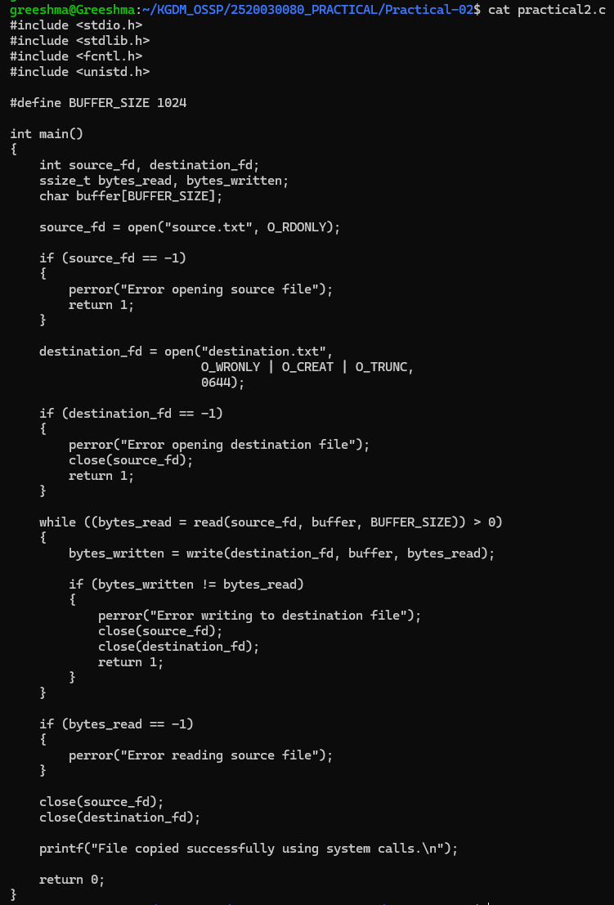

7.MakeFile:
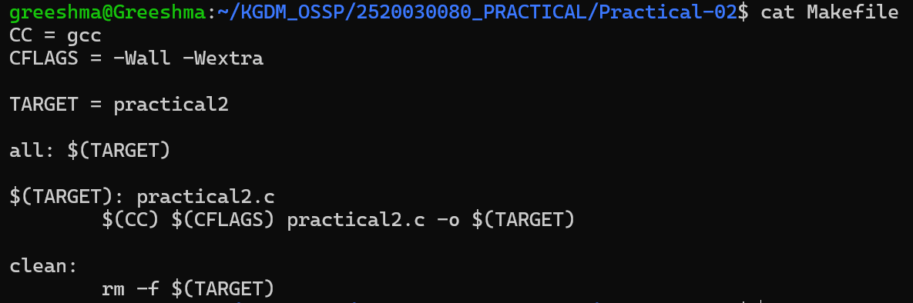
8.OUTPUT:
