OPERATING SYSTEMS AND SYSTEM PROGRAMMING
SKILL-02
Aim:
To create an interactive shell loop that displays a prompt, reads user input, handles exit conditions, and manages keyboard input including backspace, Enter key, input buffering, and multi-character commands.
Software Requirements
- Ubuntu Linux (WSL2)
- GCC Compiler
- GNU Make
- Linux Terminal
- C Programming Language
Procedure
- Open the Ubuntu terminal and navigate to the Skill-02 directory.
- Create the skill2.c source file.
- Implement an interactive main loop that continuously displays the OSSP> prompt.
- Configure the terminal to capture keyboard input character-by-character.
- Store entered characters in an input buffer.
- Implement Backspace handling to remove the previously entered character.
- Process the Enter key to complete the current input.
- Check the input for the exit command and terminate the loop when it is entered.
- Test normal, multi-character, empty and corrected inputs.
- Create and test a Makefile for automated compilation.

Control Flow Diagram:
┌─────────┐
│ START │
└────┬────┘
↓
┌─────────────────┐
│ Enable Raw Mode │
└───────┬─────────┘
↓
┌─────────────────┐
│ Display "OSSP>" │
└───────┬─────────┘
↓
┌─────────────────┐
│ Read Keyboard │
│ Input │
└───────┬─────────┘
↓
◇ Backspace? ◇
/ \
YES NO
↓ ↓
┌──────────────┐ ◇ Enter? ◇
│Remove Character│ / \
└──────┬───────┘ YES NO
│ ↓ │
└──────────→ Complete │
Input │
↓ │
◇ Is "exit"? ◇ │
/ \ │
YES NO │
↓ ↓ │
┌──────┐ ┌───────────┐
│ EXIT │ │Display │
└──────┘ │Input │
└─────┬─────┘
↓
Display Prompt
│
└──────→ Read Input
C CODE: (skill2.c)
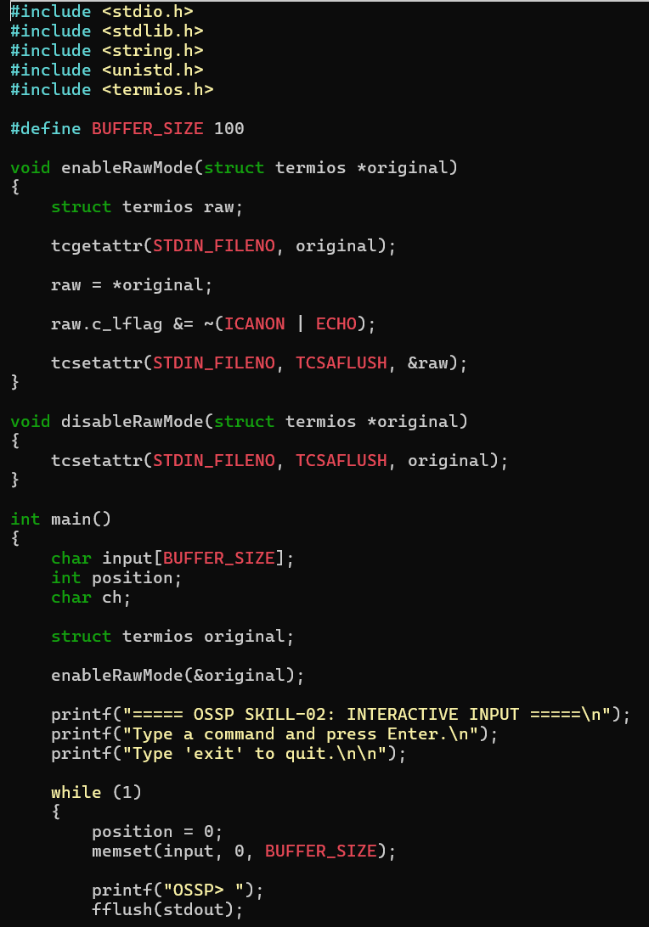
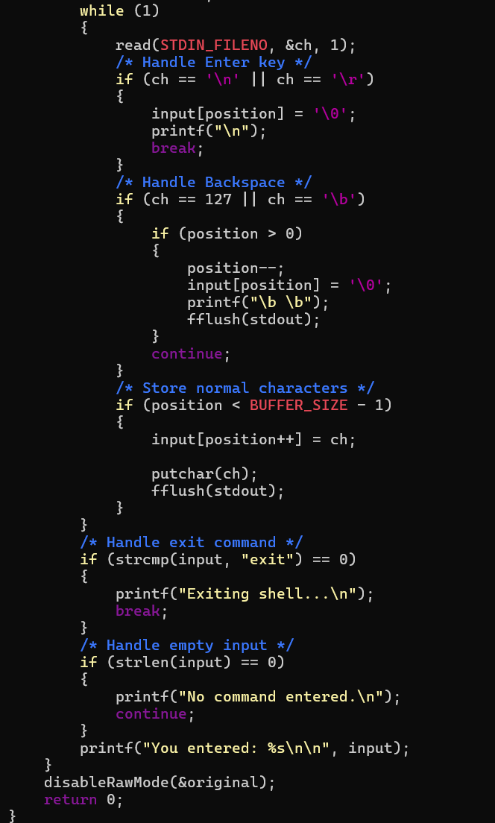

Makefile:
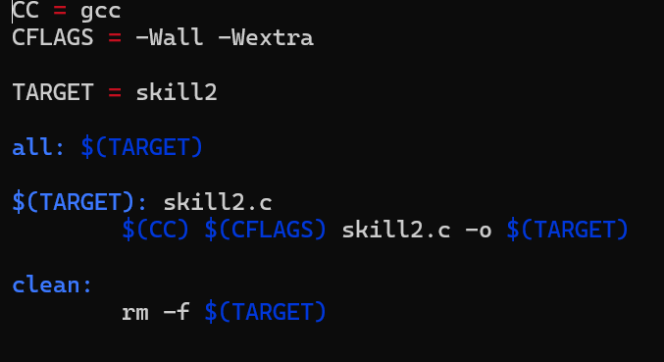
OUTPUT:
