OPERATING SYSTEMS AND SYSTEM PROGRAMMING
WEEK-1
TASK-1
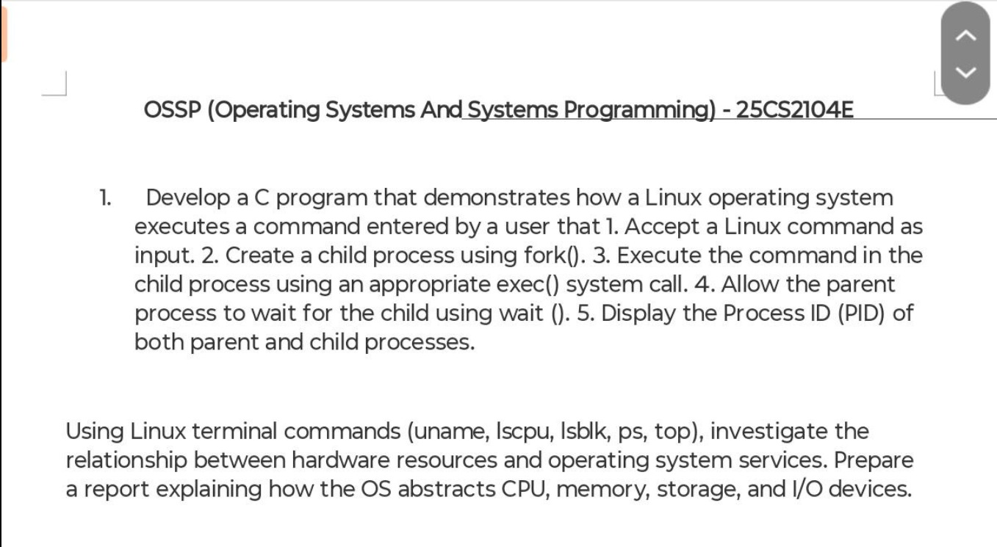

Aim:
To develop a C program that demonstrates how the Linux Operating System executes a command entered by the user by creating a child process using fork(), executing the command using exec(), allowing the parent process to wait using wait(), and displaying the Process IDs (PIDs) of both parent and child processes
Software Requirements:
- Ubuntu 24.04 LTS (WSL2)
- GCC Compiler
- Linux Terminal
Procedure:
- Open the Ubuntu terminal.
- Create a C source file named process.c.
- Write the program using fork(), execlp() and wait().
- Compile the program using the GCC compiler.
- Execute the program.
- Enter a Linux command such as pwd, ls, whoami, or date.
- Observe the Parent Process ID and Child Process ID displayed on the terminal.
- Verify that the parent process waits until the child process completes execution.
C Code:
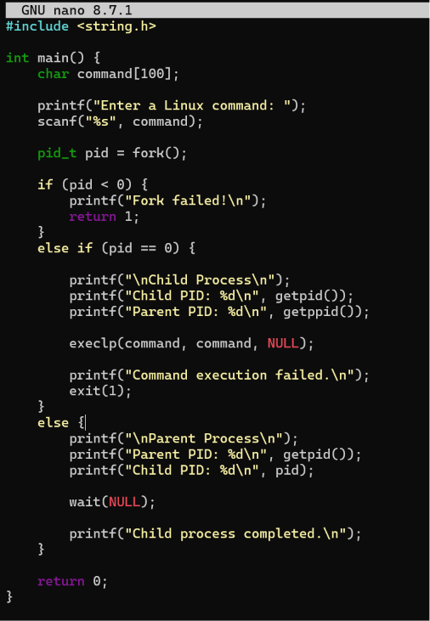
For compilation:
gcc process.c -o process
Execution
./process
Output Screenshot
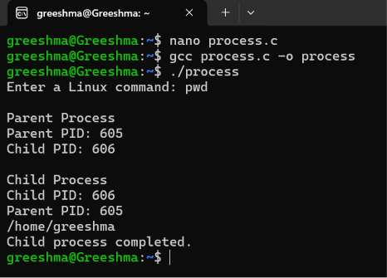

Conclusion
The program successfully demonstrates process creation using fork(), command execution using execlp(), synchronization using wait(), and displays the Process IDs of both parent and child processes in the Linux operating system.

