OPERATING SYSTEMS AND SYSTEM PROGRAMMING
Skill-01
Aim:
To configure a Linux development environment using Ubuntu WSL, GCC, Git and Make, understand Linux shell architecture, and analyze process management using fork(), exec(), parent-child relationships, process tree inspection and system call tracing.
Software Requirements:
- GCC Compiler
- Git
- GNU Make
- Linux Terminal
- pstree • Ubuntu 24.04 LTS (WSL2)
- strace
Procedure:
- Open the Ubuntu terminal.
- Verify the Linux environment.
- Configure and verify GCC.
- Verify Git, Make and strace.
- Create and configure the OSSP Git repository structure.
- Understand the Linux shell architecture and execute basic shell commands.
- Create an initial Makefile and compile the C program.
- Execute fork() to create a child process.
- Use exec() to execute another program and analyze the parent-child relationship.
- Inspect the process tree and trace system calls using pstree, ps -f and strace.

C CODE: (skill1.c)
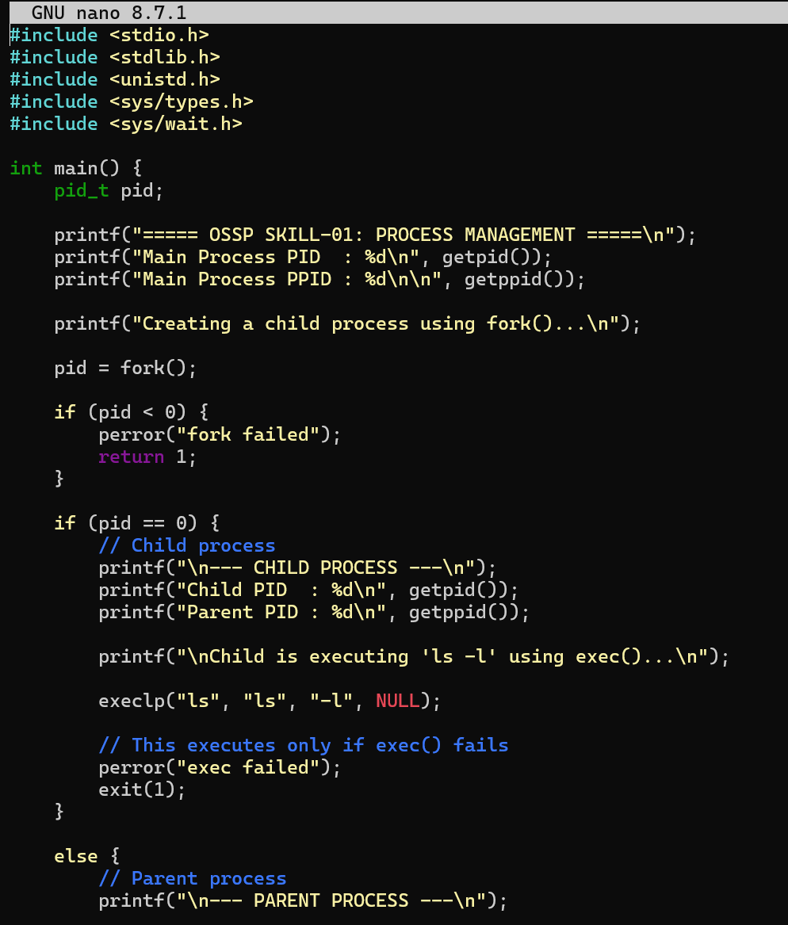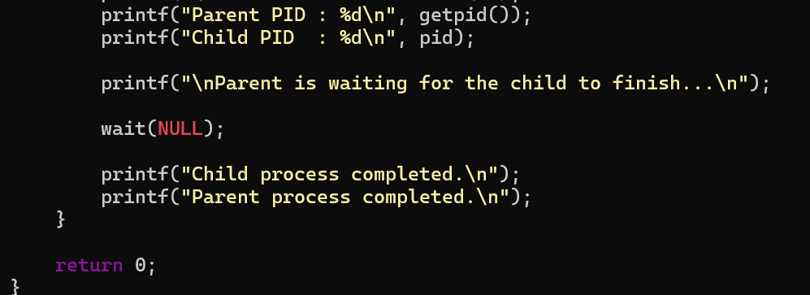
The program demonstrates process creation using fork(), identifies the parent and child using PID and PPID, executes the ls -l command using exec(), and synchronizes the parent process using wait().
Makefile:
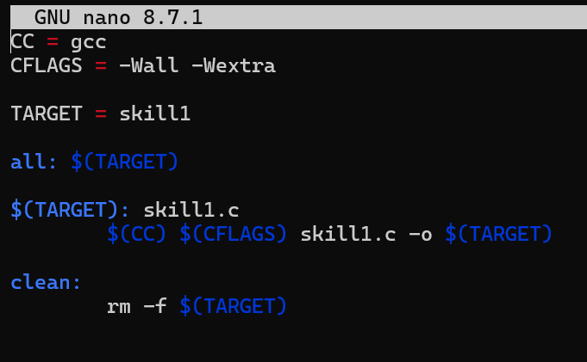
OUTPUT SCREENSHOT:
