Electricity Consumption Forecasting

Introduction:
In this project, I work on electricity consumption data collected every 15 minutes from 1:15 of 1st January 2010 until 23:45 of 18th February 2010. There are two time series one is outdoor temperature and the other one is electricity consumption that we are interested in forecasting for the next day.

Data Analysis and Preparation
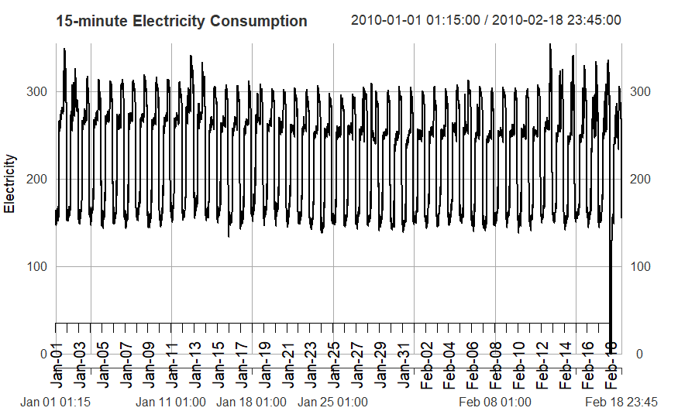
Firstly, I renamed the columned "Power (kW)" to “power”, “Temp (C°)" to "temp" and "Timestamp" to "time" and extracted data from the excel file just until 23:45 of 18th February 2010. Then I plot the power as below:

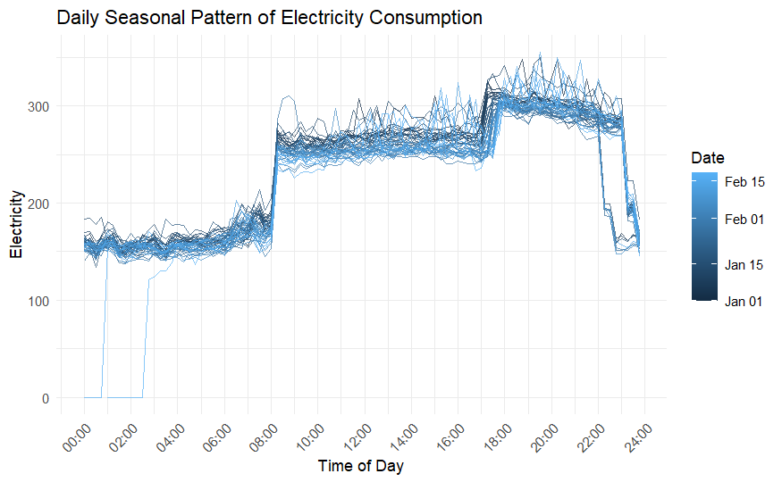
I see that there seem to be daily seasonality in this series and I confirmed with the below seasonality plot.
From the seasonality plot, we can see that there is daily pattern in this data set:
- From midnight until 8 am, the power consumption is around 150 to 200
- From 8 until 18, the power consumption is about 250 to 300
- From 18 until 23, the consumption is around 300 to 350.
However, there are some drops at the beginning of 18th Feb. so I decided to take the last two days as testing set so that we don't see a big error due to these drops and when I perform forecast for the next days by using the whole dataset, I imputed those drops so that the forecast can me more accurate.
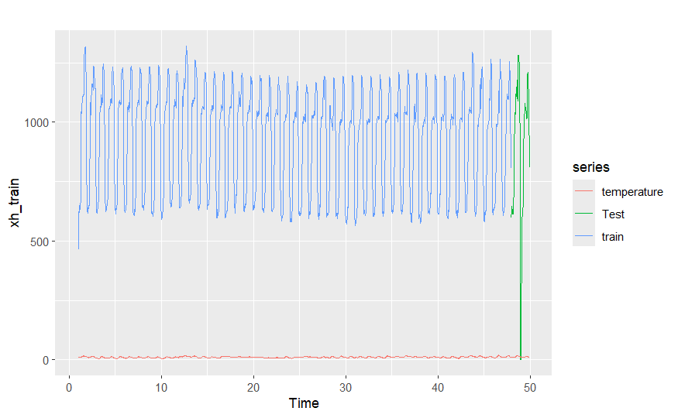
Secondly, I aggregated the data into hourly data by summing the electricity power and averaging the temperature group by day. I did this in order to make the all forecasting models work and make them run faster and this is also because the function hw doesn’t work with the frequency of 96. After that I took the last 48 hours as testing set and the remaining as training set as below plot.

Models Comparison
In order to compare all the forecasting models, I performed cross validation by using the training set. I take a window of 24 observations as validation fold and all the previous observations before those 24 observations as training fold. The window started from the first observation of the 5th day, which is at 0:00 so the first training fold is the first 4 days of the training set which are from first day at 0:00 until the 4th day at 23:00. Each iteration the window moves by one day, the forecasting models are fitted using the training fold, forecast the data the testing fold and I stored the computed mean absolute percentage error between the forecasts and the testing fold. After the cross validation I computed the mean and standard deviation of mean absolute percentage error of each folds.

Exponential Smoothing Models
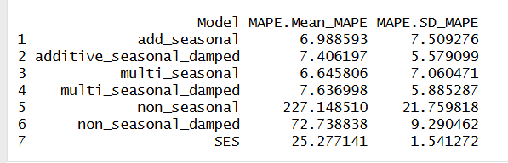
Firstly, I compare simple exponential smoothing, non-seasonal exponential smoothing, additive seasonal and multiplicative exponential smoothing and all those models with damped and as the result the multiplicative holt winter model has the lowest average of mean absolute percentage error as we can see below:

ARIMA Models
As there is daily seasonality in the data, I performed one difference operation on the data with lag 24 in order to make it stationary. From below seasonal plot of the diff(data, lag=24), we can conclude that there is no more clear seasonal patterns.
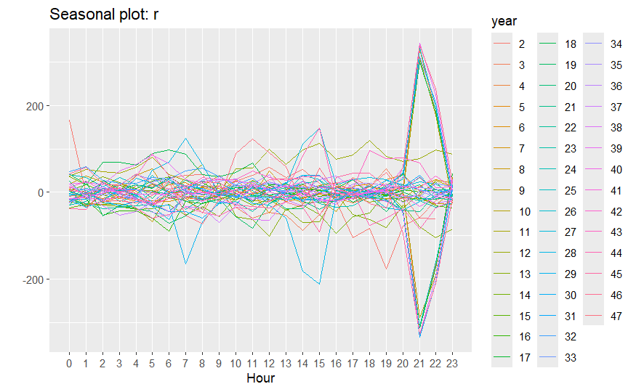

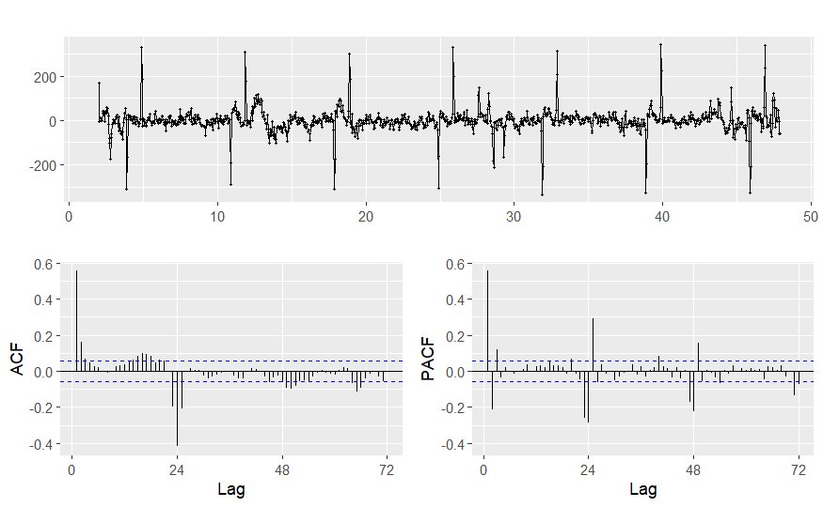
Next, I check the residual correlation in the below plot and I see that in PACF plot there is exponential decrease of the partial autocorrelation every season and in ACF plot, after the first season there is no significant autocorrelation. So, I tried ARIMA(0,0,0)(0,1,1)24

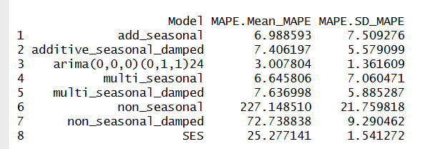
Then I performed cross validation with this model, and the result average MAPE is lower than all the Exponential smoothing models.

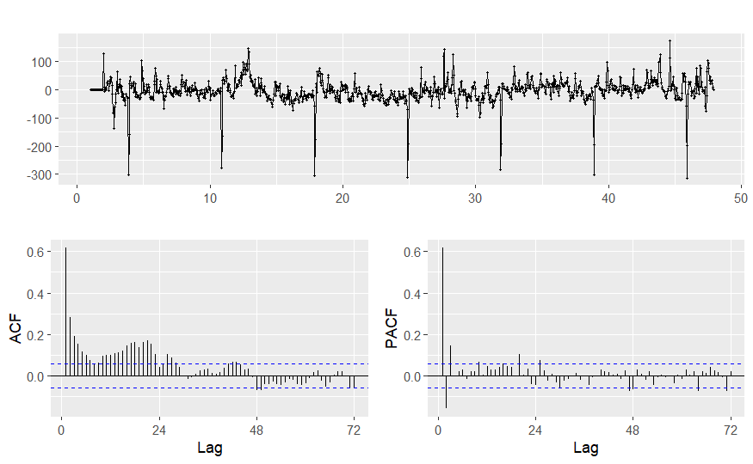
However, when I look at the residuals of this model, there are still correlations as below:

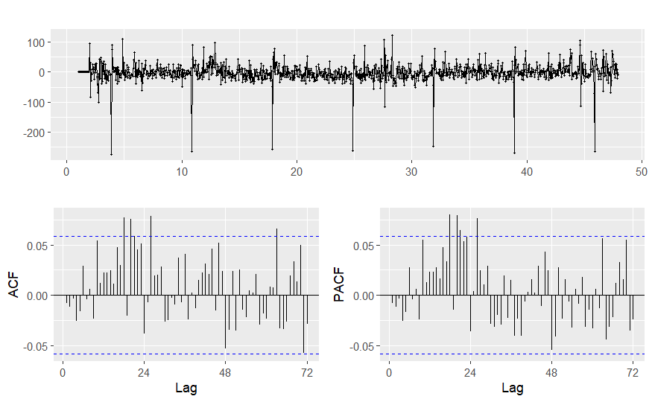
In the In ACF plot of the residuals we can see the decrease of autocorrelation and in the PACF we see that after the lag 3 there is no more significant autocorrelations, so I tried autoregressive of order 3: Arima(3,0,0)(0,1,1)24. However, there are still correlations as shown in the below plot:

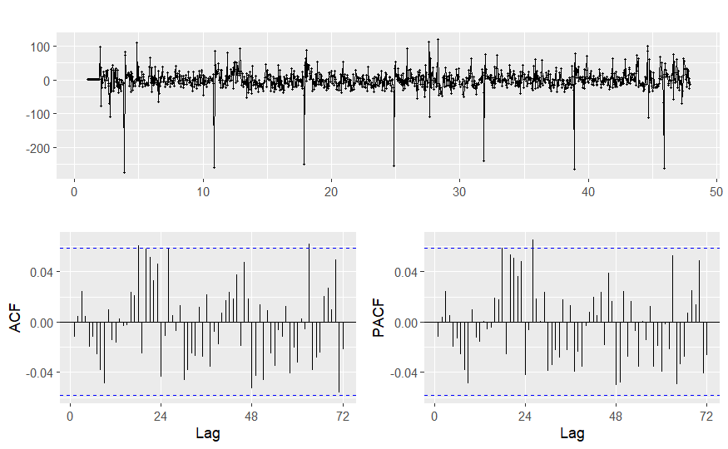
Then I tried to increase the order of moving average to 3 so the model becomes Arima(3,0,3)(0,1,1)24 and there is no more significant correlation in the residuals:
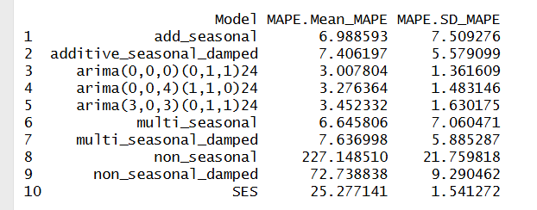
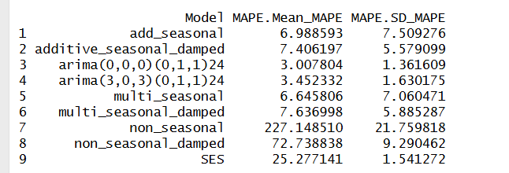
I came back to perform cross validation and as we can see in the below result, the Arima(3,0,0)(0,1,1) doesn’t perform better than the previous one:
I tried also the model proposed by auto.arima function which is Arima(0,0,4)(1,1,0) and it does not perform better neither:
Neural Network Autoregressive
I turned the neural network model by searching for the best combination of autoregressive lag p, seasonal lag P and the number of neurons k that fit with the training set. I found the best parameters are p=25, P=0 and k=3.
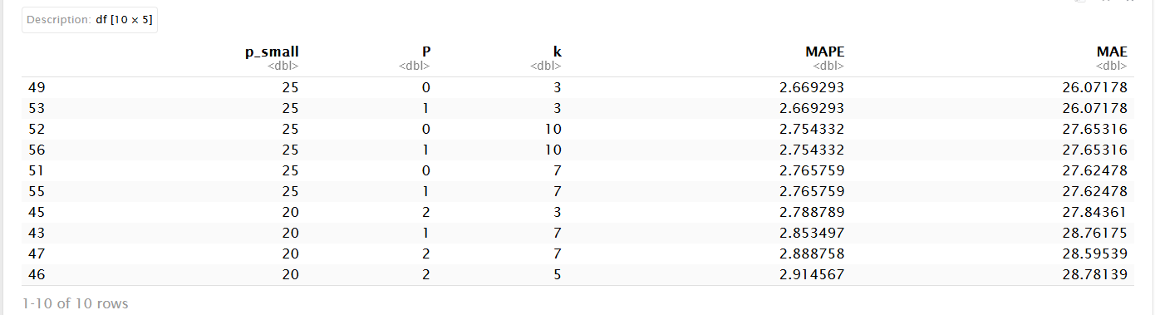
With those parameters, I came back to perform cross validation to compare the model with the best parameters I found, and the neural network model proposed by automatic by nnetar function with the previous models. As we can see from the below result, the tunned neural network is slightly better than the model proposed by the nnetar function but still not better than Arima(0,0,0)(0,1,1).
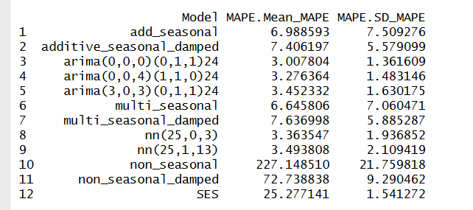
Recurrent Neural Network
I tried to tune RNN manually by looking at the validation curve to make sure that the model learning without becoming overfitted. I chose the window of 24 observations as input to train the model with 10 neurons, batch size of 64 and 20 epochs.
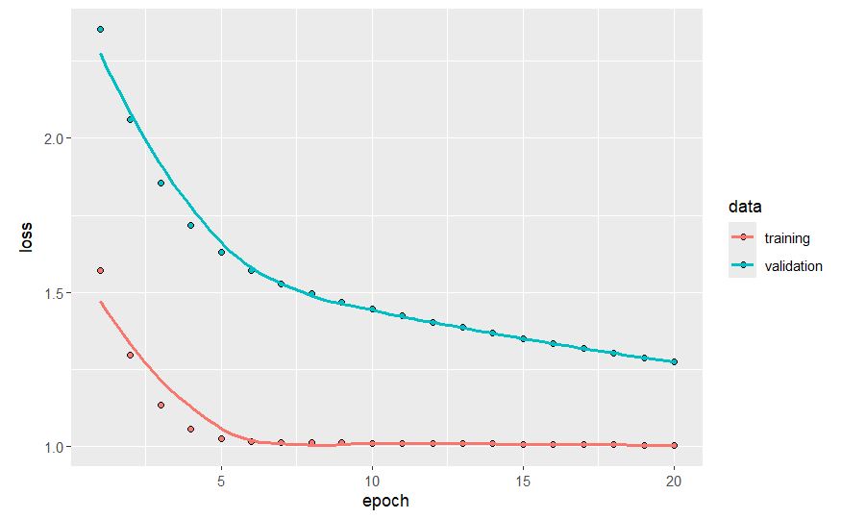

Then I checked the forecast of RNN for the testing dataset and Arima MAE is 70.01404 while RNN MAE is 257.0453 which is much worse. The plot of the forecast below we clearly see that RNN can’t be used to forecast the future of our time series.

Random Forest
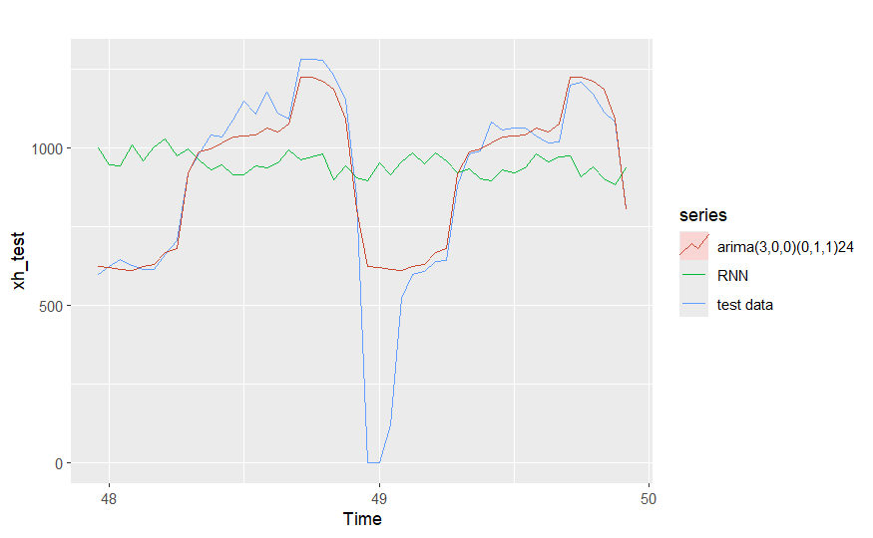
I tunned random forest model with the training set by searching for the best combination of number variable to be split mtry and size of the input window. The best parameters I found are mtry = 25 and window = 30.
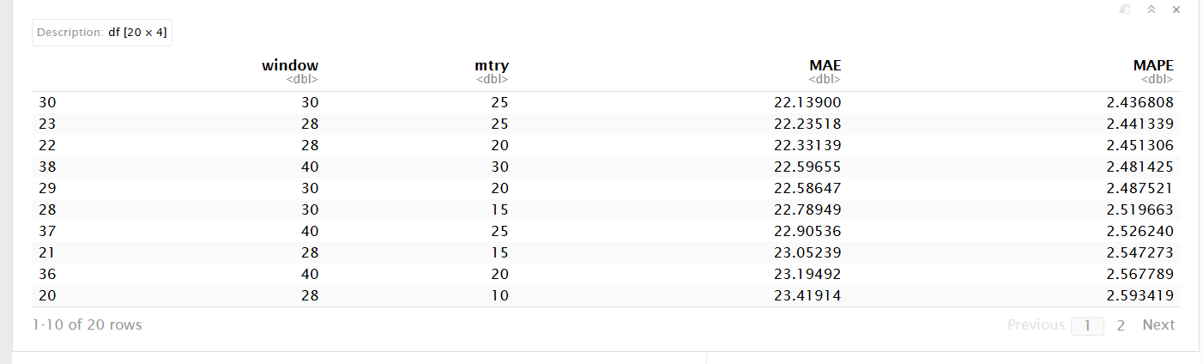
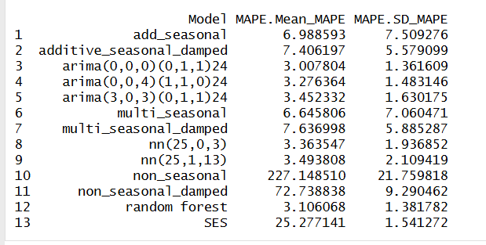
With those parameters I come back to cross validation and we can see from the below result that it is better than other models but still can’t beat the Arima(0,0,0)(0,1,1).
XGBoost
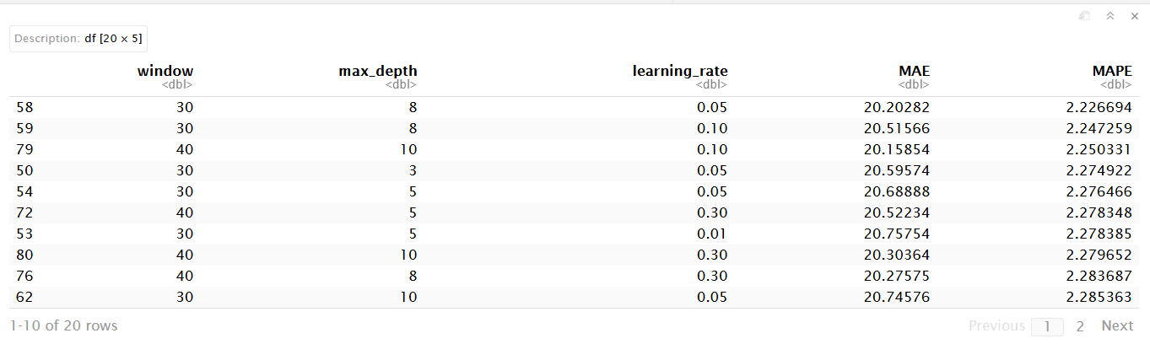
Similarly, I tunned XGboost model by searching for the best combination of the maximum depth, learning rate, and input window size. The best parameters are window = 30, max_depth = 8 and learning rate = 0.05.
With cross validation result, we can see that XGboost doesn’t perform the best.
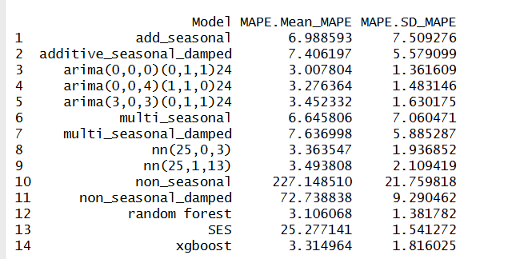
SVM
The same for SVM it doesn’t win over ARIMA.
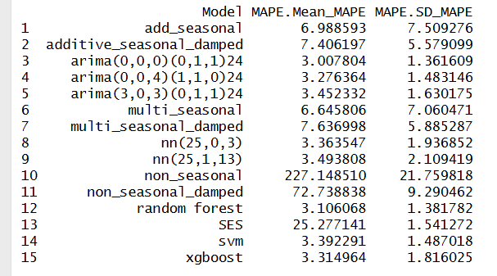
Forecast with covariate
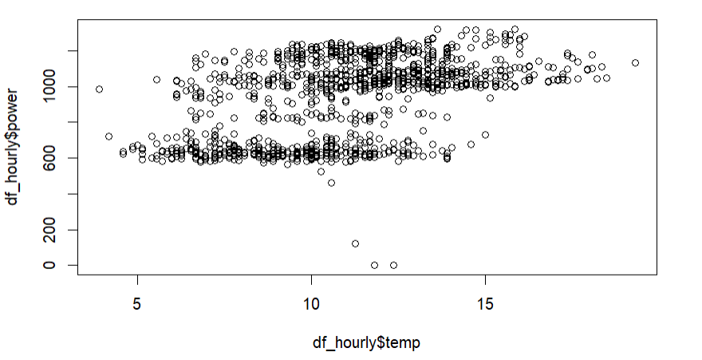
Since we have seen many models and none of them performed better than ARIMA, next I tried to use temperature time series to help the forecast of electricity consumption. First, I tried to look if there is any relationship between the two series:
From this plot we don’t see a strong relationship between the two series, but we can see that when the temperature is more than 15 the consumption seems to be higher than 700. When the temperature is around 5 the power consumption is less than 1000
First I use lstm function to extract the residuals:

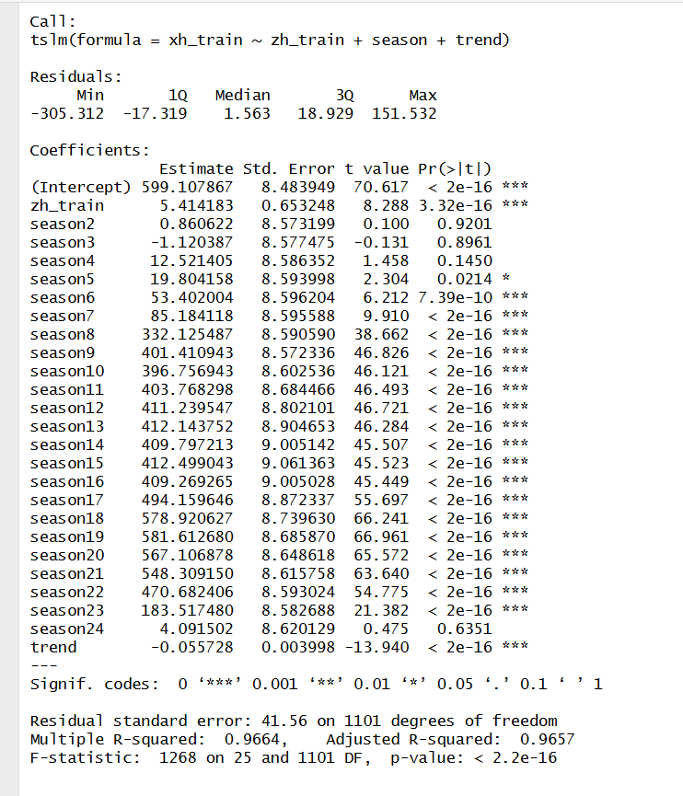
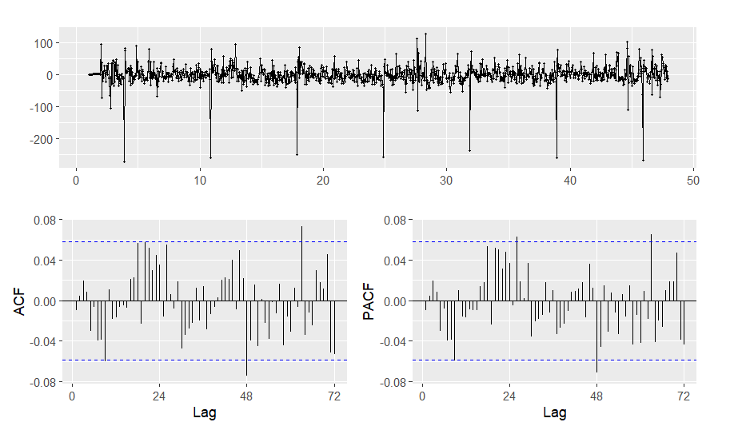
From this tslm summary, we see that most of the coefficient are significant, and we have positive coefficient for the temperature and the trend is negative. In the residual plot below we can see that there is correlation and seasonality.

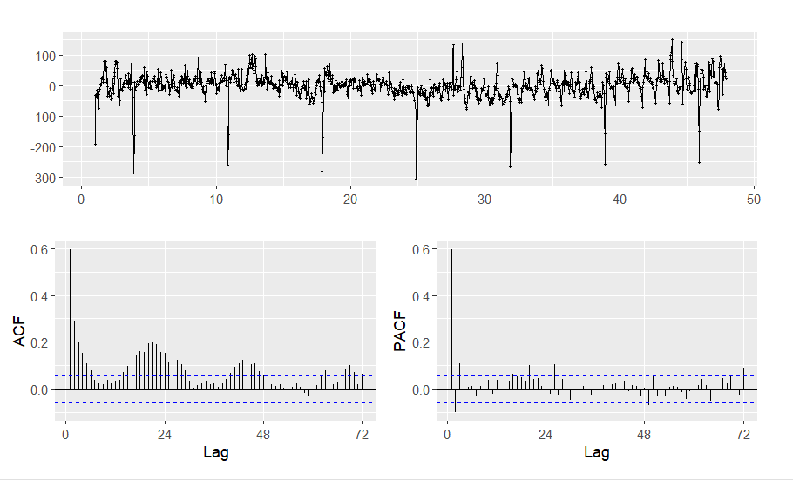
Similar to what I did previously for Arima model, I found the Arima(3,0,3)(0,1,2) can modelized all the correlation in the residuals

I performed cross validation on all the Arima I fitted with covariates that I found to compare with all the previous models I tried and as the result no model can win against Arima (0,0,0)(0,1,1)
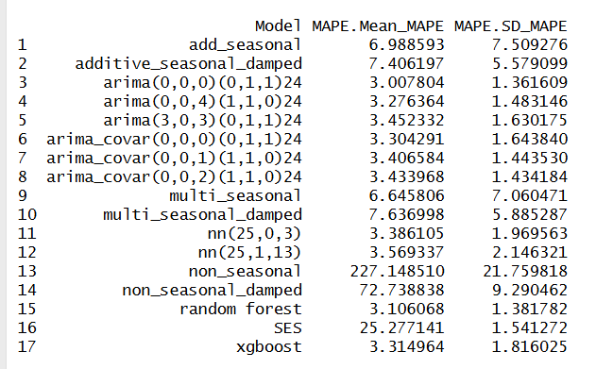

The same for Neural network, Random Forest, and XGBoost, the covariate doesn’t help them to perform better
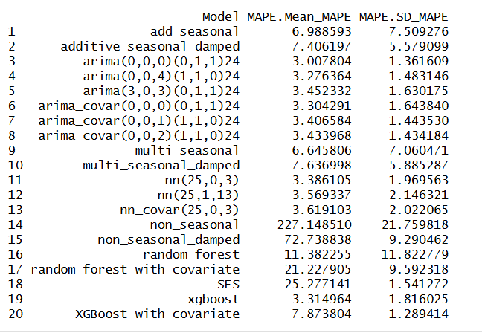
Weighted Near Neighbor
After implementing the WNN model, I tuned the parameters with hourly data by performing cross validation with different combinations of window, and k. I found that the best parameters are window = 35 and k = 5.
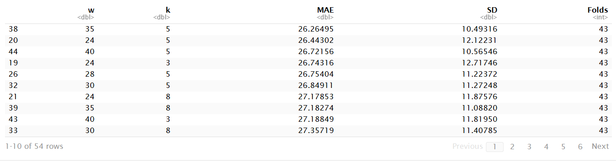
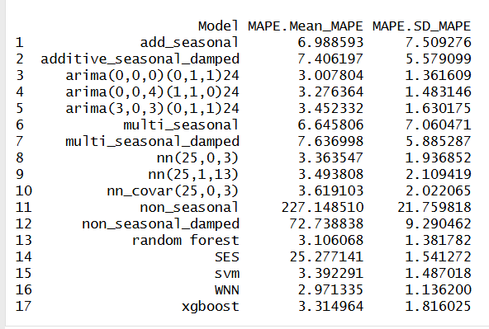
Then I come back to check cross validation errors with all the previous models and as the below result, WNN performs the best among all the models so far.
However, when I fitted those model, whose errors in average are small around 3 on cross validation, with the full training data and forecast on the test set and then computed test error. It turned out that Arima model with covariate and order (0,0,2)(1,10) performed the best. However, it is just on one test set.
Therefore, I decided to select the Arima(0,0,0)(0,1,1) to forecast the future value because it is the most stable one among others even in cross validation WNN performed slightly better it but on test set the Arima(0,0,0)(0,1,1) is better than WNN. While the Arima with covariate (0,0,2)(1,1,0) performed the best on test set but it could be the best just only on one test set because we saw in cross validation it didn’t perform the best.
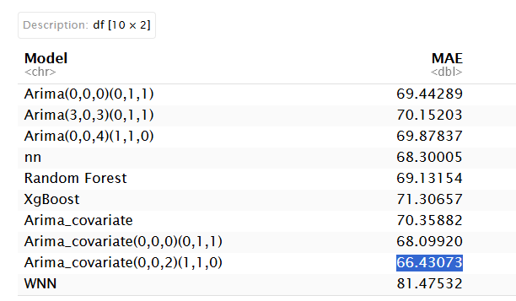
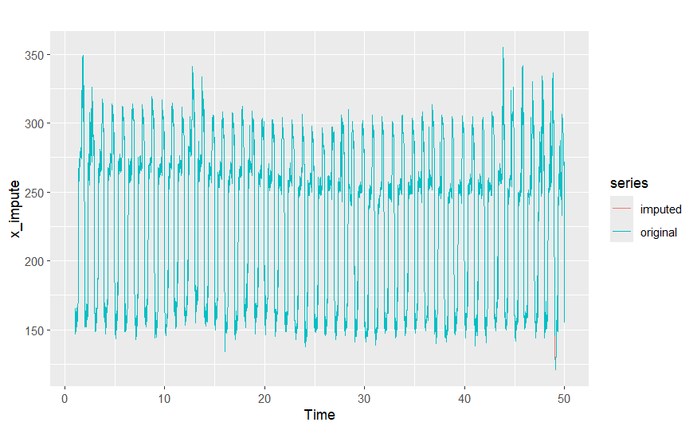
Finally, I came back to the original data with frequency = 96. I imputed the data whose value = 0 before fitting all the available data to forecast the next future day. I used the function na_seadec and algorithm is interpolation.
Here is the final forecast:
