User Stories & Use Cases
for the OpenCDC Initiative
Fourth Draft · May 3, 2026
OpenCDC is a proposed standard for the structure and semantics of database change events. Any compliant producer — CDC tool or database — can interoperate with any compliant consumer — tool, pipeline, or application — without custom translation, regardless of transport.

This document describes six use cases for an OpenCDC specification, organized by complexity and working-group priority:
# | Story | Priority
1 | Interoperability of mixed-vendor CDC tools | ● Core
2 | Same-type databases, different CDC tools | ● Core
3 | Unified lakehouse/warehouse CDC ingestion | ● Core
4 | Database fire-and-forget to streaming pipeline (no CDC tools) | ○ Stretch
5 | Database-to-database sync without CDC tools | ○ Stretch
6 | AI agent reactive CDC event stream | ○ Stretch

Core stories are the initial focus of the working group. Stretch stories represent conceptually important use cases for mid- and long-term consideration. Non-goals: we explicitly intend for this specification to remain focused on payload, not the transport. Therefore, all mentions of databases, CDC tools and transports in this document are intended as examples only.
Why now, for OpenCDC?
The rise of AI, streaming, and real-time data architectures has made change data the backbone of modern enterprise systems. Yet despite CDC becoming ubiquitous infrastructure, there is still no standard for how change events are represented and exchanged. That gap forces organizations into custom integration logic — fragmentation, duplicated effort, and inconsistent semantics that compound with every new source and consumer.
CDC tools solved how to detect and capture change. OpenCDC standardizes the remaining layer: the structure and semantics of the change event itself, enabling any producer to interoperate with any consumer regardless of vendor, database, or transport.

1. Interoperability of Mixed-Vendor CDC Tools
As a DBA in a large enterprise IT organization, I want CDC tools from different vendors to exchange change events — produced by different database types — using a common payload format, so that I can synchronize customer data across business unit databases without deploying additional CDC infrastructure or writing custom integration code.
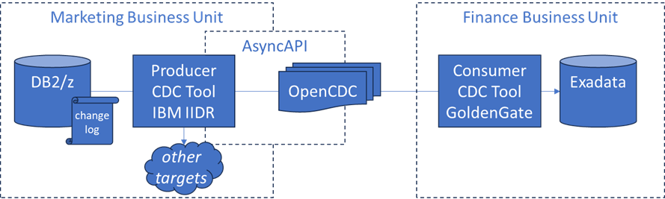

Background
Two business units each maintain their own customer database and have independently adopted CDC tools:
- Marketing runs IBM IIDR on a DB2/zSeries system
- Finance runs Oracle GoldenGate on an Exadata system

A new requirement mandates that selected customer tables be kept in sync across both systems in real time. The traditional options — deploying a third-party replication tool across both environments, or building a bespoke translation layer between the two vendors’ proprietary formats — are expensive and operationally risky in regulated enterprise settings.
Both IBM and Oracle have recently shipped OpenCDC CloudEvents as an optional output format, and both expose AsyncAPI-compliant interfaces. This enables direct point-to-point event exchange without a shared message broker.

Acceptance Criteria
Change events emitted by IIDR on DB2 can be consumed directly by GoldenGate on Exadata without transformation, and vice versa.
Events conform to the OpenCDC CloudEvents specification: operation type, before/after record state, source metadata, and a monotonic sequence identifier.
Only the configured subset of tables participates in cross-system replication.
No new CDC software is installed on either host system.
The synchronization survives a transient network outage by resuming from the last acknowledged sequence position.
A DBA can validate event conformance against the OpenCDC schema without vendor-specific tooling.

2. Same-Type Databases, Different CDC Tools
Specialization of Story 1. Because both databases share an engine family, type-semantic fidelity requirements are stricter.
As a DBA in a large enterprise IT organization, I want Debezium and Fivetran to exchange change events using the OpenCDC format over a cloud message stream, so that I can replicate data from AWS Aurora PostgreSQL to an on-premises PostgreSQL database by composing two already-deployed CDC tools — without installing new software on either system or risking data loss from type-semantic differences.
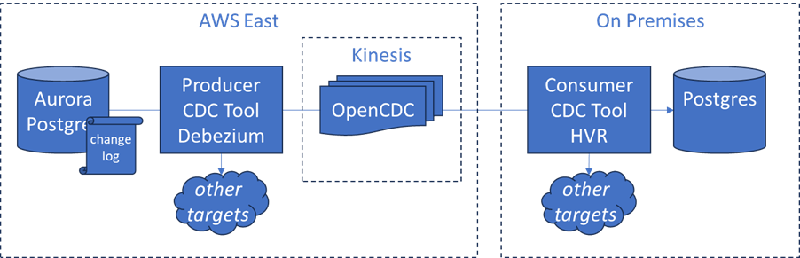

Background
A critical dataset lives in AWS Aurora PostgreSQL. A corresponding copy must stay in sync on an on-premises PostgreSQL instance — a slightly older community build running in a private data center.

Both environments already have CDC tooling running for unrelated purposes:
- Cloud (Aurora): Debezium captures change events for an AWS data warehouse pipeline
- On-premises (Postgres): Fivetran/HVR ingests data from other sources into the on-prem database

The obvious alternative — native PostgreSQL logical replication — is unreliable here: the version gap between Aurora PostgreSQL and the on-premises instance, combined with network constraints and restrictions on installing extensions, makes that path operationally risky. Standing up a new CDC tool on either side means new infrastructure, new security approvals, and impact on already-stable production workloads.

The OpenCDC Solution
Both Debezium and Fivetran/HVR have added support for OpenCDC-formatted events over Kafka/Kinesis topics. The path forward requires no new software on either side:
- Debezium publishes a filtered set of Aurora table changes as OpenCDC events to an AWS Kinesis stream — alongside its existing data warehouse feed, with no disruption to that pipeline
- Fivetran/HVR consumes from that Kinesis stream and applies the OpenCDC events to the on-premises PostgreSQL database

The two tools never need to know anything about each other. They only need to agree on the event format — and OpenCDC is that agreement.

Aurora PostgreSQL
│
Debezium
│
├──► Confluent (existing DW feed)
│
└──► Kinesis (new OpenCDC stream)
│
Fivetran/HVR
│
On-Premises PostgreSQL

Why OpenCDC Is the Critical Enabler
Aurora PostgreSQL and community PostgreSQL are not identical engines. They diverge in subtle but important ways: data type representations, system column behavior, and how certain operations are encoded in the WAL. Without a common specification, translating a Debezium event formatted for Aurora’s dialect into something Fivetran can reliably apply to on-prem Postgres requires custom mapping logic — exactly the brittle glue code that creates long-term maintenance burden and silent data quality risk.

OpenCDC resolves this by providing:
- Canonical type semantics. PostgreSQL data types are represented consistently in the OpenCDC envelope, versioned by the spec, so numeric precision, timestamp timezone handling, and array types arrive on-prem exactly as they left Aurora.
- Consistent operation semantics. INSERT, UPDATE, DELETE, and TRUNCATE are expressed identically regardless of which tool emitted the event.
- Full before/after state. Both tools agree on what the before and after record fields mean, enabling correct conflict detection and idempotent application on the consumer side.
- Sequence and transaction metadata. Events carry monotonic identifiers and transaction boundaries, so Fivetran can apply changes in the correct order even if events arrive out of sequence.

Acceptance Criteria
Debezium publishes OpenCDC-formatted change events for a configured set of Aurora tables to an AWS Kinesis stream without modifying or disrupting its existing data warehouse feed.
Fivetran/HVR consumes those events from Kinesis and applies them to the on-premises PostgreSQL database using its existing deployment — no new agents or connectors installed.
PostgreSQL data types (including numerics, timestamps, arrays, and JSON) are preserved without loss or coercion between Aurora and on-prem Postgres.
Multi-row transactions are applied atomically on the on-premises side.
A schema change on the Aurora source is reflected in the event stream in a way the on-prem consumer can detect and handle gracefully.
No new CDC software is installed on either the Aurora environment or the on-premises Postgres host.
The pipeline can be validated end-to-end using the OpenCDC schema specification without vendor-specific tooling.

3. Unified Lakehouse/Warehouse CDC Ingestion
As a Data Platform Engineer responsible for ingesting CDC feeds into a Bronze-layer lakehouse, I want all upstream CDC tools to emit events in a common OpenCDC format, so that I can build and maintain a single, unified ingestion pipeline instead of writing and managing bespoke format handlers for every source system.
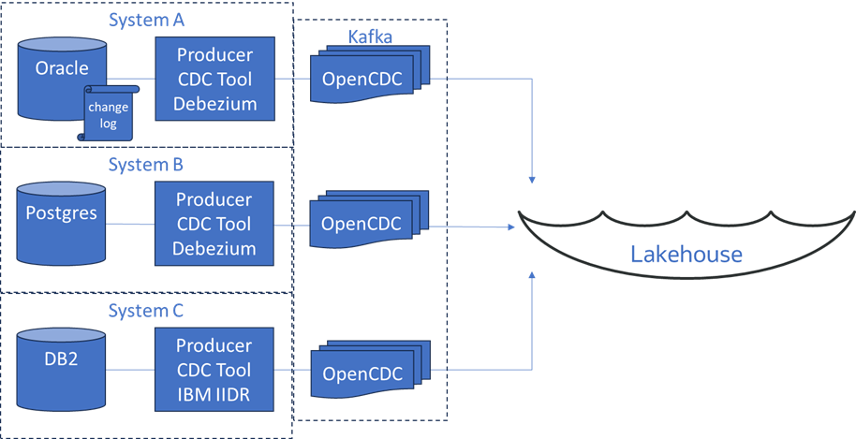

Background
The Bronze layer is the raw landing zone for dozens of source feeds, many of them CDC event streams. Today, those streams arrive in whatever format the upstream tool produces — and no two tools produce the same thing:
- Debezium on Oracle: one payload shape, one set of transaction semantics
- Debezium on PostgreSQL: similar, but with subtly different field names, type representations, and LSN-based sequencing
- IBM IIDR on DB2 LUW: a third proprietary format with its own before/after record structure and commit metadata

Despite being conceptually identical — “here is what changed, and how” — each source requires separate parsing logic, schema mapping, and transaction ordering treatment. The result:
- Three independent ingestion code paths to build, test, and maintain
- Three different interpretations of before state, delete, and transaction boundary
- Inconsistent handling of edge cases (schema changes, null values, large object types) across pipelines
- Every new CDC source risks introducing yet another format variant

The cost is not just engineering time — it is data quality risk. Subtle differences in how each pipeline interprets its source format create inconsistencies that propagate into Silver and Gold layers and ultimately into business reporting.

The OpenCDC Difference
As upstream teams adopt CDC tools that support OpenCDC as a native output format, the Data Platform Engineer can retire per-source format handlers one by one — replacing them with a single shared ingestion processor that understands the OpenCDC event envelope.

The normalized OpenCDC event provides, consistently across all sources:
- Operation type (INSERT, UPDATE, DELETE, TRUNCATE)
- Full before and after record state
- Source metadata (database, table, timestamp, partition)
- A monotonic sequence identifier enabling reliable ordering and deduplication
- Transaction boundaries, allowing atomic multi-row operations to be applied correctly

Acceptance Criteria
A single ingestion pipeline component processes OpenCDC events from Debezium (Oracle), Debezium (PostgreSQL), and IBM IIDR without source-specific branching logic.
Before/after record state, operation type, and sequence position are accessible via consistent field paths regardless of the originating tool or database.
DELETE events are represented uniformly and do not require source-specific null-handling workarounds.
Transaction boundaries are preserved such that multi-row commits land atomically in the Bronze layer.
Adding a new OpenCDC-compliant source requires configuration only — no new parsing code.
The ingestion pipeline can validate an incoming event against the OpenCDC schema without knowledge of the upstream vendor.

4. Database Fire-and-Forget to Streaming Pipeline
○ Stretch Story — No CDC tools deployed
As a Stream Processing Data Engineer building real-time logistics pipelines, I want on-premises PostgreSQL databases at regional shipping hubs to continuously emit change events in OpenCDC format over Arrow Flight, so that my Flink pipelines can react to inventory and shipment changes as they happen — without polling, without deploying a full CDC tool stack, and without adding operational complexity to hub systems my team does not own.
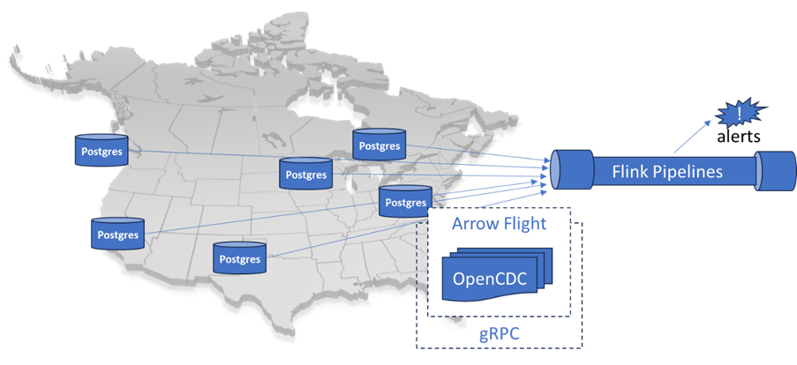

Background
My company operates just-in-time assembly lines that depend on a nationwide logistics network. Shipment delays — weather, supply disruptions, trucking pauses, warehouse backlogs — have direct downstream consequences for production schedules.

My team owns the stream processing layer. We run Flink pipelines that aggregate, correlate, and route logistics events from dozens of sources. Management has asked us to integrate live inventory change feeds from 10 regional shipping hub databases. As shipments pass through each hub, the hub’s PostgreSQL inventory system records arrival, departure, status updates, and exceptions — most critically in the bill of lading table, which is the canonical record of what is on each truck or container and where it is going.

Why Not the Obvious Approaches?
- Polling SQL queries. A query every 5 minutes is not a live feed — it is a delayed snapshot. In just-in-time logistics, a 5-minute lag on a shipment exception is too slow, and polling puts load on databases my team does not control.
- Full CDC tool deployment. Debezium, GoldenGate, and similar tools provide exactly-once guarantees, schema history, and durable replay — all genuinely valuable. But they also require agent installation on systems owned by regional IT teams, broker infrastructure to manage, security reviews per site, and ongoing operational ownership across 10 geographically distributed locations. For the data quality guarantees we actually need, this is more infrastructure than the use case warrants.

The OpenCDC Arrow Flight Approach
A PostgreSQL extension enables the database to emit a continuous stream of OpenCDC-formatted change events directly over Arrow Flight (gRPC/TLS) — no additional middleware, no broker, no agent beyond enabling the extension.

Regional Hub Postgres
(OpenCDC Arrow Flight extension)
│
gRPC / TLS
│
Flink Source (Arrow Flight consumer)
│
Flink Pipeline
(aggregation, alerting, routing)

Each hub database streams change events for subscribed tables continuously. Flink connects as a gRPC client, receives Arrow record batches containing OpenCDC envelopes, and processes them in the pipeline. Each event carries the full before/after image of the changed row, the operation type, a timestamp, and source metadata identifying the hub and table.

Why This Fits
This is a genuinely “live on the wire” scenario. The business question is not “give me a consistent historical view of all shipments” — it is “tell me right now if something at a hub is changing in a way I need to react to.” That distinction matters:
- We are reacting to events, not reconciling datasets
- Brief stream gaps during outages are acceptable — we had a gap in real-time awareness, not a data integrity failure
- At-least-once delivery with idempotent downstream handling is sufficient; exactly-once is not required
- We do not need durable replay — on reconnect, we pick up from the current stream position

OpenCDC provides the normalization layer across all 10 hubs: every hub emits the same event envelope regardless of local schema variations, Postgres version differences, or regional IT customizations. The Flink source connector sees a uniform stream — one pipeline handles all 10 sources. Arrow Flight fits naturally into our existing gRPC infrastructure, is secured with TLS, and requires no broker at hub sites.

Acceptance Criteria
The Flink pipeline receives change events from all 10 hub PostgreSQL databases over Arrow Flight without polling or scheduled queries.
Events conform to the OpenCDC specification: operation type, before/after record state, source metadata, and sequence position are consistently structured across all hub sources.
The Flink source reconnects automatically after a transient network interruption and resumes consuming from the current stream position.
A single Flink source implementation handles all 10 hub connections without source-specific parsing logic.
Events are secured in transit via TLS on all hub connections.
No agent installation or broker infrastructure is required at hub sites beyond enabling the Postgres extension.
Loss of events during a planned or unplanned stream outage is acceptable and does not constitute an SLA breach.

5. Database-to-Database Sync Without CDC Tools
○ Stretch Story — No CDC tools, no Kafka
As a DBA keeping a few tables in sync between AWS Aurora PostgreSQL and an on-premises SQL Server database, I want the simplest possible setup — ideally without installing or managing separate tools. I want both databases to directly emit and consume OpenCDC change events over a managed messaging service, so that I can maintain near-real-time data consistency without deploying or operating dedicated CDC or streaming infrastructure.
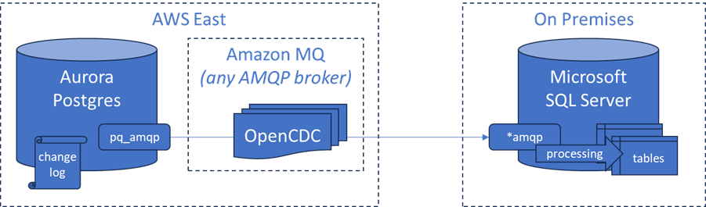

Background
A hybrid enterprise application spans cloud and on-premises environments:
- Primary transactional system: AWS Aurora PostgreSQL (cloud)
- Downstream operational system: Microsoft SQL Server (on-premises)

Only a subset of tables — primarily customer reference data and order status — need to stay in sync. Near-real-time is required; delays of a few seconds are acceptable.

The DBA team faces several constraints:
- Full CDC tools (Debezium, GoldenGate) introduce infrastructure, operational overhead, and security review processes the team cannot absorb
- Kafka or similar platforms are considered too heavyweight for this limited scope
- Native database replication is not viable due to cross-vendor incompatibilities and network constraints
- The team is willing to use a managed messaging service (AWS SQS/SNS, Azure Service Bus, or an MQ-compatible system), but does not want to build custom event formats or transformation logic

The OpenCDC Approach
Both databases expose lightweight built-in capabilities or installable extensions that enable them to:
- Emit change events in OpenCDC format directly from transaction logs or triggers
- Publish those events to a managed messaging service
- Subscribe to the same channel and apply incoming OpenCDC events to local tables

Each database acts as both a producer of its own changes and a consumer of the other system’s changes. No external CDC tool is deployed.

Why OpenCDC Is the Critical Enabler
PostgreSQL and SQL Server have fundamentally different data type systems (NUMERIC vs. DECIMAL precision handling, datetime semantics), transaction log formats, and change capture mechanisms. Without a common event specification, direct interoperability requires custom transformation logic, per-table mapping rules, and ongoing maintenance as schemas evolve.

OpenCDC eliminates these challenges through:
- Canonical payload structure. Both systems emit and consume the same event envelope.
- Consistent operation semantics. INSERT, UPDATE, DELETE are represented identically across both engines.
- Before/after record state. Enables correct application of updates and deterministic conflict handling.
- Source metadata and sequencing. Ensures correct ordering and traceability across systems.

Because OpenCDC is transport-agnostic, the DBA team can use whatever managed messaging service fits their environment without affecting payload compatibility.

A Note on Bidirectional Sync and Loop Prevention
This story requires bidirectional event flow, which introduces a loop risk: a change originating in SQL Server must not be re-emitted back to SQL Server after Aurora applies it.

OpenCDC’s source metadata — specifically the originating system identifier in the event envelope — provides the mechanism for loop detection. Each database’s consumer must be configured to suppress re-emission of events whose source identifier matches its own. The exact implementation of this filter is expected to be addressed in the OpenCDC specification.

Acceptance Criteria
Aurora PostgreSQL emits OpenCDC-formatted change events for a configured subset of tables directly to a managed messaging service without requiring an external CDC tool.
SQL Server consumes those events and applies them to corresponding tables, preserving data integrity and operation semantics.
SQL Server emits its own OpenCDC-formatted change events for the same subset of tables, which are consumed and applied by Aurora PostgreSQL.
Events include operation type, before/after record state, source metadata, and a monotonic sequence identifier consistent with the OpenCDC specification.
Data types are preserved across PostgreSQL and SQL Server without loss of precision or semantic ambiguity.
Multi-row transactions are applied in order and maintain logical consistency on both sides.
A transient network or messaging outage does not result in data corruption; processing resumes from the last successfully applied event position.
Loop detection prevents an event originating in one system from being re-emitted after the other system applies it, using OpenCDC source metadata.
No dedicated CDC tools (Debezium, GoldenGate, Kafka) are installed or required in either environment.
A DBA can validate event conformance using the OpenCDC schema specification without vendor-specific tooling.

6. AI Agent Reactive CDC Event Stream
○ Stretch Story — Proposed future capability
As an AI Engineer building a collaborative agent framework for HR onboarding, I want AI agents to autonomously request and consume OpenCDC change event streams from existing CDC infrastructure across multiple enterprise systems, so that onboarding workflows can react to real-time state changes across HR, IT, Facilities, and Security — eliminating the multi-day batch delays that today cause new employees to wait weeks for basic onboarding steps to complete.
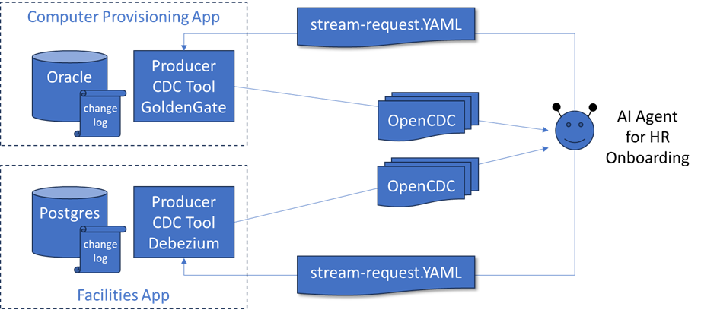

Background
Onboarding a new employee at a large enterprise requires coordinated state changes across many independent systems: HCM (employee record, job classification, start date), IT provisioning (laptop, software licensing), Facilities (desk and floor access), Security (badge and access level), and Payroll/Benefits (enrollment windows).

Today, these systems do not communicate in real time. Each runs its own batch ETL process — nightly, or every few hours at best. Delays compound: a one-day lag from HCM to IT means the laptop order is placed late; a further lag to Facilities means the desk is not assigned until the laptop is almost ready to ship. What should be a same-day coordinated process routinely takes two weeks.

Many of these systems are legacy applications with no outward-facing APIs. Direct integration is not possible. However, most have databases that are accessible, and several already have CDC tools running — not for integration, but for read-replica maintenance or data warehouse feeds. That existing CDC infrastructure becomes the integration surface.

The Agent Architecture
A collaborative AI agent framework built on a reactive event model. Rather than polling or waiting for batch updates, each agent subscribes to change event streams from the systems it cares about and acts when relevant state changes occur:

Enterprise Databases (HCM, IT, Facilities, Security)
│
Existing CDC Tools
(Debezium on Postgres, GoldenGate on Oracle)
│
OpenCDC Event Streams (Kafka / AsyncAPI)
│
┌─────┴──────┐
│ AI Agent Framework │ ◄── reacts to events
└─────┬──────┘
│
Downstream Actions
(welcome email, IT ticket, badge, manager notify)

This is a Transaction Outbox pattern with an AI agent as the consumer. The CDC tool reliably captures committed database state changes and delivers them as events. The agent interprets those events in business context and decides what to do next.

Proposed Capability: Agent-Initiated Stream Requests
Note: The following capability — allowing an AI agent to dynamically request a new CDC stream without manual DBA configuration — is a proposed future extension to the OpenCDC specification. It is not assumed to be present in an initial version of the standard.

The proposed mechanism: an agent submits a structured request document to a compliant CDC tool describing which business objects it wants to observe and where it wants events delivered. The CDC tool authenticates the request, validates the agent’s permissions, self-configures the appropriate table subscriptions and filters, and opens the requested stream.

Example: Facilities desk assignment via Debezium on PostgreSQL
opencdc: v1
request:
consumer:
id: onboarding-agent-facilities
auth: bearer <agent_token>
source:
database: facilities_db
objects:
- entity: room_assignment
filter:
status: [ASSIGNED, PENDING, RELEASED]
- entity: desk_inventory
filter:
availability: [AVAILABLE, RESERVED]
delivery:
transport: kafka
topic: agent.facilities.assignments
format: opencdc
qos: at-least-once

Debezium authenticates the agent token, confirms read permissions on the relevant tables, maps business object names to underlying PostgreSQL tables, configures the logical replication slot and publication filter, and begins emitting OpenCDC events to the specified Kafka topic. No DBA intervention required.

What an OpenCDC Event Looks Like to the Agent
Regardless of whether the event came from Debezium on Postgres or GoldenGate on Oracle, the agent receives the same CloudEvents-compatible envelope structure. The agent reads data.op, data.before, and data.after from consistent field paths regardless of source system. A desk assignment event from Facilities and a laptop shipment event from IT are processed by the same event handler — no per-system parsing, no format translation, no bespoke integration code.

The New Onboarding Workflow in Motion
When | Event | Agent Action
Day 0, 9:00 AM | HCM record created (INSERT) | Initiates downstream requests
Day 0, 9:01 AM | IT provisioning order submitted (INSERT) | Logs order, sets expectation timer
Day 0, 9:02 AM | Facilities desk assigned (UPDATE) | Sends desk confirmation to new employee
Day 1, 2:15 PM | Laptop shipped (UPDATE) | Notifies new employee and manager
Day 3, 10:30 AM | Badge record created in Security (INSERT) | Triggers building access confirmation email

Total elapsed: 3 days, driven by actual system events.
Previous experience: 10–14 days, driven by batch windows.

Acceptance Criteria
An AI agent can submit an OpenCDC stream request to a Debezium endpoint and receive change events on the specified Kafka topic without manual CDC configuration by a DBA.
An AI agent can submit an OpenCDC stream request to a GoldenGate endpoint and receive change events on the specified AsyncAPI channel without manual Extract configuration.
Both CDC tools authenticate the agent’s identity and enforce data access permissions before opening any stream.
Change events from Postgres (via Debezium) and Oracle (via GoldenGate) arrive at the agent in an identical OpenCDC envelope structure, processed by a single event handler without source-specific branching.
The agent can filter requested events by business object type and status values — receiving only the state transitions relevant to onboarding workflows.
An onboarding milestone that previously required a batch ETL window (up to 24 hours) is triggered within seconds of the underlying database record changing state.
The agent can request, consume, and act on streams from at least four distinct enterprise systems without requiring API access to any of them.

