Worksheet 3: Morphological processing + Segmentation

**Name:**

**SRN:**

Unit 3

2024

***Submission format****:*

*Make a copy of this doc -> type your answers/code + the output image after each question.*

1. Using the x31_f18.tif image perform the following:
   1. Use Erosion on the image and display.

**f = imread('x31_f18.tif');**

**xe = strel('disk',5);**

**>> erode = imerode(f,xe);**

**>> imshow(erode);**

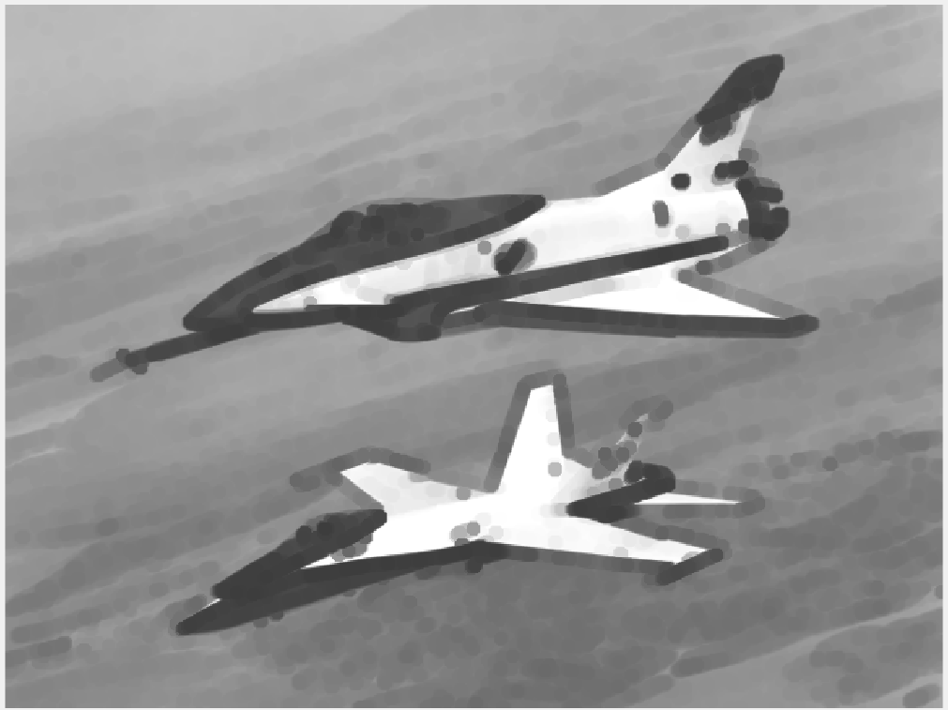

* 1. Use Dilation on the image and display.

**f = imread('x31_f18.tif');**

**xe = strel('disk',5);**

**>> dilate = imerode(f,xe);**

**>> imshow(dilate);**

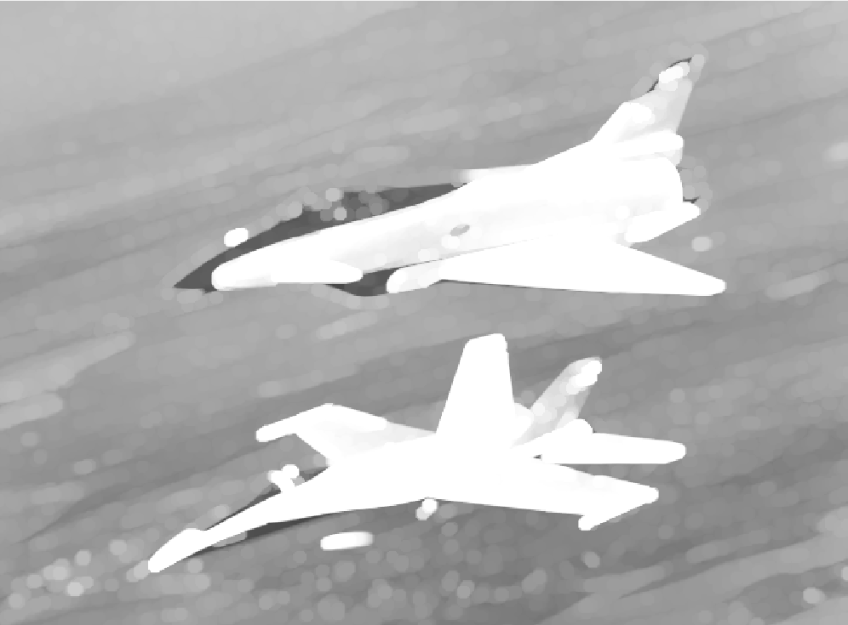

* 1. Are they inverses of each other? Justify your answer.

No, erosion and dilation are not exact inverses of each other. While they have opposing effects on object boundaries, they don't perfectly reverse each other's actions. Here's why:

1. Boundary Pixels: Erosion removes pixels on object boundaries, while dilation adds pixels to those boundaries. However, these aren't always the exact same pixels. Erosion might remove a corner pixel, while dilation might add a new pixel next to it but not exactly at the same location.

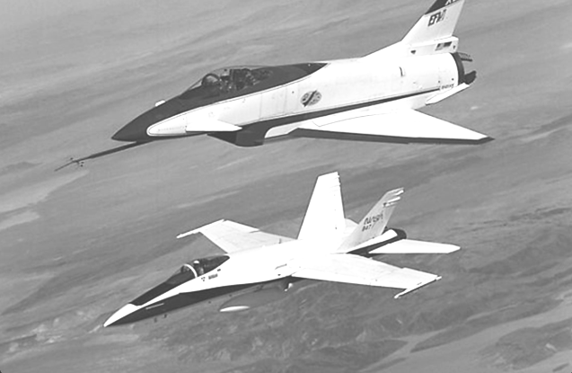

1. Extract the boundary from the FreemanCode.png

 TO-> 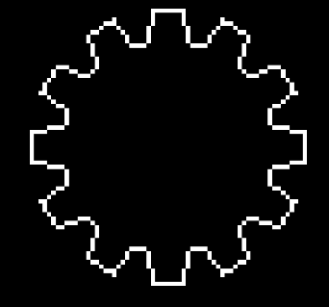

**free = imread('FreemanCode.png');**

**>> imshow(free);**

**>> xe = strel('disk',2);**

**>> dilate = imdilate(free,xe);**

**>> erode = imerode(free,xe);**

**>> diff = dilate - erode;**

**>> imshow(diff);**

1. Using coins.png, binarize the image first and then fill the holes.

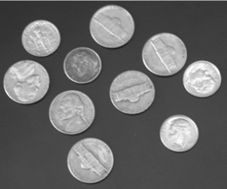 TO→ 

**coins = imread('coins.png');**

**>> bin = imbinarize(coins);**

**>> fill = imfill(bin,'holes');**

**>> imshow(fill);**

**Binarized Image :**

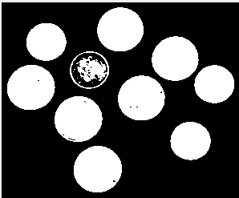

1. Take the Japanese character in kawaii.png.



* 1. Thin the image to obtain the skeleton of the image
  2. Upon thinning, have you noticed some parts are disconnected? Dilate the OG Kawaii image and then thin it.
  3. If you end up with spurs like the image below, use structural elements to fix:

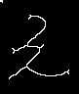

Try to obtain the image below using these morphological operators:

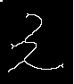

1. Given the following images:
   1. Perform Top-hat transform on the Galaxy.png and observe the results.

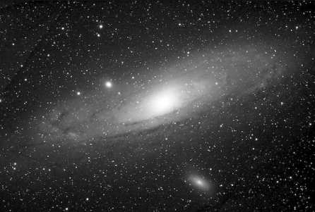

* 1. Perform Black-hat transform on the Cali.png and observe results.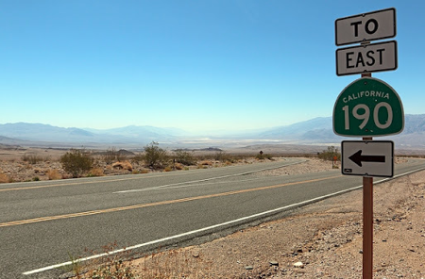
  2. Looking at the result of these transforms, explain briefly why we use Top-hat and Black-hat transforms respectively (In context of the above images).

1. What is Image Segmentation?
   1. What are the different methods used?
   2. Using segmentation, extract only the brain from scan.png. (Hint: binerize the image, use operations like ‘open’ and ‘close’, find biggest component)

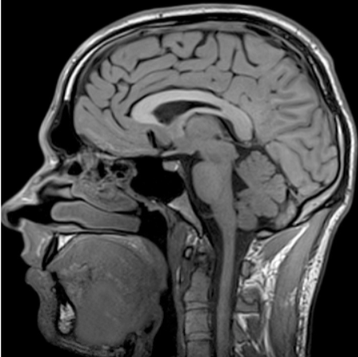 TO -> 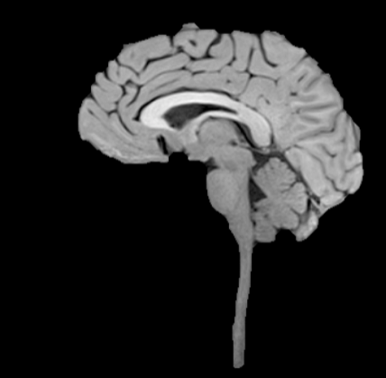

1. Edge Detection
   1. Using Marr-hildreth edge detector, give the edge output of the x31_f18.tif image.
   2. Do the same with Canny edge detection.
2. What is Hough Transform and why is it really good at filling up gaps?
   1. Using hough Transform, find the edges of x31_f18.tif image.
   2. Use thresholding to refine the image if needed.
3. Thresholding
   1. Using Simple, global Thresholding, find output on cameraman.tif
   2. Do the same with global Thresholding.
   3. Do the same with Otsu’s method.
   4. Do the same with multiple and variable methods.
   5. Explore Edge-guided Thresholding.
4. Perform K-means clustering segmentation on the butterfly.png.
   1. Put the value of k=3.
   2. Put the value of k=6.
   3. Observe and report the differences.
5. What is watershed segmentation and why is it used where regions generally touch?
   1. Using Cards.png, segment the cards.

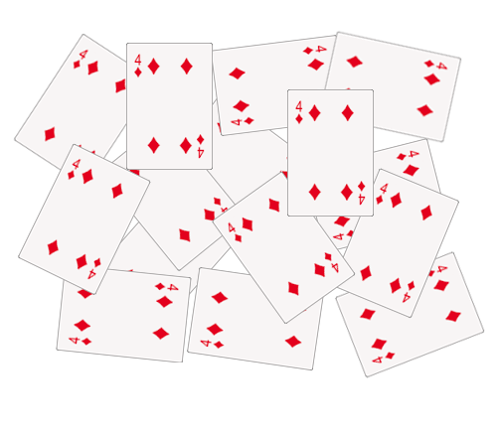TO

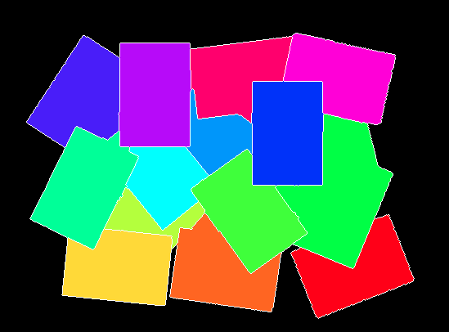

(Example is indicative. You can show the results in any way you like)