Automation AWS DMS Migration Tasks

AWS Database Migration Service:

- AWS Database Migration Service (AWS DMS) helps us migrate databases to AWS quickly and securely.
- The source database remains fully operational during the migration, minimizing downtime to applications that rely on the database.
- The AWS Database Migration Service can migrate our data to and from the most widely used commercial and open-source databases.
- We can create the tasks by using the AWS Database Migration Service (AWS DMS) and using native operating system tools either Linux or Microsoft Windows.
- We can migrate our data to and from most widely used commercial and open-source databases, such as Oracle, Microsoft SQL Server, PostgreSQL.
- The AWS Database Migration Service (AWS DMS)supports homogeneous migrations such as Oracle to Oracle, and heterogeneous migrations between different database platforms, such as Oracle to PostgreSQL or MySQL to Oracle.

To work with AWS DMS, either our source or target database must be in AWS. Currently, DMS doesn’t support migrating from an on-premises database to another on-premises database.

Find the below DMS service screen grab
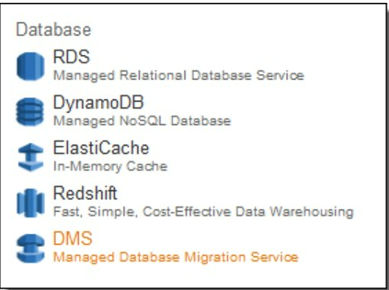
- The AWS DMS migration process consists of setting up a replication instance, source and target endpoints, and a replication task. The replication task runs on the replication instance and migrates data from the source endpoint to the target endpoint.

- To automate migration tasks, we use the AWS Command Line Interface (AWS CLI) to perform the database migration. If we are a first-time AWS CLI user, we recommend that we read the following instructions and get accustomed to how the CLI should be used and configured.
- Create an AWS Identity and Access Management (IAM) user.
- Set up required permissions for the IAM user.
- Set up the roles required to use AWS DMS.
- Set up the AWS CLI.

- Create an AWS Identity and Access Management (IAM) user:

- AWS Identity and Access Management (IAM) provides fine-grained access control across all of AWS. With IAM, we can specify who can access which services and resources, and under which conditions. With IAM policies, we can manage permissions to our workforce and systems to ensure least-privilege permissions.

- IAM is an AWS service that is offered at no additional charge. To get started using IAM or if we have already registered with AWS, go to the IAM console.

- With IAM, we can manage AWS permissions for workforce users and workloads. For workforce users, we recommend that we use AWS Single Sign-On (AWS SSO) to manage access to AWS accounts and permissions within those accounts.

- AWS SSO makes it easier to provision and manage IAM roles and policies across our AWS organization. For workload permissions, use IAM roles and policies, and grant only the required access for our workloads.

Creating IAM users (AWS API)

we can use the AWS API to create an IAM user.

find the below screengrab for AWS IAM user page

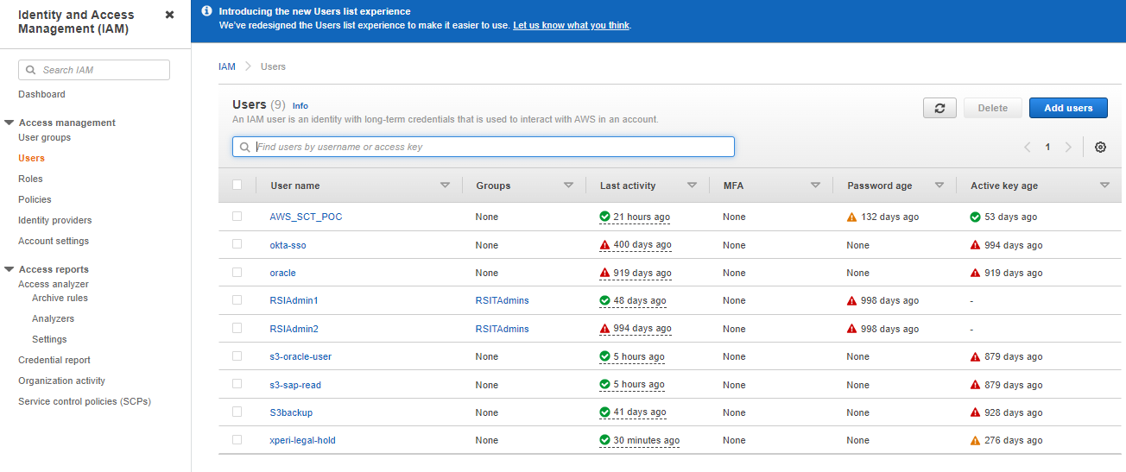

To create an IAM user from the (AWS API)

Click on Add Users page Create a user.

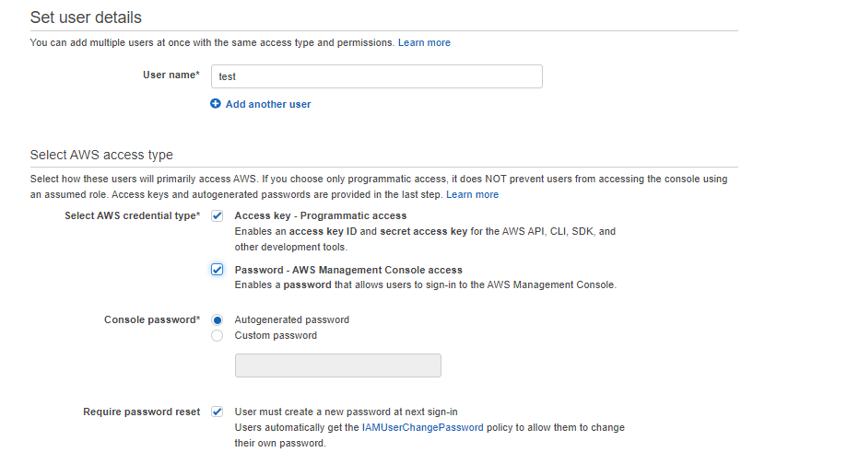

(Optional) Give the user access to the AWS Management Console. This requires a password. we must also give the user the URL of our account's sign-in page.

(Optional) Give the user programmatic access. This requires access keys.

Add the user to one or more groups. The groups that we specify should have attached policies that grant the appropriate permissions for the user.

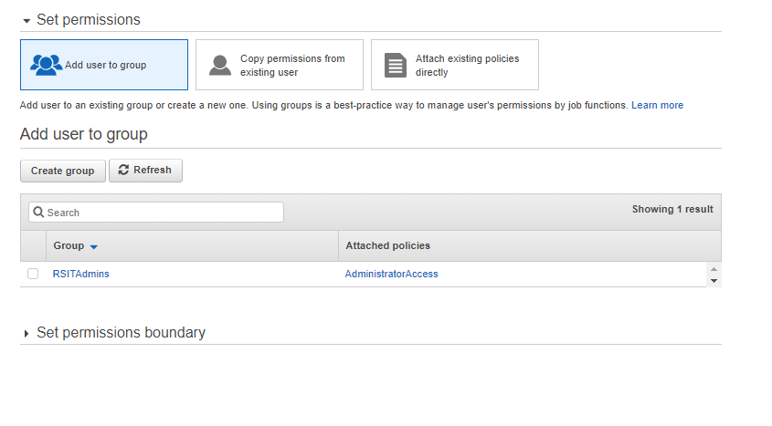

(Optional) Attach a policy to the user that defines the user's permissions. Note: We recommend that we manage user permissions by adding the user to a group and attaching a policy to the group instead of attaching directly to a user.

(Optional) Add custom attributes to the user by attaching tags. For more information, see Managing tags on IAM users (AWS CLI or AWS API).

(Optional) Give the user permission to manage their own security credentials. For more information, see AWS: Allows MFA-authenticated IAM users to manage their own credentials on the My Security Credentials page.

- Set up required permissions for the IAM user.

Below permissions are required for IAM user to run DMS tasks.

- AmazonRDSFullAccess

- DMS_Full_Access

- AmazonS3FullAccess

- Set up the roles required to use AWS DMS.

- If we use the AWS CLI or the AWS DMS API for our database migration, we must add certain IAM roles to our AWS account before we can use the features of AWS DMS.

- Two of these are dms-vpc-role and dms-cloudwatch-logs-role. If we use Amazon Redshift as a target database, we must also add the IAM role dms-access-for-endpoint to our AWS account

- CustomPoCAccountPolicy

- AmazonDMSCloudWatchLogsRole

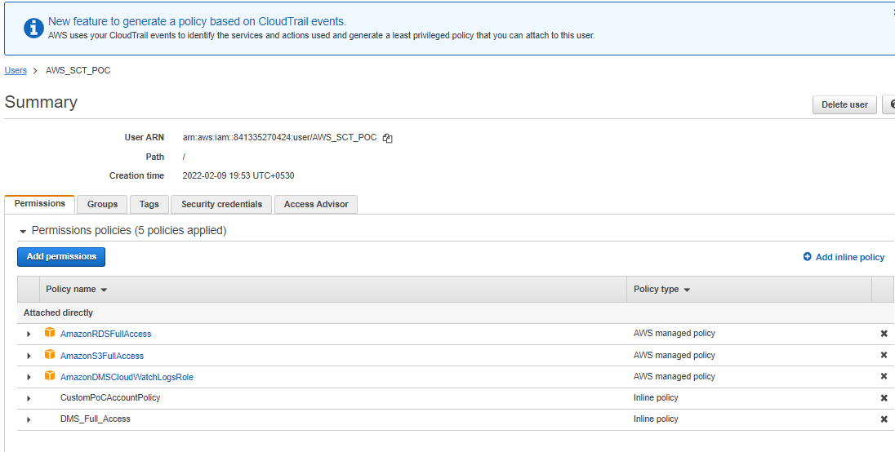

- Set up the AWS CLI.

Download and run the AWS CLI MSI installer for Windows (64-bit):
https://awscli.amazonaws.com/AWSCLIV2.msi
Alternatively, we can run the msiexec command to run the MSI installer.

- For various parameters that can be used with msiexec, see msiexec on the Microsoft Docs website.
- To confirm the installation, open the Start menu, search for cmd to open a command prompt window, and at the command prompt use the aws --version command.
- C:\> aws --version
- aws-cli/2.4.5 Python/3.8.8 Windows/10 exe/AMD64 prompt/off

- If Windows is unable to find the program, we might need to close and reopen the command prompt window to refresh the path

Currently, DMS tasks cannot be scheduled using the DMS console. To schedule DMS tasks, we need to use the native tools present in the OS (Windows or Linux) that we use to access AWS resources.
Following is a detailed description on how to automatically execute the DMS task or schedule it for execution in Windows.
- Install the AWS CLI on our Windows machine from Install the AWS Command Line Interface on Microsoft Windows in the AWS documentation.
  - Find version upgrades on the AWS CLI GitHub site.
  - Find source code elsewhere on that site.
- Configure the installed CLI by following the instructions from Configuring the AWS CLI in the AWS documentation.
AmgMusicMore Automation On prem-Aws
Step1: Once the installation and configuration are done, from the Start menu, open the Notepad
And write below scripts and save as .bat file

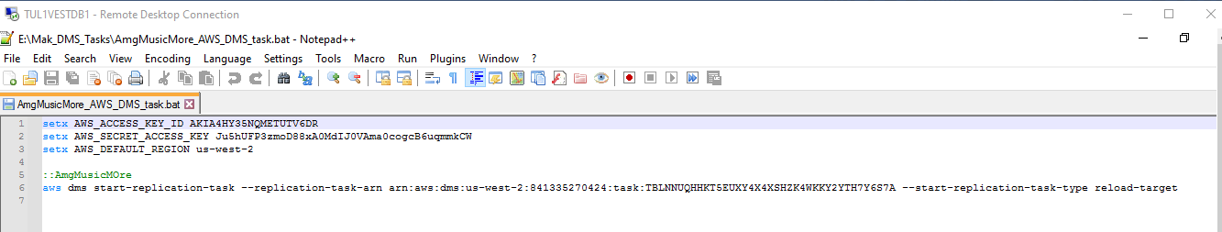

Step 2: From the Start menu, open Task Scheduler.

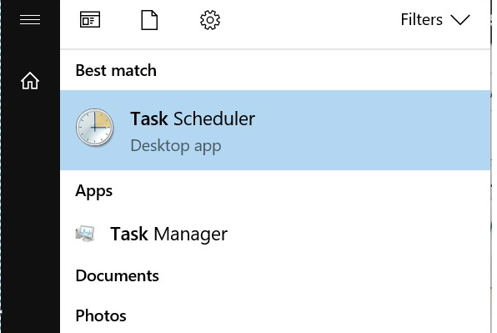

Step 3: From the right pane of the program, choose Create Task

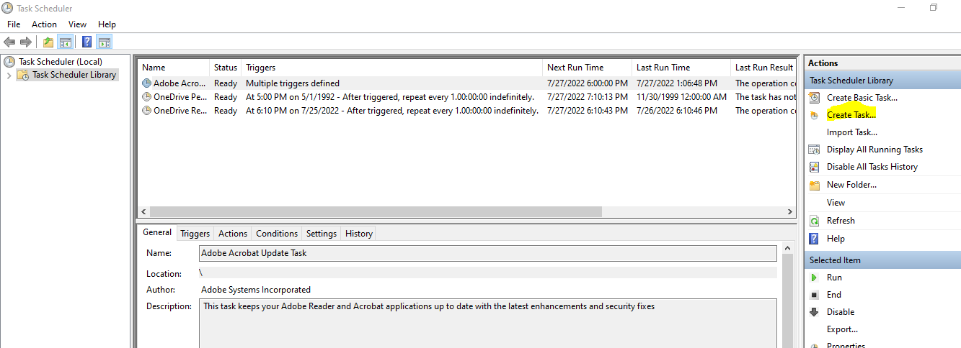
Step 4:
- On the Create Task window, fill in the following options:
- Name: Provide a task name. For this post, we use dmstask.
- Description (Optional): Comments about the task.
- Security Options: Make sure that the user account used has enough privileges to run the task. Check the option Run whether user is Logged on or not.
- Selecting Run with Highest Privileges is optional. If we select this check box, Task Scheduler runs the task using an elevated privileges token rather than a least privileges (UAC) token.
- Only tasks that require elevated privileges to complete their actions should run with elevated privileges.

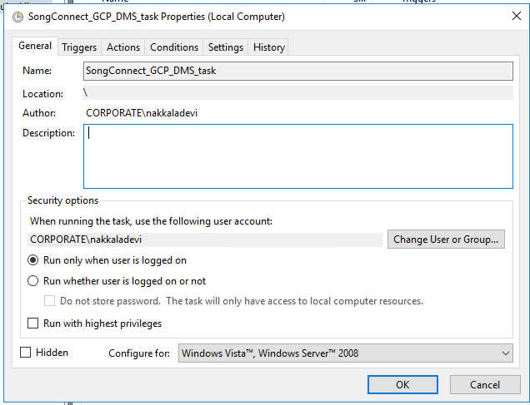

Step 5:

Navigate to the Triggers tab and create a schedule for task execution, by choosing New

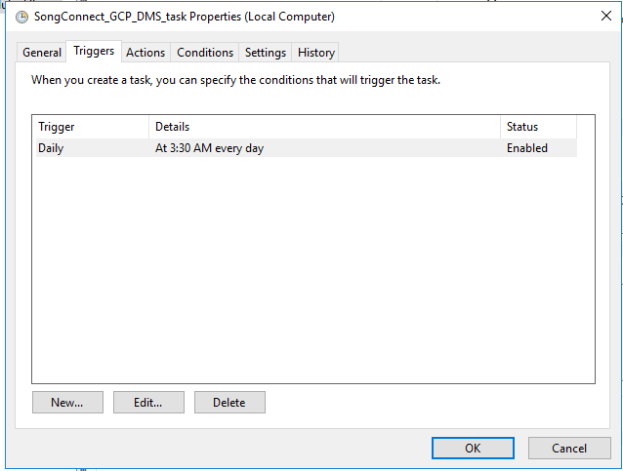

Step6:

The preceding trigger makes sure that a PowerShell script executes every day from today onward at 3:30 A.M. EST. Choose OK when we done.
Navigate to the Actions tab and choose New. Here, we can design how the script runs. Fill in the fields in the following manner.
Action: Start a program
Program/script: AmgMusicMore_AWS_DMS_task.bat Add arguments (Optional): -ExecutionPolicy Bypass E:\Mak_DMS_Tasks\ AmgMusicMore_AWS_DMS_task.bat

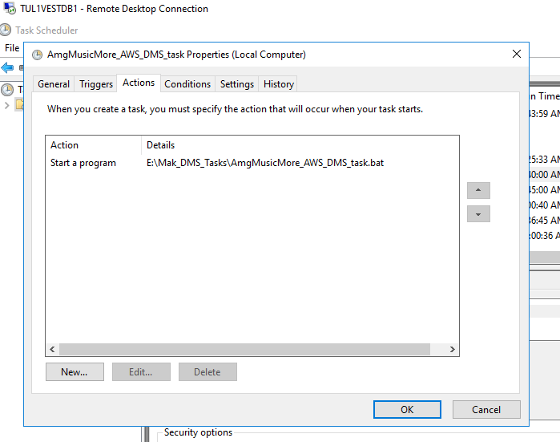

Step 7:

- Choose OK once we done.
- On the Condition tab, make sure that we have the following options selected.

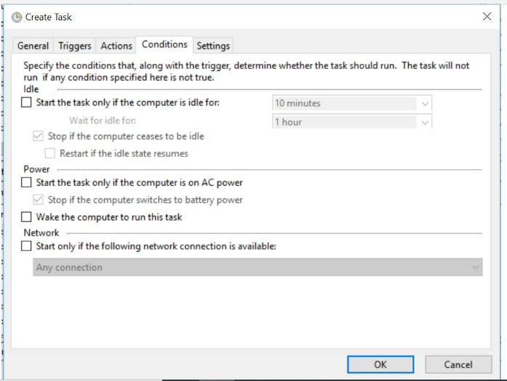

Step 8:

When we choose OK, we are prompted to enter the password for the user account logged in to our Windows machine, or with the user account that we have set to run the task.

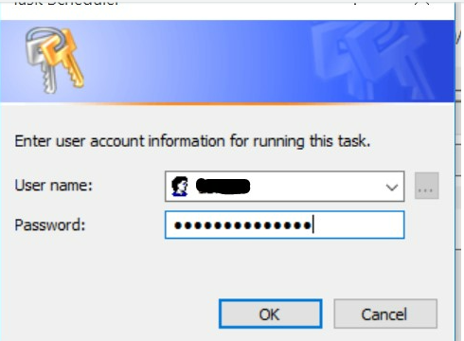
Step 9:
Choose OK when we’re ready. At this point, the migration task is created

Step 10:
Choose the History tab for the task to see the job execution status and logs for the task.

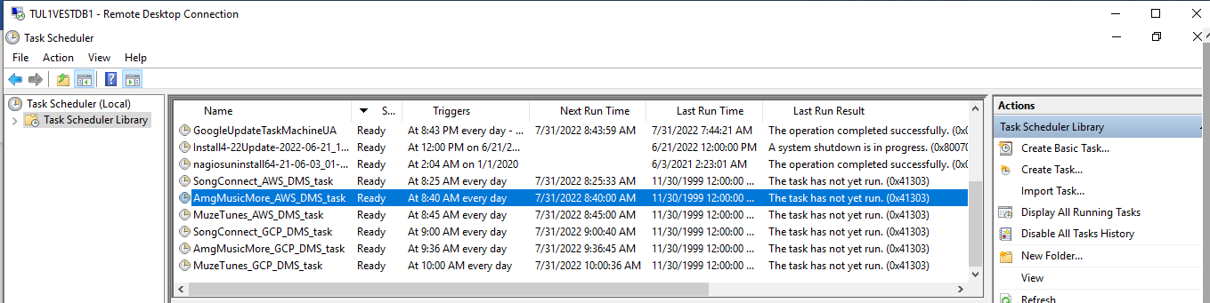

AmgMusicMore Automation On AWS-GCP

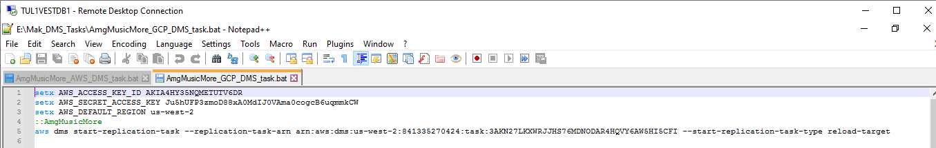

Do follow step 2 - Step 10 for the schedular

