SupplierHub
Training Guide
Chef Role

Confidential — Internal Use Only

Section 1: Welcome
As a chef, you are the day-to-day user of SupplierHub. You manage your kitchen’s purchasing — connecting suppliers, reviewing matched products, building order lists, and placing orders.
This guide walks you through each part of the system so you can get up and running quickly.

Section 2: Your Dashboard
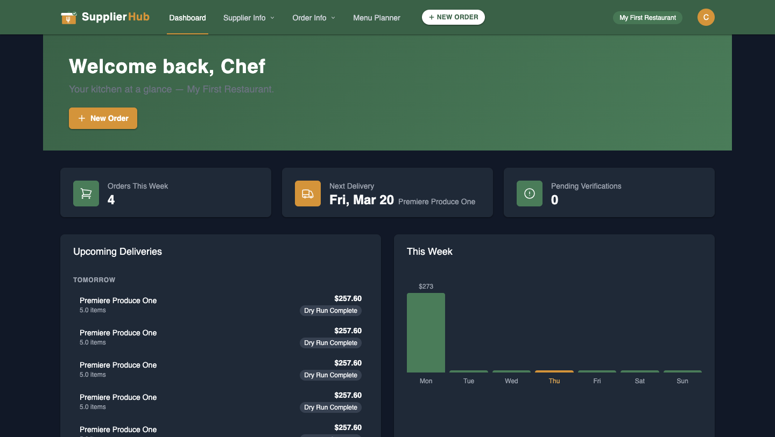
The dashboard is your home base. At a glance, you can see:
- Orders placed this week
- Next delivery information
- Pending verifications requiring your attention
- Upcoming deliveries list
- Weekly spending chart

Check your dashboard each morning to stay on top of incoming deliveries and any actions that need your attention.

Section 3: Connecting Suppliers

Supplier Credentials
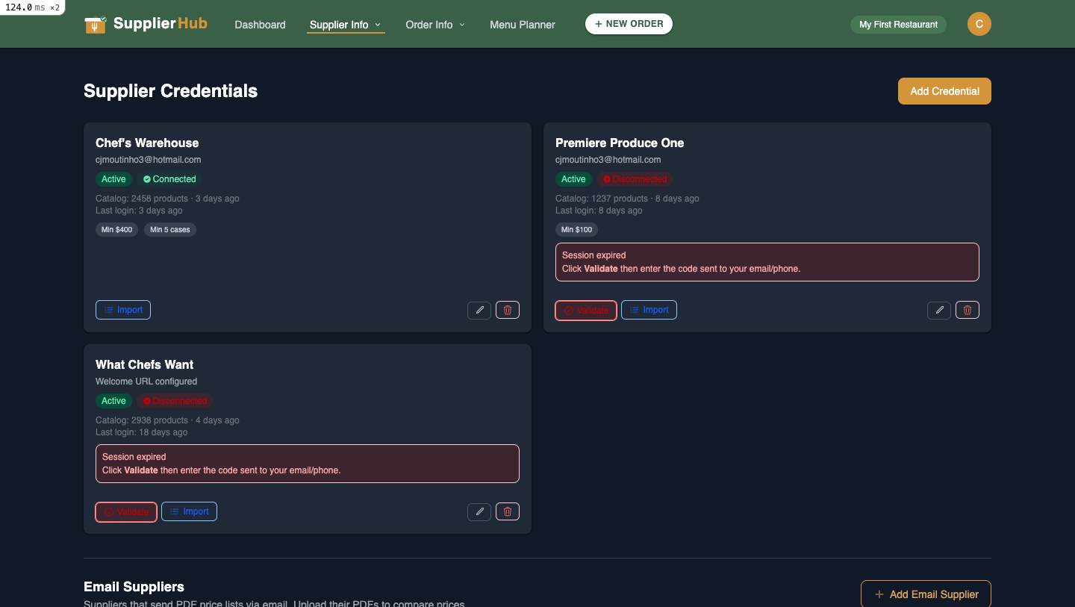
You manage your own supplier logins. Each credential card shows the supplier name, connection status (Active/Connected or Disconnected), catalog size, and order minimums.

There are two types of supplier connections:

Password-based (Chef’s Warehouse, What Chefs Want)
Enter your username and password. SupplierHub stores them securely and uses them to log in on your behalf.

2FA-only (US Foods, Premiere Produce One)
Enter your email or phone number. When SupplierHub needs to connect, it triggers a verification code sent to you. Enter the code in SupplierHub to complete the connection.

Sessions expire periodically. When you see “Session expired,” click Validate to reconnect. Your credentials are encrypted and only you can use them.

Section 4: Product Matching

Matched Lists
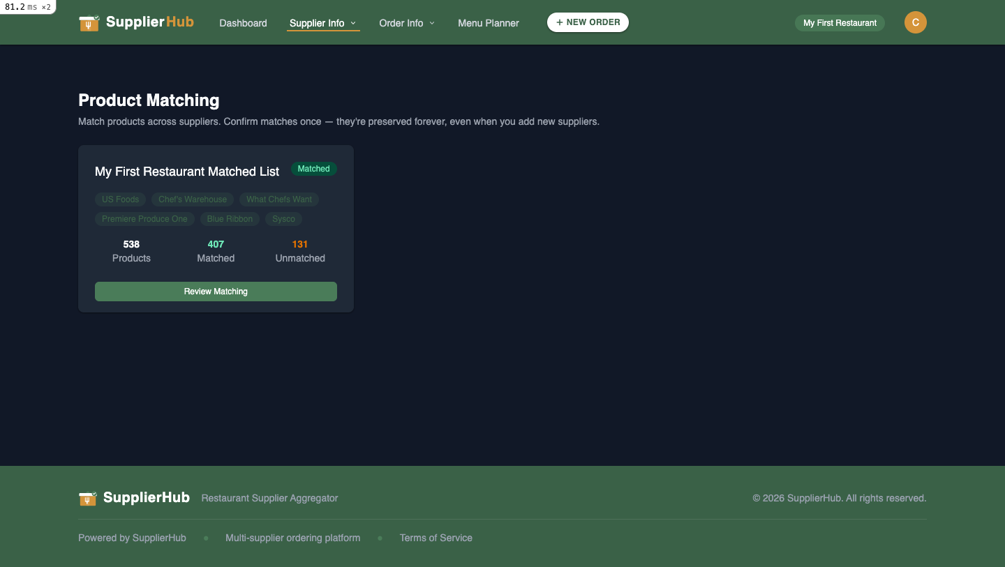
Once your suppliers are connected, SupplierHub automatically imports their catalogs and matches equivalent products across suppliers. Your Matched List shows how many products were found, how many were matched, and how many are unmatched.

Click "Review Matching" to:
- Confirm matches the AI got right
- Reject incorrect matches
- Manually assign unmatched products
- Rename products to your kitchen’s terminology (e.g., rename "Hellmanns Mayonnaise 4/1 GA" to "Mayo")

Each row shows a "BEST" badge on the lowest per-unit price, making it easy to identify the best deal at a glance.

Section 5: Order Lists
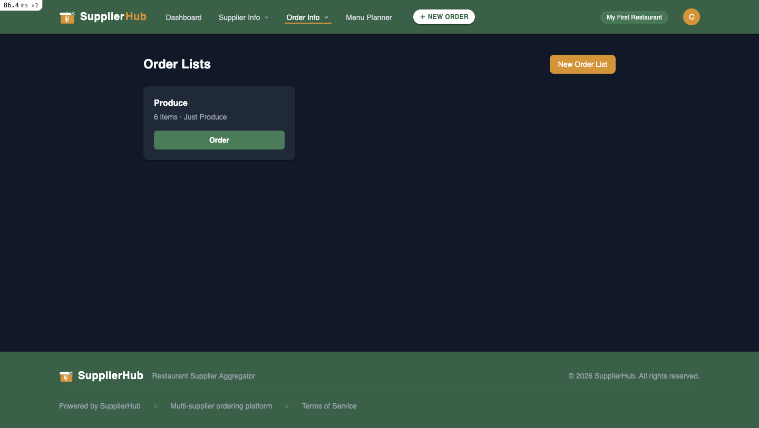
Order Lists are reusable shopping templates. Create lists for recurring orders like "Monday Prep," "Weekend Brunch," or "Produce." Each list pulls from your Matched List, so you see price comparisons across suppliers.

Key points:
- Order Lists are about WHICH products, not how many — quantities are set when you create an order
- All users at your location can see the same Order Lists
- You can duplicate and favorite lists for quick access

Section 6: Placing an Order
When you are ready to order, follow these steps:

- Open an Order List and click "Order"
- The Order Builder shows all items with prices from each supplier
- Set quantities for what you need
- Choose a delivery date (check supplier delivery schedules)
- Submit — SupplierHub automatically logs into the supplier’s website, adds your items, and places the order

Orders from multiple suppliers are batched automatically (one order per supplier).
Every order requires a delivery date. Suppliers have specific delivery days and cutoff times — check these before submitting.

Section 7: Order History
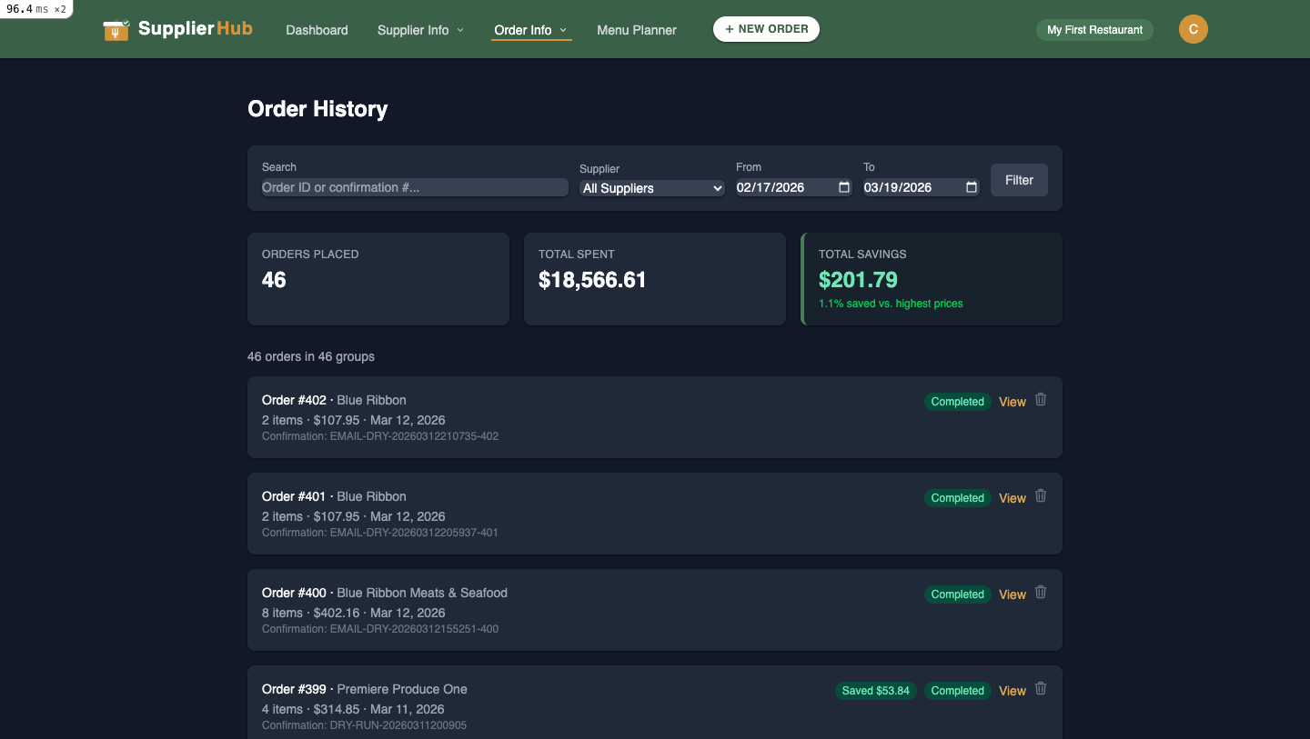
Track all your orders with filters by supplier, date range, and search. Each order shows the supplier, item count, total cost, delivery date, and status.
The summary cards at the top show total orders placed, total spent, and savings vs. competitor pricing.

Order statuses:
- Pending → Verifying → Processing → Submitted → Confirmed
- Failed or Cancelled (if something went wrong)

Section 8: What You CAN’T Do
As a Chef, certain actions are reserved for Managers and Owners:

- Create new Matched Lists (but you can edit matches on your existing one)
- Manage team members or invite users
- View other locations’ data
- Promote lists org-wide

If you need any of these actions taken, reach out to your Manager or Owner.

Section 9: Quick Reference
Use this table to quickly find where to go for common tasks.

Action | Where to Find It
Connect a supplier | Supplier Info → Supplier Credentials
Review product matches | Supplier Info → Product Matching
Create an order list | Order Info → Order Lists → New Order List
Place an order | Open an Order List → Order, or use + NEW ORDER button
View order history | Order Info → Order History
Update your profile | Click your avatar → Profile

