SupplierHub
Training Guide
Manager Role
Confidential — Internal Use Only

1. Welcome
As a manager, you have a supervisory view of your organization’s ordering activity. You can see spending, orders, product pricing, and supplier comparisons across your assigned locations — but you don’t place orders or manage supplier accounts.
Your role is oversight: monitoring costs, reviewing purchasing patterns, and ensuring your team’s ordering stays on track.

2. Your Dashboard
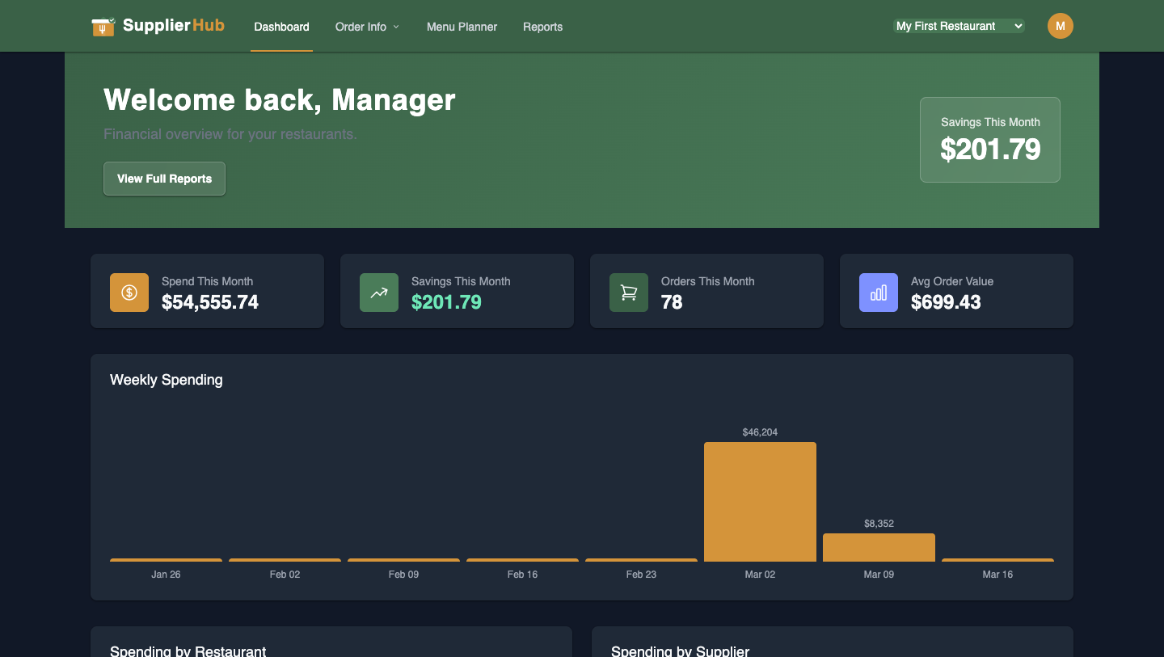
Figure 1: Manager Dashboard
Your dashboard shows key metrics for your assigned locations:
- Spend This Month: Total purchasing across your locations
- Savings This Month: How much your team saved by choosing lower-priced supplier options
- Orders This Month: Total number of orders placed
- Avg Order Value: Average order size
- Weekly Spending chart: Trend over recent weeks
- Spending by Restaurant: Compare costs across locations
- Spending by Supplier: See which suppliers get the most business
All data is scoped to the locations your owner has assigned you to.

3. What You Can See

Matched Lists
View the product comparisons across suppliers. See which products are matched, prices from each supplier, and “BEST” price badges. You cannot edit matches, but you can see what your chefs are ordering from.

Order Lists
View the reusable order templates your chefs have created. See which products are on each list.

Orders
View complete order history for your assigned locations. Filter by supplier, date range, or search.

Reports
Access spending reports and analytics for your assigned locations.

4. Order History
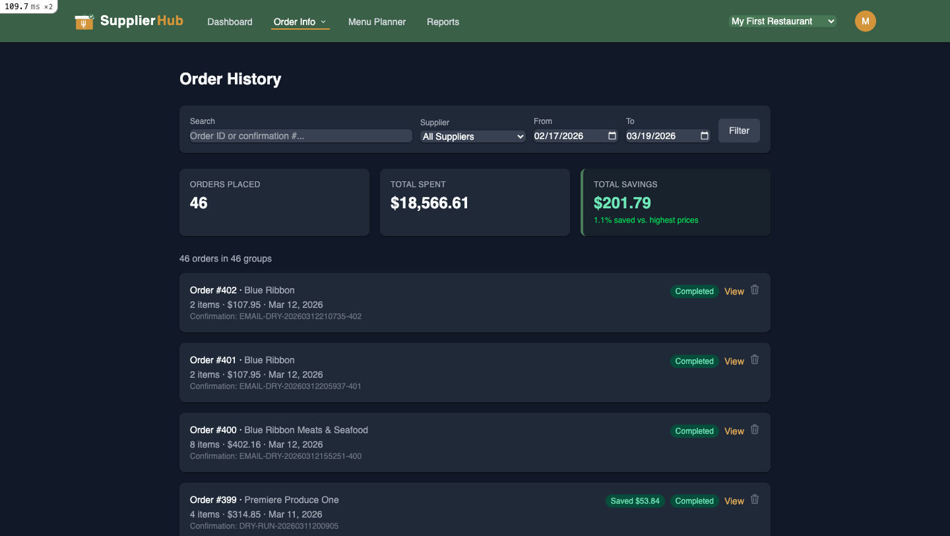
Figure 2: Order History
Track all orders across your locations with filters. Each order shows supplier, item count, total cost, delivery date, and status. Summary cards show total orders placed, total spent, and savings.

5. Understanding the Data
Key things to watch for:
- Spending trends: Is weekly spend increasing or decreasing? Why?
- Supplier distribution: Orders concentrated with one supplier, or spread across several?
- Savings opportunities: Are chefs choosing the best-priced options?
- Order frequency: Too frequently (small orders) or too infrequently (inventory gaps)?

6. What You CAN’T Do
As a manager, the following actions are not available to you:
- Place or edit orders
- Create or edit Matched Lists or Order Lists
- Connect or manage supplier credentials
- Invite or manage team members
- View locations you haven’t been assigned to
- Manage billing or subscription
If you need any of these capabilities, ask your organization’s owner to update your role.

7. Quick Reference
Action | Where to Find It
View your dashboard | Dashboard (home page)
View product matches | Supplier Info → Product Matching
View order lists | Order Info → Order Lists
View order history | Order Info → Order History
View reports | Reports (in nav bar)
Switch locations | Location selector dropdown in top-right nav

