SupplierHub
Training Guide
Owner Role
Confidential — For Internal Use Only

1. Welcome
As the owner, you have full control over your organization in SupplierHub. You manage your restaurants, team, and supplier relationships. You can do everything a chef does — plus manage team members, promote standardized lists across all locations, and view spending across your entire organization.
2. Your Dashboard
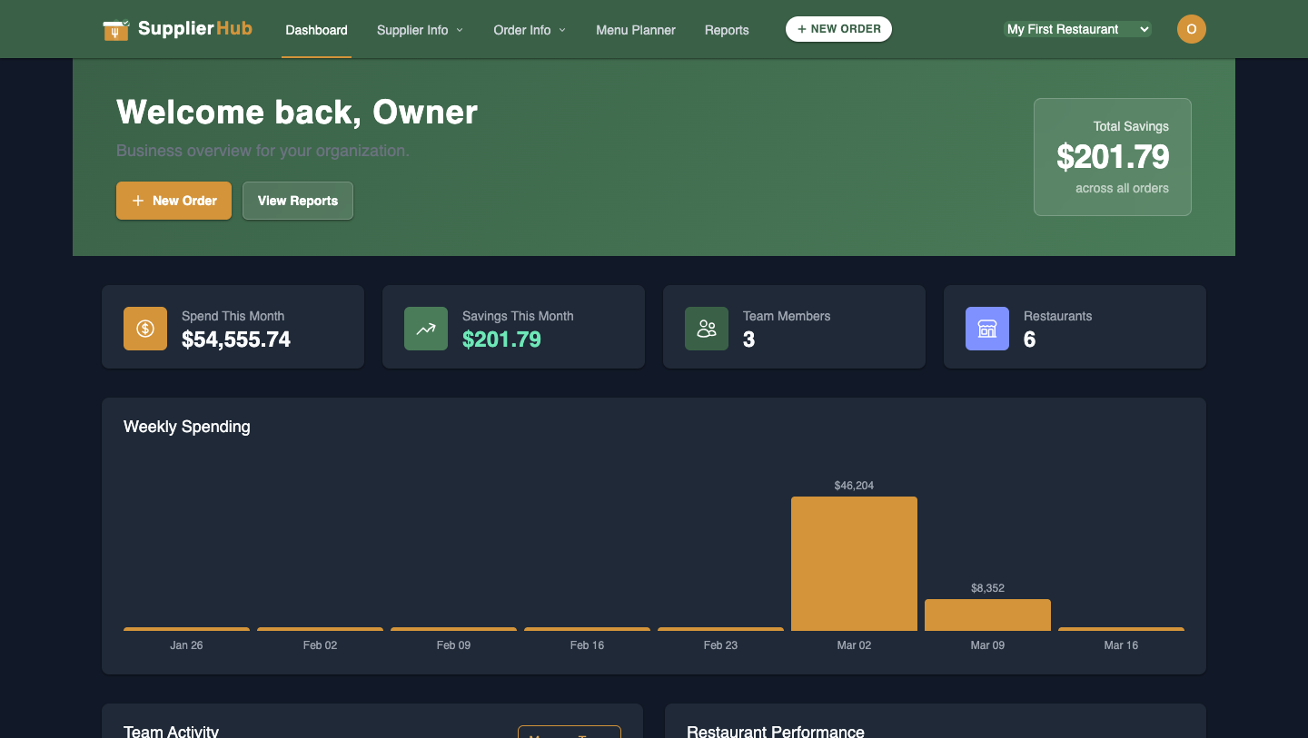
Your Dashboard
Your dashboard provides a business overview across all locations. Key metrics include:
- Spend This Month and Savings This Month
- Team Members count and Restaurants count
- Weekly Spending chart showing trends over time
- Total Savings badge in the top-right
You can switch between "All Locations" or drill into a specific restaurant using the location selector in the top-right nav.
3. Team & Organization Management
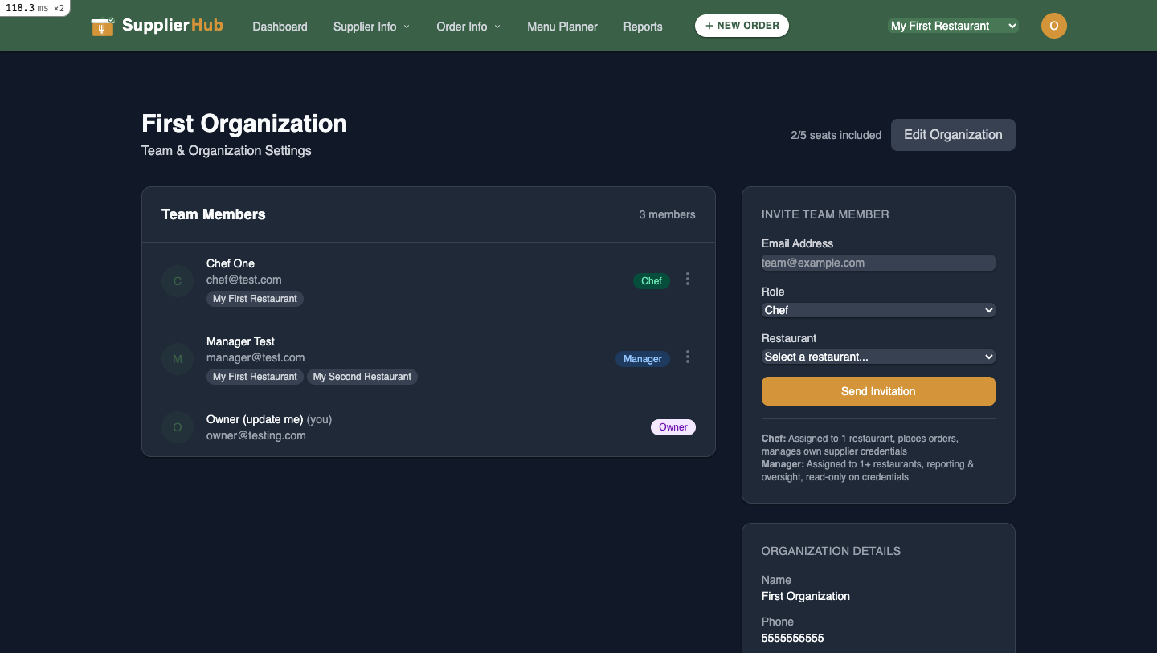
Team & Organization Settings
Access via the Organization page. Here you can:
- View all team members with their roles (Chef, Manager, Owner) and assigned locations
- Invite new team members by email, assigning them a role and restaurant
- Edit or remove existing members
- Update organization details (name, phone)

Roles Explained
- Chef: Assigned to one restaurant. Places orders, manages their own supplier credentials, reviews product matches.
- Manager: Assigned to one or more restaurants. Read-only access to orders, spending, and reports. Cannot place orders or manage credentials.
- Owner: Full access to everything across all locations.
4. Connecting Suppliers
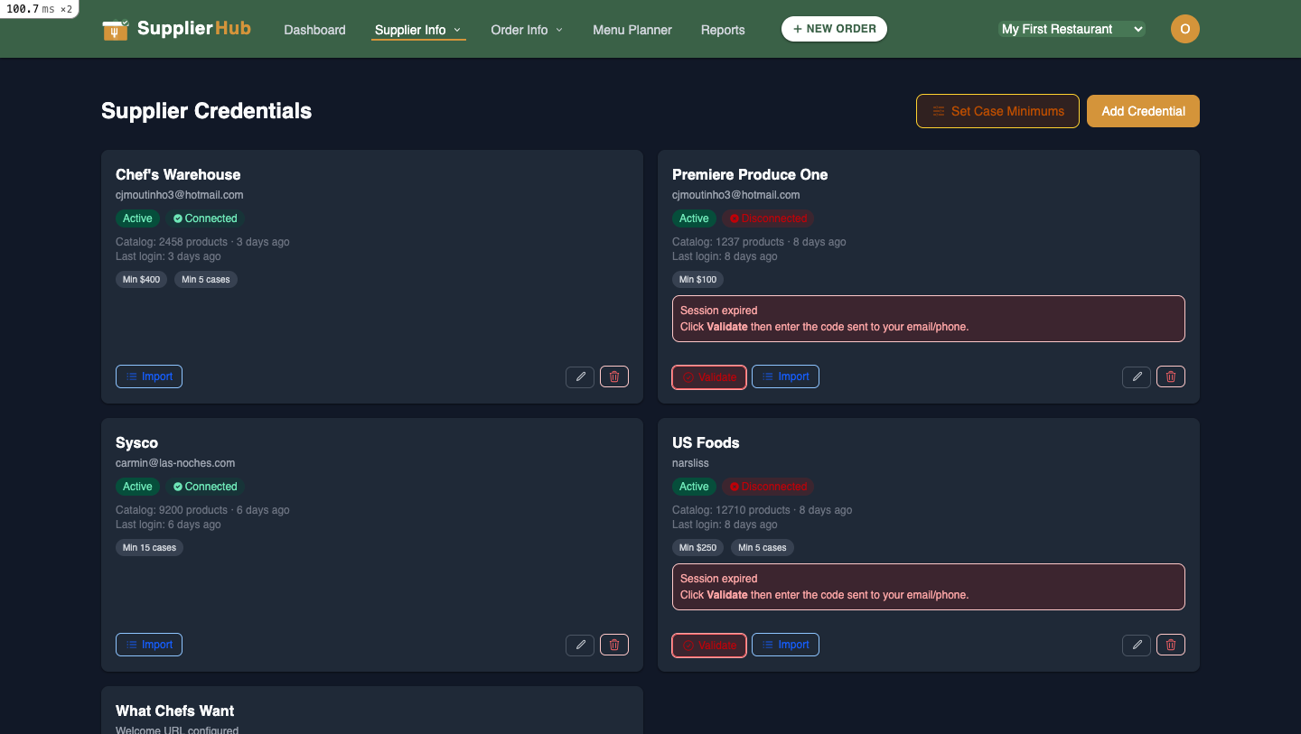
Supplier Credentials
Same as a chef — you manage your own supplier credentials. Two types:
- Password-based (Chef's Warehouse, What Chefs Want): Username + password
- 2FA-only (US Foods, Premiere Produce One): Email/phone + verification code
Your credentials are private — no one else can see or use them. Each chef manages their own.
5. Product Matching
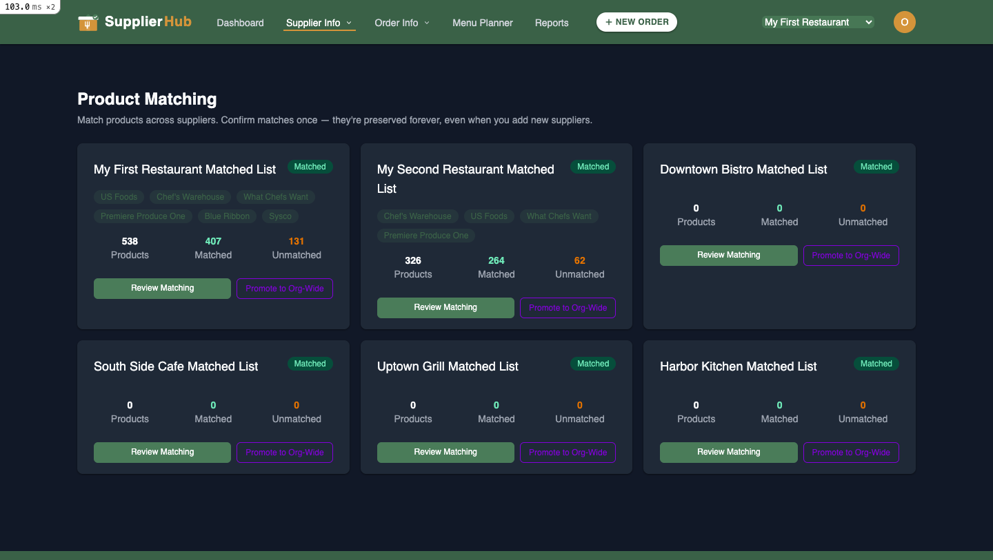
Product Matching
Once suppliers are connected, SupplierHub automatically imports catalogs and matches products across suppliers. You can review, confirm, reject, or manually assign matches — same as a chef.

OWNER-ONLY: You can PROMOTE a Matched List to make it the org-wide standard. When promoted, every chef across all locations sees the same comparison. This is optional — if you don't promote, each location uses its own list.
6. Order Lists
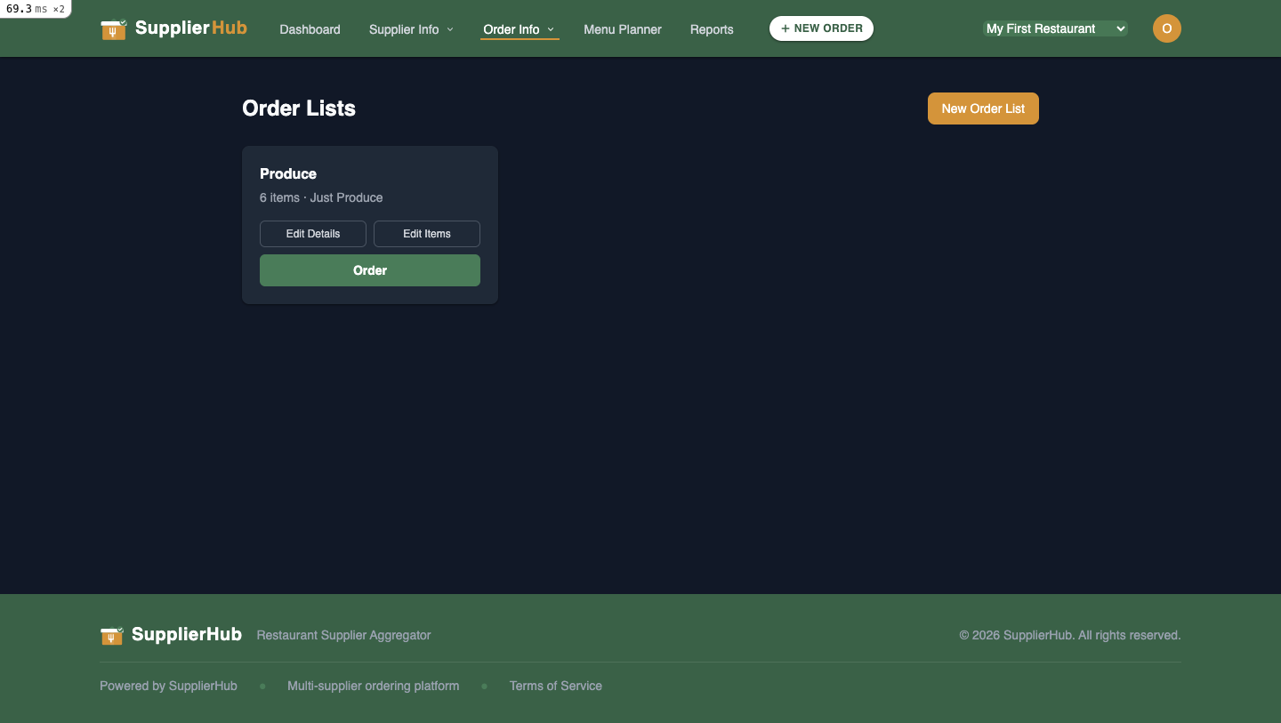
Order Lists
Create reusable order templates just like a chef. But as an owner, you can also see order lists across all locations.

Tip: Create standardized order lists and promote the underlying matched list so all your chefs order from the same product set.
7. Orders & Spending
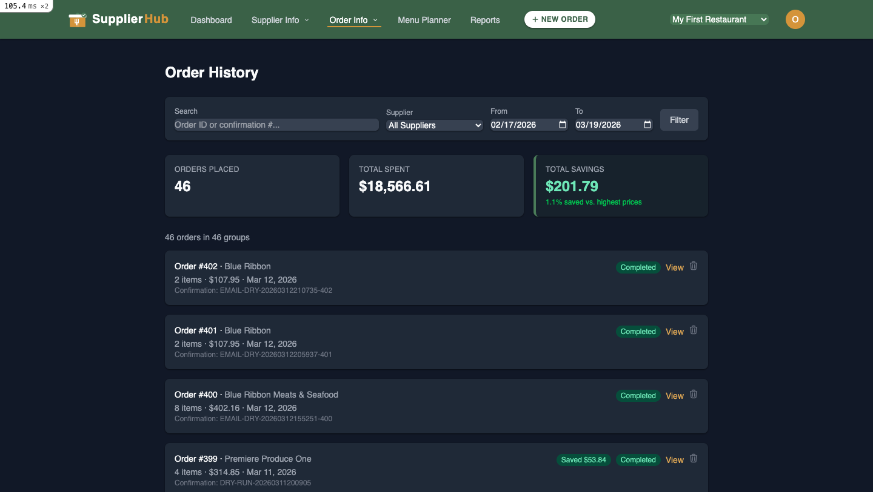
Order History
View complete order history across all locations. Filter by supplier, date range, or search. Summary cards show total orders, total spent, and savings.
As an owner, you see orders from ALL team members at ALL locations — not just your own. This gives you full visibility into purchasing activity.
8. What Only YOU Can Do

Action | Description
Create Matched Lists | Set up new product comparisons for locations
Promote Lists Org-Wide | Make a matched list the standard across all locations
Manage Team Members | Invite, assign roles, assign locations, remove members
View All Locations | See spending and orders across every restaurant
Manage Billing | Handle subscription and payment settings
9. Permissions Overview

Action | Owner | Manager | Chef
Create Matched List | Yes | No | No
View Matched List | Yes | Yes | Yes
Confirm/Edit Matches | Yes | No | Yes
Promote List Org-Wide | Yes | No | No
Create Order List | Yes | No | Yes
View Order Lists | Yes | Yes | Yes
Create & Submit Orders | Yes | No | Yes
View Orders | Yes | Yes | Yes
Manage Supplier Credentials | Yes (own) | No | Yes (own)
Manage Team Members | Yes | No | No
View All Locations | Yes | No | No
Manage Billing | Yes | No | No
10. Quick Reference

Action | Where to Find It
Manage your team | Organization page (click org name or avatar → Organization)
Connect a supplier | Supplier Info → Supplier Credentials
Review product matches | Supplier Info → Product Matching
Promote a matched list | Product Matching → select list → Promote
Create an order list | Order Info → Order Lists → New Order List
Place an order | Open an Order List → Order, or + NEW ORDER
View all orders | Order Info → Order History
View reports | Reports (in nav bar)
Switch locations | Location selector dropdown in top-right nav

