**Maximum and minimum values of karnataka_weather_new.csv dataset**

|  | **Maximum value** | **Minimum value** |
| --- | --- | --- |
| **avgtempC** | 37 | 16 |
| **maxtempC** | 41 | 17 |
| **mintempC** | 28 | 13 |
| **sunHour** | 12.9 | 4.2 |
| **uvIndex** | 9 | 4 |
| **windspeedKmph** | 40 | 2 |
| **precipMM** | 2779.2 | 0.0 |
| **avg_precipMM** | 115.8 | 0.0 |
| **humidity** | 97 | 21 |
| **pressure** | 1019 | 1002 |
| **DewPointC** | 21 | 1 |

**AD_FULLER test**

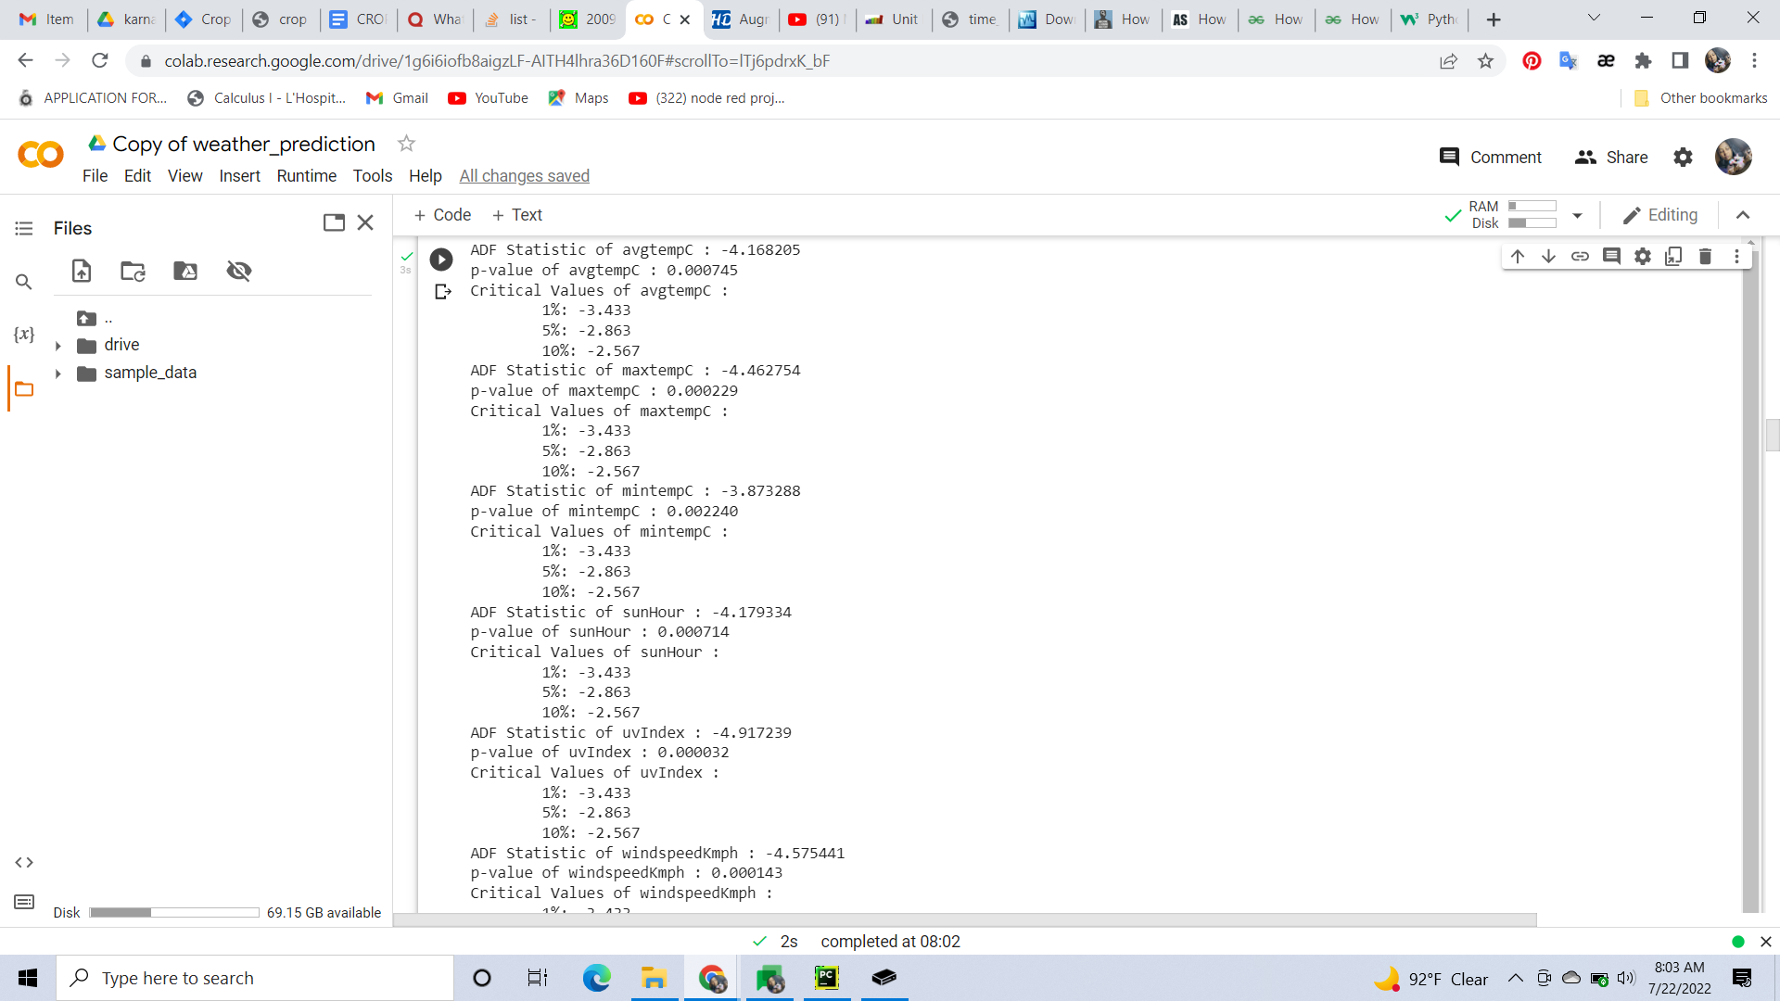

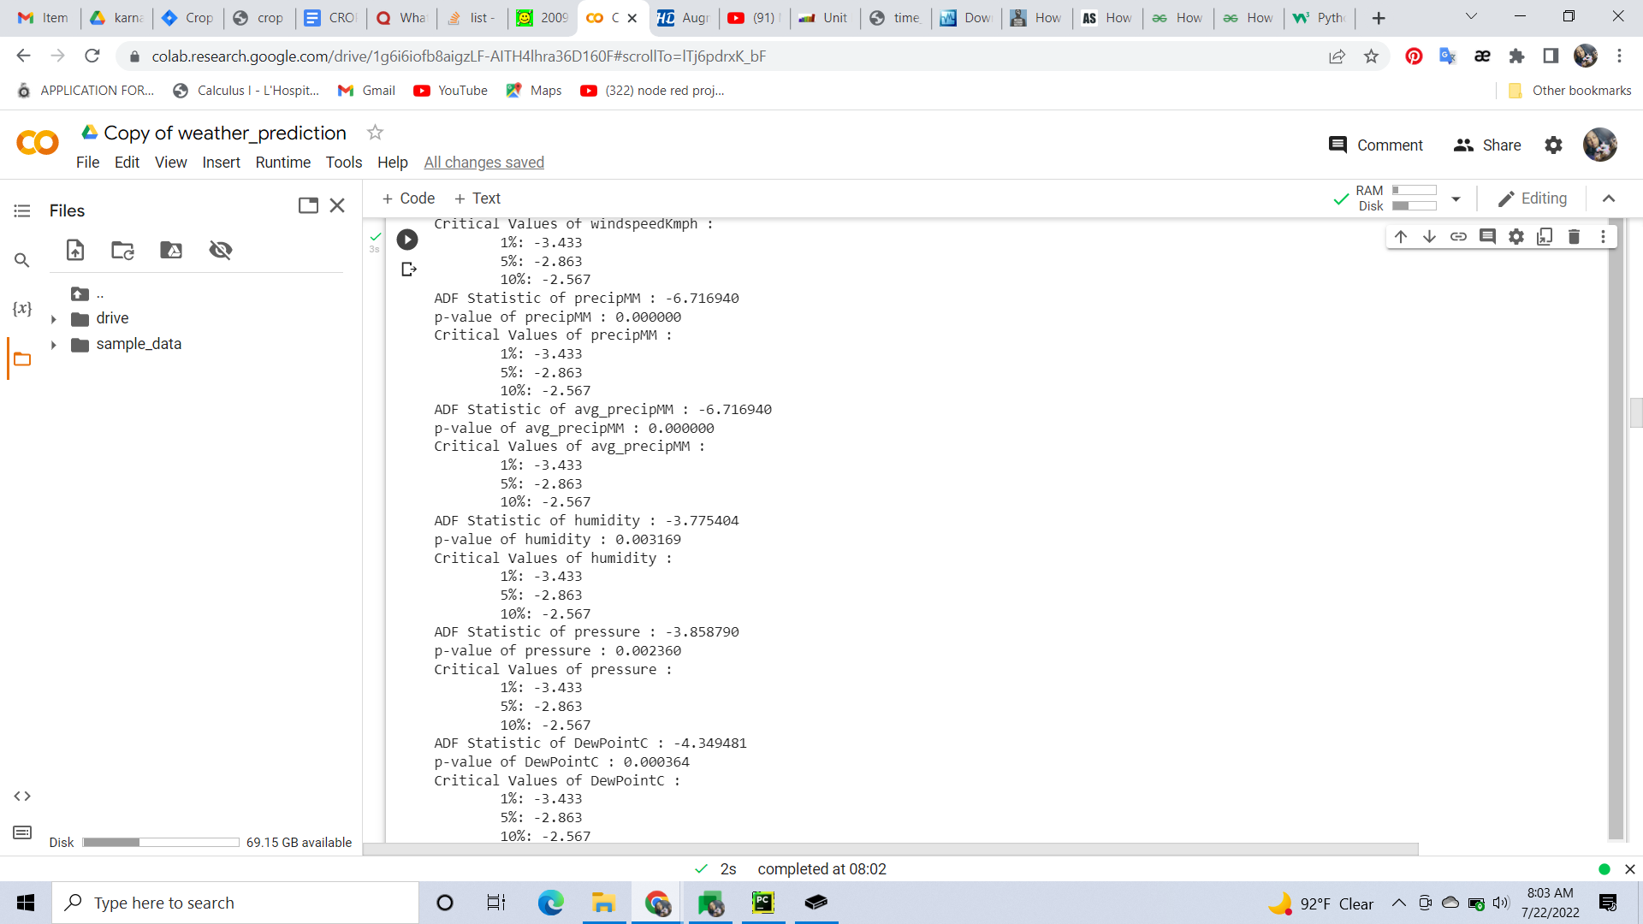

**CROP DETAILS - NHB dataset**

| **Fruits** | **If seasonal the season** | **Vegetables** | **If seasonal the season** |
| --- | --- | --- | --- |
| Acid lime |  | Bitter Gourd - seasonal | Nov-Dec  Dec-Jan  Jun-Jul |
| Aonla |  | Brinjal |  |
| Apple - seasonal | rainy | Cabbage |  |
| Banana |  | Cauliflower |  |
| Ber |  | Garlic |  |
| Citrus |  | Ginger |  |
| Grapes - seasonal | winter | Green chilli |  |
| Guava |  | Okra |  |
| Litchi |  | Onion |  |
| Mango - seasonal | summer | Peas |  |
| Mulberry |  | Potato |  |
| Papaya - seasonal | summer | Tomato |  |
| Phalsa |  |  |  |
| Pineapple - seasonal | spring |  |  |
| Pomegranate |  |  |  |
| Sapota |  |  |  |

**REFERENCES**

1. <https://presscs.com/seasonal-fruits/>
2. <https://www.allthatgrows.in/blogs/posts/vegetable-growing-season-chart-india>

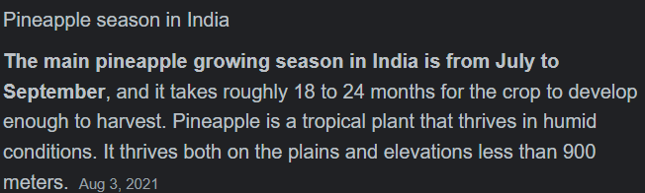



<https://kau.in/sites/default/files/documents/pineapple_sector_in_kerala-_status_opportunities_challenges_and_stakeholders.pdf>

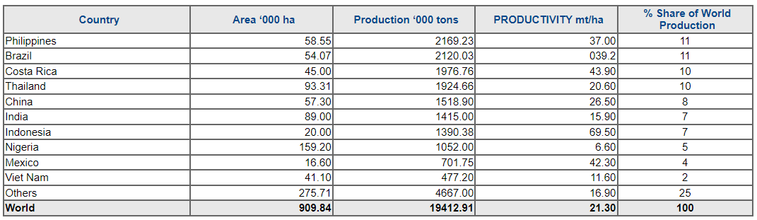

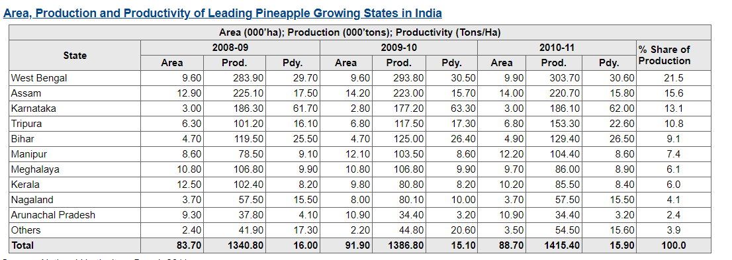

* From 2012



**Tomato related Analysis**