a. Write a ListView class to display a list of all vlogs with pagination (10 vlogs per page). Provide the code and explain the pagination logic. (5 Points)

1. Write a ListView class to display a list of all vlogs with pagination (10 vlogs per page). Provide the code and explain the pagination logic. (5 Points)

The logic uses the django ListView from django.views.generic where pagination is implemented

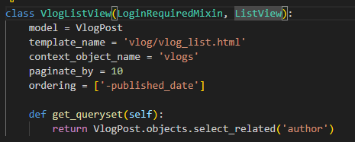

b. Write a DetailView for a single VlogPost, based on its id. Include an example URL pattern for this view. (5 Points)

2. Create and Update Views for VlogPost: a

. Write a CreateView for creating a new VlogPost, using VlogPostForm. Describe the purpose of this view and how it handles form submission. (5 Points)

b. Write an UpdateView for editing an existing VlogPost, explaining how the view identifies the specific vlog to update. Provide code examples in report too. (5 Points)

Section 3: Templates (10 Points) 1. Detail Template for VlogPost:

a. Create a vlog_detail.html template to display a single vlog, with fields such as title, video_url, description, author, published_date, and tags. Provide the HTML structure. (10 Points)

Section 4: Django Forms and Modal Forms (20 Points)

1. Creating a VlogPost Form: a. Write a Django form for the VlogPost model, including fields for title, video_url, description, and tags. Show the code for this form in forms.py (10 Points) 2. Modal Form for VlogPost Creation:

a. Explain how to create a modal form for adding a new VlogPost in a template, including the necessary HTML structure to trigger the modal. (10 Points

Section 5: URL Configuration (10 Points)

1. Define URL Patterns: o Write URL patterns for the following views: ▪

Displaying all vlogs (/vlog/). ▪ Displaying a single vlog post by id (/vlog//). ▪ Creating a new vlog (/vlog/new/). ▪ Editing a vlog by id (/vlog/edit//). Provide the code for urls.py with these patterns. (10 Points)

Section 6: Admin Interface Customization (10 Points)

1. Admin Setup for VlogPost and Category: o Register VlogPost and Category models in Django admin. Provide the code for admin.py. (5 Points)

2. Customizing the Admin Interface: o Customize the VlogPost admin to display title, author, published_date, and category in the list view, and enable filtering by category. Provide the code and explain the customization. (5 Points)

Section 7: Deployment on AWS (ElasticBeanStalk) (10 Points)

1. Deploy your project to AWS via ElasticBeanStalk service and provide deployed link in your