Contents

Project Details 1

Functionality Screenshot. 3

1.Displaying Main Menu 3

2.Getting File Name. 3

3.Adding File to Folder 3

4.Deleting File From Folder 4

5.Exiting From Menu 4

# Functionality Screenshot.

## 1.Displaying Main Menu

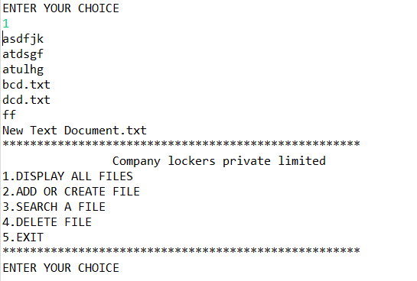

## 2.Getting File Name.



## 3.Adding File to Folder

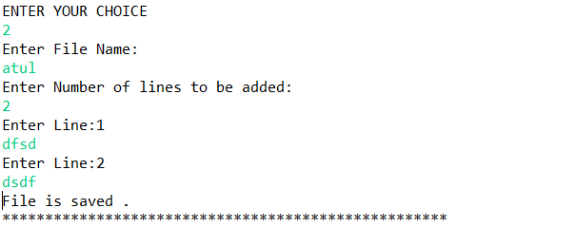

## 4.Deleting File From Folder

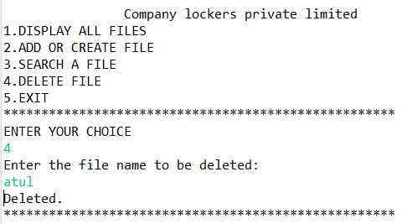

## 5.Exiting From Menu

