第一题 A：

select geo.EnglishCountryRegionName, cus.EnglishEducation, cus.Gender, count(*) as Count

from [dbo].[DimCustomer] cus

inner join [dbo].[DimGeography] geo

on cus.GeographyKey = geo.[GeographyKey]

where geo.EnglishCountryRegionName in ('France', 'Germany')

group by geo.EnglishCountryRegionName, rollup(cus.EnglishEducation,cus.Gender)

order by geo.EnglishCountryRegionName;

B：

暂定：

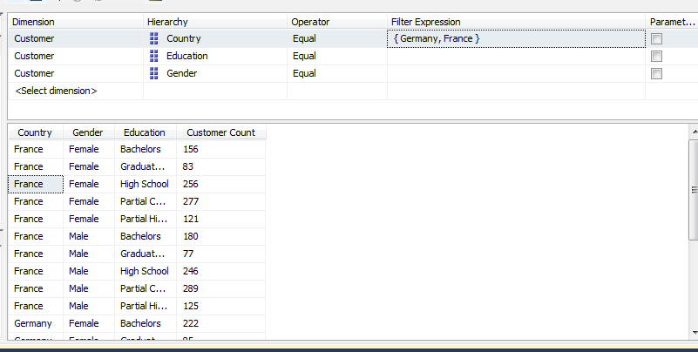

第二题：

SELECT

([Gender].children) on columns,

({[France], [Germany]}, education.children) on rows

From [Adventure Works]

WHERE [Measures].[Customer Count]

第三题：

SELECT

[Male] on columns,

([Country].children, education.members) on rows

From [Adventure Works]

WHERE [Measures].[Customer Count]

第四题：

with

MEMBER [Measures].[Percentage] AS

([Customer].[Gender].[Male], [Measures].[Customer Count])/

([Customer].[Gender].[All Customers], [Measures].[Customer Count]),

FORMAT_STRING = '0.0000%'

SELECT

[Measures].[Percentage] ON COLUMNS,

non empty{([Customer].[Country].children, [Date].[Calendar Year].children)} ON ROWS

FROM [Adventure Works]

第五题：

SELECT

NON EMPTY {[Measures].[Internet Sales Amount]} on columns,

NON EMPTY {({Germany, France}, City.Members )} on rows

FROM [Adventure Works]