***System Architecture Document for MovieLens Dataset Analysis Project***

**1. Introduction**

This document provides an overview of the system architecture for the MovieLens dataset analysis project. The project aims to perform analytical tasks on a semi-structured dataset containing a million records using Spark and Scala. The system architecture outlines the components, data flow, and interactions involved in processing and analyzing the dataset to derive insights about users and movies.

**2. Architecture Overview**

The system architecture for the MovieLens dataset analysis project is designed to leverage the capabilities of Spark and Scala. It comprises the following components:

* ***Data Source:*** The MovieLens dataset, consisting of a million records, serves as the primary data source for analysis.
* ***Data Ingestion:*** This component is responsible for reading and loading the dataset into Spark RDDs or DataFrames. It involves configuring the file format, handling data validation, and preprocessing steps to ensure data integrity and usability.
* ***Data Processing:*** The Data Processing component performs various transformations and cleaning operations on the dataset. It utilizes Spark RDD, Spark SQL, and Spark DataFrames to process and transform the data, adhering to the defined data schema and validation rules.
* ***Analysis:*** The Analysis component applies analytical queries and algorithms to extract meaningful insights from the dataset. It utilizes Spark SQL, aggregations, calculations, and statistical analysis methods to derive metrics and measures related to user behavior and movie attributes.
* ***Resultant Output:*** The Resultant Output component is responsible for storing and presenting the analysis results. It involves selecting appropriate storage formats, generating reports, creating visualizations, and integrating with other systems for further utilization of the derived insights.
* ***Spark Cluster:*** The Spark Cluster consists of a set of machines that distribute the data and computations across multiple nodes. It enables parallel processing and leverages Spark's distributed computing capabilities for efficient analysis.
* ***PySpark Shell:*** This Shell, utilizing the Python API, serves as the interactive development environment for executing Spark operations, running analytical queries, and testing code snippets.

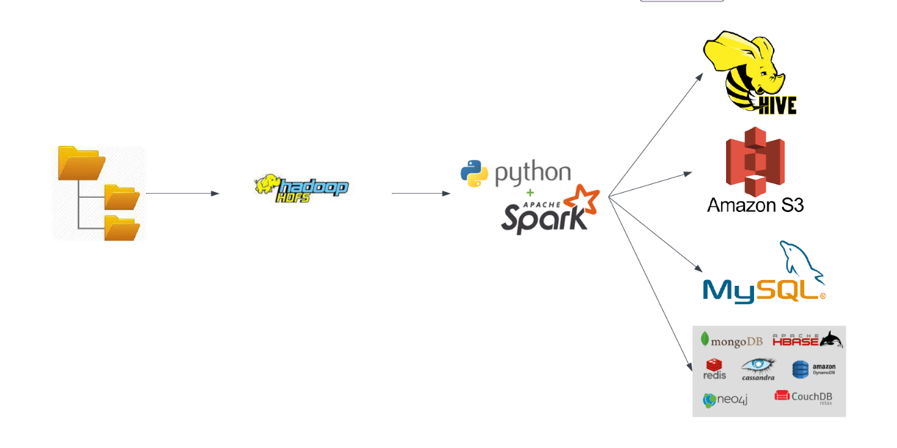

**3. Data Flow**

The data flow within the system architecture follows the following sequence:

* The Data Source component provides access to the MovieLens dataset, which is stored in a suitable file format.
* The Data Ingestion component reads and loads the dataset into Spark RDDs or DataFrames, configuring the file format and handling any necessary data validation or pre-processing steps.
* The Data Processing component applies transformations and cleaning operations on the dataset using Spark RDD, Spark SQL, and Spark DataFrames. This step involves data manipulation, filtering, aggregation, and joining operations as required.
* The Analysis component performs analytical queries and algorithms on the processed data using Spark SQL and Spark DataFrames. It derives insights related to movie genres, ratings, user behaviour, and other relevant metrics.
* The Resultant Output component stores the analysis results in suitable storage formats such as Parquet, CSV, or database tables. It also generates reports, creates visualizations, or integrates with other systems for further utilization of the insights.

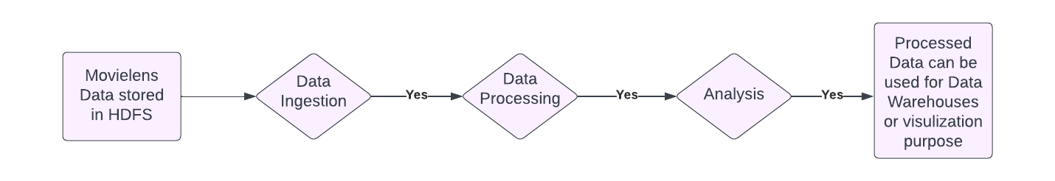

**4. Interactions and Dependencies**

The components in the system architecture interact and depend on each other as follows:

* The Data Ingestion component depends on the Data Source to read and load the dataset into Spark RDDs or DataFrames.
* The Data Processing component depends on the Data Ingestion component to receive the processed dataset and apply transformations and cleaning operations.
* The Analysis component depends on the processed data provided by the Data Processing component to perform analytical queries and derive insights.
* The Resultant Output component depends on the Analysis component to receive the analysis results and store them in the appropriate storage formats. It also utilizes the results to generate reports, create visualizations, or integrate with other systems.
* The Spark Cluster provides the underlying distributed computing infrastructure, enabling parallel processing and data distribution across multiple nodes.
* The Spark Shell, using the Scala API, serves as the development and execution environment for Spark operations, analytical queries, and code testing.

**5. Deployment Considerations**

The system can be deployed on a distributed computing cluster capable of running PySpark jobs. The cluster should have sufficient computational resources and storage capacity to handle the size of the MovieLens dataset. It is recommended to use a scalable cluster management system, such as Apache Hadoop YARN or Apache Mesos, for efficient resource allocation and job scheduling.

**6. Technologies Used**

  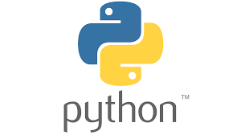

**PySpark**: The primary technology for processing and analyzing the MovieLens dataset.

**Spark RDD:** Used for low-level data processing and transformations.

**Spark SQL:** Used for executing SQL-like queries on the dataset.

**Spark DataFrames:** Used for high-level, structured data processing and analysis.

**Hadoop Distributed File System (HDFS):** Storage system for the MovieLens dataset.

**7. Conclusion**

The system architecture document outlines the high-level design and interactions involved in the MovieLens dataset analysis project using Spark and Python. It defines the components, data flow, and dependencies within the system, facilitating efficient processing, analysis, and utilization of the dataset to derive valuable insights about users and movies. The system architecture provides a foundation for the implementation phase, ensuring a structured and scalable approach to data analysis using Spark and Python.