

**CPE341 Optimization Design and Reliablity Engineering**

**Topic :**

**`**

**Short path to travel around the airbnb hotel based in New york city using Simulated annealing**

**Created By**

**Mr. Napas Vinitnantharat**

**Present to**

**Prof Naruemon Wattana**

**Department of Computer Engineering, Faculty of Engineering**

**King Mongkut’s University of Technology Thonburi**

**Semester 2/2022**

**1.Problem Definition**

**1.1 Project Description**

Travelling Salesman Problem (TSP) is a problem to find the shortest path distance to travel all the given list of cities and distance between each pair of cities.These are a lot of way to calculate the shortest path distance such as Dijkstra’s Algorithm,Bellman-Ford algorithm, A* algorithm and etc.Simulated annealing (SA) is a one of the probabilistic optimization algorithm technique for approxing the global optimum of the given function.In this project the Simulated Annealing(SA) is used to optimize the shortest path to travel Airbnb hotel in New york city.This project also analysis how different parameter of simulated algorithm will effect to speed of convegence of solution and is it a global optimum or not.

**1.2 Scope**

- The hotel (vectices) is random selected from the dataset airbnb hotel to find the shortest path

- In this study 30 airbnb hotel that have been random selected is considered to use in find the shortest path

- The starting hotel(vectices) of the path can be any hotel.

- The destination hotel(vectices) of the path can be any hotel.

- The location of the hotel is represent in latitude and longitude base on the world geodetic system projection

- The AirBnB hotel is all located in New City base on the kaggle dataset.

-Analysis different simulated annealing parameter effect to the speed convegence of solution or not.

**1.3. Input Dataset**

The Dataset is used from kaggle dataset. The dataset is related to the Airbnb Hotel.Airbnb, Inc is an American company that operates an online marketplace for lodging, primarily homestays for vacation rentals, and tourism activities. Based in San Francisco, California, the platform is accessible via website and mobile app. Airbnb does not own any of the listed properties; instead, it profits by receiving commission from each booking.

In This dataset have more than 102599 ยนหhotel.Some of the data is missing and not able to used.The missing data have been delete and cleaned before use in this project.airbnb open dataset has 26 features in this study will focus on only 4 features including latitude, longitude,price and service fee

<https://www.kaggle.com/datasets/arianazmoudeh/airbnbopendata>

**1.4. Model formulation with notation description**

**1.4.1 Objective(s)**

**1.4.1.1 Distance Objective**

Minize the distance route to travel 30 hotel in New york city. The total distance can be calculated by sum all of the distance between each hotel.In order to calculate the total distance between the hotel by using latitude and longitude The haversine formula have been used as shown in the following equation.

d - Distance between to point

r - Earth radius

- Destination latitude

- Starting latitude

- Destination longitude

- Starting longitude

**1.4.1.2 Cost Objective**

for the cost objective.cost of hotel including two factor the price of booking and service fee

**1.5 Decision Variable**

use list to represent the travel route.

**1.6 Constraint(s)**

none

**2.Related Theory**

**2.1 Algorithm and Parameter Setting**

In This Project the Simulated Annealing is used to find the best path solution.Simulated Annealing is c computatioal method borrowing inspiration from the field of physic introsuced by.It simulate the physical process of solid annealing. This method has been one of heuristic model to avoiding local minina.The base concept of this algorithm is accept worse candidate base o the probability dependent on the temperature and the rate of change of the fitness value or cost.

P =

P - The Probability of accepting the new solution candidate

fitness(s) - In This problem we use the total distance of the path so if delta fitness < 0 mean the the new route is shorter than the previous route.

T - Tempature which is use in the control parameter

**2.1.1 Algorithm**

While Current_Temp <= Final_temp:

for i until i = iterationpertemp:

find neighbor

calculate the neighbor fitness value

if fitness(neighbor) < fitness(S) # new solution is better

set neighbor to be the new solution

else

random number r in range 0 to 1

if r <

set neighbor to be the new solution

else

do nothing

update the tempurature T = T*α

**2.2. Weight Sum Method**

The Weighted Sum Method can applied when two or more objective functions need to be minimized or maximized.Weighted Sum Method(WSM) scalarizes a set of objective with a user supplied weight

**3.Methodology**

**3.1 Methodolgy**

Simulated annealing has been apply to find the shortest path in New york airbnb dataset by random 30 airbnb host from 102599 ยนหhosts.

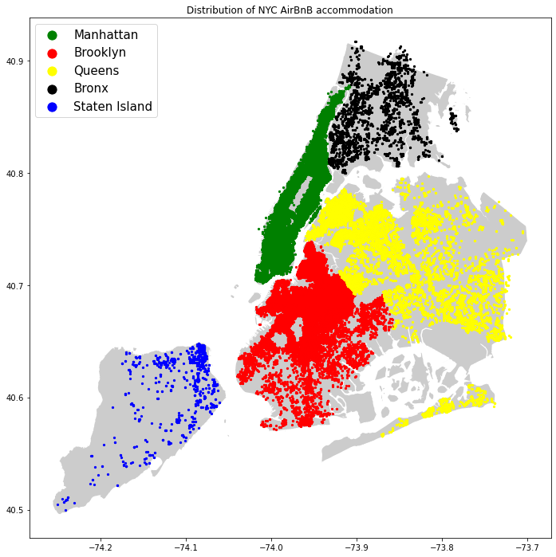

**Figure 3.1. Distribution of NYC AirBnB accommodation**

**Figure 3.1** show the Distibution of the New york Air bnb accomodation 30 hotels was selected to test the performance of applying Simulated Annealing Algorithm with different iteration Per temperature and α to solve Travelling Saleman Problem.The starting hotel can be any of 30 hotels.The ending hotel is same as the starting hotel.The Distance and Price of the hotel is a objective to minize.Distance between two hotel can calculated by using haversine formula

**3.2 Parameter Setting**

**Intial Solution :** Random Route

**Initial Temp :** 200

**iterationPer temp :** 100,200,500,1000

**Decrease tempature** by Geometric Reduction Rule : T = T*α

α is equal to จ0.98,0.9,0.7,0.6,0.5

**Termination condition :** Current_Temp <= Final_Temp, final_Temp = 0.01

**find neighbor by Swap 2 node**

This exchanges the position of two cities in a route. Two positions, i and j are selected at random and the cities in these positions are swapped with each other. ‘1–2–3–4–5–6’ could become ‘1–5–3–4–2–6’.

**Weight Sum Method**

weight distance : 0.7

weight price: 0.3

**3.3 Objective Function**

Goal in this study is to minize the distance to travel all of the node and minize the price cost for booking and service fee which can represent as the following function

- represent as a path to travel hotel

- represent as distance of path

- represent as Cost to travel all the hotel

**4. Result and Discussion**

**4.1 Iteration per temp factor**

**Figure 4.1.1 - 4.1.4** show the result of apply simulated annealing algorithm to solve traveling saleman problem with different iteration per temp lead to the different path solution.for parameter for this problem ,IntialTemp = 200, Decrease tempature by geometric reduction rule T = T*α ,α is equal to จ0.98.From this sample the cost of objective function with iteration per temp equal to 100,200,500,1000 is equal to 6784.93,6786.92,6784.60,6783.54 respectively

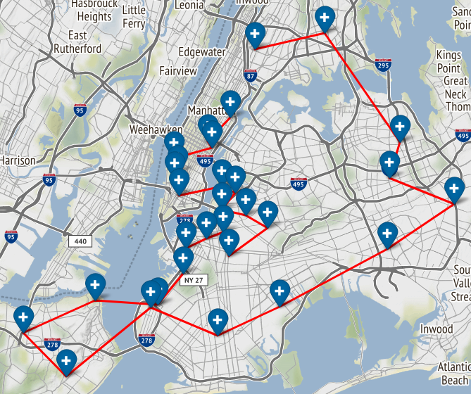

**Figure 4.1.1 Simulated Annelaing when iteration per temp equal to 100**

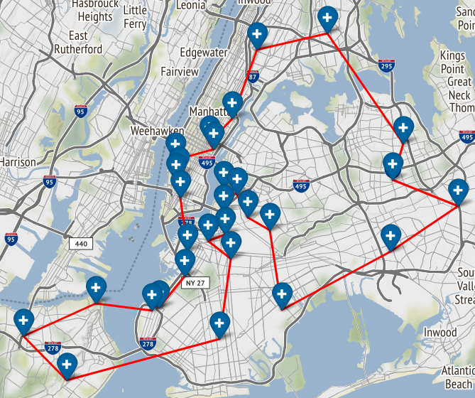

**Figure 4.1.2 Simulated Annelaing when iteration per temp equal to 200**

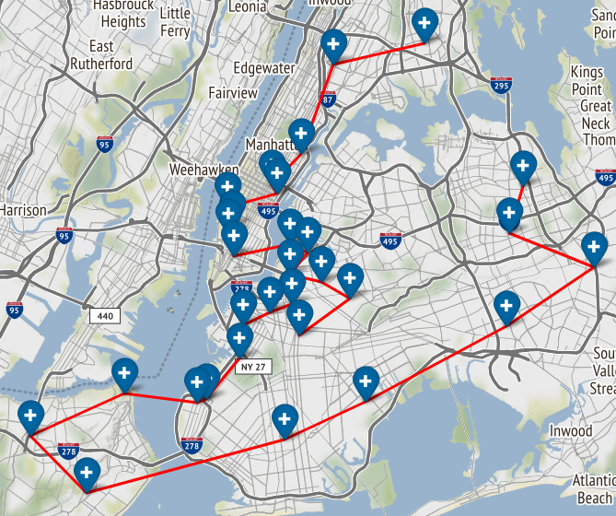

**Figure 4.1.3 Simulated Annelaing when iteration per temp equal to 500**



**Figure 4.1.4 Simulated Annelaing when iteration per temp equal to 1000**

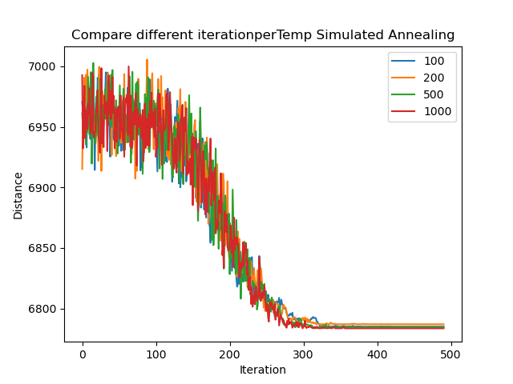

**Figure 4.1.5 Compare different iteration per temp effect to the solution**

By testing 5 times with different random 30 hotel.Result show that Iteration Per Temp parameter has a little correlation with the answer of the solution.Sometime applying simulated annealing with Iteration Per Temp equal to 1000 is trend to get the best result. Sometime applying simulated annealing with Iteration Per Temp equal to 200 get better result.Increase the iteration per temp is not improving Convergence of the solution because the probability of accept worse is solution is not change during one iteration.So In term of apply to real problem iteration per temp equal to 200 , 500 is best parameter for using because it give a good result with a low compute time.

**4.2 Decrease Temp Rate Factor**

**Figure 4.2.1 - 4.2.5** show the result of apply simulated annealing algorithm to solve traveling saleman problem with different alpha (parameter to decrease temp rate).for a parameter for this problem , IntialTemp = 200, iterationPertemp =200, Decrease tempature by geometric reduction rule T = T*α. From this sample test the cost of objective function with (alpha) α is equal to 0.5,0.6,0.7,0.9,จ0.98 is 5399.46,5397.47,5389.05,5387.68,5386.96 respectively

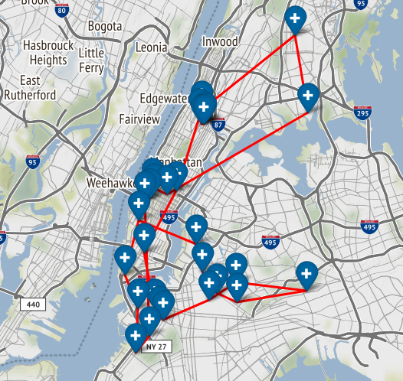

**Figure 4.2.1 Simulated Annelaing when alpha = 0.5**

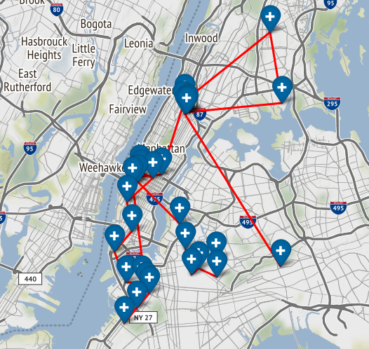

**Figure 4.2.2 Simulated Annelaing when alpha = 0.6**

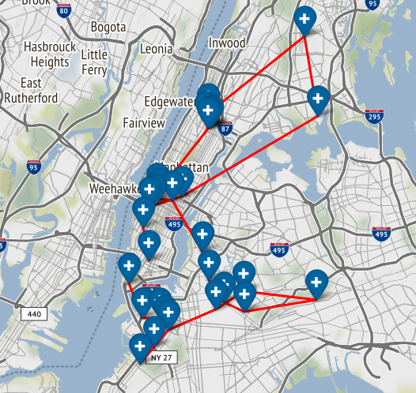

**Figure 4.2.3 Simulated Annelaing when alpha = 0.7**

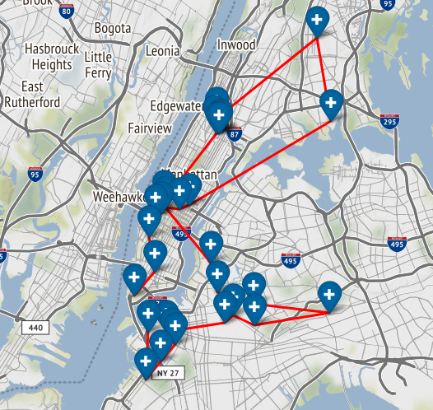

**Figure 4.2.4 Simulated Annelaing when alpha = 0.9**

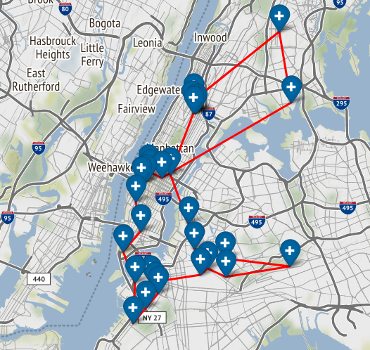

**Figure 4.2.5 Simulated Annelaing when alpha = 0.98**

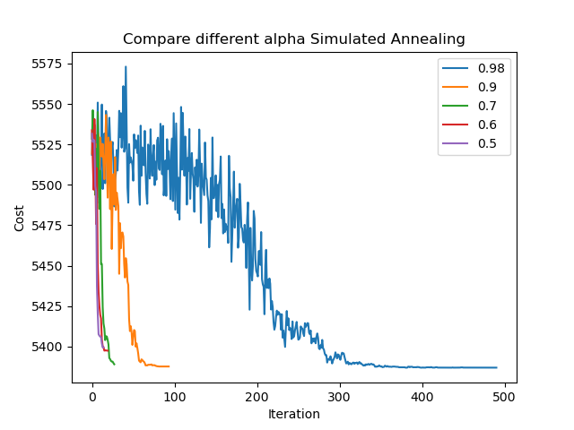

**Figure 4.2.6 Compare different alpha parameter effect to the solution**

By testing 5 times of with different random 30 hotel.Result show that higher alpha get a better result. From **Figure 4.2.6 ห** show different alpha parameter effect to convergence of solution.In case of alpha is small the tempurature is decrease faster than the simulated annealing with the higher alpha.

**5.Conclusion**

This study on apply Simulated Annealing Algorithm to solve the short path to travel all airbnb hotel in New york City with different parameter setup.The result show that the parameter iterationpertemp is less effect to convergence of solution. The higher iterationpertemp is not guarantee it is better than algorithm with lower iterationpertemp.While alpha parameter which is a parameter to that determine the rate of decrease the temperture show that, the higher alpha lead to the better performance of the algorithm

**6.Reference**

[1]<https://medium.com/ai-techsystems/simulated-annealing-580f73bd807a>

[2]<https://medium.com/swlh/how-to-implement-simulated-annealing-algorithm-in-python-ab196c2f56a0>

[3]<https://towardsdatascience.com/optimization-techniques-simulated-annealing-d6a4785a1de7>

[4]<https://medium.com/@francis.allanah/travelling-salesman-problem-using-simulated-annealing-f547a71ab3c6>