1. **Project Name**

Short path to travel around the airbnb hotel based in New york city using Simulated annealing

1. **Student Name**

- Napas Vinitnantharat 63070503422

1. **Project description and scope**

**3.1 Project description**

Shortest path problem is the problem of finding a path between two vertices in a graph.There are a lot of way to calculate the the shortest path such as Dijkstra’s Algorithm,Bellman-Ford algorithm,A* algorithm and etc .In this project the Simulated Annealing(SA) is used to optimize the shortest path to travel 30 Airbnb hotel in New York City.

**3.2 Scope**

- The hotel (vectices) is random selected from the dataset airbnb hotel to find the shortest path

- In this study 30 airbnb hotel that have been random selected is considered to use in find the shortest path

- The starting hotel(vectices) of the path can be any hotel.

- The destination hotel(vectices) of the path can be any hotel.

- The location of the hotel is represent in latitude and longitude base on the world geodetic system projection

- The AirBnB hotel is all located in New City base on the kaggle dataset.

1. **Model formulation with notation description**
   1. **Objective(s)**

Minize the distance route to travel 30 hotel in New york city. The total distance can be calculated by sum all of the distance between each hotel.In order to calculate the total distance between the hotel by using latitude and longitude The haversine formula have been used as shown in the following equation.

d - Distance between to point

r - Earth radius

- Destination latitude

- Starting latitude

- Destination longitude

- Starting longitude

* 1. **Decision Variable(s)**

- use list to represent the travel route.

**Example**

[8,1,2,9,4,7,3,5]

mean route from

8 -> 1 -> 2 -> 9 -> 4 -> 7 -> 3 -> 5

* 1. **Constraint(s)**

None

1. **Input dataset**

The Dataset is used from kaggle dataset. The dataset is related to the Airbnb Hotel.Airbnb, Inc is an American company that operates an online marketplace for lodging, primarily homestays for vacation rentals, and tourism activities. Based in San Francisco, California, the platform is accessible via website and mobile app. Airbnb does not own any of the listed properties; instead, it profits by receiving commission from each booking.

In This dataset have more than 102599 ยนหhotel.Some of the data is missing and not able to used.The missing data have been delete and cleaned before use in this project.

<https://www.kaggle.com/datasets/arianazmoudeh/airbnbopendata>

1. **Problem size**

In This Database We have 30 ีืรunique airbnb hotel so the Problem size is equal to 30! solutions approximately 2.652e32 solutions

1. **Algorithm and parameter setting**

In This Project we use the Simulated Annealing to find the best path solution.Simulated Annealing is c computatioal method borrowing inspiration from the field of physic introsuced by.It simulate the physical process of solid annealing. This method has been one of heuristic model to avoiding local minina.The base concept of this algorithm is accept worse candidate base o the probability dependent on the temperature and the rate of change of the fitness value or cost.[1][2][3]

P =

P - The Probability of accepting the new solution candidate

fitness(s) - In This problem we use the total distance of the path so if delta fitness < 0 mean the the new route is shorter than the previous route.

T - Tempature which is use in the control parameter

* 1. **Algorithm**

While Current_Temp <= Final_temp:

for i until i = iterationpertemp:

find neighbor

calculate the neighbor fitness value

if fitness(neighbor) < fitness(S) # new solution is better

set neighbor to be the new solution

else

random number r in range 0 to 1

if r <

set neighbor to be the new solution

else

do nothing

update the tempurature T = T*α

**7.2 Parameter Setting**

**Intial Solution :** Random Route

**Initial Temp :** 300

**iterationPer temp :** 1000

**Decrease tempature** by Geometric Reduction Rule : T = T*α

α is equal to จ0.98

**Termination condition :** Current_Temp <= Final_Temp

**find neighbor by Swap 2 node**

This exchanges the position of two cities in a route. Two positions, i and j are selected at random and the cities in these positions are swapped with each other. ‘1–2–3–4–5–6’ could become ‘1–5–3–4–2–6’.

1. **Experimental**

In This project The Simulated annealing had been tested to find the shortest route to travel all 30 Airbnb hotel.The Dataset that has been used in this experiement is from Kaggle Dataset which consist of 102599Hotel.Thirty Airbnb hotel have been random selected to used in the test algorithm.The neighbor of solution is calculated by swap 2 hotel in the path.The algorithm is be tested for 10 time to test the performance of the algorithm.The fitness value also recorded to see the performance of the algorithm.

1. **Result discussion and verification**

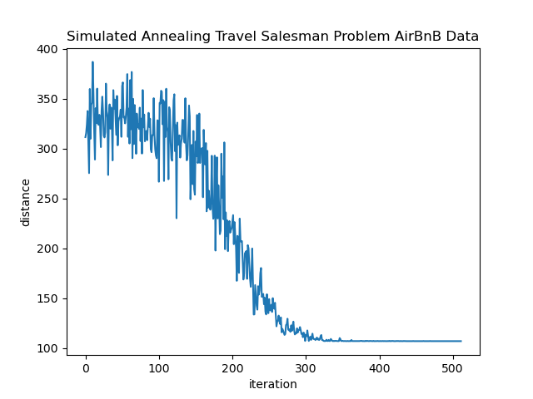

**Figure 9.1 Simulated Annealing Travel Saleman Problem fitness value distance and iteration**

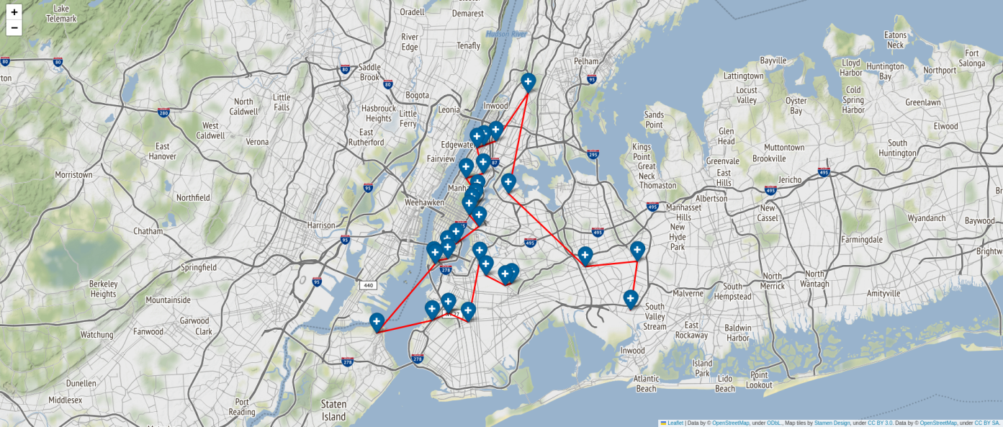

**Figure 9.2 The Solution path to travel in 30 New york Hotel**

1. **Reference**

[1]<https://medium.com/ai-techsystems/simulated-annealing-580f73bd807a>

[2]<https://medium.com/swlh/how-to-implement-simulated-annealing-algorithm-in-python-ab196c2f56a0>

[3]<https://towardsdatascience.com/optimization-techniques-simulated-annealing-d6a4785a1de7>

[4]<https://medium.com/@francis.allanah/travelling-salesman-problem-using-simulated-annealing-f547a71ab3c6>