Smallholders are small-scale farmers managing areas varying from less than one hectare to 10 hectares. Women comprise up to almost 50 percent of the agricultural labour force

Smallholders provide up to 80 percent of the food supply in Asian and sub-Saharan Africa.

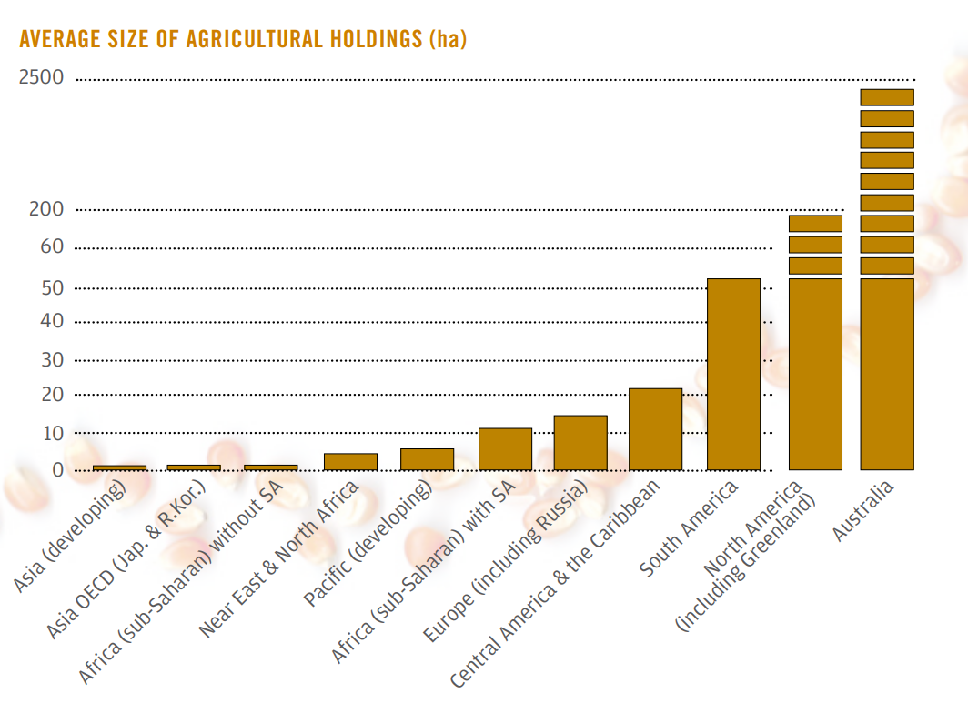

There are an estimated 500 million smallholder farms in developing countries of the world alone, supporting almost two billion people.

Historic rainfall, moisture and temperature conditions related to the current agri-season ones would help smallholders to plan ahead water requirements or variety selection.

These data are recorded by NASA satellites.

We want to bring to the smallholder’s farm such information.

Once the init/end agriseason are defined, the farmer will get:

Some developing countries do not enjoy the best telecommunications infrastructure.

