Why?
Farmers need support against these issues, by means of improved weather data and predictions (more precise, timely, adapted to their specific crops / livestock)
This will enable farmers to:
• Make informed decisions based on relevant, useful, actual data
• Manage the risks of drought and floodings and use water efficiently
• Improve their farming practices
• Optimize production
In turn, this contributes to a steadysupply of food, which benefits farmers and consumers (predictable deliveries,stable prices).

WHO

Smallholders are small-scale farmers managing areas varying from less than one hectare to 10 hectares. Women comprise up to almost 50 percent of the agricultural labor force

Smallholders provide up to 80 percent of the food supply in Asian and sub-Saharan Africa.

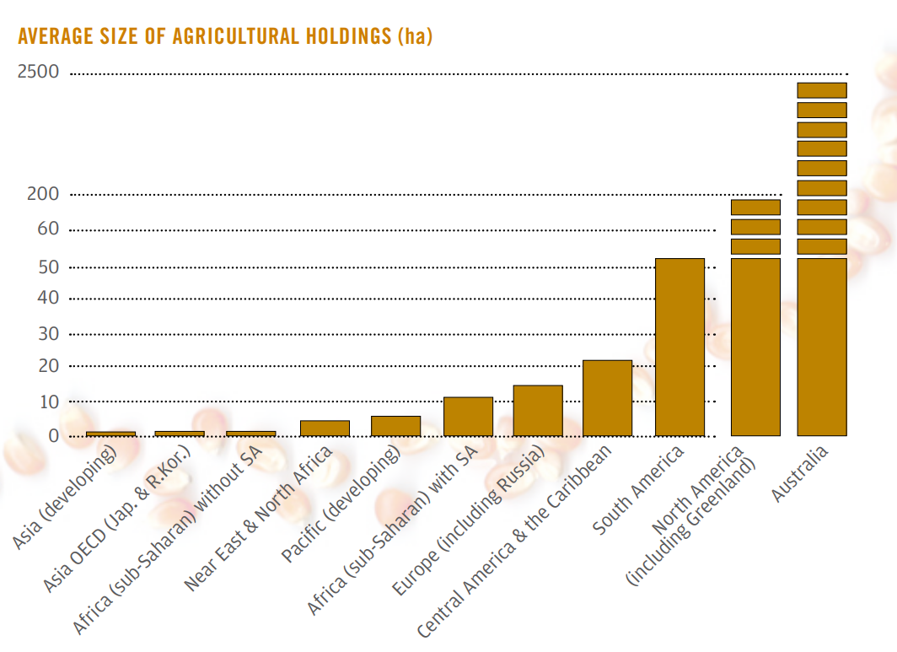

There are an estimated 500 million smallholder farms in developing countries of the world alone, supporting almost two billion people.

Historic rainfall, moisture and temperature conditions related to the current agri-season ones would help smallholders to plan ahead water requirements or variety selection.

These data are recorded by NASA satellites.
We want to bring to the smallholder’s farm such information.
Once the init/end agriseason are defined, the farmer will get:

A Season to day rainfall of current year compared with previous ones

A Season to day rainfall of current year in perspective of previous full seasons

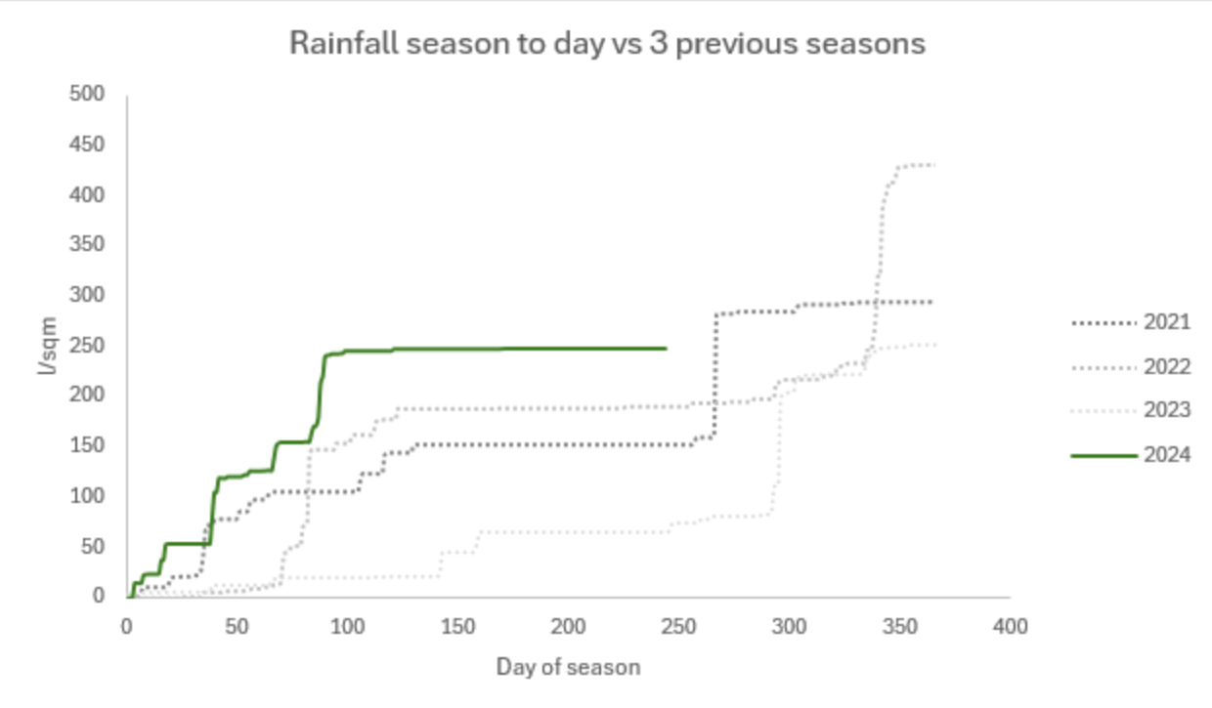
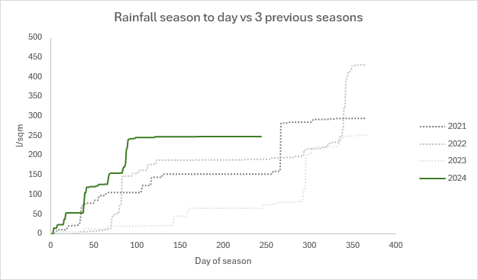

A quadrant will express current season compared with historical data

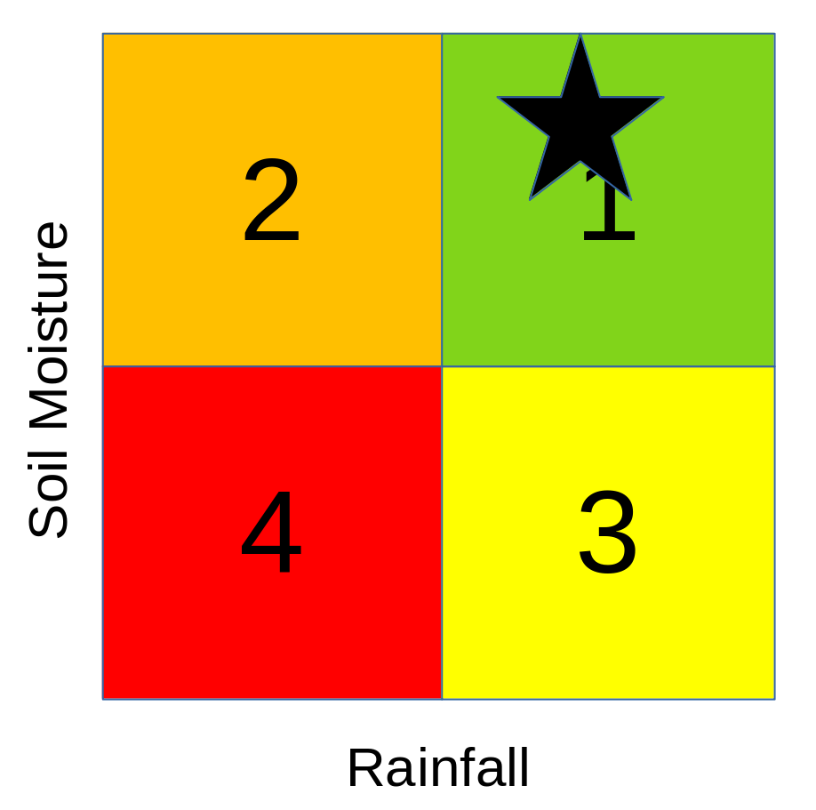

These quadrant will support water management decisions

Scenario 1: is the best scenario for the farmer. Current season rainfall is above the average as well as soil moisture. Water care can relax a little bit.

Scenario 4; is the worst case for the farmer. He must check if has enough water reserves to finish a successful crop or choose a variety with less water requirements.

Scenario 2 and 3

Some developing countries do not enjoy the best telecommunications infrastructure.

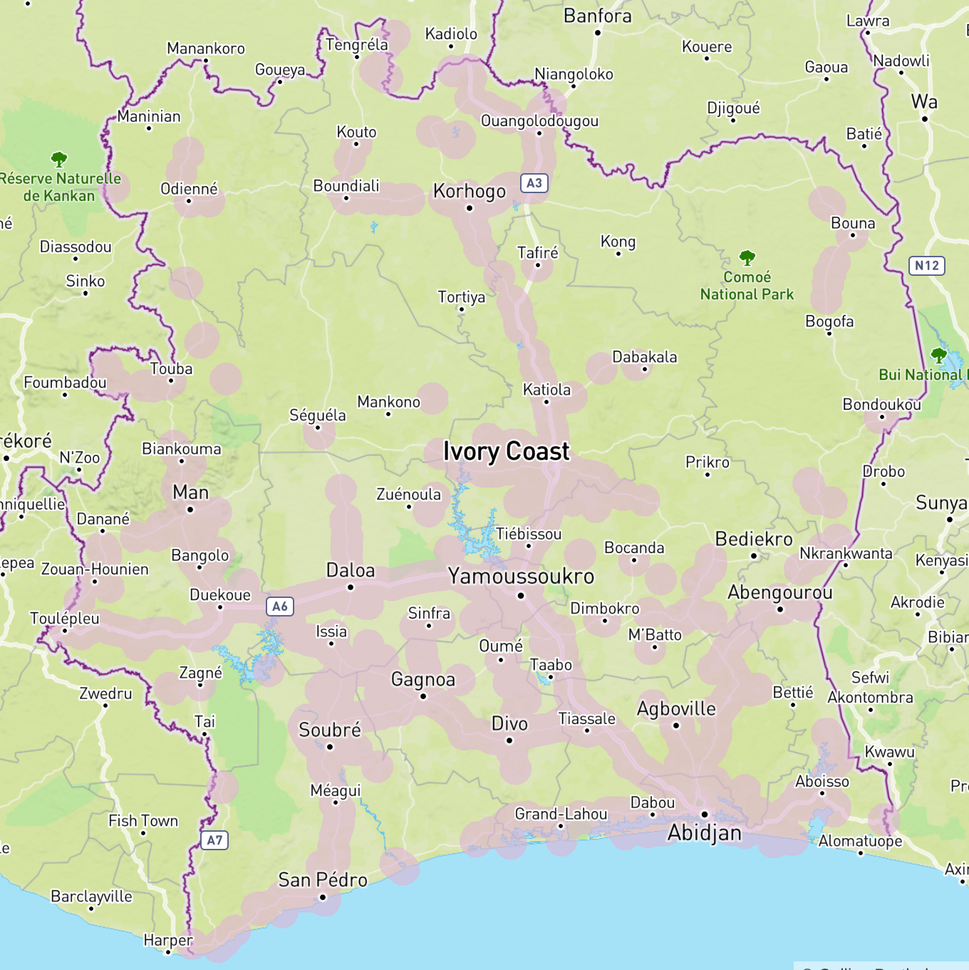

The app will download historical data for NASA data sources for each plot the smallholders wants to include.

As far as new current rainfall and moisture data is available, that app will download it when a good signal is available.

