Name: Md. Nasarul Hasan

Roll: 18

Home Task for Module-2 Multimedia Systems Design

1. **What is the main difference between adobe illustrator and photoshop?**

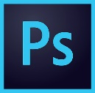Photoshop is raster-based and uses pixels to create images. Photoshop is designed for editing and creating photos or raster-based art. Photoshop is known to create interface designs, web pages, banner ads, video graphics, and editing and creating images for print.

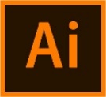Illustrator works off vectors, these are points used to create perfectly smooth lines. This program is for creating and editing vector-based work such as graphics, logos, and other design elements. Vectors are scalable images that can be sized as small or as large are we need, but looks the same when it comes to clarity and resolution.

1. **What is Adobe Director used for?**

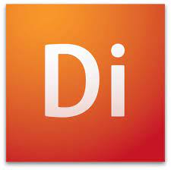Adobe Director is a multimedia authoring system that runs on both Macintosh and PC computers. It is a great rapid prototyping tool as well as a great development tool. Director uses a number of theatrical metaphors. Adobe Director is a slick program that will require less space than many software in the category design & photography software.

Adobe Director used to create and publish compelling interactive games, demos, prototypes, kiosks, simulations, and eLearning courses for the web, iOS devices, Mac and Windows desktops, DVDs, and CDs.

1. **What is vector graphics animation?**

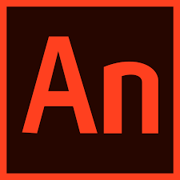Vector graphics animation is an animation where the art or motion is controlled by vectors rather than pixels. Smoother animation images are displayed and resized using mathematical values instead of stored pixel values. Vector animation have the unique advantage over raster graphics in that the points, lines, and curves may be [scaled](https://en.wikipedia.org/wiki/Scaling_(geometry)) up or down to any [resolution](https://en.wikipedia.org/wiki/Display_resolution) with no [aliasing](https://en.wikipedia.org/wiki/Aliasing). The points determine the direction of the [vector path](https://en.wikipedia.org/wiki/Vector_path); each path may have various properties including values for stroke color, shape, curve, thickness, and fill. Vector graphics animation are commonly found today in the SVG, EPS, PDF formats.