Sintaxe_TabelaGrafico.R

rafael

2024-03-27

#######################################################  
# CARREGAR BASE DE DADOS  
dados = read.csv2("Questionario_modif.csv", dec=".")  
names(dados)

## [1] "ID" "Sexo" "Peso" "Altura" "Idade"   
## [6] "Cursinho" "Dinheiro" "Trabalho" "Cidade" "Gosta_Est"   
## [11] "Gosta_Curso" "IMC" "IMC_Cat"

#######################################################  
# TABELA PARA UMA VARIAVEL QUALITATIVA  
ftabela = table(dados$Gosta_Est, useNA = "ifany")   
ptabela = round(prop.table(ftabela)*100,1)  
tabela1 = data.frame(ftabela,ptabela)  
tabela1 = tabela1[,-3]  
colnames(tabela1) <- c("Gosta_Est","Frequencia","Porcentagem")  
tabela1

## Gosta_Est Frequencia Porcentagem  
## 1 Não sei 14 33.3  
## 2 Sim 28 66.7

write.table(tabela1,"Tabela.csv", sep=";", dec=",", row.names=TRUE)  
  
  
#######################################################  
# GRAFICO PARA UMA VARIAVEL QUALITATIVA  
library(ggplot2)  
ggplot(dados, aes(x=Cidade )) +  
 geom_bar(color="blue", fill=rgb(0.1,0.6,0.7,0.7) ) +  
 labs(title="Gráfico para Cidade",  
 x ="Cidade", y = "Frequência")

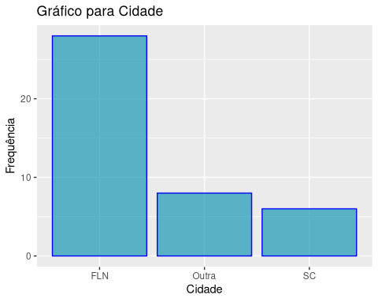

#######################################################  
# TABELA PARA DUAS VARIAVEIS QUALITATIVAS  
ftabela2 = table(dados$Sexo, dados$Gosta_Est, useNA = "ifany")   
ptabela2 = round(prop.table(ftabela2,1)*100,1)  
tabela2 = data.frame(ftabela2,ptabela2)  
tabela2 = tabela2[,-c(4,5)]  
colnames(tabela2) <- c("Sexo","Gosta_Est","Frequencia","Porcentagem")  
tabela2

## Sexo Gosta_Est Frequencia Porcentagem  
## 1 Fem Não sei 5 50.0  
## 2 Masc Não sei 9 28.1  
## 3 Fem Sim 5 50.0  
## 4 Masc Sim 23 71.9

write.table(tabela1,"Tabela2.csv", sep=";", dec=",", row.names=TRUE)  
  
  
#######################################################  
# GRAFICO PARA DUAS VARIAVEIS QUALITATIVAS  
library(ggplot2)  
ggplot(dados, aes(x=Sexo, fill=Gosta_Est)) +   
 geom_bar(position="fill") +  
 ylab("Porcentagem")

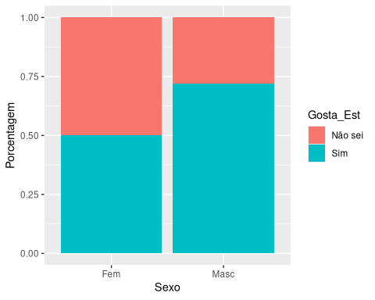

#######################################################  
# GRAFICO DE DISPERSAO  
library(ggplot2)  
ggplot(dados, aes(x=Altura, y=Peso)) +  
 geom_point()

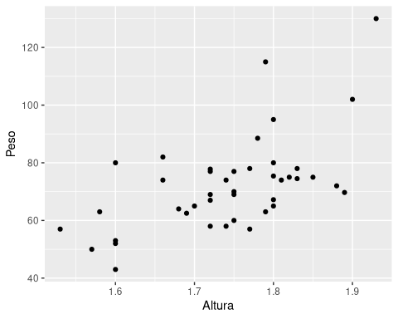

ggplot(dados, aes(x=Altura, y=Peso, color=Sexo)) +  
 geom_point()

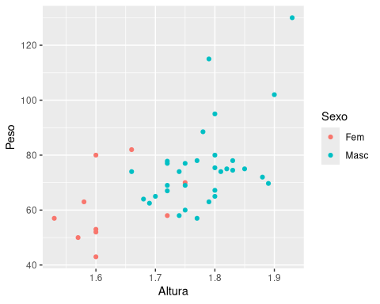

#######################################################  
# GRAFICO PARA UMA VARIAVEL QUANTITATIVA  
# Histograma  
library(ggplot2)  
ggplot(dados, aes(x=IMC)) +   
 geom_histogram(bins=7)

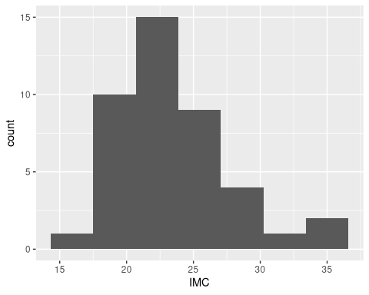

ggplot(dados, aes(x=IMC)) +   
 geom_histogram(bins = 7, fill = 'blue', color = 'white')

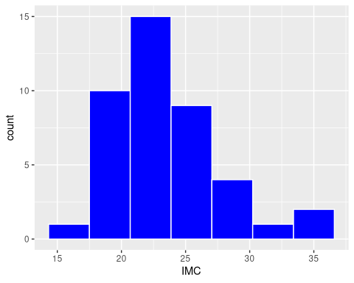

#######################################################  
# TABELA PARA UMA VARIAVEL QUALITATIVA E UMA QUANTITATIVA  
tabela.medias <- aggregate(dados$IMC, by=list(dados$Sexo), FUN="mean")  
colnames(tabela.medias) <- c("IMC","Media")  
tabela.medias

## IMC Media  
## 1 Fem 23.11532  
## 2 Masc 23.85776

#######################################################  
# SALVAR ARQUIVO EM FORMATO DE RELATORIO  
# File -> Compile Report...