Compilação do Trabalho01

2024-04-29

library(readr)  
library(doBy)  
library(dplyr)

##   
## Attaching package: 'dplyr'

## The following object is masked from 'package:doBy':  
##   
## order_by

## The following objects are masked from 'package:stats':  
##   
## filter, lag

## The following objects are masked from 'package:base':  
##   
## intersect, setdiff, setequal, union

######################################################################  
##00 Tratamento de Dados   
######################################################################  
  
## Leitura da Base de Dados  
stroke_data <- read_csv("healthcare-dataset-stroke-data.csv")

## Rows: 5110 Columns: 12

## ── Column specification ────────────────────────────────────────────────────────  
## Delimiter: ","  
## chr (6): gender, ever_married, work_type, Residence_type, bmi, smoking_status  
## dbl (6): id, age, hypertension, heart_disease, avg_glucose_level, stroke  
##   
## ℹ Use `spec()` to retrieve the full column specification for this data.  
## ℹ Specify the column types or set `show_col_types = FALSE` to quiet this message.

## Remoção de Colunas não usadas  
stroke_data = select(stroke_data, -work_type)  
stroke_data = select(stroke_data, -ever_married)  
stroke_data = select(stroke_data, -Residence_type)  
  
## Exclusão de objeto na Base de Dados  
stroke_data = stroke_data[stroke_data$gender!="Other",]  
  
## Mudança de status das variáveis  
stroke_data$hypertension = case_match(stroke_data$hypertension, 0~"Não", 1~"Sim")  
stroke_data$heart_disease = case_match(stroke_data$heart_disease, 0~"Não", 1~"Sim")  
stroke_data$stroke = case_match(stroke_data$stroke, 0~"Não", 1~"Sim")  
stroke_data$gender = case_match(stroke_data$gender, "Female"~"Feminino", "Male"~"Masculino")  
stroke_data$smoking_status = case_match(stroke_data$smoking_status,"formerly smoked"~"Fumou","never smoked"~"Nunca Fumou","smokes"~"Fuma", "Unknown"~"S/ info")  
  
## Mudança de tipagem da variavel IMC : chr --> float  
stroke_data = stroke_data %>%  
 mutate(imc = case_when(bmi == "N/A" ~ -1,   
 .default = as.numeric(bmi)))

## Warning: There was 1 warning in `mutate()`.  
## ℹ In argument: `imc = case_when(bmi == "N/A" ~ -1, .default =  
## as.numeric(bmi))`.  
## Caused by warning in `vec_case_when()`:  
## ! NAs introduced by coercion

stroke_data = select(stroke_data, -bmi)  
  
  
######################################################################  
##01 Análise de Dados   
######################################################################  
  
######################################################################  
# Funções Úteis Criadas:  
  
## Criação de uma Tabela de apenas uma variável  
one_var_table <- function(data_var, name_var){  
 ftabela = table(data_var, useNA = "ifany")   
 ptabela = round(prop.table(ftabela)*100,1)  
 tabela = data.frame(ftabela,ptabela)  
 tabela = tabela[,-3]  
 colnames(tabela) <- c(name_var,"Frequencia","Porcentagem")  
   
 print(tabela)  
   
 return(tabela)  
}  
  
## Criação de uma Tabela de duas variáveis  
two_var_table <- function(var1, var2, name1, name2){  
 ftabela = table(var1, var2, useNA = "ifany")   
 ptabela = round(prop.table(ftabela,1)*100,1)  
 tabela = data.frame(ftabela,ptabela)  
 tabela = tabela[,-c(4,5)]  
 colnames(tabela) <- c(name1,name2,"Frequencia","Porcentagem")  
   
 return(tabela)  
}  
  
## Criação de uma Tabela relacionando uma variável à variável AVC  
stroke_var_table <- function(data_var, name_var){  
 tabela = two_var_table(data_var, stroke_data$stroke, name_var, "AVC")  
   
 print(tabela)  
   
 return(tabela)  
}  
  
  
######################################################################  
# TABELAS PARA VARIAVEIS QUALITATIVAS:  
  
## Gênero:  
tabela_gender = one_var_table(stroke_data$gender, "Gênero")

## Gênero Frequencia Porcentagem  
## 1 Feminino 2994 58.6  
## 2 Masculino 2115 41.4

tabela_gender_stroke = stroke_var_table(stroke_data$gender, "Gênero")

## Gênero AVC Frequencia Porcentagem  
## 1 Feminino Não 2853 95.3  
## 2 Masculino Não 2007 94.9  
## 3 Feminino Sim 141 4.7  
## 4 Masculino Sim 108 5.1

write.table(tabela_gender,"tabela_gender.csv", sep=";", dec=",", row.names=TRUE)  
write.table(tabela_gender_stroke,"tabela_gender_stroke.csv", sep=";", dec=",", row.names=TRUE)  
  
## Hipertensão  
tabela_hypertension = one_var_table(stroke_data$hypertension, "Hipertensão")

## Hipertensão Frequencia Porcentagem  
## 1 Não 4611 90.3  
## 2 Sim 498 9.7

tabela_hypertension_stroke = stroke_var_table(stroke_data$hypertension, "Hipertensão")

## Hipertensão AVC Frequencia Porcentagem  
## 1 Não Não 4428 96.0  
## 2 Sim Não 432 86.7  
## 3 Não Sim 183 4.0  
## 4 Sim Sim 66 13.3

write.table(tabela_hypertension,"tabela_hypertension.csv", sep=";", dec=",", row.names=TRUE)  
write.table(tabela_hypertension_stroke,"tabela_hypertension_stroke.csv", sep=";", dec=",", row.names=TRUE)  
  
## Problema no Coração  
tabela_heart = one_var_table(stroke_data$heart_disease, "Cardiaco")

## Cardiaco Frequencia Porcentagem  
## 1 Não 4833 94.6  
## 2 Sim 276 5.4

tabela_heart_stroke = stroke_var_table(stroke_data$heart_disease, "Cardiaco")

## Cardiaco AVC Frequencia Porcentagem  
## 1 Não Não 4631 95.8  
## 2 Sim Não 229 83.0  
## 3 Não Sim 202 4.2  
## 4 Sim Sim 47 17.0

write.table(tabela_heart,"tabela_heart.csv", sep=";", dec=",", row.names=TRUE)  
write.table(tabela_heart_stroke,"tabela_heart_stroke.csv", sep=";", dec=",", row.names=TRUE)  
  
## Fumante  
tabela_smoke = one_var_table(stroke_data$smoking_status, "Cigarro")

## Cigarro Frequencia Porcentagem  
## 1 Fuma 789 15.4  
## 2 Fumou 884 17.3  
## 3 Nunca Fumou 1892 37.0  
## 4 S/ info 1544 30.2

tabela_smoke_stroke = stroke_var_table(stroke_data$smoking_status, "Cigarro")

## Cigarro AVC Frequencia Porcentagem  
## 1 Fuma Não 747 94.7  
## 2 Fumou Não 814 92.1  
## 3 Nunca Fumou Não 1802 95.2  
## 4 S/ info Não 1497 97.0  
## 5 Fuma Sim 42 5.3  
## 6 Fumou Sim 70 7.9  
## 7 Nunca Fumou Sim 90 4.8  
## 8 S/ info Sim 47 3.0

write.table(tabela_smoke,"tabela_smoke.csv", sep=";", dec=",", row.names=TRUE)  
write.table(tabela_smoke_stroke,"tabela_smoke_stroke.csv", sep=";", dec=",", row.names=TRUE)  
  
  
## AVC  
tabela_stroke = one_var_table(stroke_data$stroke, "AVC")

## AVC Frequencia Porcentagem  
## 1 Não 4860 95.1  
## 2 Sim 249 4.9

write.table(tabela_stroke,"tabela_stroke.csv", sep=";", dec=",", row.names=TRUE)  
  
######################################################################  
# MEDIDAS DE RESUMO PARA QUANTITATIVAS:  
  
## Idade  
summary(stroke_data$age)

## Min. 1st Qu. Median Mean 3rd Qu. Max.   
## 0.08 25.00 45.00 43.23 61.00 82.00

## Glicose no Sangue  
summary(stroke_data$avg_glucose_level)

## Min. 1st Qu. Median Mean 3rd Qu. Max.   
## 55.12 77.24 91.88 106.14 114.09 271.74

## IMC  
summary(stroke_data$imc[stroke_data$imc != -1])

## Min. 1st Qu. Median Mean 3rd Qu. Max.   
## 10.30 23.50 28.10 28.89 33.10 97.60

######################################################################  
# GRAFICOS DAS VARIAVEIS DE ESTUDO:  
  
## Gênero  
library(ggplot2)  
ggplot(stroke_data, aes(x=gender)) +  
 geom_bar(fill="lightblue", color="blue", alpha=0.8) +  
 labs(x="Gênero", y="Contagem")

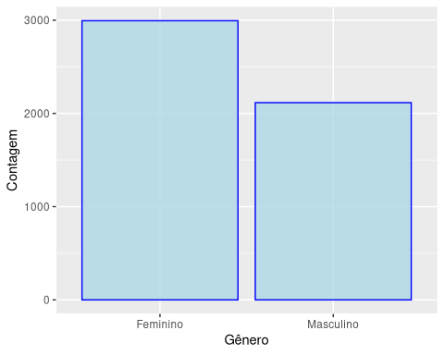

ggplot(stroke_data, aes(x=gender, fill=stroke)) +   
 geom_bar(position="fill") +  
 xlab("Gênero") +  
 ylab("Porcentagem")

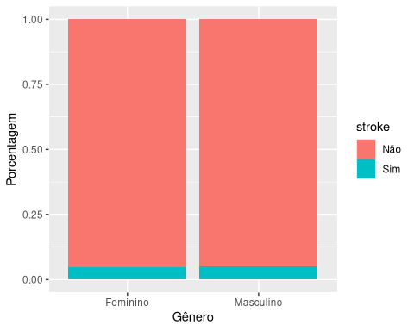

## Idade  
ggplot(stroke_data, aes(x=age)) +  
 geom_histogram(binwidth=1, alpha=0.7, color="blue", fill="lightblue") +   
 labs(x="Idade", y="Contagem")

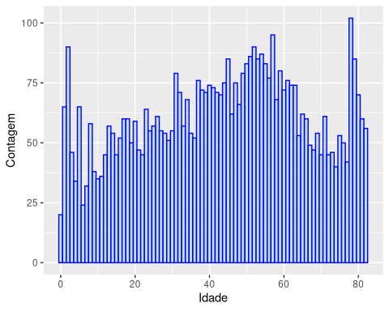

boxplot(age~stroke,  
 data = stroke_data,  
 main = "AVC em relação a idade",  
 xlab = "Idade",  
 ylab = "AVC",  
 col = c("lightblue","lightyellow"),  
 ylim = c(0,100))

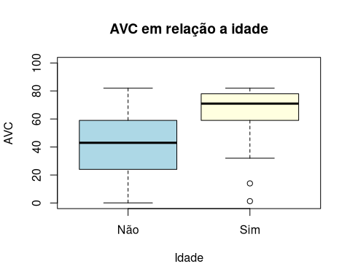

## Hipertensão  
ggplot(stroke_data, aes(x=hypertension)) +  
 geom_bar(fill="lightblue", color="blue", alpha=0.8) +  
 labs(x="Tem hipertensão", y="Contagem")

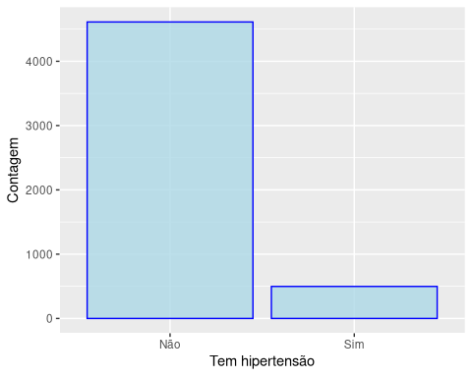

ggplot(stroke_data, aes(x=hypertension, fill=stroke)) +   
 geom_bar(position="fill") +  
 xlab("Hipertensão") +  
 ylab("Porcentagem")

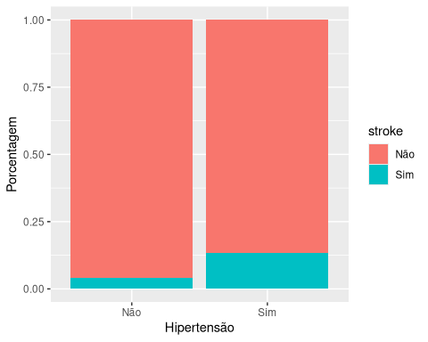

## Problema de coração  
ggplot(stroke_data, aes(x=heart_disease)) +  
 geom_bar(fill="lightblue", color="blue", alpha=0.8) +  
 labs(x="Tem problema de coração", y="Contagem")

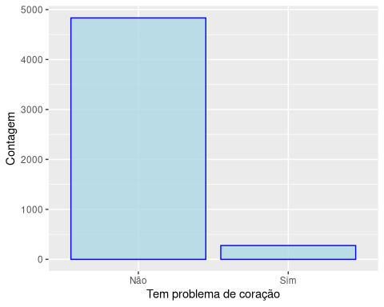

ggplot(stroke_data, aes(x=heart_disease, fill=stroke)) +   
 geom_bar(position="fill") +  
 xlab("Problema de coração") +  
 ylab("Porcentagem")

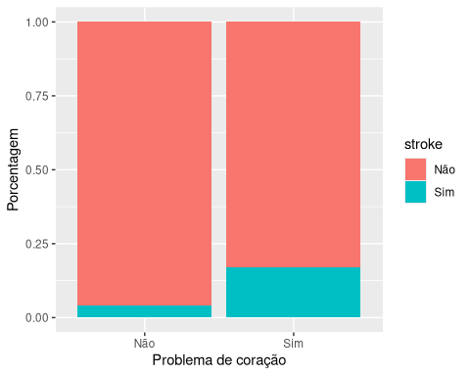

## Nível médio de glicose  
ggplot(stroke_data, aes(x=avg_glucose_level)) +  
 geom_histogram(binwidth=5, alpha=0.7, color="blue", fill="lightblue") +   
 labs(x="Nível de glicose médio", y="Contagem")

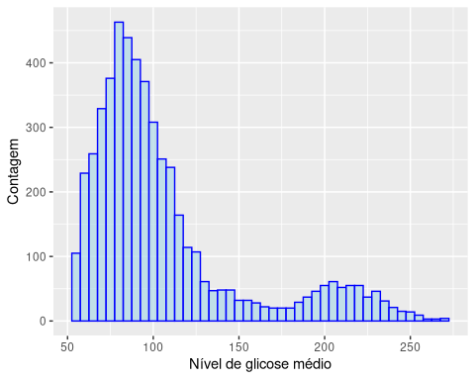

boxplot(avg_glucose_level~stroke,  
 data = stroke_data,  
 main = "AVC em relação ao nível de médio de glicose",  
 xlab = "Nível médio de glicose ",  
 ylab = "AVC",  
 col = c("lightblue","lightyellow"),  
 ylim = c(0,300))

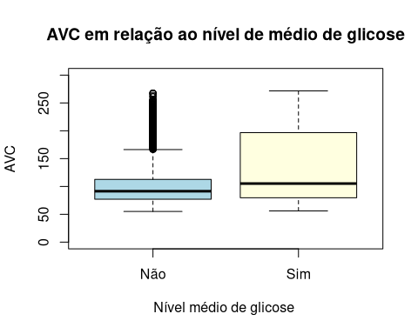

## Status de fumante  
ggplot(stroke_data, aes(x=smoking_status)) +  
 geom_bar(fill="lightblue", color="blue", alpha=0.8) +  
 labs(x="Status de fumante", y="Contagem")

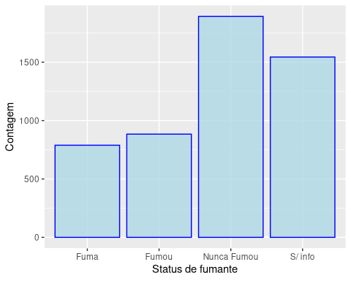

ggplot(stroke_data, aes(x=smoking_status, fill=stroke)) +   
 geom_bar(position="fill") +  
 xlab("Status de fumante") +  
 ylab("Porcentagem")

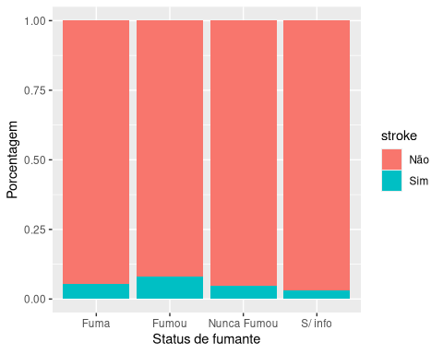

## AVC  
ggplot(stroke_data, aes(x=stroke)) +  
 geom_bar(fill="lightblue", color="blue", alpha=0.8) +  
 labs(x="Teve AVC", y="Contagem")

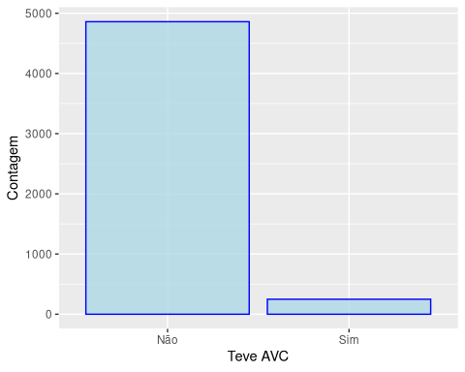

## IMC  
ggplot(stroke_data, aes(x=imc)) +  
 geom_histogram(binwidth=1, alpha=0.7, color="blue", fill="lightblue") +   
 labs(x="IMC", y="Contagem")

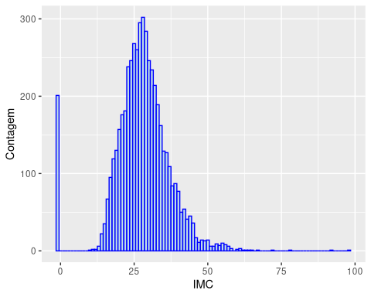

stroke_data_filtered = stroke_data[stroke_data$imc != -1,]  
boxplot(imc~stroke,  
 data = stroke_data_filtered,  
 main = "AVC em relação ao IMC",  
 xlab = "Nível médio de glicose ",  
 ylab = "IMC",  
 col = c("lightblue","lightyellow"),  
 ylim = c(0,100))

