exercicio03.R

Betman

2024-04-21

#0 Leitura da base de dados e amostra aleatória simples de 600 celulares  
dados <- read.csv2("mobile.csv", dec=".")  
  
library(dplyr)

##   
## Attaching package: 'dplyr'

## The following objects are masked from 'package:stats':  
##   
## filter, lag

## The following objects are masked from 'package:base':  
##   
## intersect, setdiff, setequal, union

library(doBy)

##   
## Attaching package: 'doBy'

## The following object is masked from 'package:dplyr':  
##   
## order_by

set.seed("12345")  
tam_amostra = 600  
  
amostra = sample_n(dados, tam_amostra)  
  
## Fuções para cálculo da média, desvio padrão e coeficiente de variação  
cof_var <- function(values){  
 return(100*sd(values)/mean(values))  
}  
questao01 <- function(x){  
 c(media=mean(x), desvio=sd(x), cof=cof_var(x))  
}  
  
## Mudança de valores de variáveis para melhor interpretação  
amostra$touch_screen = case_match(amostra$touch_screen, 0~"Sem Touch", 1~"Com Touch")  
amostra$blue = case_match(amostra$blue, 0~"Sem Bluetooth", 1~"Com Bluetooth")  
  
  
###########################################################################################  
#1 Calcule a média, desvio padrão e coeficiente de variação para as seguintes variáveis: ##  
###########################################################################################  
  
## (a) “battery_power”, em função das categorias da variável “touch_screen”;  
resultA = summaryBy(battery_power ~ touch_screen, data=amostra, FUN = questao01)  
resultA

## touch_screen battery_power.media battery_power.desvio battery_power.cof  
## 1 Com Touch 1253.937 443.742 35.38790  
## 2 Sem Touch 1231.205 434.208 35.26692

## (b) “m_dep”, em função das categorias da variável “touch_screen”;  
resultB = summaryBy(m_dep ~ touch_screen, data=amostra, FUN = questao01)  
resultB

## touch_screen m_dep.media m_dep.desvio m_dep.cof  
## 1 Com Touch 0.5122517 0.2923423 57.07005  
## 2 Sem Touch 0.4902685 0.2836853 57.86326

## (c) “int_memory”, em função das categorias da variável “blue”.  
resultC = summaryBy(int_memory ~ blue, data=amostra, FUN = questao01)  
resultC

## blue int_memory.media int_memory.desvio int_memory.cof  
## 1 Com Bluetooth 34.17082 19.29543 56.46756  
## 2 Sem Bluetooth 32.08777 18.10187 56.41361

###########################################################################################  
#2 Faça os gráficos de caixa das análises dos itens 1a, 1b, 1c e tire conclusões. #########  
###########################################################################################  
  
## (a) Gráfico de Caixa: “battery_power” x “touch_screen”;  
boxplot(battery_power~touch_screen,  
 data = amostra,  
 main = "Comparação de Bateria: Celular com e sem Touch",  
 xlab = "Touch Screen",  
 ylab = "Capacidade da Bateria ( mAh )",  
 col = c("lightgreen","pink"),  
 ylim = c(200, 2200))

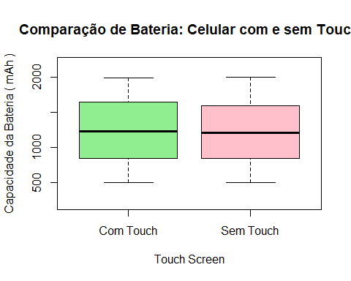

## (b) Gráfico de Caixa: “m_dep” x “touch_screen”;  
boxplot(m_dep~touch_screen,  
 data = amostra,  
 main = "Comparação de Profundidade: Celular com e sem Touch",  
 xlab = "Touch Screen",  
 ylab = "Profundidade do Celular ( cm )",  
 col = c("lightgreen","pink"),  
 ylim = c(0.0, 1.2))

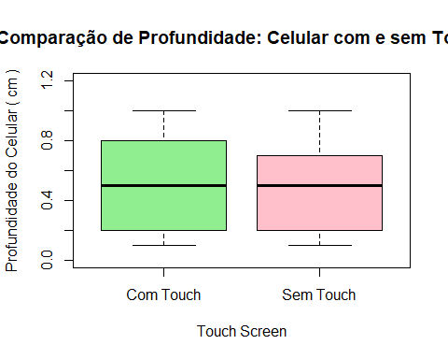

## (c) Gráfico de Caixa: “int_memory” x “blue”.  
boxplot(int_memory~blue,  
 data = amostra,  
 main = "Comparação de Memória Interna: Celular com e sem Bluetooth",  
 xlab = "Bluetooth",  
 ylab = "Memória Interna ( GB )",  
 col = c("lightblue","lightyellow"),  
 ylim = c(0,70))

