ALMUZAHIM NASEEF MUHAMAD B30296 S24B38/006

The 6Fs which relate to the pathways of fecal-oral transmission include feces , fingers, fields, flies, food and fluids. They work in a way that the feces contain germs that contaminate various environments, the insects then carry the germs from feces and they come into contact with these germs and these contact events spread germs causing illness in individuals

The F-diagram highlights the importance of hygiene practices which include;

Proper sanitation and disposal of feces

Handwashing with soap

Safe food handling and preparation

Preventing flies from contaminating food or surfaces

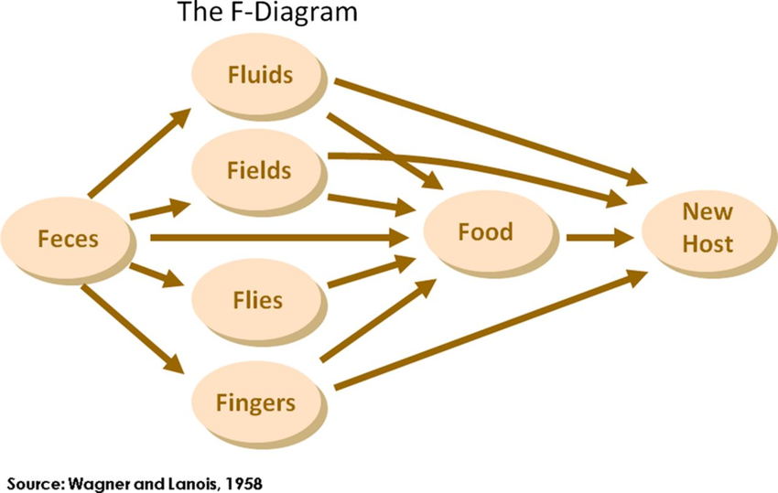

From this diagram we learn a lot of things that can reduce on spread of diseases and pathogens to people. The diagram shows pathways and associated routes in which pathogens reach people. There are physical and secondary barriers for example;

Drinking water may

be contaminated by a dirty water container or food may be infected by dirty cooking utensils this can be taken as a secondary barrier.

We can follow some guidelines that can help us prevent disease spread by following the above diagram and the guidelines are as follows;

Separation of feces from the environment so that germ carriers don’t get into contact with them and spread to humans, washing of hands after defecation, proper drainage systems so that wastes don’t get into contact with water sources, washing of hands before preparing food, covering food so that disease carriers do not get into contact with it, and we can see a recurring theme here which involves washing anything you will consume or apply to your body so that the bodies do not get affected.

Some of the diseases one can acquire if these guidelines aren’t followed include cholera, typhoid, diarrhea and dysentery.