**Title**

*Job Seeker Account Revamp*

*Features include Status Tracker, Recommended Jobs, Profile Review and Support and Recruiter Feedback*

**Stakeholders**

* *Team - Design team, Engineering teams will be involved in developing the feature.*
* *Sponsors/Approvers - The Product Line Manager for Jobs, VP of Subscriptions*
* *Supporting Teams - User Research Teams,*
* *User - Job Seeker Account subscribers*

**Status**

* *Design and Planning*

**Background**

Context

User research data reveals that user satisfaction for the Job seeker account is average or below expectations. This in turn leads to user churn and reduced premium subscribers leading to loss in revenue. Adding the status tracker as well as recruiter feedback will attract and retain more users. Also, it will make Users apply for jobs directly through LinkedIn which will increase the direct leads from LinkedIn to the jobs advertised in LinkedIn thereby attracting more jobs from enterprise customers.

Product

There is no feedback about the job application currently on the product. The job seeker can see the jobs he/she has applied to in the jobs dashboard. The only time a job seeker is notified is when the recruiter checks out the applicant’s profile.

Competition

The application status feature seems to be much valued amongst job seekers and is something competitors in the space are providing even on free accounts. This has become more of a parity feature. The recruiter feedback feature might be the differentiator feature in this space for LinkedIn.

Users

The primary motivation for most Users on LinkedIN is to land their next job. The active job seekers make up for most of the premium subscription users, and the feedback feature came up as a most wanted feature in User Surveys. Most active job seekers want to see what the update on the application is. Only when they see that the resume that they submitted is acted upon, will they apply through the job search page, else the user’s apply for the job via the company portal or other websites.

Metrics:

Number of job seeker subscriptions

Customer feedback about the feature

Number of page views

Analysis

It will address the issues of User satisfaction with the premium account users, It will increase the usage of the job search and apply feature and prevent customers from leaving the site when it comes to applying for the job. This can also turn into the only platform that companies use for recruiting talent and they could decide to decommission their own career sites.

Further Analysis - The feedback feature will be the differentiator. Though the implementation would be tough, the recruiter could be incentivised to do this.

Metrics:

Customer feedback on the feature and the overall satisfaction for the premium account should increase

Benefits from the feature:

Since the job seeker account brings the majority of traffic to the site, guess that increase in customer satisfaction would impact revenue positively.

**Success Metrics**

The customer satisfaction for the job seeker account is the success metric. Increase in number of job seeker accounts is an indirect metric to follow.

**Epics**

* *As a Job seeker, I want to see the status of my application as this gives me end to end view of where my application is in the hiring process.*
* *As a Job Seeker, I want to see job recommendations that match my interest and my skillset as this eases my job search process and helps me apply for the jobs that are a best match for me.*
* *As a Job Seeker, I want my profile to be reviewed by an expert as the feedback will help me in my increase my profile views and catch the Recruiter/Hiring Manager’s attention*
* *As a Job seeker, I want to receive feedback from the recruiter about my resume/interview to see how I can improve my job search process, acquire skills etc*
* *As a Recruiter, I want to give feedback so that I can find the right talent and justify selecting one candidate vs another*

**Requirements**

**Feature 1 : Status Tracker**

**Epics**

As a Job seeker, I want to see the status of my application as this gives me a easy view of of the hiring process

**User Stories**

As a Job seeker, I want to able to see if the recruiter has received my application as this will give me the confirmation that my application is in the company’s internal system

As a Job seeker, I want to able to see if the recruiter has read, reviewed and downloaded my application as this shows that the recruiter is interested in my application

As a Job seeker, I want to know if my application was selected for the Phone interview process as this shows that I got selected for the Phone interview

As a Job seeker, I want to know if my application was selected for the Onsite interview process as this shows that I got through the phone interview

As a job seeker , I want to know if my application was chosen after the interview and an offer made as this shows me that I got an offer

As a Job seeker, I want to know if the position has been filled as this shows me that the job has been filled and that the hiring process has ended.

**Job Recommendations**

Epics

*As a Job Seeker, I want to see job recommendations that match my skillset as this eases my job search process and helps me apply for the jobs that are a best match for me.*

*As a Job Seeker, I want to see job recommendations that match my interest as this eases my job search process and helps me apply for the jobs that are a best match for me.*

**Profile Review and Support**

Epics

*As a Job Seeker, I want to improve my profile so that I make my profile more attractive for the recruiters.*

Recruiter Feedback

Epics

*As a Job Seeker, I want get the feedback from the recruiter when I don’t make the cut for the next stage of the hiring process, this helps*

**Design**

**Feature : Status Tracker**

*Flow1*

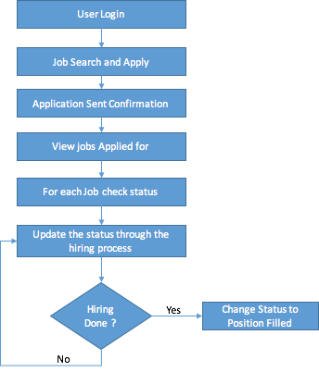

*Wireframes/Mockups*

*Navigation: Home → Jobs → My Jobs*

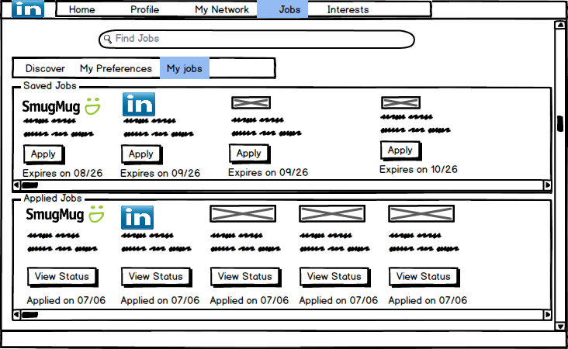

*Navigation: Home → Jobs → My Jobs → View Status ( pop up screen)*

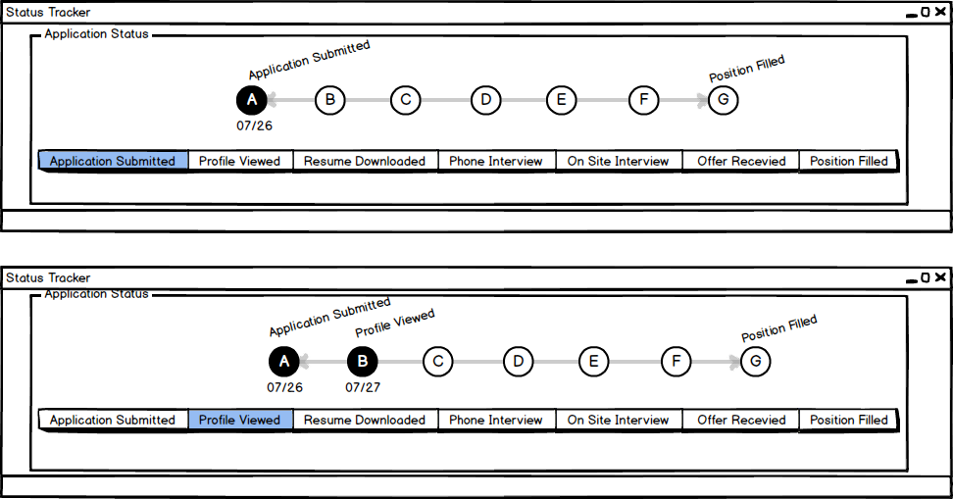

**Feature2 : Recommended Jobs for you**

*Flow1*

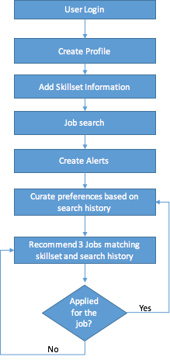

*Wireframes/Mockups*

*Navigation: Home → Jobs → Discover*

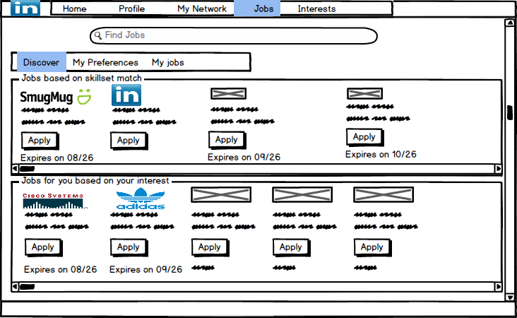

**Feature 3 : Profile Review and Support**

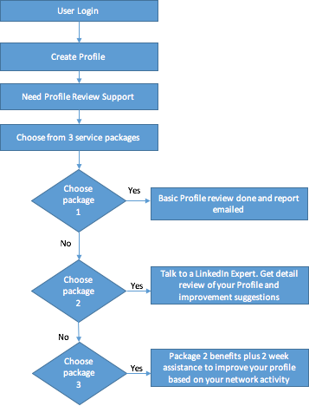

*Wireframes/Mockups*

*Navigation: Home → Profile*

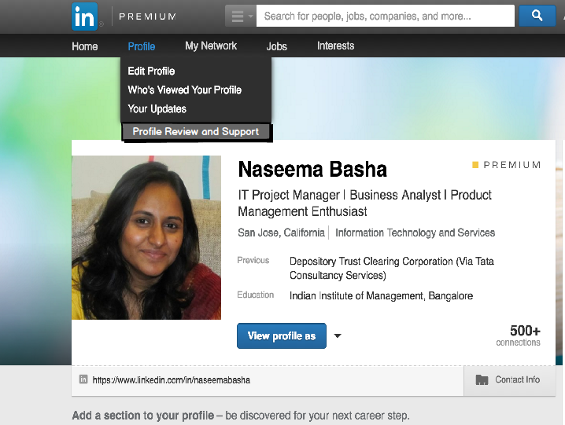

**Timeline & Release Planning**

* Rough estimate from design & engineering

The status tracker feature will take 2 months to roll out, this includes the design,build and test effort.

The recommendations feature will take estimated 3 months to design,build and test.

The profile review and support feature will take about 6 months to roll out. This can be a staggered roll out with the package 1 rolled out in 4 months followed by the package 2 and 3 rollout in 6 months.

All these features can be developed independently as there is no dependency between the feature themselves

* Any important dates

Target dates for the different features

Status Tracker - 30/09/16

Recommendations Feature - 31/10/16

Profile Review and Support - 31/12/16

Recruiter Feedback - 31/10/16

https://trello.com/b/Zpiooy1o

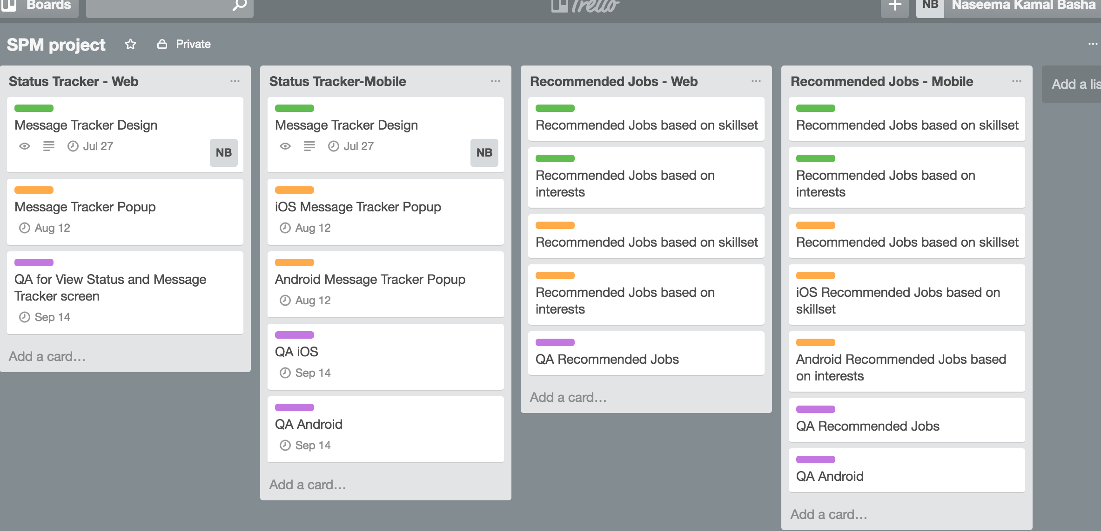

**Checklists**

* **Assumptions**
  + The user research data is good and that the satisfaction levels for the job seeker premium account holders is very low
  + The talent solutions market is getting very competitive with solutions like hired and industry specific networking sites, that these features are needed to make the User perceive value in remaining a premium member.
* **Known issues**
  + Recruiter Feedback is difficult to get, as the recruiters are paid for placing the candidates and don’t have any incentive to rate and give feedback to every candidate. However, the recruiter can be incentivised by providing inmail credits for every feedback given with a candidate satisfaction rating.
  + Initially the features added seem to be provided for free, however the user research strongly suggest that these features need to be provided to make the members happy if not to improve customer satisfaction. This will help in retention.
* **For future consideration (not in scope)**
* Recommendations based on interest for certifications/learning courses in Lynda
* Recommend people with similar interests in the network, like if a connection or second degree connection is interested in collaborating and working on similar interest project, show on the home page.
* Also show job postings, services offered by individuals etc based on the personal interests..

**Release Notes**

*Add this section after launch with dates and a brief description of what was changed. This is especially helpful if someone notices a change in a metric so you're able to go back and see if it might be related to a feature change.*