OBJECTIVE
To secure a challenging position where I can effectively contribute my skills as software professional for growth of organization and myself

EDUCATION
Government senior secondary school tapukara alwar 2018
10th
71%

Government senior secondary school tapukara
12th science
70%
Lords university alwar
Bea Running

PERSONAL SKILLS

C on fid en t Team player
Godd communication skills Problem solving

2020

2023

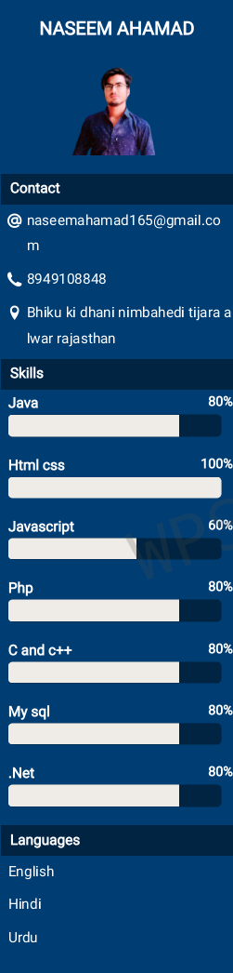
PROJECTS
E notes website
E notes website using java jsp servlet and mysql database

Portfolio
Develop a portfolio using html,css ,php and mysql database

Mail system
Develop a mail system using html ,css,php,and musql database

Calculator
Using advance java awt

HOBBIES
Software development
Web development
Internet Surfing NASEEM AHAMAD

